1

**WORLD SOLAR GUIDE**

**Part 2**

**An Analysis of Solar Energy and Hydrogen Storage Potentials**

**on a Global Scale**

Jon D. Canaday, Ph.D.

Research Scientist

World Solar Guide LLC Website: [www.world-solar-guide.com](http://www.world-solar-guide.com)

2209 Francis Street

St. Joseph, Missouri 64501 Email: [jon.canaday@world-solar-guide.com](mailto:jon.canaday@world-solar-guide.com)

USA

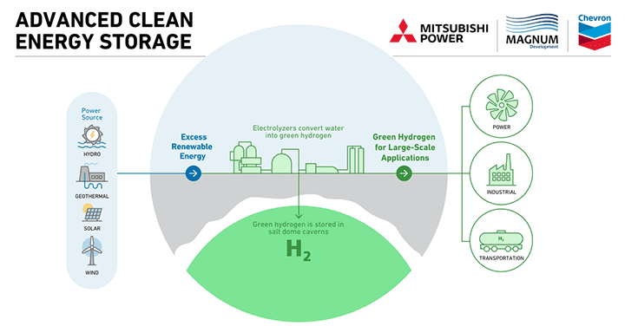

Image from Mitsubishi.com

Copyright © 2023, Jon D. Canaday

2

**WORLD SOLAR GUIDE**

**Part 2**

**An Analysis of Solar Energy and Storage Potentials**

**on a Global Scale**

Table of Contents Page

1. Introduction 3

2. Climate Imperatives 3

3. Solar Energy 4

4. Variable Renewable Energy 4

5. Energy Storage 4

6. Water Resources 4

7. Hydrogen Storage 5

8. Working Systems and Simulations 5

9. Solar Energy Models 6

9.1 Scaled Models 9

9.2 Hypothetical World Model 12

10. Four Energy Regions 21

10.1 China 21

10.2 United States 22

10.3 Europe-E5 Countries 23

10.4 India 24

11. Environmental and Economic Factors 25

11.1 China 25

11.2 United States 26

11.3 Europe-E5 Countries 27

11.4 India 26

12. Land-Use Management 28

12.1 China 31

12.2 United States 31

12.3 Europe-E5 Countries 33

12.4 India 35

13. Commercial Systems 36

14. Hydrogen Applications, Projections, Pathways, and Models 44

15. Cost Summary of Green Hydrogen Production 68

16. Summary 72

17. Conclusions and Subsequent Guide Segments 75

18. References 78

19. Appendix 81

3

**Part 2**

**An Analysis of Solar Energy and Storage Potentials**

**on a Global Scale**

1. Introduction

The website, [www.world-solar-guide.com](http://www.world-solar-guide.com), (WSG) presents aspects of worldwide solar energy in the context of global warming and climate change. **Part 1** of the Guide was limited to the day-time production of solar energy without consideration for energy storage.

While solar power is incident on the earth’s surface at the rate of 1,000 watts per square meter, its diurnal cycle and other variations means that dual systems for “day-time” and “night-time” hours are required in order to provide level sources of power and energy.

The analysis in **Part 2** considers green hydrogen energy storage requirements of various systems which are connected to electrical utility-scale grids or other loads. These systems consist of a dual solar photovoltaic (PV) array, electrolyzer (EL), and fuel cell (FC) connected to a utility-scale grid. The analysis is then expanded to consider a hypothetical global system with allocations to its four largest energy users, China, the United States, Europe-E5 countries (Germany, France, Spain, Italy, the UK), and India. A model for both electric grid use and sector hydrogen production is then considered. Environmental and land-use concerns are also addressed.

2. Climate Imperatives

As set forth by the International Panel on Climate Change [1], the world faces the possibility of an increase in global temperature. The Paris Agreement [2] attempted to limit this temperature increase to 1.5 to 2.0 C with the (implicit) understanding that the world has already experienced an increase of 1.0 C since 1850. The year, 1750, has also been considered as a baseline as it represents the historical beginning of the Industrial Revolution.

The most viable solution to the phenomenon of global warming will most likely be the replacement of fossil fuels by renewable energy sources, such as solar, wind, hydro, bio-mass, tides, and geo-thermal. While the G20 countries consume about 80% of the world’s energy, the “Big Four” regions consume approximately 54% of this energy [3], cause 56% of the earth’s CO2 emissions [4], and install 67% of solar PV panels [4], seen in Table 2.1. These geographical areas will be the foci of the energy-production and energy-storage requirements in this analysis.

Table 2.1. Energy, environmental, and solar PV features of the world’s four largest regions.

|  |  |  |  |
| --- | --- | --- | --- |
| **Country or Region** | **Energy Use (%)** | **CO2 Emissions (%)** | **Solar PV (%)** |
| China | 24 | 29 | 33 |
| US | 17 | 14 | 12 |
| Europe-E5 Countries* | 7 | 6 | 15 |
| India | 6 | 7 | 7 |
| Total | 54 | 56 | 67 |

*Europe-E5 Countries: Germany, France, Spain, Italy, and the UK

4 3. Solar Energy

Solar energy will likely provide the largest amount of renewable energy for the replacement of fossil fuels. Examples of this source have been discussed by IRENA [5].

4. Variable Renewable Energy

In addition to the diurnal cycle of solar energy, its variability (VRE) also reduces output. This variability [6] is characterized by a “capacity factor” [7]. In the analysis, a capacity factor of 0.25 was assumed for the six hours of solar PV power over a 24-hour period.

5. Energy Storage

The solution to solar PV variability is the storage of energy when this source is not available.

Among the many forms of storage, hydrogen is seen as the most promising [8] for utility-scale grid systems. Hydrogen is produced by the electrolysis of water in which the electrolyzer is powered by a PV array during the day-time hours. This hydrogen is then stored for use when solar power is not available. During this period, the hydrogen is transported to a fuel cell which produces electricity for the grid or load.

6. Water Resources

Fresh water is considered an inadequate source for utility-scale electrolysis [9].

Seawater, which provides about 95% of earth’s water, will become the primary source for this application. Two methods of dealing with the salt component are currently under investigation: (1) desalination and electrolysis and (2) direct electrolysis of seawater which is shown in Figures 6.1(a) and 6.1(b). Desalination is an expensive process, and direct electrolysis of seawater degrades the electrodes because of chlorine ions. Arid (irradiant) coastal regions will be required for these resources.

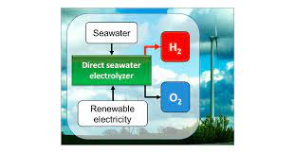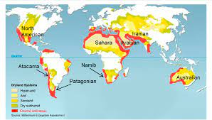

Figures 6.1(a) and 6.1(b) direct seawater electrolysis.

Images from technischechemie.tu.ber

5

7. Hydrogen Storage

Utility-scale storage of hydrogen [10] will most likely occur in the utilization of existing salt caverns or in the production of new caverns through the dissolution of salt deposits and returning the solution as brine, with areas seen in Figures 7.1 and 7.2. As is the case for water, hydrogen is also utilized in a closed-loop system with electrolyzer production and fuel-cell consumption.

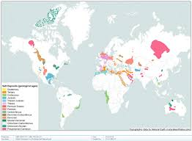 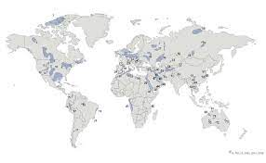

Figures 7.1. Potential hydrogen storage areas Figure 7.2. World salt deposits

Image from energnet.eu Image from researchgate.net

Scientists at Germany’s Julich Institute for Energy and Climate Research reported [11] a potential hydrogen energy storage capacity of 85 PWh (85x1015 Wh) in salt caverns. Taking the energy density of hydrogen at 33.6 KWh-kg-1 and a volume of 0.0898 m3-kg-1, the corresponding volume is 2.27 x 1011 m3 or 227 km3 at a pressure of one bar. At 150 bars, this volume is 1.51 km3. Assuming a typical salt cavern volume of 500,000 m3 (see below), the number of such caverns would be 3,020.

8. Working Systems and Simulations

Small-scale systems and simulations have been demonstrated. The following references are experimental/modelling examples of solar energy capacity factors which are generally less that about 0.25, with the energy/power and efficiencies (e) of the systems as shown in Table 8.1.

Table 8.1. Examples of small-scale working PV-EL-FC systems and simulations.

|  |  |  |  |  |  |  |  |  |
| --- | --- | --- | --- | --- | --- | --- | --- | --- |
| **Reference**  **(Units)** | **PV**  **energy/**  **power** | **Direct**  **Energy**  **to load**  **demand** | **Energy/**  **power to**  **EL** | **Hydrogen**  **Production** | **Hydrogen**  **Storage** | **Energy/**  **power**  **to FC** | **Energy**  **From FC** | **Energy**  **to load**  **or**  **demand** |
| Dihrab [12]  (KWh) | 0.78 | 0.27 | 0.51 | 0.35 | 0.08 | 0.27 | 0.12 | 0.37  e = 47% |
| Ganguli [13]  (KW) | 3.825 | NA | 3.3 | NA | NA | 2 x 0.48 | NA | NA |
| Pascuzzi [14]  (KW) | 5.76 |  | 2.5 | NA | NA | 2.0 | NA | NA |
| Mubaarak [15]  (KWh-y-1)  (Simulations) | 27,545 | 7,051 | 11,823 | 2,857 m3 | 2,777 m3  Consumed |  | 6,163 | 7,051  6,163  e = 48% |

6

9. Solar Energy Models

The replacement of fossil fuels by the renewable sources of bio-energy, geo-thermal, hydro, oceans, solar, and wind have been proposed [16]. Three renewable sources, wind, water, and solar have also been cited for this replacement [17]. Solar, wind, and other renewables were seen to provide 100% of earth’s energy needs [18,19].

In this analysis, it is assumed that solar energy alone, converted to electrical energy, will provide all the world’s supply. Clearly, the solar irradiance at the earth’s surface [20] provides more than enough power and energy for the world’s needs as seen in simple calculations. The total power received at the earth’s surface is 1.28x1017 watts, and the annual energy is 1.13x1018 KWh. With the world’s energy demand of approximately 500 EJ (EJ = Exa Joules, 1018 Joules) or 1.39x1014 KWh per year, the ratio of solar energy supply-to-demand is 8,100.

It is also assumed that during the transition period of 2020-2050, the world will require a constant amount of energy, 500 EJ, per year. While the actual demand for total energy due to population growth, economic activities, and other factors may increase, this need for electrical energy as provided by utility-scale PV sources may be offset by several reduction factors:

1. Other sources such as wind and bio-energy will reduce PV requirements.

2. Efficiencies of PV arrays and electrical devices will increase.

3. Roof-top arrays will reduce utility demand.

4. Conservation will reduce energy demand.

5. Passive building practices will lower heating and cooling requirements as well as the energy

needs for producing building materials.

Therefore, in order to calculate first-order approximations for scaled-systems and energy supplies on a global scale, the annual value of 1.39x1014 KWh will be taken as a constant. No attempt has been made to match energy supply with demand on a diurnal basis.

As hydrogen storage is considered the most viable means of leveling the variability of solar PV power, it is important to consider that the largest cost component of hydrogen production is the electrical power for electrolysis. The cost of solar PV power has been reduced by 70% during the past decade, meaning that the combination of hydrogen and solar will likely become the most significant set or resources in the replacement of fossil fuels with renewable energy. “Green Hydrogen” produced from the electrolysis of water powered by renewable energy. While the guide will focus on this combination for the provision of electrical power, the application of hydrogen in the other major sectors, namely industry, transportation, and buildings will be considered.

7

A schematic of a US Model C with hydrogen storage is shown in Figure 9.1. PV1, PV2, and PV3 represent photovoltaic power sources to the electric grid and to the electrolyzer, EL. The PV arrays produce power during a six-hour “day-time” period. The fuel cell, FC, provides power to the grid during the 18-hour “night-time” period. The terms URFC and DRFC [21] denote “unitized reversible fuel cells” and “discrete reversible fuel cells.” These distinctions have not been further considered here nor have their optimizations. Similarly, desalination and direct seawater electrolysis methods were not considered in detail. The “E” terms are energy input and output values as calculated in Sections 9.1 and 9.2. Grid water and hydrogen are utilized in closed-loop systems. Industry, transportation, and building sectors, are also shown.

Input Energy Output Energy

E1, in E1, out

Electric

Grid

Inverter

PV1

E 2, in, electric

PV2

URFC

DRFC

E2, out, electric

EL

Grid

FC

Grid

1 8 18 hours

EL, H2

Sectors

US, E out = 100 EJ/year

PV3

(90% electrification)

Sectors (Section 14.4)

E3, in, sectors

Water/Grid

Industry

Ein

Water/Sectors

6 hours

WSG E2, out, sectors

Transportation

US Model C

Ein = 475 EJ/year

H2 Storage/Grid

(Section 14.4)

Buildings

H2 Storage/Sectors

10% H2 energy, 325 Mt/yr

Figure 9.1. Components of a PV-EL-FC energy system with water source and hydrogen storage.

This analysis does not consider the diurnal dispatchable characteristics of the PV-EL-FC system in which the supply of electrical power and energy are matched with their demand requirements. Rather, the analysis has concentrated on the determination of estimates for system resources. These resources, on the supply side, include the sizes and land areas of the PV installations, powers of the electrolyzers and fuel cells, water requirements, as well as hydrogen production and storage volumes. These data will then be used in a subsequent analysis to address the material limitations of such systems on a global scale. For example, PV arrays will face limitations of silver as used in electrical contacts. In addition, electrolyzer and fuel-cell installations will be limited by their electrode catalytic materials such as the platinum group of metals. Stored green hydrogen can also be produced by water electrolysis in open systems for the industry, transportation, and building sectors as discussed in Section 14.

8

As discussed in Section 4, solar energy is a variable renewable source. To describe the variability of energy sources, a “capacity factor” defined as the following ratio:

CF = Actual output period

Potential output period

is employed. In this analysis, the solar CF is taken to be six hours per day or 2,190 hours per year, giving

CF = 6 = 2,190 = 25%

24 8,760

Therefore, while 100% of the energy must be produced during the six-hour “day-time” period, 75% of the energy must be stored for “night-time” use. However, due to electrolyzer and fuel-cell inefficiencies, it will be seen that the necessary “night-time” input energy will be more than three times the “day-time” requirement.

This solar variability for is shown schematically in Figure 9.2

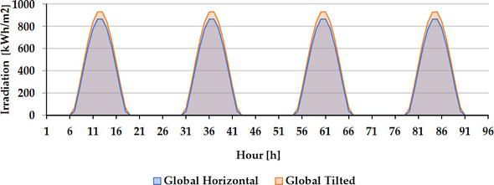

Figure 9.2 Ideal representation of solar variability. Image from IntechOpen.com

Various methods have been proposed for the mitigation of this variability which include the combining of solar arrays in different time locations and coupling solar with wind sources. These measures do not, however, consider the storage of solar energy for periods when direct power is not available. In addition, they do not result in the production of hydrogen which will be necessary in some application of the transportation sector, for example, such as vehicles powered by fuel cells. Most likely, other measures will be developed by countries depending on their own resources in efforts to produce the most cost-effective system. As seen through projections in Sections ___ , not only will hydrogen storage be necessary but that the electrification rate of the world’s energy budget will be 90% in order to achieve net-zero CO2 emissions by 2050 according to the IEA “Net-Zero by 2050” pathway.[xxxxxxxxxx]

9

9.1 Scaled Models

PV-EL-FC systems are considered first in which a linear scaling of electrolyzer capacities has been assumed for increasingly larger components. Simplifications and omissions include electrical connections, hydrogen compression, temperature and pressure, PV-EL-FC

optimizations, and inverters.

With reference to Figure 9.1, the following **sequence** of calculations is given:

(1) The analysis begins with a **1 MW water electrolyzer** having a manufacturers’ [22,23] hydrogen production rate of Hp = 200 m3-h-1 or 5.55 x 10-2 m3-s-1 (see Appendix). With a conversion factor for hydrogen of 0.0898 kg-m-3, this rate becomes Hp = 4.98 x 10-3 kg-s-1.

(2) The quantity of hydrogen produced in six hours is

Qp = Hpt = 108 kg

or 1,203 m3 at one bar and 8.0 m3 at 150 bars, a typical pressure for hydrogen storage.

(3) While the stoichiometric amount of water required for hydrogen production is 9 kg per kg of hydrogen, the actual water use ranges between about 20 and 120 kg depending on the PV and EL systems [24]. In this analysis, 60 kg of water is assumed per kg water, and the water requirement is 6450 kg or 6.45 m3. The FC production of water may differ, but it is taken to be the same as the EL usage. The dimensions of a cubic water container are given as (m3)1/3.

(4) The same quantity of hydrogen was transferred to the fuel cell over the night-time consumption period of period of 18 hours at one-third the production rate, or a rate of

Hc = 1.66 x 10-3 kg-s-1.

(5) The fuel-cell hydrogen consumption rate is also

`

H c = nc I, moles-s-1

2F

where nc, I, and F are the number of cells, current, and Faraday’s constant.

The fuel cell power (**Part 3 Appendix**) with nc =1 is given by Pe = ncIVc so that

Hc = Pe

2FVc

With the molar mass of hydrogen as 2.02 x 10-3 kg-mole-1

Hc = 1.05 x 10-8 Pe

Vc

10

where Vc is the fuel-cell, single-cell voltage, assumed to be 0.65 V nominally, from which the fuel cell input power can be calculated as

P FC, in = 1.66 x 10-3 (0.65 V) = 103 KW

1.05 x 10- 8

(6) Assuming a fuel cell efficiency of 50%, the output power of the fuel cell to the grid is

PFC, out = 51.5 KW

(7) The energy produced by the fuel cell over the 18-hour night-time period is E2, out= 927 KWh.

(8) This 18-hour period represents 75% of the energy input to the grid with the remaining 25% day-time contribution from PV1 as E1, out = 309 KWh which is produced in the 6-hour period at a rate of 51.5 KW.

(9) The total energy to the grid from PV1 and PV2-EL-FC is ET = 1,236 KWh per day.

(10) To calculate the area of PV1, the following relations can be used. The solar power density is

Dp = Ise = 0.20 KW-m-2

where Is is the solar irradiance at the earth’s surface, 1,000 W-m-2, and e is the panel efficiency, 0.20. The energy density is

De = Dpt1 = 0.20 KW-m-2 (6 h-day-1) = 1.20 KWh day 6h = 0.30 KWh

m2-day 24 h qtr-day m2- qtr-day

A1 = E1 = 309 KWh-day-1 = 1,030 m2

De  0.30 KWh

m2- qtr-day

(11) As PV2 is required to produced 1MW in order to power the electrolyzer, its area must be

A2 = PEL = 1 MW = 5,000 m2, (PV2-EL energy optimization has not been considered here).

Dp 0.20KW-m2

Alternatively,

A2 = EELt = 1 MW (6 h-day-1) = 5,000 m2

De  1.2 KWh

m2 - day

(12) The total PV area is 6,030 m2.

(13) The ratio of PV2 to PV1 areas is 5,000/1,030 = 4.85.

11

(14) The efficiency of this system can now be determined (Figure 9.1) where the required energy input to the electrolyzer is E2, in = 1 MW (6h) = 6,000 KWH and

η = E out = E 1, out + E 2, out = ET = 309 + 927 = 20%

E in E 1, in + E 2, in Ein 309 + 6,000

The above-numbered calculation sequence for commercial electrolyzers (EL) of various powers is summarized below in Table 9.1. In addition, the component quantities for various system sizes are given.

Table 9.1. Scaled PV-EL-FC models

|  |  |  |  |  |  |  |  |  |
| --- | --- | --- | --- | --- | --- | --- | --- | --- |
| PV1  Direct  Power  to Grid/load  6 hours  Area  (m2) | PV2  Power  to EL,  Total  PV area  6 hours  Areas  (m2) | EL, MW  Mfr. Specs.  200 m3/h  1 MW  6 hours  H2  Prod  rate  (kg/s) | Water  Source  6 hours  (kg)  (m3)  (m3)1/3 | Water  Sink  18 hours  (kg), (m3)  (m3)1/3 | Hydrogen  Production  by EL  6 hours  (kg)  (m3)  1 bar  150 bars | Hydrogen  use rate  by FC  18 hours  Rate  (kg/s) | FC  input  power  18 hours  (KW) | Grid  Load  6 + 18 h  24 hours  (KW)  (KWh)  (%) |
| (10) | (11)  (12)  (13) | (1) | (3) | (3) | (2) | (4) | (5) | (6)  (7)  (8)  (9)  (14) |
| 1,030 | 5,000  6,030  4.9 | **1 MW**  4.981x10-3  **Model** | 6450  6.45  1.86 | 6450  6.45  1.86 | 108  1,203  8 | 1.66 X 10-3 | 103 | 51.5  927  309  1,236  20 |
| 10,300 | 50,000  60,300  4.9 | 10 MW  4.98x10-2 | 64,500  64.5  4.00 | 64,500  64.5  4.00 | 1,080  12,030  80 | 1.66 x 10-2 | 1,030 | 515  9,270  3,090  12,360  20 |
| 2.06x105  **WSG**  **Part 6**  **Table 1** | 1.00x106  1.21x106  4.9 | **206 MW**  9.96x10-1 | 1.29x16  1,290  10.9 | 1.29x106  1,290  10.9 | 2.16x104  2.41x105  1,600 | 3.32x10-1 | 20,600 | 10,300  185,400  61,800  247,000  20  **US Grid**  **10.3 MW** |
| 1.03x106 | 5.00x106  6.03x106  4.9 | 1 GW  4.98 | 6.5x106  6,450  18.6 | 6.5x106  6,450  18.6 | 10,800  120,300  8,000 | 1.66 | 103,000 | 51,500  927,000  309,000  1,236,000  20 |
| 1.03x107 | 5.00x107  6.03x107  4.9 | 10 GW  4.98x101 | 6.5x107  64,500  40.0 | 6.5x107  64,500  40.0 | 1.08x105  1.2x106  8.0x104 | 1.66x101 | 1.03x106 | 5.15x105  9.27x106  3.09x106  1.236107  20 |

12 9.2 Hypothetical World Model

A constant 500 EJ, 1.39x1014 KWh, or 4,170 million tonnes of hydrogen annually during the period of 2020-2050 is taken to be the world’s energy demand. At this level, the **sequence** of component calculations is as follows:

(1) The world’s daily energy demand is E = 3.81 x 1011 KWh-day-1 which corresponds to a power level of P = 15.9 TW or 1.59 x 1010 KW. It is assumed for simplicity that this level will be constant over the 24-hour diurnal cycle.

(2) The daytime requirement is 25% of the total energy, E1, in = E1, out= 9.52x 1010 KWh per six hours.

(3) The energy produced by hydrogen, 75% of the total, E2, out = 2.86 x 1011 KWhin 18 hours.

(4) The necessary fuel cell output power which utilizes stored hydrogen energy of 2.86 x 1011 KWh per 18 hours is also PFC, out = 1.59 x 1010 KW.

(5) With an efficiency of 50 %, the fuel cell input power is PFC, in = PFC, out/0.50 = 3.18 x 1010 KW, and the number of 1GW fuel cells, NFC, has been calculated to be 31,800.

(6) The 18-hour hydrogen consumption rate to produce this power is given (Appendix) by

Hc = 1.05 x 10-8 Pe = 5.14 x 105 kg-s-1, where the single cell voltage is Vc = 0.65V.

Vc

(7) As the hydrogen production period is one-third of the consumption period, this rate is Hp = 1.54 x 106 kg-s-1 or 12,100 Mt-yr-1 during the daily 6-hour periods (Mt-yr-1 = million tonnes/yr).

(8) From manufacturers’ specifications of 4.98 x 10-3 kg-s-1 for a 1 MW electrolyzer and the required hydrogen production rate, the electrolyzer power can be determined as

PEL = [ 1.54 x 106 kg-s-1] = 3.10 x 1014 W = 3.10 x 1011 KW

4.98 x 10-3 kg-s-1

1 MW

The number of 1GW electrolyzers, NEL, has also been calculated as 310,000.

(9) The quantity of hydrogen produced during the six-hour period is

Qp = Hpt = 3.33 x 1010 kg = 3.71 x 1011 m3 = 372 km3 at 1 bar

and 2.47 x 109 m3 at150 bars. With an average size salt cavern of 5 x 105 m3, the number of such

caverns would beNs = 4,940.

13

(10) The actual or non-stoichiometric quantity of water required to produce hydrogen on a world scale is taken to be 60 times [24] the hydrogen amount or 2.00 x 1011 kg, or 2.00 x 1011 liters, 2.00 x 108 m3, or 2.00 x km3. The linear dimensions of these cubic volumes are given by (m3)1/3.

(11) With a solar irradiance of I = 1,000 W-m-2 and a solar panel efficiency of e = 20%, the power density is

Dp = Ie = 200 W-m-2

The energy density is

De = Dpt = 0.20KWh 6h = 1.2 KWh day 6h = 0.30

m2  day m2 – day 24h qtr-day m2 – qtr day

giving the panel array area for PV1 as

A1 = E1 = 9.53x1010 KWh = 3.18x1011 m2 = 3.18x105 km2

De 0.30 KWh

m2 - qtr day

(12) The power for PV2, without consideration for PV-EL optimization is taken to be equal to the electrolyzer power, PV2 = PEL= 3.10 x 1011 KW which gives this panel array area of

A2 = EEL = PELt = 3.10 x 1011KW 6h = 1.55 x 1012 m2 = 1.55 x 106 km2

De  De  1.2KWh day

m2 - day

Alternatively, this area can also be determined from the solar irradiance as

A2 = PEL = 3.10 x 1011 KW = 1.55x1012 m2

Dp 0.20 KW-m-2

(13) The total area of the PV panels is then AT = 1.87 x 106 km2

(14) The ratio of A2 to A1 is 4.87.

(15) The efficiency of this system can now be calculated (see Figure 4).

The power produced by PV1 as a direct input to the grid is given by

P1, in = DpA1 = 0.20 KW (3.18x1011 m2) = 6.36x1010 KW

m2

which gives a direct input energy to the grid of E1, in = P1, int1 = 6.36x1010 KW(6h) =

3.82x1011 KWh.

14

The energy input to the electrolyzer is determined from P2 = PEL and the daytime period as

E2, in = P2 t1 = 3.10x1011 KW (6h) = 1.86x1012 KWh

giving the total input energy directly to the grid and to the electrolyzer Ein = 2.24x1012 KWh.

The output energy from the 50% efficient fuel cell over the 18-hour night-time period, t2, is

E2, out = EFC, out = PFC, out t2 = (0.50) (3.18x1010 KW) (18h) = 2.86x1011 KWh.

The total system energy efficiency of this hypothetical world model (in KWh) is then

η = E out = E1, out + E2, out = 9.53 x1010 + 2.86x1011 = ET = 20%

Ein E1, in + E2, in 9.53 x1010 + 1.86x1012 Ein

This calculation sequence for the hypothetical world system (Figure 9.1) is given in Table 9.2.

Table 9.2. Component rates and quantities for a world PV-EL-FC model with hydrogen storage.

|  |  |  |  |  |  |  |  |  |
| --- | --- | --- | --- | --- | --- | --- | --- | --- |
| PV1  direct  power to  Grid/Load  6 hours  Area  (km2)  Energy  (KWh) | PV2  power  to EL  and  total PV  6 hours  Areas  (km2)  Energy  (KWh) | EL  200 m3/h  1 MW power  Prod.  6 hours  Rate  (kg/s)  (Mt/yr)  (KW)  NEL(GW) | Water  source  6 hours  (kg), (L)  (m3)  (m3)1/3  (km3) | Water  sink  18 hours  (kg), (L)  (m3)  (m3)1/3  (km3) | Hydrogen  production  and  storage  6 hours  (kg)  (m3)  1 bar  150 bars  Ns(cavern) | Hydrogen  consumption  rate for FC input power  18 hours  Rate  (kg/s) | FC  input  power  18 hours  (KW)  NFC(GW) | Grid  load  and  system  efficiency  6 + 18  hours  (KW)  (KWh)  (%) |
| (11) | (12)  (13)  (14) | (7)  (8) | (10) | (10) | (9) | (6) | (5) | (4)  (3)  (2)  (1)  (15) |
| 3.18x105 | 1.55x106  1.87x106  4.9 | 1.54 x106  12,100  3.10x1011  310,000 | 2.00x1012  2.00x109  1,251  2.00 | 2.00x1012  2.00x109  1,251  2.00 | 3.33x1010  3.71x1011  2.47x109  4,940 | 5.14x105 | 3.18x1010  31,800 | 1.59x1010  2.86x1011  9.52x1010  3.81x1011  20 |

15 With increased PV efficiencies the array areas can be reduced. In addition, placement of the PV arrays in desert locations with annual sunshine times of 3,500 hours or 9.6 hours daily will further reduce the required areas. Table 9.3 illustrates these reductions.

Table 9.3. Comparison of PV array areas for increased efficiency and sunshine levels (km2).

|  |  |
| --- | --- |
| e = 20%, h = 6 hr (present analysis)  A1 = 317,000 A2 = 1,550,000  AT = 1,870,000  100% | e = 20 %, h = 9.6 hr  A1 = 198,000 A2 = 1,550,000  AT = 1,750,000  94% |
| e = 40%, h = 6 hr  A1 = 159,000 A2 = 775,000  AT = 935,000  50% | e = 40%, h = 9.6 hr  A1 = 99,200 A2 = 775,000  AT 874,000  48% |

Rates and quantities for the world and the “Big Four” entities are given in Table 9.4.

Table 9.4. Comparison of PV-EL-FC rates and quantities for the five regions.

|  |  |  |  |  |  |  |
| --- | --- | --- | --- | --- | --- | --- |
| Region  Energy use  (%) | PV Area  (km2) | Electrolyzer  200 m3/h  1 MW  H2 production  rate (kg-s-1)  Power (KW)  NEL (1 GW) | Water  Source  and  Sink  (kg), (L)  (m3)  (m3)1/3 = m  (km3) | Hydrogen  Production  and  Consumption  (kg)  (m3)  1 bar  150 bars  Ns (caverns) | Fuel Cell  H2 consumption  rate (kg-s-1)  Power (KW)  NFC (1 GW) | Grid/Load  Power  (KW)  Energy  (KWh) |
| World, 100% | 1,870,000 | 1.54 x 106  3.10 x 1011  3.10 x 105 | 2.00 x 1012  2.00 x109  1,251  2.00 | 3.33 x 1010  3.71x 1011  2.47x109  4,940 | 5.14x105  3.18x1010  3.18 x 104 | 1.59x1010  3.81x1011 |
| China, 24% | 449,000 | 3.70x105  7.44x1010  7.44 x 104 | 4.80x1011  4.80x108  778  4.80x10-1 | 7.99x109  8.90x1010  5.92x108  1,186 | 1.23x105  7.63x109  7.63 x 103 | 3.82x109  9.14x1010 |
| US, 17% | 318,000 | 2.62x105  5.27x1010  5.27x104 | 3.40x1011  3.40x108  693  3.40x10-1 | 5.66x109  6.31x1010  4.20x108  840 | 8.73x104  5.41x109  5.41x103 | 2.70x109  6.45x1010 |
| *Europe-E5 7% | 131,000 | 1.08x105  2.17x1010  2.17x104 | 1.40x1011  1.40x108  516  1.40x10-1 | 2.33x109  2.60 x1010  1.73x108  346 | 3.60x104  2.23x109  2.23x103 | 1.12x109  2.77x1010 |
| India, 6% | 112,000 | 9.24x104  1.86x1010  1.87x104 | 1.20x1011  1.20x108  490  1.20x10-1 | 2.00x109  2.23x1010  1.48x108  296 | 3.08x104  1.91x109  1.85x103 | 9.54x108  2.29x1010 |

*Europe-E5 = Germany, France, Spain, Italy, UK

16

A comparison of electric energy use is shown in Table 9.5.

Table 9.5. World energy use and comparable areas.

|  |  |  |  |  |
| --- | --- | --- | --- | --- |
| **Region** | **Percentage of**  **World electric**  **energy Usage** | **Required PV**  **Size**  **(km2)** | **Comparable**  **Area of Province, State,**  **Country, or Region (km2)** |  |
| World | 100 | 1,870,000 | Combined area of  Germany, France, Spain,  Italy, UK 1,800,000 km2 or  20% of Sahara Desert |  |
| China | 24 | 449,000 | Gansu, 426.000 |  |
| US | 17 | 318,000 | New Mexico, 314,000 |  |
| Europe-E5 | 7 | 131,000 | Greece, 132,000 |  |
| India | 6 | 112,000 | Telangana, 112,000 |  |

The required PV sizes for various regions is compared with geographical areas of similar dimensions in Figures 10.1-10.16.

17

Table 9.6 provides comparisons of PV array areas with their coverage of potential sites and with the total land areas of the energy regions.

Table 9.6. Comparison of potential solar locations and PV areas.

|  |  |  |  |  |  |
| --- | --- | --- | --- | --- | --- |
| **Energy regions**  **and PV sites**  **annual solar**  **radiation**  **(hours)** | **PV arrays**  **200 W-m-2**  **(km2)** | **Desert areas**  **(km2)** | **Region areas**  **(km2)** | **Ratio of**  **PV area to**  **desert area**  **(%)** | **Ratio of**  **PV area to**  **region area**  **(%)** |
| World-Sahara  3,500 | 1.87M | 9.2M | 510M  Land mass | 20 | 0.37 |
| China-Tibet  3,200 | 449K | 1.2M | 9.7M | 37 | 4.6 |
| US-Southwest  3,500 | 318K | 1.4M | 8.1M  Continental US | 23 | 3.9 |
| Europe-E5-Sahara  3,500 | 131K | 9.2M | 2.0M | 1.4 | 6.6 |
| India-Thar  2,800 | 112K | 208K | 3.3M | 54 | 3.4 |

It is emphasized that actual power density of the “Solar Farms” as measured in W-m-2 will be considerably less than that of the solar panels. This result means that the land area of solar installations will be larger than that of the panels.

In all likelihood, the utility-scale installation of solar sites with hydrogen storage will occur in diverse locations rather than in concentrated areas. Many of these installations have already been seen. The analysis here merely gives the calculated PV array areas necessary to produce the required amounts of power and energy. Environmental factors and land management considerations will be briefly discussed subsequently. Not only are the large PV areas of concern, but large amounts of additional resources will be necessary:

1. Water resources from the direct electrolysis of seawater for hydrogen production.

2. Salt caverns for hydrogen storage.

3. Transmission and distribution of grid connections.

4. Estimates of these resource requirements on a global scale and for the four energy regions

as given in Table 5.

5. Connections of all components into utility-scale systems.

These concerns may be mitigated to some degree by considering other energy sectors of the countries’ economies. For example, the building sector which includes industrial, commercial, and residential units, accounts for about 40% of the world’s total energy demand when materials production is included. While new passive structures will lower energy demand, this effect may require 50-100 years in order to detect measurable results.

18

The following results arise from Table 9.6:

1. The entire world’s PV array would cover only 0.37% of the earth’s total land mass or 20%

of the Sahara Desert.

2. In China, the province with the highest solar irradiance, Tibet, would see 37% of its area

covered with panels.

3. The Southwest deserts in the United States will, no doubt, host a large fraction of its solar

installations, but placing all the required panels in this region could be problematic.

4. Several factors should be considered for the European-E5 region: (1) the population

density is larger than that of China (Table 11), (2) the PV coverage of this region would be

6.6%, and (3) the solar irradiance is about 50% less that than this incidence in areas such as

the Sahara Desert.

5. The Thar Desert in India, considered as the primary location for solar power would, in itself,

be insufficient to host the required PV arrays.

Table 9.7 compares additional required resources of the energy regions. As previously addressed [11], the large-scale production of hydrogen will require the direct electrolysis of seawater powered by PV arrays in arid (irradiant) regions. These areas were shown in Figure 1. This hydrogen will require storage in salt caverns seen in Figure 2. According to these requirements, only the US has all of these resources in fairly close proximity. This result does not mean that the other countries or regions will not have viable solar programs as they have demonstrated significant installed capacities. However, extensive infrastructure such as electric cables, water pipelines, and hydrogen pipelines may be necessary for utility-scale systems. Other options, including hydrogen importation or exportation and the relocation of PV arrays, may also be required.

Table 9.7. Necessary energy resources for utility-scale hydrogen systems.

|  |  |
| --- | --- |
| **Country/Region** | **Resources** |
| China  US  Europe-E5  India  Sahara Desert  Arabian Peninsula | Hydrogen Production Hydrogen Storage Existing  Irradiant and Coastal [11] PV Capacity*  Photovoltaic Seawater Salt Caverns  No No Yes 32.6  Yes Yes Yes 12.1  No No Yes 18.6  Yes Yes No 6.8  Yes Yes No NA  Yes Yes No NA  Total 70.1  *World % |

Another critical resource is the large areas required for PV installations. Although the PV power density employed in this analysis is 200 W-m-2, this density for the “Solar Farms” will be much less due to the necessary spacing between the arrays. Likely Solar Farm power densities will be in the range of 50-100 W-m-2. The areas of the “Solar Farms” will thus be 2-4 times the PV areas as shown in Table 9.8.

19

Table 9.8. Areas of PV arrays and Solar Farms.

|  |  |  |  |  |  |  |
| --- | --- | --- | --- | --- | --- | --- |
| Column1  Region | Column 2  Percentage of  world  energy use | Column 3  Required  PV array areas  Conversion  efficiency  20%  Power density  200 W-m-2  Energy  density  1.20 KWh  m2-day  (km2) | Column 4  Required PV array  areas  Conversion  efficiency  40%  Power  density  400 W-m-2  Energy  density  2.40 KWh  m2-day  (km2) | Column 5  Solar Farm  areas  Conversion  efficiency  20%  (km2) | Column 6  Solar Farm  areas  Conversion  efficiency  40%  or  Solar farm  power  density  100 W-m2  (km2) | Column 7  Potential  high  irradiance  land-use  areas  (km2) |
| (World  Reference) | (100) | (1,870,000) | (935,000) | (7,480,000) | (3,740,000) | (Sahara  9.2 M) |
| China | 24 | 449,000 | 225,000 | 1,796,000 | 900,000 | Tibet  1.2 M |
| US | 17 | 318,000 | 159,000 | 1,272,000 | 636,000 | Deserts  1.4 M |
| Europe-E5 | 7 | 131,000 | 66,000 | 524,000 | 262,000 | Sahara  9.2 M |
| India | 6 | 112,000 | 56,000 | 448,000 | 224,000 | Thar  0.21 M |

Column 1: The world’s four largest energy-consuming regions.

Column 2: Percentage of world energy usage by the four regions.

Column 3: Required PV array area for each region based on a power density of 200 W-m-2.

Column 4: Required PV array area for each region based on a power density of 400 W-m-2.

Column 5: Solar Farm areas with PV array spacing; Farms are four times PV areas.

Column 6: Solar Farm areas with PV array spacing; Farms are four times PV areas.

Column 7: Potential high irradiance land-use areas.

From Table 9.8, it can be seen, that with the exception of the Europe-E5 countries obtaining power 0from the Sahara, that all regions will require PV arrays with 40% conversion efficiencies for installation within the potentially high irradiance areas. Figure 23 is an example of a “Solar Farm” PV array with spacing.

A model of the Sahara Desert [25], Section 11.3, determined that a PV coverage of 20% would cause a moderate increase in atmospheric temperature and rainfall. As seen in Table 9.8, the world’s PV requirement is also 20% of the Sahara’s land area. In addition, the “Solar Farms,” with a power density of 50 W- m-2, would see a 25% PV coverage. Also, the four energy regions would theoretically “fit” within the high-irradiance land areas at 40% conversion efficiency. The actual PV coverages in these areas are given in Column 4 and are less than the 20% threshold.

20

The US National Renewable Energy Laboratory, NREL [26], maintains records of solar cell efficiencies as produced by different researchers. Recent developments have resulted in efficiencies approaching 40% as shown in Figure 9.3. In view of the very large PV arrays necessary for utility-scale applications, these results are very encouraging. However, material limitations such as silvers used in electrical contacts may result from these large arrays which would require substitute metals for this application.

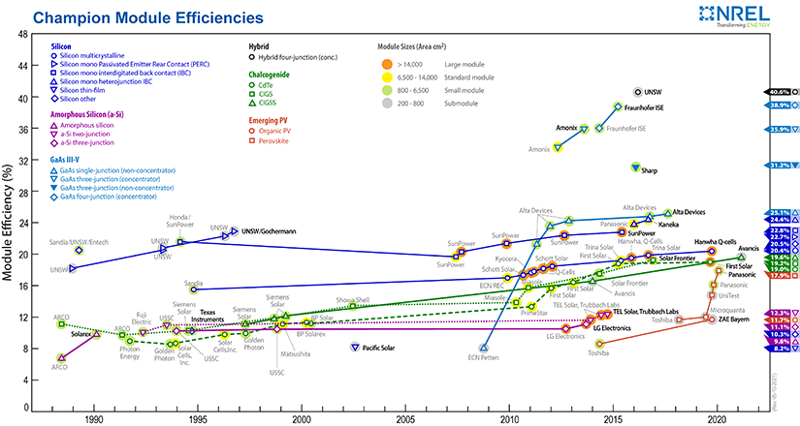

Figure 9.3. Solar cell efficiencies. Image from nrel.gov/pv/module-efficiencies

Additional needs of solar energy storage are the catalytic and materials requirements for anodes, cathodes, and electrolytes as used in electrolyzers and fuel cells. Unitized Reversible Fuel Cells, URFC, shown in Figure 9.4 and Discrete Reversible Fuel Cells, DRFC, as shown schematically earlier in this section will have difference requirements. Because of the large number of cells, non-platinum-group of metals will be necessary. Catalysis research is a critical field in improving the performance of both components [27].

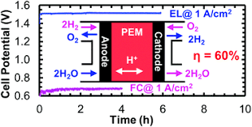

Figure 9.4. A low-temperature unitized regenerative fuel cell. Image from pubs.rsc.org

21

**10.** **Four Regions**

Solar irradiance, country maps, and scaled PV areas are shown in Figures 10.1-10.15. It should be noted that the PV arrays with power densities of 200 W-m-2 are shown in approximately the same scales as their country or regional maps.

10.1 China

China, the world’s largest user of energy, will require a significant area of PV installations in a country with a small region of high solar irradiance. This area would be about half the size of Tibet, its most radiant province.

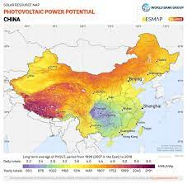

Figure 10.1. Solar irradiance of China.

Image from solargis.com

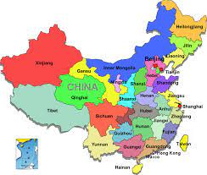

China PV

Figure 10.2. Scaled size of Figure 10.3. Map of China

China PV area. Image from chinadiscovery.com

22

10.2 United States

The United States will require a PV area about the size of New Mexico to provide its electrical needs. This area could be located in the Southwest four desert regions, most likely on federal land administered by the Bureau of Land Management. There should be no impact of PV sites on Native American lands.

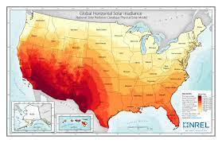

Figure 10.4 Solar irradiance of the US.

Image from nrel.gov

Figure10.5. Scaled size 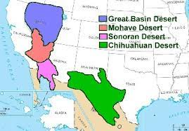

of US PV area Figure 10.6. Deserts of the US. Image fom ducksters.com

Figure 10.7. Native American Lands Figure 10.8. Bureau of Land Management

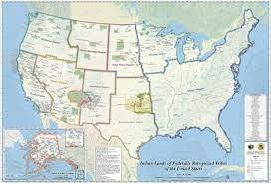 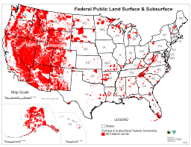

Image from en.wikipedia.org Image from en.wikipedia.org

23

10.3 Europe-E5 and the Sahara Desert

The Sahara Desert has long been considered as an ideal location for solar PV installations on a global scale. More recently, European countries have proposed the development of a facility in Tunisia. Although this country has a higher irradiance than Europe, Libya, Egypt, Chad, and Sudan have even more sun. It can be seen that the scaled model of world PV panels could be constructed in the Sahara with a surface coverage of 20%. This percentage has been described [] as the level at which moderate increases in atmospheric temperature and rain fall would occur as discussed in Section 11.3. The European-E5 countries considered here are Germany, France, Spain, Italy, and the UK.

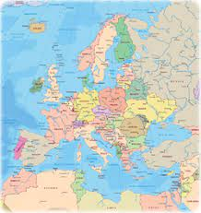 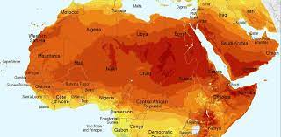 Figure 10.9. Europe and the Mediterranean Figure 10.10 Solar irradiance of the Sahara Desert.

Image from geographicguide.com Image from the conversation.com

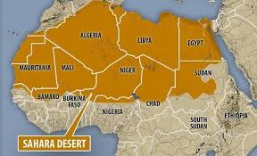

World PV

Figure 10.12. Map of the Sahara Desert

European-E5 PV Image from adagebiopower.com

Figure 10.11 Scaled sizes of the World

and European-E5 PV areas.

24

10.4 India

India’s Thar Desert in the province of Rajasthan has been considered as the primary location for solar PV installations as seen in Section 12.4.

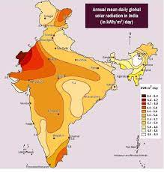

Figure 10.13. Solar Irradiance of India.

Image from solarmango.com

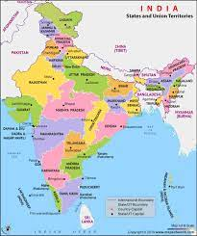

India

PV

Figure 10.15. Scaled size Figure 10.16. Map of India.

of India PV area Image from mapsofindia.com

25

11. Environmental and Economic Factors

Solar panel manufacturing processes require extensive use of chemicals which require proper disposal methods. An additional problem with solar panels among most countries is their disposal and/or recyclability at the end of their lifetimes of about 20-30 years. This problem will reach a peak around 2040.

Concerns for the global environment as a result of utility-scale solar-panel installations in many parts of the world has prompted investigations in different areas including climate, habitat, species, and human needs. While a detailed discussion of these findings is beyond the scope of this analysis, a few examples will be given.

A general study has been reported which offers a management strategy for improving the sustainability of manufacturing processes, improving economic value, and mitigating negative environmental impacts of solar PV devices [28]. This study proposed that the negative environmental impacts of of PV systems could be substantially mitigated with the following measures:

1. Optimized designs

2. Development of novel manufacturing materials

3. Minimizing the use of hazardous materials

4. Recycling (42% reduction in GHG emissions)

5. Careful site selection

The carbon footprint from PVs was found to be 14-73 g CO2-eq./kWh as compared with the burning of oil (742 g CO2-eq./kWh).

11.1 China

An analysis of China’s climate and energy policy changes during the past 30 years has been written [29]. It was concluded that after the Paris Agreement in which China submitted its Nationally Determined Contribution (NDC) that were aligned with its five-year planning cycle, China’s biggest policy change has been technological innovation in the power and transport sectors. China has set priorities for measures, laws, and policies for developing renewable energy, especially solar and wind. In addition, China has also embraced the “green growth” approach for responding to climate change. Additional measures will be required in order to set a cap on coal utilization in its national energy-transition strategy. In 2020, China set a carbon-neutrality goal by 2060.

26

11.2 US

The term “Agrivoltaics” has recently been coined to describe the Food-Energy-Water Nexus in which eco-friendly solutions are delivered. Researchers at the University of Arizona located near the Sonoran Desert in the US reported interesting results [30]:

1. The plants, protected by the solar panels from the highest levels of the midday sun’s rays (irradiance), become small evaporative coolers on the landscape. These plants absorb CO2 used for photosynthesis by opening their pores (stomata), while evaporating water from their leaves to create a cooler microclimate.

2. Solar panel modules lose efficiency while operating in hot climates which usually accompny regions of maximum irradiance. These panels have been shown to operate more efficiently as a result of the cooler microclimate produced by plants.

3. The panels, in turn, protect the plants from sunburn and dehydration. Less water is required for these plants.

4. Foods and plants which have benefited from this arrangement include peanuts, alfalfa, yams, taro, cassava, sweet potatoes, lettuce, tomatoes, chard, kale, cabbage, and onions.

5. Shade-resistant plants such as wheat did not benefit from solar panel shade.

6. Greenhouses with roofs half covered with solar panels experienced a reduction in crop yield.

11.3 Europe

The EU has stated its potential to produce 70% of its electricity with renewable sources by 2030 and to achieve climate neutrality by 2050. However, concerns have been raised that achieving renewable electricity could shift environmental burdens in ways that do not always lower overall pressures. In this regard, the European Environmental Agency [31] has identified six essential impact categories which showed four decreasing and two inceasing areas as are illustrated in Table 11.1.

Table 11.1. European impact categories.

|  |  |  |
| --- | --- | --- |
| **Category** | **Measurement** | **Change, 2005-2018 (%)** |
| Climate change (global warmeing potential) | MtCO2e | - 25 |
| Freshwater eutrification | MtPe | - 21 |
| Particulate mater formation | MtPMe | - 20 |
| Terrestrial acidification | MtSO2e | - 25 |
| Freshwater ecotoxicity | Mt1.4DCBe | + 22 |
| Land occupation | Km2a | + 60 |

These data indicate that the EU has taken an active approach in identifying the environmental factors involved with the development of renewable energy sources.

27

Some European countries are currently considering the installatin of PV in the Sahara Desert, primarily in Tunisia. An environmental study of the effectc of solar panels in the Sahara Desert has been reported [25]. This models in this analysis predicted moderate increases in atmospheric temperature and rainfall with a 20% PV coverage. At a 50% coverage, severe increase in temperature and rainfall were predicted. A map of these effects is shown in Figure 11.1.

As seen in Table 9.5, the required PV area for the total world would be only 20%. This area for the E5 Countries of Europe would need only 2.8% of the Sahara Desert. Thus, any installation of solar panels by individual countries would have a neglible impact on the global climate.

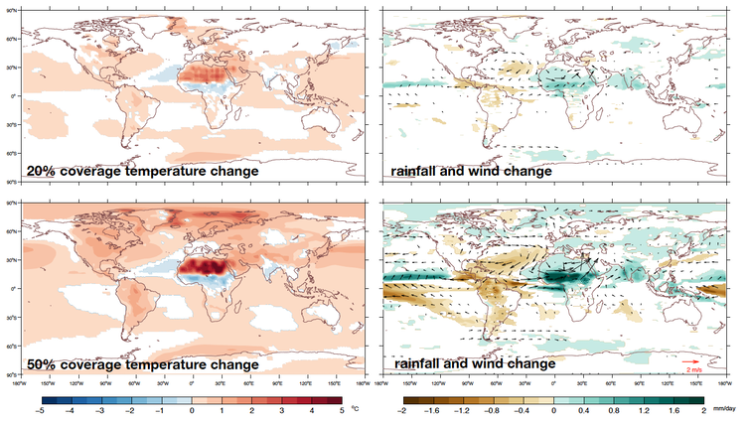

Figure 11.1. PV coverage effects on the atmosphere. Image from theconversation.com

11.4 India

The Thar Desert is becoming one largest solar sites in India, primarily because of its high irradiance seen in Figure 19. All of these solar installations will experience similar global environmental concerns which include land-use, habitat-loss, water, soil, and socio-economic [32].

In addition to environmental impacts, India’s per capita GDP in 2020 was $6,400 US as compared with China’s value of $17,500 US. India also relies heavily on coal for its energy, and changing to solar will be a difficult transition [33]. Neverthless, India is making progress towards replacing fossil fuels with renewables. This progress is notable in both urban and rural regions with grid and off-grid solar systems.

28

12. Land-Use Management

Site selection for utility-scale solar PV systems is a complex and critical process. Additioinal importance in this process is necessary as solar land is a non-renewable resource which competes with agricultural and forrest needs. Few studies have been made for these large systems (> 100 KW), and a recent analysis using Geographical Information System (GIS) data bases as applied to the Valencia region of Spain [34] will be briefly discussed here.

This process begins with the exclusion of certain areas on the basis of political, legal, and environmental restrictions. Included areas are subjected to potential site evaluation based on the criteria as shown in Figure 12.1. These criteria are evaluated in a four-stage process. It should be noted that energy requirements were not included in this analysis.

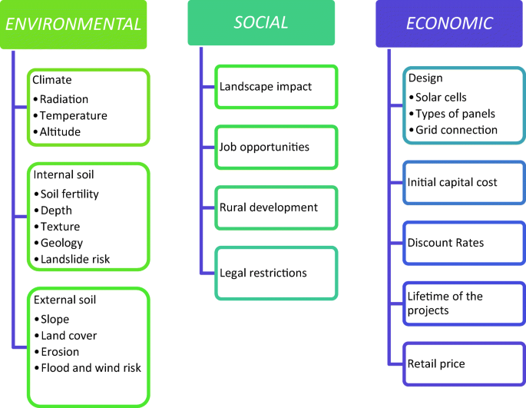

Figure 12.1. GIS land-use criteria. Image from [41]

The analysis identified 22 potential solar PV sites in Valencia.

29

In an example from Kuwait [35], the GSI model considered a number of spatial indicators that reflect four main criteria, namely solar irradiation, physical suitability, cost-effectiveness, and land availability. From the analysis, an equation was developed to calculate the electric energy that could be produced annually from these sites. This equation, in modified form, is given by:

E = RηACS, where

R = annual solar radiation received per km2 = 2,087 kWh-(m2-year)-1

η = efficiency of the solar PV system = 13%

A = total area of suitable sites = 2,515 km2

C = fraction of area that can be covered by solar panels = 70%

S = fraction of suitable areas for solar panel installation = 15%

From these quantities, the potential annual energy generated is 71,646 GWh-year-1 which was compared to an actual usage of 65,950 GWh-year-1.

A fundamental property of energy sources is their power densities. In the present analysis, the solar power density, Dp, is calculated as the product of the assumed solar irradiance, I, and solar cell or panel conversion efficiencies, e, of 40% and 20%. In the case of Solar Farms, a reduction factor of 50% is added to account for the spacing between the panels. These installations are typically double the panel areas with half of the power densities. Data are shown in Table 12.1.

Table 12.1 A comparision of power densities for solar panels and solar farms.

|  |
| --- |
| **Power Densities** |
| Solar Constant, SC = 1,368  above earth  atmosphere, W-m-2  Solar Irradiance, I = 1,000  at earth surface, W-m-2  Power Density  W-m-2  PV conversion efficiency,e Panel Solar Farm  Panel  (%) Dp = Ie Dp = IeS  40 400  20 200  Solar Farm  panel spacing, S  for 50% coverage  and infrastructure  (%)  40 200  20 100 |

30

The land-use requirements of solar PV systems have been addressed for the EU, India, Japan, and South Korea using an integrated assessment model [36]. At 25-80% penetration of the electricity mix, it was found that solar devices may occupy 0.5-5% of the total land area. These land coverage changes could cause a net release of carbon in the range of 0-50 gCO2/kWh depending of the region, scale, efficiency, and land management of solar parks. This report called for a coordinated planning and regulation enforcement of solar infrastructures to avoid significant increases of carbon emissions. A graphic illustration of this solar land usage is shown in Figure 12.2.

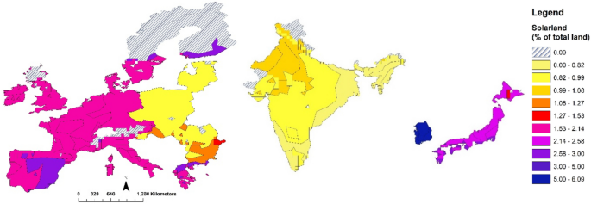

Figure 12.2. Solar land usage for the EU, India, Japan and South Korea

Image from Dirk-Jan van de Ven

Similar data from this analysis are shown in Table 12.2.

Table 12.2 Features of the four energy regions.

|  |  |  |  |  |  |
| --- | --- | --- | --- | --- | --- |
| Country or  Region | Population  Density (per km2) | Installed  PV Capacity (GW) | Required  PV Area (km2) | Country or  Region Area (km2) | Ratio of  Areas  (%) |
| China | 148 | 254 | 449,000 | 9.7 M | 4.6 |
| US (continental) | 33 | 76 | 318,000 | 7.6 M | 4.2 |
| Europe-E5  Germany  France  Spain  Italy  UK  Average | 233  123  93  200  280  186 | 116 | 131,000 | 2.0 M | 6.6 |
| India | 411 | 39 | 112,000 | 3.3 M | 3.4 |

31

12.1 China

Land-use policies of solar energy in China have been discussed [37] in which a Photovoltaic Carrying Capacity (PVCC) was used as a spatial planning tool. The PVCC was defined as the ratio of electric supply-to demand. The primary influence factors of the PVCC were found to be solar irradiation, urban population density, built-up area, available land area, and transmission distance. These policy measurements were applied to China, the United States, parts of Europe, India, Australia, and Brazil.

12.2 US

In the US, the Federal Bureau of Land Management has recognized 19 million acres (77,000 km2) that have excellent potential for solar energy [38]. However, this area represents only 24% of the total area necessary to provide its energy. It has been claimed by the Institute for Energy Economics and Financial Analysis, IEEFA, [39] that the BLM has “ignored” 100 million acres (405,000 km2) which would provide a substantial portion of US power. Areas covered by different energy scenarios are compared in Table 12.3.

Table 12.3. Regional PV areas.

|  |  |
| --- | --- |
| **Region** | **Area (km2)** |
| World  World PV  World land mass  PV coverage (%) 1.25 | 1.87x106  1.49x108 |
| US  US PV  Continental US  PV coverage (%) 4.21  Solar Farms (2-4 x PV area)  Current energy sources areas [37]  Bureau of Land Management- total areas  BLM-solar areas  US/Mexico deserts | 318,000 (New Mexico area)  7.55x106  636,000 – 1.27x106  328,000 (Iowa and Missouri areas)  1.00x106  482,000  1.38x106 |

32

These US areas may be compared with an analysis by Princeton University [40] in which five scenarios were considered as partially summarized in Table 12.4.

Table 12.4. Renewable energy scenarios in the US.

**Scenarios/Pathways Areas (km2)**

|  |  |  |  |  |  |  |
| --- | --- | --- | --- | --- | --- | --- |
|  |  | **Wind** | **Solar** | **Biomass** | **Total** | **US**  **Coverage (%)** |
| Renewables  Constrained | E + RE - | 240,000 | 13,000 | NA | 253,000 | 3.3 |
| High  Biomass | E – B + | 470,000 | 38,000 | 260,000 | 768,000 | 10.0 |
| High  Electrification | E + | 550,000 | 44,000 | NA | 584,000 | 7.7 |
| Les High  Electrification | E - | 700,000 | 44,000 | NA | 744,000 | 9.7 |
| 100%  Renewables | E + Re + | 1,000,000 | 63,000 | NA | 1,063,000 | 13.8 |

Cost estimates for these scenarios [40] range from 4-6% of GDP as illustrated in Figure 25.

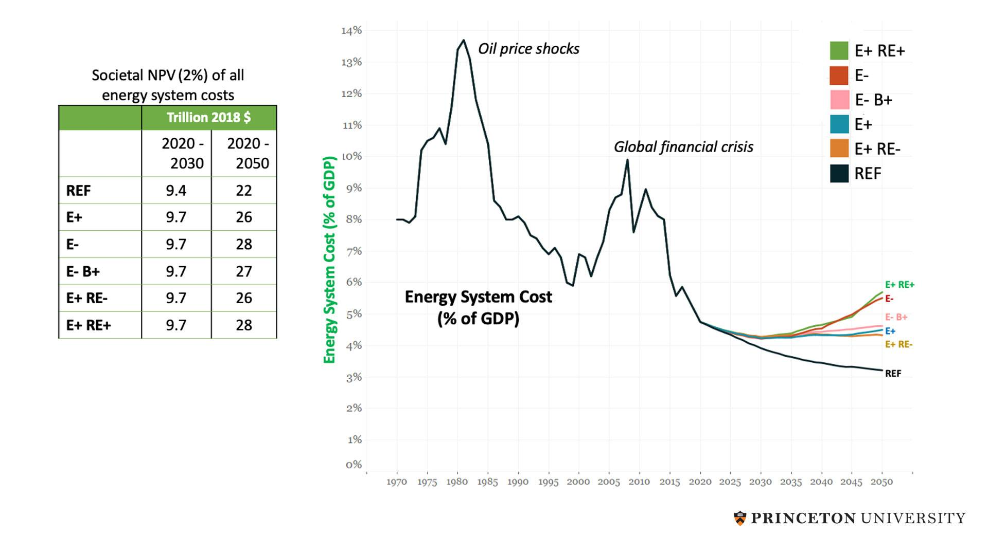

Figure 12.3. US costs and GDP % for net-zero-emissions. Image from princeton.edu

It can also be noted that the proposed defense contributions for NATO countries is 2% of GDP.

33

12.3 Europe

Several interesting points emerge from Table 12.2:

1. The European-E5 countries have a higher average population density than China.

2. These countries have the second highest installed PV capacity in the world.

3. The ratio of the E5 countires’ required PV area to their geographical areas of 6.6% is the

highest of the four regions.

Europe appears to have two possibilities for obtaining solar energy. First, a study [41] using multi-criteria assessment (MCA) supported by a Geographical Information System (GIS), existing data on solar radiation was combined with other geographical factors such as slope, land use, urban extent, population distribution, and proximity to the power grid. From this analysis, a suitability map for PV power plants across the EU was developed. It should be noted that neither regional energy requirements nor required PV area estimates were provided in this analysis. The range of EU solar irradiation was given as 517-2,189 KWh-m-2, with an average value of about 1,300 KWh-m-2.

Secondly, it has been proposed by some European countries [42] that their solar power be produced from Tunesia in the Sahara Desert with transmission lines to their end-use destinations. This location would have the advantage of a higher solar input relative to Europe, (3,500 hours vs. 2,200 hour per year), an increase of 60%. While transmission and distribution losses would be about 5%, a net solar increase of 50% could be expected. In addition, a location on the Southern Mediterranean shore would provide access to direct electrolysis of seawater. A disadvantage of this location may be the lack of salt caverns or salt deposits for hydrogen storage which are abunadant in Europe. Existing natural gas pipelines could be converted to hydrogen carriers. It should be noted that both water and hydrogen resources would be used in closed systems as provided by the electrolysis and fuel cell components. With these closed systems, water and hydrogen will be recycled rather than requiring continuous replenishment.

A solar irradiation map of Europe and Africa is shown in Figure 12.4. The irradiance in Tunisia of 1,541 KWh-m -2 is only marginally higher that the values in Spain or Southern Europe, while

the average Europen irradiance is around 1,300 KWh-m-2. In addition, with a PV area requirement for the Europe E5 countries of 131,000 km2, this area alone, not to mention the “Solar Farm” area, would cover most of Tunisia’s 160,000 km2.

The highest solar input occurs in Lybia, Egypt, Chad, and Sudan with a level of 2,100 KWh-m-2. Although the transmission distance to Europe would be further than from Tunisia, the higher irradiance would more than offset the extra transmission cost.

34

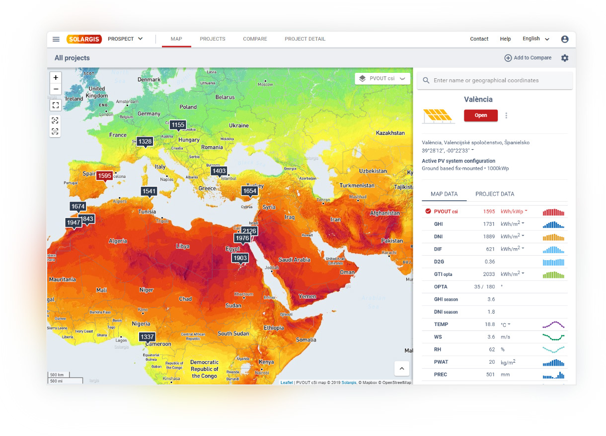

Figure 12.4. Comparison of solar irradiance in Europe with Northern Africa and

the Middle East. Image from solargis.com/maps-and-gis-data

35

12.4 India

The footprint for solar and wind energy sources in India was found to be 55,000-123,000 km2 [43]. Potential impacts include 6,700-11,900 km2 of forest land and 24,100-55,700 km2 of agricultural land.

A site suitability analysis was conducted for solar potential in five southern states of India [44]. Using GIS and other tools, this study found that 46,500 km2 out of a tota geographical area of 635.000 km2 or 7.3% of land coverage was suitable for solar PV sites.

The Thar Desert in the western province of Rajasthan has been recognized as a prime site for solar PV installations, an example of which is shown in Figure 12.5.

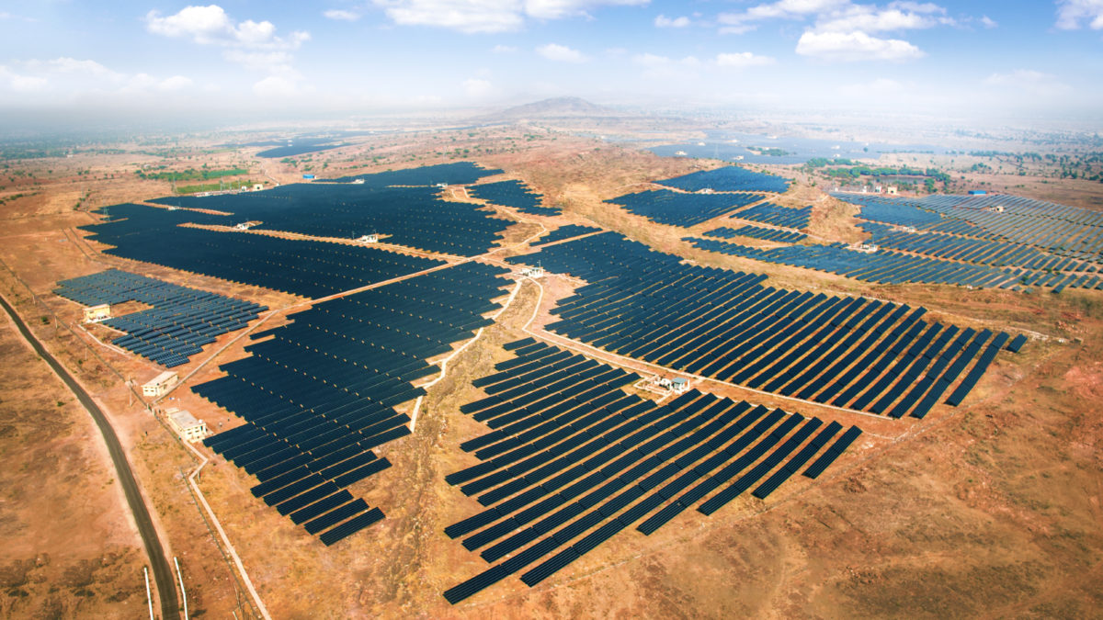

Figure 12.5. Solar installation in Rajasthan. Image from pv-magazine-india.com

36

**13. Commercial Systems**

Although the focus of this analysis has been hydrogen storage for utility-scale PV-EL-FC systems connected to electrical grids, the industrial, transportation, and building sectors will also have requirements for hydrogen. A few examples of these applications are given in this section.

Currently, Europe and Asia are leading in the early development of large-scale hydrogen production. The European Clean Hydrogen Alliance [45] as part of the European Commission is leading the way in the development industrial programs, utilizing its strength in electrolysis systems. Both “blue hydrogen” produced from fossil sources and “green hydrogen” produced by the electrolysis of water are under development, with the latter apparently derived from fresh water as direct electrolysis of seawater was not discussed. The cost of hydrogen still prohibits its large-scale consumption until this cost approaches $1 to $2 per kg.

The US is also developing large solar installations with energy storage facilities.

For example, Ballard [46] has proposed a commercial system for renewable power to electric grids and also for energy storage as shown in Figure 13.1.

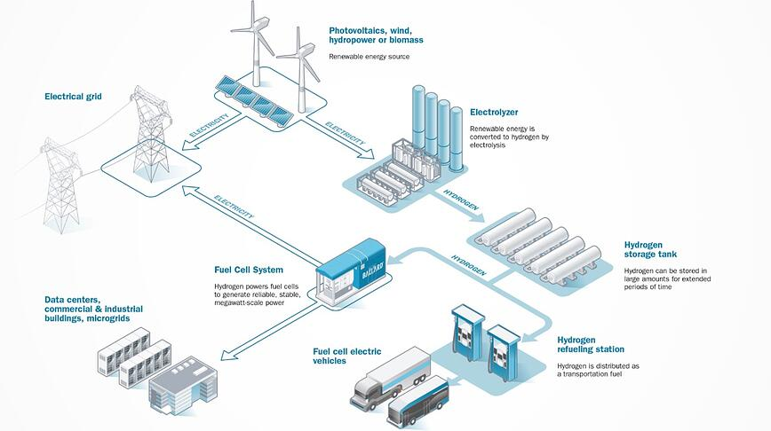

Figure 13.1. A commercial PV-EL-FC system.

Image from blog.ballard.com/renewable-energy-storage

37

Hydrogen is expected to play a critical role in climate-neutral economies of the future [47]. In an energy system dominated by renewable sources, hydrogen serves as a link between the electrical, industrial, transportation, and building sectors.

Among the topics considered here are hydrogen export and import. The European Union will become a net importer of hydrogen because of is modest energy resources, restricted area, and high population density. As the sunniest year-around area in the world with 9.4 million km2 and a low population density, the Sahara Desert will become a major exporter of hydrogen.

A hydrogen infrastructure system has also been proposed. The costs of hydrogen include not only its production through electrolysis powered by a renewable source, but also its storage and transport. Figure 13.2 shows an outline for a European Transnational Hydrogen system (orange). The blue and purple lines show the existing natural gas infrastructure.

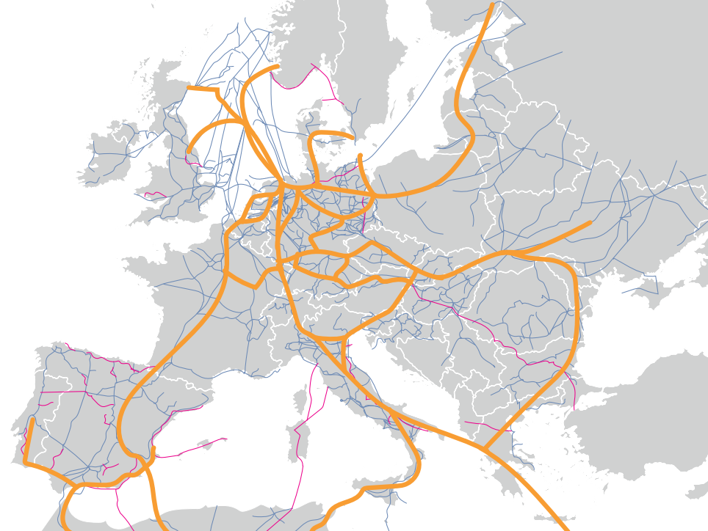

Figure 13.2.  Outline for a European Transnational Hydrogen Backbone [47].

The European transport grid for natural gas is 200,000 km in length with a much longer distribution grid. A pipeline operating at 100 bars pressure could transport hydrogen at a cost of

€0.10[ kg H2-1,000 km]-1. A production system could transport one million tonnes of hydrogen per year from Morocco to Germany, which is a distance of 3,000 km, at a cost of €300 million.

38

The power systems for hydrogen production require large amounts of space. These spaces for the annual production of one million tonnes of hydrogen are given in Table 13.1.

Table 13.1. Space needed for producing approximately 1x106 tonnes hydrogen per year [47]

|  |  |  |  |  |  |
| --- | --- | --- | --- | --- | --- |
|  | Capacity  Factor  (full-load hours  per year) | Installed  Capacity  (GW) | Hydrogen  Production  (EL efficiency  80% HHV)  (million tonnes) | Specific space  requirement  (km2-GW-1) | Space  Requirement  (km2) |
| Solar PV  southern Europe | 1,800 | 30 | 1.10 | 16.5 | 500 |
| Solar PV  northern Africa | 2,100 | 25 | 1.07 | 16.5 | 420 |
| Solar CSP | 4,000 | 12.5 | 1.02 | 30 | 375 |
| Wind onshore  (wind-farm space) | 4,000 | 12.5 | 1.02 | 170 | 2,125 |
| Wind offshore  (wind-farm space) | 6,000 | 9 | 1.10 | 125 | 1,125 |

Finally, the requirement for a comprehensive hydrogen policy was discussed and is summarized here in point form:

1. Goals of current strategy: reduce emissions, diversify energy supply, grow economy,

integrate renewables, develop hydrogen supply for export.

2. Required policy: implement and integrate hydrogen into energy, climate, economic, and geo-

political policies.

3. Policy framework: coherently stimulate hydrogen supply (production) and demand together

with a spatial planning policy.

4. Policy: develop a dedicated hydrogen infrastructure including storage together with market

mechanisms, international trading, supply security, and strategic reserves.

Hydrogen supply-demand and export-import factors were represented schematically in the following report.

39

A map of the (Persian) Gulf Cooperation Council (GCC) countries, which consists of Saudi Arabia, Kuwait, United Arab Emirates, Qatar, Bahrain, and Oman, as shown in Figure 13.3, has developed a plan for its export of hydrogen [48]. This trading block has identified four types of countries based on their potential for hydrogen export and import. Figure 13.4 is a modified diagram of the reference exhibit which also shows the “Big Four” energy regions.

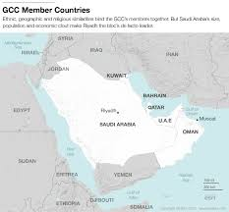

Figure 13.3. The GCC countries. Image from worldview.stratfor.com

**Exporters** **Self-sufficient**

GCC

Australia

Canada China

Chile US

Brazil India

Argentina

(Europen-E5 countries)

Norway France

Germany

New Zealand Italy UK

Japan

**Limited Potential Importers**

South Korea

**Limited potential Importers Importers**

**High**

**Hydrogen**

**Production**

**Potential**

**(Supply)**

**Low**

**Low** **Domestic Consumption (Demand) of Hydrogen High**

Figure 13.4. Hydrogen Import and export countries [48].

40

These four types of countries were described as follows:

1. China, the US, India, and Brazil exhibit large-scale and relatively low-cost green hydrogen

production. However, their export potential is limited as domestic demand will absorb most

of their own production.

2. The GCC has the highest production potential. Argentina, Australia, Canada, and Saudi

Arabia can export most of the green hydrogen production because electricity and gas are

cheaper than hydrogen for these countries’ domestic energy requirements.

3. The European countries, Germany, France, Italy, and the UK as well as Japan and South

Korea show a low production potential and a high domestic consumption.

4. Norway and New Zealand exhibit both a low production potential and a low demand.

The “Big Four” energy regions appear with China, the US, and India as “Self-Sufficient” and the European-E5 countries, except the UK (not shown), as “Importers.”

Based on this scenario, it appears that the European countries may have to choose between importing hydrogen and constructing their own facilities in, for example, the Sahara Desert. As reported by the GCC, transporting hydrogen for distances less than about 1,800 km, pipelines are less expensive than ammonia ships. Two possible options can be considered.

Option 1

With the option of importing hydrogen, Europe has an abundance of salt caverns from which the hydrogen could be transported to fuel cells for the generation of grid power.

Option 2

If Europe developed PV-EL-FC systems in the Sahara, the generated electricity would be sent to these countries through electric cables under the Mediterranean Sea.

A comparative cost analysis would likely be the determining factor in the choice between the options. Presumably, these systems would be installed on a country-by-country basis, but economies of scale may arise for multi-country installations.

Three resources were cited as enabling the GCC to become an exporter of green hydrogen:

1.This region has a high incidence of solar radiation, nearly double that of Central Europe as

well a as wind speeds above seven meters per second.

2. Saudi Arabia with an area of 2.1 million km2 could provide one-fifth of its barren land area,

420,000 km2, to meet the global export demand for green hydrogen.

3. The estimated 2050 demand for green hydrogen would require 5.6 trillion liters of water

which could be accessed from the electrolysis of seawater.

Hydrogen storage was not considered in this report.

41

The Advanced Clean Energy Storage Project in Utah [49] will produce hydrogen for storage in salt caverns. This facility will produce 450 tonnes of green hydrogen per day powered by 1,000 MW electrolyzers. Salt caverns will store 5,500 tonnes of this hydrogen. This project has been undertaken by Mitsubishi Power American and Magnum Development as shown in Figure 13.5.

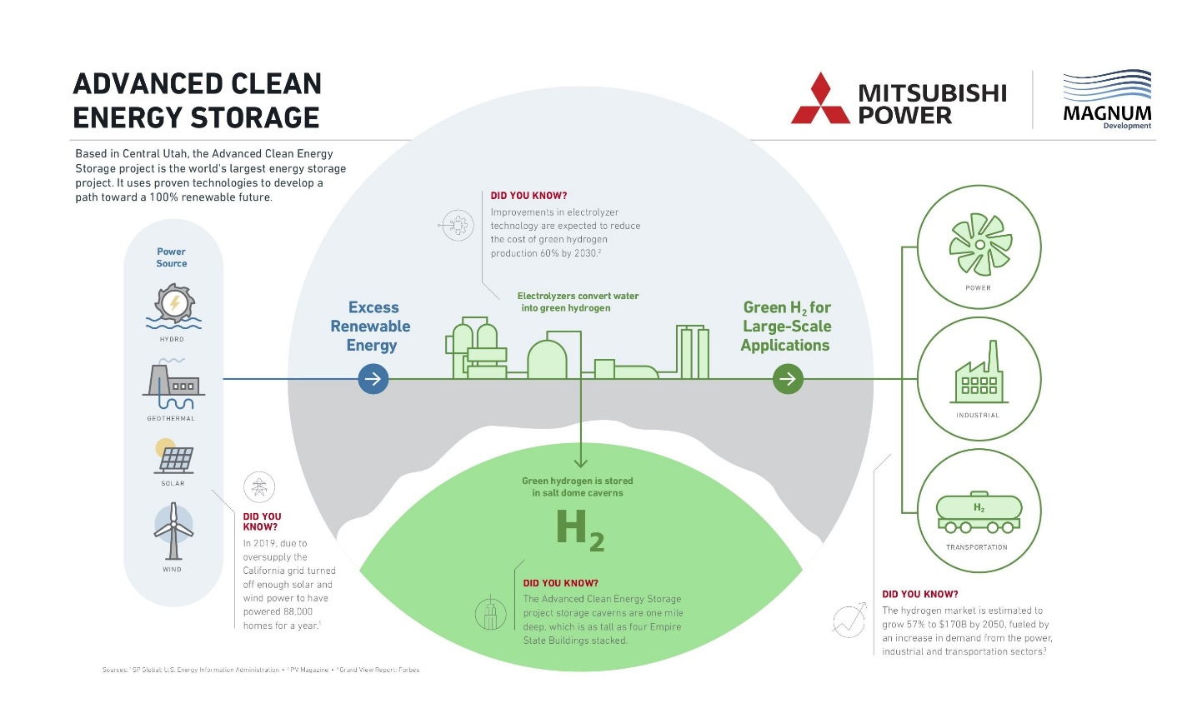

Figure 13.5. Utah ACES Project. Image from Mitsubishi

Although electolyzers on the scale of 1 GW have been developed, the highest power of fuel cells is in the MW range.

As seen the Tables 9.1 and 9.2 the ratio of electrolyzer input power to fuel-cell output power is 20:1. Thus, a 1 GW electrolyzer, when coupled with a hydrogen storage system, will result is fuel cell with an output power to the grid of 50 MW for the models considered in these analyses.

42

MTU Solutions [50] has also developed a RE system with hydrogen storage for the electric sector as shown in Figure 13.6.

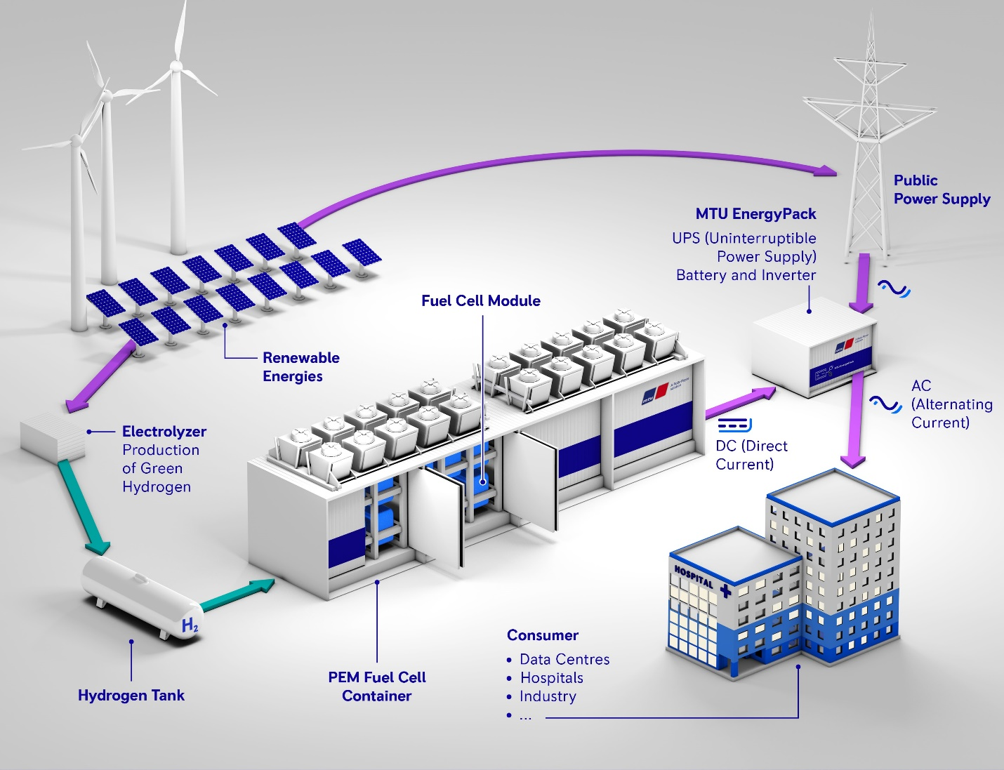

Figure 13.6. RE system with hydrogen storage. Image from mtu-solutions.com

In Mississippi [51], Hy Stor has partnered with Connor, Clark and Lunn to develop the first zero-carbon, green hydrogen facility in the US. With this system, 0.11 Mt of hydrogen will be produced annually with 0.07Mt stored in salt caverns (see Figures 7.1 and 7.2).

The government of Australia [52] has announced a program to produce blue and green hydrogen. It was pointed out, however, the producing hydrogen from fossil fuels will result in the emission of greenhouse gases. In addition, the capturing (and storing, CCS) of these gases would be more expensive than producing hydrogen from renewable sources. This hydrogen would be exported to Asian countries. These projects are summarized in 13.2.

43

Table 13.2. Summary of commercial hydrogen projects.

|  |  |  |  |  |  |  |  |
| --- | --- | --- | --- | --- | --- | --- | --- |
| **Project** | **Energy**  **Sources** | **Electrolyzer**  **H2**  **Production** | **Water**  **source**  **and sink** | **Hydrogen**  **export/**  **import** | **Hydrogen**  **Storage** | **Power**  **to grid** | **Grid** |
| European  Clean  Hydrogen  Alliance  [45] | NA | 40 GW  by 2030  Blue, Green  $1-$5 per  Tonne | NA | NA | NA | NA | NA |
| Ballard  [46] | Solar PV  wind | Water  Electrolysis | NA | NA | Tanks | Fuel cells | Fuel cell  Vehicles |
| European  Transnation  hydrogen  backbone  [47] | Solar PV  wind | Import  2,700 tonnes  per day | NA | Morocco  export  via  3,000 km  pipeline | NA | NA | NA |
| (Persion) Gulf  Cooperation  Council  (GCC) [48] | NA | NA | NA | Imported  by Europe,  Japan,  S. Korea | NA | NA | NA |
| Utah  ACES  Mitsubishi  Magnum Dev  [49] | Hydro  geothermal  solar PV  wind | 1 GW  450 tonnes  per day  natural gas  blue  green | NA | NA | Salt caverns  5,500 tonnes  150 GWh  150 hours | SOFC  turbines  generators | 150,000  house-  holds |
| MTU  Solutions  [50] | Solar PV  wind | Green | NA | NA | Tanks | PEM  fuel cells | Power  to grid |
| Mississippi  Hy Stor  Connor, Clark, Lunn  [51] | NA | 300  tonnes  per day  green | NA | NA | Salt caverns  70,000 tonnes | NA | NA |
| Australia  Trafigura  [52] | 440 MW | 100 tonnes  per day  green | NA | Export to  Asia-  Pacific  Countries | NA | NA | NA |

44

**14. Hydrogen Applications, Projections, Pathways, and Models**

14.1 Applications

Examples of hydrogen uses are shown schematically in Figures 14.1 and 14.2.

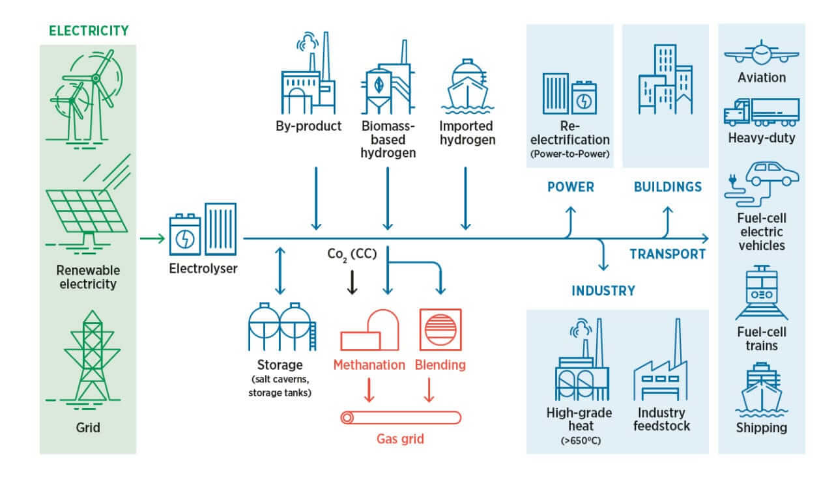

Figure 14.1. Sector uses of hydrogen. Image from fuelcellstore.com [53]

45

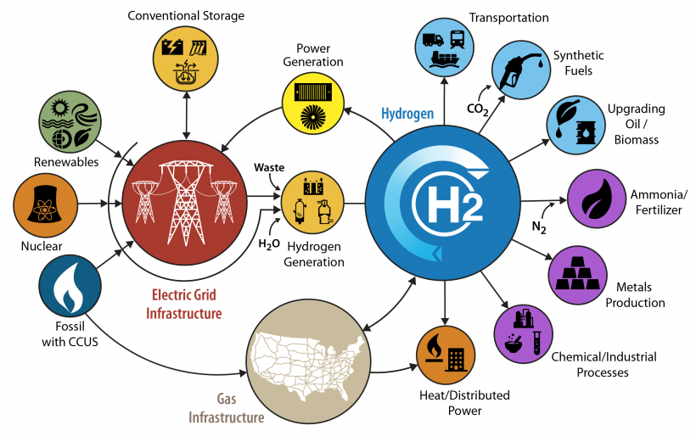

Figure 14.2. US DOE H2Scale@Hydrogen Initiative [54]. Image from energy.gov

46

With the goal of achieving net-zero CO2 emissions by 2050, an extensive presentation of hydrogen applications in the various sectors has been provided by the International Energy Association (IEA) [55] a summarized outline of which is shown in Figure 14.3.

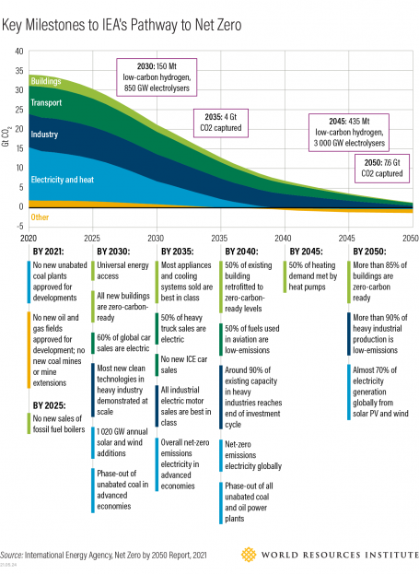

Figure 14.3. IEA Pathway to Net Zero 2050. Image from wri.org

As shown in Figure 36, the 2020 sectoral contributions to CO2 emissions as measured in Gt/year (Giga-tonnes/year) were approximately as follows:

Electricity and heat – 14

Industry – 9

Transport – 8

Buildings – 3

Total 34

47

14.2 Projections

The current world production of hydrogen is 87 million tonnes per year [56], mostly from non-renewable sources with “green hydrogen” accounting for less than one million tonnes annually.

Taking this renewable hydrogen to be one million tons in 2020, the production level in 2050 to be 100 million tonnes for a period of 30 years, the required annual growth rate for projected levels can be determined with a financial calculator from the relation,

FV = PV(1+r)n, where

FV = Future Value (projected level)

PV = Present Value

r = annual rate of growth

n = number of years

The required annual growth rate for “green hydrogen” produced by water electrolysis is:

1 M tonne +/- PV, 2020, (the +/- symbol is a feature of financial calculators)

100 M tonnes FV, 2050

30 n

r = 17 %

Frost & Sullivan [57] recently made the following “green hydrogen” production projection:

40,000 tonnes +/- PV, 2019

5.7 M tonnes FV, 2030 (0.69 EJ)

11 n

r = 57 %

Continuing this projection in approximate terms to 2050,

1 EJ +/- PV, 2030

100 EJ FV, 2050

20 n

r = 26 %

According to the IEA [55], 630 GW of solar PV power will be produced by 2030. With the world power level of 1.59 x 1013 W in 2050, the require growth rate is

630 GW +/- PV, 2030

1.59 x 1013 W FV, 2050

20 n

r = 18%

Although these rates of growth are high, other renewable sources such as solar PV’s, have recently been installed at similar rates of growth.

48

PWC [58] provided projections of three hydrogen demand scenarios as shown Figure 14.4.

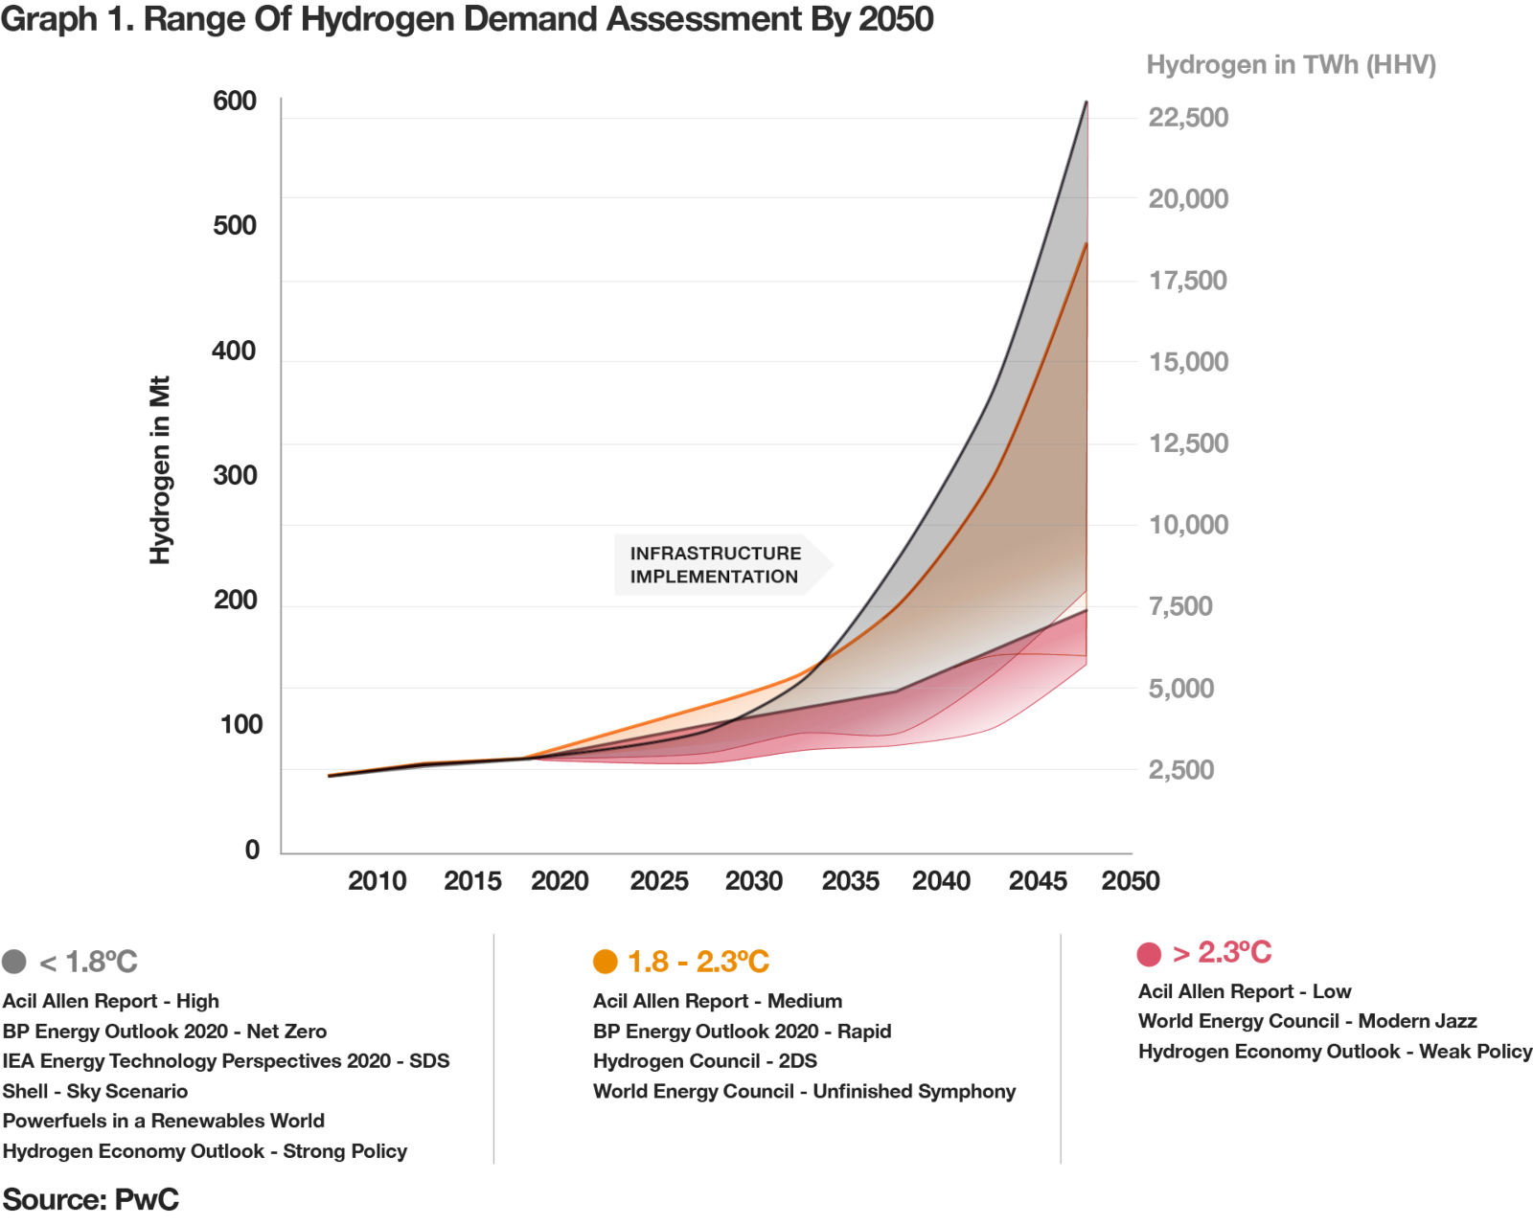

Figure 14.4. Projections of hydrogen demand. Image from pwc.com

From Figure 14.4, the growth rate of hydrogen demand for the <1.8 C scenario is given as follows:

70 +/- PV, 2020

600 FV, 2050

30 n

r = 7.4 %

49

While the importance of hydrogen in replacing fossil fuel has been established, the quantifications of its projected global supply and demand levels are less well known.

Five takeaways from the IEA Net Zero by 2050 pathway [55] were given by the World Resource Institute. This IEA source was seen as *a* pathway, not *the* pathway [63]:

1. Annual renewable electricity installations must triple by 2030.
2. The phaseout of fossil fuels is inevitable; it must also be equitable.
3. Clean energy investments will benefit the economy and human health near term.
4. Carbon capture and storage was questioned for its scale and cost; is not the only solution.
5. Bioenergy may compete with human and ecological needs.

Bloomberg NEF [59] sees a higher demand for hydrogen, identifying the technical potential to meet 30% of final global energy demand in 2050. In a pathway that limits warming to 1.5 C and in which overall energy use is much lower, BNEF sees hydrogen meeting 24% of final global energy demand. These studies together with additional hydrogen supply and demand projections for 2050 are shown in Table 14.1. These demand projections are compared with WSG Model C (Tables 14.2, 14.3, 14.4) production for the US and global levels.

50

Table 14.1. Green hydrogen projections of world supply and demand.

|  |  |  |
| --- | --- | --- |
| **Reference** | **2050 Annual**  **US and World**  **Green Hydrogen Supply**  **(Mt/day and Mt/yr)** | **2050 Annual**  **World**  **Green Hydrogen Demand**  **(Mt/yr)** |
| Current world production [56] | 70 Mt/yr, blue, grey  Result: 830 Mt CO2/yr |  |
| World Solar Guide - US  100 EJ/yr, CF = 25%  Model C, 90% Electrification  22.5% Direct  67.5% Storage  10% Sectors, H2  Tables 14.2, 14.3, 14.4 | Mt/day Mt/yr  1 day = 6 hrs  Grid storage* **6.00**  2,190  Sectors* 0.89 **325**  Total Q p, tot = 6.89 2,515 |  |
| World Solar Guide – World  500 EJ/yr, CF = 25%  Model C, 90% Electrification  22.5% Direct  67.5% Storage  10% Sectors, H2  Tables 14.2, 14.3, 14.4 | Mt/day Mt/yr  1 day = 6 hrs  Grid storage* **30.00** 10,950  Sectors* 4.45 **1,625**  Total Q p, tot = 34.45 12,575 |  |
|  | *Note: Grid water/hydrogen  storage is closed  (recyclable) system.  Sector water/hydrogen  storage is open system. |  |
| /////////////////////////////////////////// | ////////////////////////////////////////////// | //////////////////////////////////////// |
| IEA [55] |  | 528 |
| PWC [58]  Figure 14.4 |  | 600 |
| Bloomberg NEF [59] |  | 800 - 1,310 |
| Hydrogen Council [60] |  | 568 |
| IRENA [61] |  | 614 |
| strategyand.pwc [62]  GCC |  | 530 |
| Average +/- S. D. |  | 707 +/- 281 |

51

14.3 Pathways to Net-Zero

For the purpose of deriving relationships to describe PV-EL-FC systems, the estimated world’s annual energy demand during the period of 2020 to 2050 has been taken to be the constant level of 500 EJ or 1.39 x 1014KWh. In this regard, it is instructive to consider both the amount of hydrogen which will be available and its consumption rate for the purpose of achieving net-zero CO2 by the year, 2050.

Clearly, hydrogen will not provide power for all sectors of buildings, industry, transportation, and electric power. Nevertheless, this source will be a major component of renewable energy in the replacement of fossil fuels.

The International Energy Agency (IEA) has developed a Pathway to Net Zero [55]emissions for the four economic sectors by 2050 as shown in Figure 36.

The IEA compared its pathway with that of the IPCC as shown in Table 14.2.

Table 14.2. IEA and IPCC projected world energy supply and demand components

|  |  |
| --- | --- |
| **World Energy Supply 2050** | **World Energy Demand and CO2 Removal** |
| IEA  Energy type Amount (EJ)  Other renewables 25  Wind 88  Solar 113  Hydro 25  Biomass/energy 100  Nuclear 63  Natural gas 63  Oil 38  Coal 13  Total 540 | Technology IPCC IEA  CCUS * Median 15 Gt CO2 7 Gt CO2  CDR ** 3.5-16 Gt CO2 1.9 Gt CO2  Biomass/energy Median 200 EJ 100 EJ  Energy efficiency Consumption 300-550 EJ Consumption 410 EJ  Hydrogen 18 EJ 33 EJ  Electric generation  wind, solar 15-80% 70%  Median 50% |
|  | CCUS* – carbon capture, utilization and storage  CDR** – carbon direct removal |

The World Resources Institute [63] applauded the IEA Pathway and stated that renewables could contribute more than 70% of the world’s energy requirements. This organization also stated its view that the current sectoral progress is inadequate to achieve the goal of limiting the global temperature increase to 1.5 C.

52

Table 14.3. Comparison of RE shares and CO2 emission scenarios. [61]

|  |  |
| --- | --- |
| **RE shares in TPES* 2050** | **CO2 emissions for electrification rates** |
| TPES*  Entity RE share (%) EJ/yr  Teske 94 415  Greenpeace Advanced 93 460  (low-overshoot)  IEA-NZ 70 585  IRENA 1.5-S 75 615  IPCC 1.5 60 550  (high-over-estimate) 62 650  BP-Net Zero 58 625    Average 73 557 | Electrification rate (%) CO2 Gt/yr  Current 25 35  ___________________________________  Greenpeace Advanced 91 0  IEA-NZ 88 0  IRENA 1.5-S 90 0  Average 90 0 |
| TPES* = Total primary energy supply |  |

Table 14.3 shows that the achievement of net-zero, will require an electrification rate of approximately 90%. From Table 14.3, an estimate of the required world production of hydrogen can also be made. The average RE share, 73%, of the average TPES, 553 “EJ/yr is about 400 EJ. With “daytime” solar PV of 100 EJ/yr, the remainder for “nighttime” energy storage is 300 EJ/yr. At a 90% electrification rate, the corresponding energy is 270 EJ/year which is equivalent to 2,200 Mt of H2.

53

A comparison of the IEA, IRENA, and Bloomberg NEF pathways is shown in Table 14.4.

Table 14.4. IEA, IRENA, Bloomberg NEF pathway features.

|  |  |  |  |  |
| --- | --- | --- | --- | --- |
|  | **IEA [55]** | **IRENA [61]** | **Bloomberg NEF [59]** | **Averages**  **+/- S. D.** |
| Features | 27 % non-RE  73 % RE, wind  and solar | 90 % electrification  for net-zero | 10 % fossil  85 % RE  5 % nuclear  Statkraft xxx |  |
| World energy  demand  EJ/year, ET | 540 | 378-🡪348 | 516 | 468 +/- 105 |
| RE-EL, input  Capacities, supply  GW, TW  EJ | Wind  600 GW/yr  Solar  340 GW/yr  19 TW, 2050  150 EJ, 2050 | NA | Wind  505 GW/yr  Solar  455 GW/yr  20 TW, 2050  158 EJ, 2050 | Wind 553+/-67 GW/yr  Solar 398+/-81 GW/r  Power 19.5+/10.7 TW  Energy 154 +/-6 EJ |
| Hydrogen energy as  percentages of  total world energy demand | 15 | 12 | 24 | 17 +/- 6 |
| Cost Estimates  $Trillions | 120 | 131 | 92-173 | 129 +/- 34 |

Although these pathways utilized different assumptions and analyses, their projections of world energy demands, RE capacities, hydrogen levels, and costs are remarkably similar.

54

14.4 Models

Three WSG models of potential global-scale RE systems with hydrogen storage can be compared with IRENA, IPCC, and IEA pathways in Table 14.5 where Figure 9.1 is a schematic reference. The WSG models assume an annual energy demand of 500 EJ, and the average energy demand in the IRENA pathway is 557 EJ.

The primary focus of the WSG, Part 2 has been 100% electrification with solar PV and hydrogen storage shown here as Model A. Additional properties of this model are given in Table 4. While Model A may offer an excess of electric energy through solar PV, it provides an upper limit to the required material resources and land uses for this system.

Model B proposes solar PV with 50% electrification and 50% towards other sectors having somewhat arbitrary hydrogen allocations based on Table 14.1.

Model C represents a “Goldie-Locks” or “Just-Right” scenario with 100% RE and an electrification rate of **90%**.

An IRENA [61] plan, modified here, considers a mix of energy sources, non-RE and RE, which will result in a net-zero production of CO2 by 2050. Among the RE sources, a level of 90% electrification is required for net-zero. The hydrogen allocation among the sectors is also arbitrary. The WSG Model C and the IRENA pathway can also be compared with similar IPCC and IEA hydrogen levels.

Table 14.5. Comparison of WSG models with IRENA, IEA, and IPCC pathways.

|  |  |  |  |  |
| --- | --- | --- | --- | --- |
| **Parameters** | **World Solar Guide**  **Model A** | **World Solar Guide**  **Model B** | **World Solar Guide**  **Model C** | **IRENA**  **Pathway [61]** |
| Assumed annual.  world energy demand 2020-2050 (EJ) | 500 | 500 | 500 | Average = 557  (Table 14.3) |
| Non-RE sources (%) | 0 | 0 | 0 | Average = 27 |
| RE source: solar PV (%)  (EJ) | 100  500 | 100  500 | 100  500 | Average = 73  407 EJ |
| Electrification rate (%)  (EJ) | **100**  500 | **50**  250 | **90**  450 | **90**  366 |
| Available energy to  other sectors (%)  (EJ) | 0  0 | 50  250 | 10  50 | 10  41 |
| Arbitrary hydrogen  distribution    Industry  Transportation  Buildings | 0  0  0 | EJ/yr MtH2/yr  125 1043  75 626  50 42 | EJ/yr MtH2/yr  25 209  15 125  10 84 | EJ/y MtH2/yr  20 167  12 100  9 75 |
|  |  |  |  |  |
| IPCC hydrogen [72] | NA | NA | EJ MtH2  18 150 | EJ MtH2  18 150 |
| IEA hydrogen, NZE [55] | NA | NA | EJ MtH2  33 275 | EJ MtH2  33 275 |

55

By combining the IRENA Pathway [61] with the WSG Model C, a model for the US can by developed. Taking the US annual energy consumption to be a constant 20% of the world demand, 500 EJ, 90% electrification rate, and 10% for sector hydrogen production with the same capacity factor as in previous models, 22.5 EJ, 67.5 EJ, and 10 EJ will be produced by PV1, PV2, PV3 and the electrolyzer. A calculation sequence, similar for the one utilized in developing the scaled models and the hypothetical world model of Figure 9.1 and of Tables 9.1 and 9.2 is also used here.

(1) The total US energy demand is taken to be ET = Eout = 100 EJ/yr or 7.62 x 1010 KWh/day.

(2) The daytime requirement is 22.5% or E1, in = E1, out = 1.71 x 1010 KWh/day during the six-hour period (22.5 EJ-yr-1) which is produced by PV1 = 2.85 TW as a direct output and input to the grid.

(3.1) From the stored hydrogen produced in by the electrolyzer, 67.5% or E2, out, electric = 5.14 x 1010 KWh/day is derived over the 18-hour period to the grid.

(3.2) The energy output of hydrogen to the sectors is 10% or E2, out, sector = 7.62 x 109 KWh/day.

(4) The necessary fuel-cell output power to the grid over this period is then

PFC, out = E2, out,electric = 2.86 x 109 KW, or an installed capacity of NFC = 2,860 1GW plants.

18 hr

(5) With an efficiency of 50%, the fuel-cell input power is PFC, in = 5.72 x 109 KW, and the average fuel-cell capacity for the 7,000 US power plants is about 800,000 KW or 0.8 MW.

(6) The 18-hour hydrogen consumption rate to produce this fuel-cell power for the grid is given in the Appendix by:

Hc = 1.05 x 10-8 PFC, in = 9.24 x 104 kg-s-1 where the single cell voltage is Vc = 0.65 V.

Vc

(7.1) As the hydrogen production period is one-third of the fuel-cell consumption period, this rate is:

Hp = 3Hc = 2.78 x 105 kg-s-1 or 6.00 Mt-day-1 (Mt = million tonnes, 1 day = 6 hours).

7.2) In addition to hydrogen production of fuel-cell for the electric grid, hydrogen is also required for the other sectors in the ratio of (10 EJ/67.5 EJ). Therefore, a further stream of hydrogen in the amount of 4.12 x 104 kg-s-1 or 0.89 Mt-day-1is necessary.

(7.3) The total hydrogen production rate is then Hp, tot = 3.19 x 105 kg-s-1 or 6.89 Mt-day-1.

56

(8) The required electrolyzer electrical power is given by the ratio of the hydrogen production rate, Hp, and the manufacturer’s specifications, M:

PEL = Hp

M

(8.1) From manufacturers’ specifications of M = 4.98 x 10-3 kg-s-1for a 1 MW electrolyzer and the required hydrogen production rate, the electrolyzer power for the grid can be determined as:

PEL, grid = Hp, grid

M

PEL, grid = [ 2.78 x 105 kg-s-1] = 5.58 x 1010 KW.

4.98 x 10-3 kg-s-1

1 MW

The average electrolyzer capacity for the 7,000 US power plants is then about 8 MW, and the number of 1 GW electrolyzers 55,800. The energy input to the grid is

E2, in, electric = PEL, Gridt1 = 5.58 x 1010 KW (6h) = 3.34 x 1011 KWh-(6h-day)-1 = 439 EJ-yr-1.

(8.2) In a similar calculation, the electrolyzer power for the sector hydrogen production is:

PEL, sectors = Hp, sectors

M

The hydrogen production rate for the sectors can be determined from the sector energy and the energy density of hydrogen

Hp, sectors = [E2, out, sectors][De, H2] = [7.62 x 109 KWh-(6h)-1][kg H2(39.2 KWh)-1][h(3,600 s)-1]

Hp, sectors = 9.00 x 103 kg H2-s-1

from which

PEL, sectors = [9.00 x 103 kg H2] = 1.81 x 109 KW

4.98 x 10-3 kg- s-1

1 MW

and the required energy input for hydrogen production is

E2, in, sectors = PEL, sectorst1 = 1.81 x 109 KW][6h] = 1.086 x 1010 KWh-(6-hr day)-1 = 13 EJ-yr-1.

(8.3) The total electrolyzer power in then 5.77 x 1010 KW = 5.77 x104 GW, and the number of 1GW electrolyzers is 5.77 x 104.

57

(9) The quantity of hydrogen produced during the six-hour day-time period is given by

Qp = Hpt1

(9.1) For the electric grid, this daily six-hour and yearly production quantities are:

Qp = [2.78 x 105 kg-s-1] [6 h] = 6.00 x 109 kg-day-1 = 6.00 Mt-day-1 = 2,190 Mt-yr-1.

The volume of this quantity is 6.68 x1010 m3 at one atmosphere of pressure or 4.45 x 108 m3 at 150 bars, a typical pressure for hydrogen storage in salt caverns. With the average volume of salt cavern at 5 x 105 m3, the number of caverns is 891 (Part 3, Appendix).

(9.2) The industry, transportation and building sectors require hydrogen in the amount of:

Qp = [4.12 x 104 kg-s-1] [6h] = 8.90 x 108 kg-day-1 = 325 Mt-yr-1, with Ns =132.

(9.3) The total amount of hydrogen is then Qp, tot = 6.89 x 109 kg/day (6.89 Mt/day) = 2,515 Mt-yr-1, and the number of caverns is Ns = 1,023.

(10) The non-stoichiometric amounts of water to produce these levels of hydrogen is assumed to be:

W = 60 Qp

(10.1) The required quantity of water for the grid is

W = 60 [6.00 x 109 kg] = 3.60 x 1011 kg or 3.60 x 1011 L.

The volume of water associated with this amount is 3.60 x 108 m3 or 0.360 km3, and the length of a cube for this volume is 711 m.

(10.2) The water for sector hydrogen production is

W = 60 [ 8.90 x 108 kg] = 5.34 x0 1010 kg or 5.34 x 1010 L

which has a volume of 5.34 x 107 m3 or 5.34 x 10-2 km3 with a cubic length of 376 m.

(10.3) The total quantity of water for the electrolyzer and sector hydrogen production is

W = 60 [6.89 x 109 kg] = 4.13 x 1011 kg or 4.13 x 1011 L.

The total volume water is then 4.13 x 108 m3 or 0.413 km3 with a cubic length of 740 m.

58

(11) The PV areas can now be determined. PV1 provides direct power to the US grid throughout the six-hour day-time period in which 90 EJ per year is 6.84 x 1010 KWh per day, and the solar energy density, De is 1.20 KWh(m2-day)-1. Its area is given by:

A1 = EUS = (0.90) (7.62 x 1010 KWh-day-1) = 5.70 x 1010 m2 =5.70 x 104 km2.

De 1.20 KWh

m2 - day

(12) PV2 and PV3 provide electricity to the electrolyzer(s) for grid power during the 18-hour night-time period and the production of sector-use hydrogen. These arrays may be a single unit or separate units, but their areas will be calculated individually.

A2= PEL, grid = 5.58 x 1010 KW = 2.79 x 1011 m2 or 2.79 x 105 km2 (528 km x 528 km).

Dp 0.20 KW-m-2

A3 = 10 A2 = 4.13 x 1010 m2 or 4.13 x 104 km2 (203 km x 203 km)

67.5

(13) The total panel area is 3.77 x 10 x11 m2 or 3.77 x 105 km2 (614km x 614 km)

(14) The ratio of (A2 + A3) to A1 is 5.62.

(15 a) Efficiencies of the US-WSG Model C system as given in units of KWh-day-1 and EJ-year-1 (Figure 9.1) can be determined where the electrolyzer efficiency for hydrogen production is calculated as:

ηEL= E2, out, sector = 7.62 x 109 = 70 %, and the total-system efficiencyfor this sequence is:

E2, in, sector 1.086 x 1010

ηs = (2) + (3.1) + (3.2) = (2.85 x 109 KW)(6h) + (2.85 x 109 KW)(18h) + (1.27 x 109 KW)(6h)

(2) + (8.1) + (8.2) (2.85 x 109 KW)(6h) + (5.58 x 1010 KW)(6h) + (1.81 x 109 KW)(6h)

ηs = E out = E1, out + [E2, out, electric + E2, out, sector] = 1.71 x 1010 + [5.14 x 1010 + 7.62 x 109]

Ein  E1, in + [E2, in, electric + E2, in, sector] 1.71 x 1010 + [3.34 x 1011 + 1.086 x 1010]

ηs = 7.62 x 1010 KWh-day-1 = 100 EJ-year-1 = 21%

3.62 x 1011 KWh-day-1  475 EJ-year-1

This total-system efficiency of 21% means that the annual solar input energy to the system must be 475 EJ in order to produce an output energy of 90 EJ electrical energy and 10 EJ hydrogen energy in the US-WSG Model C. Thus, even though the ratio of “night-time” to “day-time” periods is 3:1 with a capacity factor of 25%, the ratio of input to output energies is larger than 3:1 because the electrolyzer and fuel-cell efficiencies, although greater than most conversion systems, are less than 100%.

59

In economic theory, supply and demand are related through prices and quantities. With energy systems, supply and demand can be connected to their efficiencies by the definition:

ηs = output-demand = D

input-supply S

For the **US** and **World** models,

S = D = 100 EJ (US) = 475 EJ; S = D = 500 EJ (World) = 2,375 EJ

ηs 0.21 ηs 0.21

(15 b) The efficiencies for equal hydrogen production and consumption periods can also be considered. The above efficiency calculations in (15a) are for a system in which the energy input “day-time” period is six hours, and the energy out “night-time” period for grid power is 18 hours. These calculations can be modified for the case in which the input and electrical output periods are both six hours. Here,

Hp = Hc = 9.24 x 104kg-s-1

PEL, Grid = Hp = 9.24x 104 kg-s-1 = 1.86 x 1010 KW

M 4.98 x 10-3 kg-s-1

1 MW

E2, in, electric = PEL,Grid t1 = 1.11 x 1011 KWh

A2 = PEL, Grid = 1.11 x 10 11 KWh = 9.30 x 104 km2

Dp 0.20 KW-m2

The total panel area is 1.91 x 105 km2

and the ratio of (A2 + A3) to A1 is 2.36

The efficiency for this system then becomes

ηs = 1.71 x 1010 + 5.14 x 1010 + 7.62 x 109 = 55%

1.71 x 1010 + 1.11 x 1011 + 1.086 x 1010

The required annual energy supplies for the **US** and **World** models are

S = D = 100 EJ (US) = 182 EJ = 500 EJ (World) = 909 EJ

ηs 0.55 0.55

Although this system is invalid for 24-hour electrical power, it illustrates the effects of a shorter electrolyzer hydrogen production period compared to the fuel-cell consumption period: the efficiency is higher, and the necessary input energy is lower.

60

These quantities for the US model are summarized in Table 14.6.

Table 14.6. US-WSG Model C (100 EJ/yr and 90% electrification, Figure 9.1)

|  |  |  |  |  |  |  |  |  |
| --- | --- | --- | --- | --- | --- | --- | --- | --- |
| Systems  and units | **Input**  PV1  direct  energy  to grid  6 hrs  Energy  (KWh)  Area  (km2) | **Input**  PV2  energy  to EL,  for grid  PV3  energy  to EL  for H2  PVTot  6 hrs  Energy  (KWh)  Areas  (km2) | EL  200m3/hr  1 MW  green  hydrogen  prod.  rate  6 hrs  Rate  (Mt/day)  (Mt./yr)  (KW)  NEL, 1GW | Water  source  consum.  rate 6h  and  sink  prod.  rate 18h  6 + 18hrs  (kg), (L)  (m3)  (m3) 1/3  (km3) | Hydrogen  Prod.  and  storage  6 hrs  Rate  (Mt/day)  (Mt/yr)  (m3)  150 bars  Ns, cavern | Hydrogen  consum.  rate, FC  18 hrs  Rate  (kg/s) | FC input  power  18 hrs  (KW)  FC cap.  GW | **Output**  US electric  energy  to grid  (90%)  and  hydrogen  production  (10%)  6+18 hrs  (KW)  (KWh)  (KWh)  (KWh)  (%) |
| Sequence  numbers | (11) | (12)  (13)  (14) | (7)  (8) | (10) | (9) | (6) | (5) | (4)  (3)  (2)  (1)  (15 a,b) |
| Electric  sector  grid  Closed  system | (2)  **23 EJ/yr**  1.71x1010  PV1  5.70x104 | (8.1)  **439 EJ/yr**  3.34x1011  PV2  2.79x105 | (7.1)  6.00  2,190  (8.1)  5.58x1010 | (10.1)  3.60x1011  3.60x108  711  0.360 | (9.1)  6.00  2,190  4.45x108  891 | 9.24x104 | 5.7x109 | **90 EJ/yr**  2.86x109  5.14x1010  1.71x1010  7.62x1010  21, 55 |
| H2  Sectors  Industry  Transp.  Bldgs.  Open  System | NA | (8.2)  **13 EJ/yr**  1.08x1010  PV3  4.13x104 | (7.2)  0.89  325  (8.2)  1.81x109 | (10.2)  5.34x1010  5.34x107  376  0.053 | (9.2)  0.89  325  6.60x107  132 | NA | NA | **10 EJ/yr**  7.62x109 |
| Total | **23 EJ/yr**  5.70x104 | **452 EJ/yr**  3.20x105  5.62  PVTot  **475EJ/yr** | (7.3)  6.89  2,515  (8.3)  57,700 | (10.3)  4.13x1011  4.13x108  740  0.413 | (9.3)  6.89  2,515  5.11x108  1,023 | 9.24x104 | 5.7x109  5,720 | **100 EJ/yr** |
| Rates of  growth, r  US  sources |  | 100 GW  PV  3200GW  FV  30 n  r=12 % | 4x106  PV  5.58x1010  FV  30 n  r= 37 |  | 10 Mt/yr  PV  40 Mt/yr  FV  30 n  r = 5 % |  | 5.0x105  PV  5.7x109  FV  30 n  r = 26 |  |

61

The data from Figure 9.1 and Table 14.6 show that an annual US production of hydrogen for sector use is 325 MT. These data may be compared with the NREL map [xx] of Figure 14.5 in which the total US annual hydrogen demand in the industrial and transportation sectors is 107 MT. Therefore, the US hydrogen supply model in the World Solar Guide exceeds the NREL demand requirement.

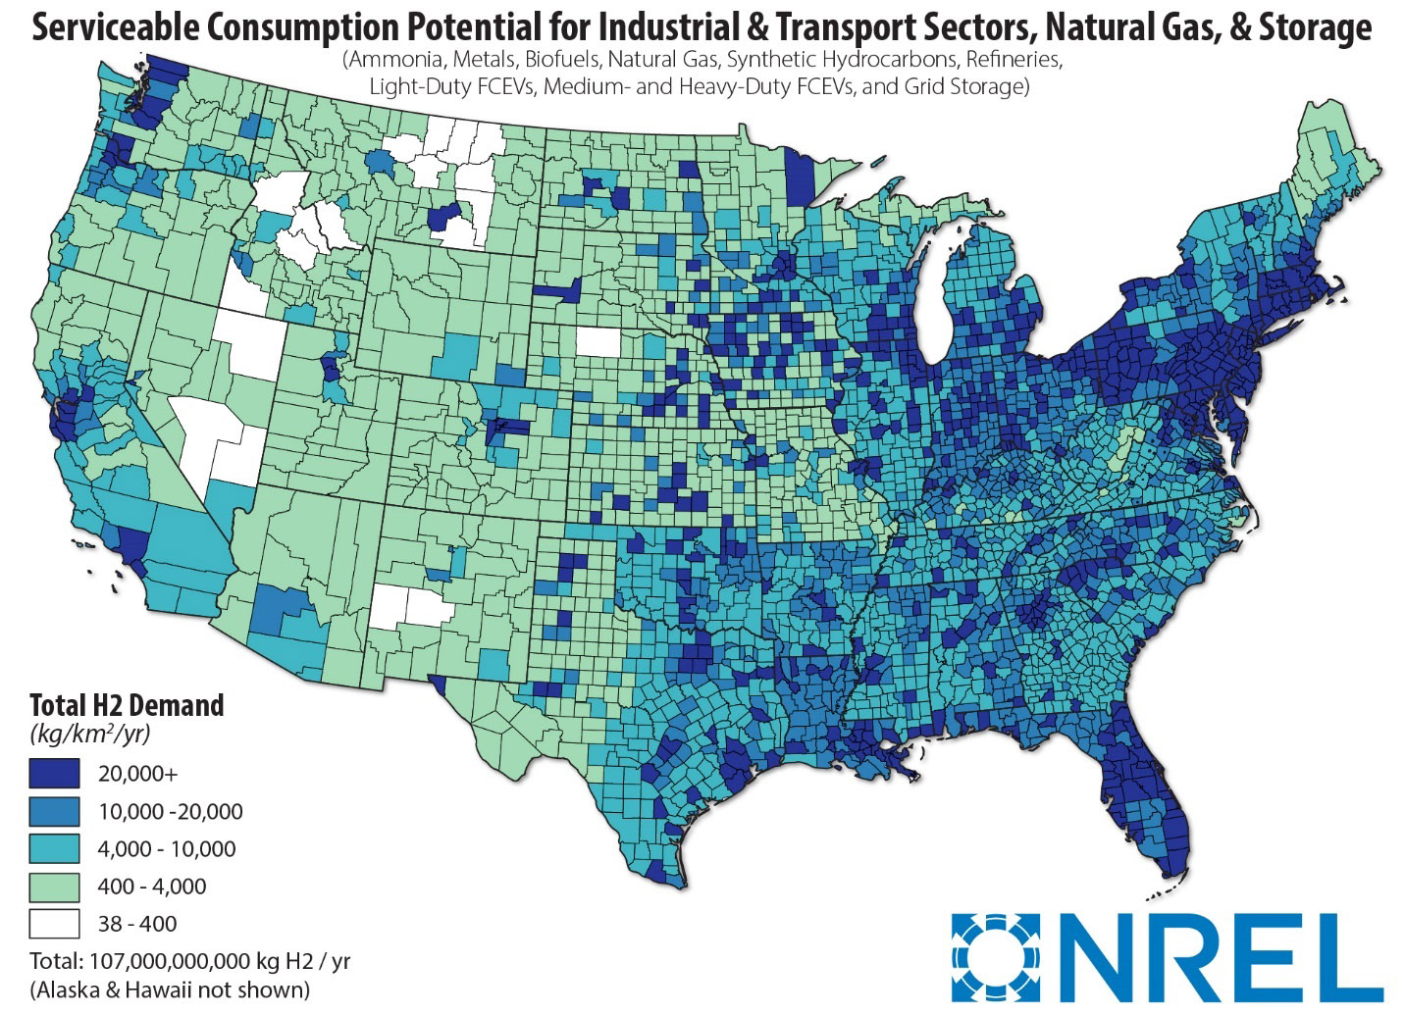

Figure 14.5 US Hydrogen demand. Image from NREL

62

Based on the principle of linear scaling as utilized in Section 9, the US quantities in Table 14.6 are increased by a factor of five for the world model as given in Table 14.7.

Table 14.7. World-WSG Model C (500 EJ/yr and 90% electrification, Figure 9.1)

|  |  |  |  |  |  |  |  |  |
| --- | --- | --- | --- | --- | --- | --- | --- | --- |
| Systems  and units | **Input**  PV1  direct  energy  to grid  6 hrs  Energy  (KWh)  Area  (km2) | **Input**  PV2  energy  to EL  for grid  PV3  energy  to EL  for H2  PVTot  6 hrs  Energy  (KWh)  Areas  (km2) | EL  200 m3/hr  1 MW  green  hydrogen  prod.  rate  6 hrs  Rate  (Mt/day)  (Mt/yr)  (KW)  NEL  1GW | Water source  consump.  rate, 6 hr  and  sink  prod.  rate, 18 hr  6+18 hrs  (kg), (L)  (m3)  (m3)1/3  (km3) | Hydrogen  prod.  and  storage  6 hrs  (Mt/day)  (Mt/yr)  (m3)  150 bars  Ns,  caverns | Hydrogen  consump.  rate, FC  18 hrs  Rate  (kg/s) | FC input  power  18 hrs  (KW)  FC cap.  GW | **Output**  World  electric  energy  to grid  (90%)  and  hydrogen  production  (10%)  6+18 hrs  (KW)  (KWh)  (KWh)  (KWh)  (%) |
| Sequence  numbers | (11) | (12)  (13)  (14) | (7)  (8) | (10) | (9) | (6) | (5) | (4)  (3)  (2)  (1)  (15a, b) |
| Electric  Sector  grid  Closed  System | (2)  **115 EJ/yr**  8.55xo1010  PV1  2.85x105 | (8.1)  **2,195EJ/yr**  1.67x1012  PV2  1.40x106 | (7.1)  30.00  10,950  (8.1)  2.79x1011 | (10.1)  1.80x1012  1.80x109  3,555  1.80 | (9.1)  30.00  10,950  2.23x109  4,455 | 4.62x105 | 2.8x1010 | **450 EJ/yr**  1.43x1010  2.57x1011  8.55x1010  3.81x1011  21, 55 |
| H2  Sectors  Industry  Transp.  Bldgs.  Open  System | NA | (8.2)  **65 EJ/yr**  5.43x1010  PV3  2.07x105 | (7.2)  4.45  1,625  (8.2)  9.05x19 9 | (10.2)  2.67x1011  2.67x108  1,880  0.265 | (9.2)  4.45  1,625  3.30x108  660 | NA | NA | **50 EJ/yr**  3.81x1010 |
| Total | **115 EJ/yr**  2.85x105 | **2,260EJ/yr**  1.60x106  5.62  PVTot  **2,375EJ/yr** | (7.3)  34.45  12,575  (8.3)  288,000 | (10.3)  2.07x01012  2.07x109  1,273  2.07 | (9.3)  34.45  12,575  2.56x109  5,115 | 4.62x105 | 2.8x1010  28,100 | **500 EJ/yr**  3.81x1011 |

63

The PV-EL-FC equations are summarized in Table 14.8. Additional information is provided in Table 4.1 and Figure 14.6.

Table 14.8 Summary of equations.

Fuel Cell (FC)

Hydrogen fuel cell for

electric grid power

Faraday’s Laws

Rate of Hc = dn= I

hydrogen dt 2F

consumption Hc = Pe

2FV

Quantity of Qc = Hct

hydrogen

consumption

Fuel Cell efficiency

ηFC = 50%, assumed

PV-EL-FC system efficiency

ηs = 21%

Electrolyzer (EL)

Water electrolyzer for

hydrogen production

Faraday’s Laws

Rate of Hp = dn = I

hydrogen dt 2F

production

Quantity of Qp = Hpt

hydrogen

production

Manufacturer specifications:

Hp = 4.98x10-3 kg-sec-1

1 MW

Installation projections:

F = P(1 + r)n

Electrolyzer efficiency

ηEL = 70%

Solar Photovoltaic (PV)

Power for electrolyzer

Solar Constant (Irradiance, Is)

Above atmosphere: 1,368 W-m-2

Earth surface: 1,000 W- m-2

Capacity = actual energy = 25%

factor, CF potential energy

Quantum = no. electrons-sec-1

efficiency no. photons-sec-1

Conversion = 20%

Efficiency, e

Power density: Dp = Ise

Energy density: De = Dpt

Panel area: A = E

De

Energy supply: Ein = E out

ηs

Power supply: Pin = Pout

(CF)ηs

System efficiency: ηs

Solar Photovoltaic (PV) Electrolysis (EL) Fuel Cell (FC)

x x x

64

The production and utilization of hydrogen shown in Tables 14.6 and 14.7 can be viewed through the economic lens of supply and demand where equilibrium prices and quantities are determined. The inputs and outputs can also be considered in terms of physical quantities and management.

1. Economic commodity

2. Physical quantities, Table 14.6 and 14.7

3. Management

These concepts are developed further in **Part 4** and **Part 6**

Management

Smart Grids

Supply/Input

Ein = E out = 500 EJ-yr-1 = 2,375 EJ-yr-1

η 0.21

24 hours per day

Pin = Pout = 15.9 TW = 302 TW

CF(η) (0.25) (0.21)

6 hours per day

Demand/Output

E out = 500 EJ-yr-1 (90% electric)

(10% hydrogen)

24 hours per day

Pout = 15.9 TW 24 hours per day

If capacity factor, CF = 100%

If system efficiency, η = 100%

24

Electric grid 112.5 EJ-yr-1

EG= 14 TW daytime

6 hours

Direct power to electric grid

PV1 = 14 TW 🡪

daytime, 6 hours

🡨 Balance 🡪

Grid hydrogen

production

ELG = 279TW🡪

6 hours

PV2 = 279 TW 🡪

daytime

6 hours

Electric grid

EG=14 TW

337.5 EJ-yr-1

nighttime

18 hours

Hydrogen

utilization-input

FCG = 28 TW 🡪

nighttime

18 hours

Hydrogen

production

ELH = 9 TW 🡪

6 hours

PV3 = 9 TW 🡪

daytime

6 hours

PV tot = 302 TW

Hydrogen to sectors: 50 EJ-yr-1

Industry

Transportation

Buildings

Figure 14.6 Management of electric grids

65

Several results emerge from the models shown in Tables 14.6 and 14.7. Although PV installations to reach net-zero for both “day-time” direct power and “night-time” storage power will be quite feasible, the current installed capacity of utility-scale electrolyzers and fuel cells in relation to their required levels in 2050 differ by about four orders of magnitude. Assuming these values for the present values and future values over a 30-year period, an annual growth rates of 25% to 35%will be required.

From Tables 14.1 and 14.7 hydrogen production levels may be compared with other sources as shown in Table 14.9 with units of tonnes/(day-km2). Also shown in these references are comparisons of PV-EL production levels with those generated by photoelectrochemical cells, PECs, in panel planar arrays. The PEC mechanisms will be discussed in **Part 5**, and the advantage of their earth-abundant materials appears in **Part 4**.

Table 14.9 Comparison of hydrogen production levels (tonnes/(day-km2).

|  |  |  |  |
| --- | --- | --- | --- |
| **World Solar Guide** | **Grimm [69]** | **Shaner [70]** | **BD James [71]** |
| PV-EL  Grid 21  Sector 21 | PV-EL PEC  21 19 | PV-EL PEC  13 13 | PEC  22  (Assume CF = 0.25) |

In addition, the installation of salt caverns for hydrogen storage will require rapid acceleration in order to reach net-zero by 2050. For example, the Utah ACES and Mississippi facilities will soon have 0.0055 Mt/yr and 0.0700 Mt/yr respectively of hydrogen storage. The necessary annual growth rate to reach the predicted US 20-40 Mt/yr (average of 30 Mt/yr) of hydrogen by 2050 will be 22 %. Extrapolating the number of average size salt caverns (500,000 m3) of the US Strategic Petroleum Reserve, currently at about four, to 1,000 caverns, corresponding to the model value of 2,500 Mt/yr, in the next 30 years in this model will require a 20% growth rate.

It is likely the other countries will encounter similar difficulties. Furthermore, although the US, China, Europe, and Australia have large geological areas of salt deposits suitable for the installation of salt-cavern hydrogen storage sites, India and Japan do not possess these features. Figures 2 and 3 show global areas of salt deposits.

These models can be applied to other countries as first-order approximations by scaling their annual energy uses as percentages of the projected world value, 500EJ/year. Analyses of PV, EL, FC, water, and hydrogen storage requirements will result in site-specific recommendations for installations. Countries will also vary in terms of geography, and population. For example, Scandinavian countries may import large amounts of hydrogen and/or solar power while countries in Southern Europe may be self-sufficient in their necessary resources.

Significantly, it is noted that no country or region possesses all the necessary resources of solar PV sites, sea water, and salt caverns in the same general location. For example, in the US, the highest levels of solar irradiance occur in the Southwestern states, but the major salt deposits are

66

located along the gulf coast. Although Northern Europe has access to large salt deposit areas, its solar irradiance is approximately half of that found in Northern Africa and the Middle East. This region may, therefore, find it necessary to locate its solar PV sites in Southern latitudes. As discussed in Section 12, land-use management is another factor in the development of utility-scale electric grids powered by renewable energy with storage. These analyses will become even more critical as the PV-farm areas to power “night-time” storage facilities (electrolyzers and fuel cells) are four to six times the PV areas for direct “day-time” power to the grid.

Existing infrastructure components such as natural gas pipelines, underground gas storage facilities, and electric grids will provide foundations for renewable-source implementation. Conversions of these facilities to renewables are soon destined to become major activities and are beyond the scope of this guide.

A summary of the models, as shown generally in Figure 9.1, developed in this guide is in order:

1. Section 9.1 exhibited scaled models in which PV-EL-FC components were sized for

various electrolyzer powers. Here, 100% of the renewable energy produced was in the electrical form.

1. In Section 9.2, a hypothetical world model was presented where the annual energy consumption was taken to be 500 EJ. From this model, properties of regional models for China, the US, Europe’s E-5 countries, and India were calculated as fractions of their energy usage. Again, 100 % of the energy was electrical.
2. From the IRENA net-zero requirement of 90 % electrification, a model for the US was developed in Section 14.4 with 10 % of the energy going to green-hydrogen production for the industrial, transportation, and building sectors. The assumed energy level was one fifth of the world use or 100 EJ annually with the global model scaled up accordingly.

In all models, the component rates and quantities were derived from daily energy uses. Energy production from the PV and EL components arose, in part, the from six-hour, “day-time” periods. The “night-time” energy to the grid was provided by hydrogen-consuming fuel cells.

As the PV-EL-FC components, together with their water and hydrogen sources and sinks, were closed, recyclable, systems, their sizes and quantities were based on daily periods for the Section 9.1 and9.2 models with hydrogen production shown as Mt/day. Annual levels of hydrogen production were shown in units of Mt/yr. Thus, the water and hydrogen quantities are for daily accumulations and depletions. In the Section 14.4 model, hydrogen can be periodically distributed to sector needs.

These global hydrogen production levels are compared with their 2050 demand projections in Table 18 where the annual supplies exceed the demand values by factors of two to three.

The necessary hydrogen production energy of the US and World Models can be compared with the general water-electrolysis requirement of 50KWh per kg H2. From Table 14.1, and from sequence number (15a), 56 KWh per kg H2 is required.

67

The large levels of PV-EL-FC input energies, hydrogen, and costs shown in the WSG Model C for the US and the World are likely to be overstatements of necessary supplies. These estimates are overstatements for several reasons.

First, the building sector is said to require about 40 % of the entire world’s energy budget. Passive building measures will dramatically lower total energy demand although, like planting trees, measurable results may not occur until after 2050.

Second, other RE sources such as wind, hydro, and bio-mass will reduce the need for solar and hydrogen.

Third, there will likely be a continuation of small, “roof-top” installations of solar arrays even though the cost of these systems is twice that of grid connections. The installations may or may not have storage capacities.

Fourth, the various pathways cited in this guide allow for significant amounts, roughly 25 %, of non-renewable sources while still achieving net-zero CO2 emissions by 2050.

Fifth, increases in component efficiencies and reductions in cost through larger manufacturing scales, will make these systems more cost effective.

Even a reduction of the Model C systems would render them still larger than the pathway designs. However, the Model C systems will be retained as upper limits for required materials (silver, platinum, perovskites, oxides, etc.) and their potential substitutes on a global scale. These concepts will be developed in Part 4 of this Guide for the PV, EL, and FC components.

In addition to these system considerations, it appears likely that the Paris temperature increase limitation of 1.5-2.0 C 2050 will require a considerable re-direction and acceleration of efforts, particularly (1) since about 1.0 C of this increase has already been recorded during the IPCC negotiating period of 1988-2015, (2) because relatively few countries have made substantial commitments to restraining this increased temperature, and (3) some countries have actually increased their production of fossil fuels, especially, coal.

Nevertheless, it is imperative that all nations increase their efforts to not only make the transition from fossil fuels to renewables, but to also develop their own specific plans to manage these long-range (10-30 year) transitions effectively. These efforts will not only result in a sustainable planet but also in a more stable geo-political world.

68

15. Cost Summary of Green Hydrogen Production

The primary of components of green hydrogen production costs are the costs of electricity to power the electrolyzers and the electrolyzer capital costs. Projections of reductions in these levelized cost of hydrogen (LCOH) amounts during the period of 2020 to 2050 are shown in Figure 15.1 [61].

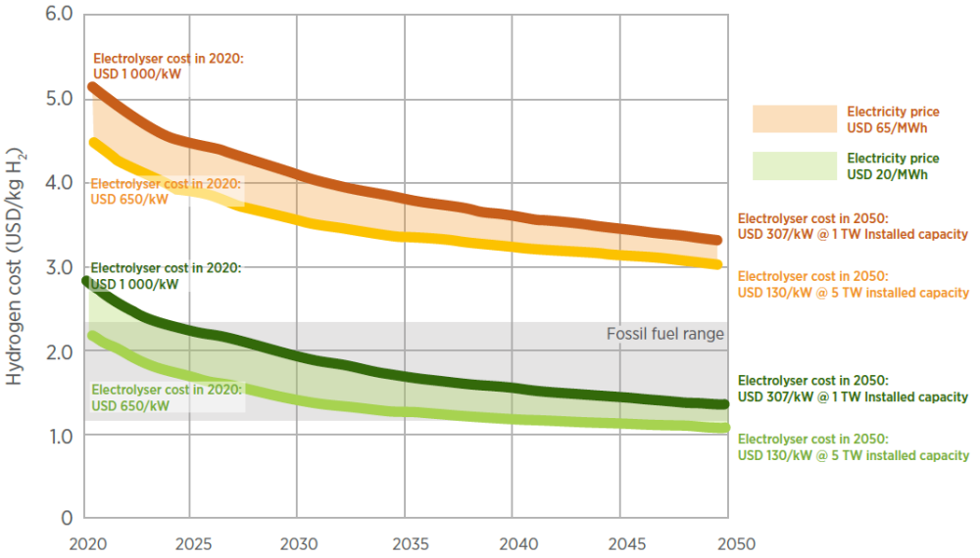

Figure 15.1. Cost reductions of green hydrogen production (IRENA) [61].

Image from energypost.eu

The LCOH of green hydrogen is seen to be competitive with hydrogen produced from fossil fuels by 2030.

69

The production cost of “green” hydrogen currently exceeds those of its “blue” and “grey” counterparts by significant margins, making this renewable energy storage source uneconomical. Examples of production cost-reduction methods are summarized in Table 15.1. Hydrogen storage and transmission costs have not been considered here.

Table 15.1 Green hydrogen production costs.

|  |  |
| --- | --- |
| **Summary of green hydrogen costs and reductions (USD/kg)** | **Ref.** |
| **Statistica** 2020 2030  Average $6.00 $5.40  Optimal $2.30 $1.40 | [64] |
| **IRENA (LCOH)**  Current 80% reduction in Reduction in Electrolyzer Full load Lifetime of WACC*  Cost electrolyzer cost electricity cost efficiency hours-wind Electrolyzers 10 to 6%  53 to 20 USD/MWh 65 to 76% 3,200 to4,200 10 to 20 yr  $4.90 $3.10 $1.70 1.30 $1.20 $1.10 $1.00 | [61] |
| **leefa.org** USDOE announced “Hydrogen Shot” program goal of reducing cost of green hydrogen 80%  to $1.00 by 2030 | [65] |
| **Lazard’s Levelized Costs of Hydrogen (LCOH)**    Sensitivity to electric cost and EL CAPEX** Sensitivity to electric cost and utilization rates  Alkaline (100 MW) PEM (100 MW) Alkaline (100 MW) PEM (100 MW)  $1.09 - $1.72 $1.50 - $2.25 $1.16 - $1.83 $1.62 - $2.42 | [66] |
| **spglobal** Nel goal for 2025 $1.50  Malysia-Petrol Nasional Bkd $1.00 - $2.00 | [67] |
| **pv-magazine**  **ETIP-PV** 2020 2030 2050  Cost (€/kg) 0.70 – 1.80 0.30 – 0.90  LCOH (CAPEX + OPEX***, €/KWh) 0.031 – 0.081 0.020 – 0.050 | [68] |
| WACC* = Weighted average cost of capital  EL CAPEX** = Electrolyzer capital expenditure  OPEX*** = Operating expenditure |  |

From these analyses, a consensus has emerged that the production cost of “green” hydrogen will reach $1.00 per kg by 2050 and, according to some estimates, earlier, making this form cost-competitive with its “blue” and “grey” analogs.

70

Table 15.2 shows estimated hydrogen costs for US and World Models.

Table 15.2 Estimated hydrogen costs

|  |  |  |
| --- | --- | --- |
|  | **US Model Table 14.6**  **(20% of World Model)** | **World Model Table 14.7** |
| **Grid** | Hydrogen Production Annual Cost  Model (57.7 TW)  2,190 MT $2.190 T  Reduced Estimates  (19-29 TW)  729-1095 MT $0.729T-$1.095T | Hydrogen Production Annual Cost  Model (288 TW)  10,950 MT $10.950 T  Reduced Estimates  (96-144 TW)  3,646-5,475 MT $3,646-$5,475T |
| **Sectors** | Hydrogen Production Annual Cost  Model (57.7 TW)  325 MT $0.325 T  Reduced Estimates  (19-29 TW)  108-163 MT $0.108T-$0.163T | Hydrogen Production Annual Cost  Model (288 TW)  1,625 MT $1.625 T  Reduced Estimates  (96-144 TW)  541-813 MT $0.541T-$0.813T |
| **Total** | Hydrogen Production Annual Cost  Model (57.7 TW)  2,515 MT $2,515 T  Reduced Estimates  (19-29 TW)  837-1,258 MT $0.837-$1,258 T | Hydrogen Production Annual Cost  Model (288 TW)  12,515 MT $12.515 T  Reduced Estimates  (96-144 TW)  4,167-6,257 MT $4.167T-$6.257T |

The cost estimates in Table 15.2 are based data in Tables 14.6 and 14.7. In addition, it is

assumed that the hydrogen production cost is $1.00 per kg as projected for 2050. Because the models may be overestimates, reduced estimates of 33% and 50% are also given. Other sources give world power levels of 100 TW, suggesting that the reduced estimates will be reasonable.

Here, the US Model is considered 20% of the World Model. Other countries can estimate projected costs by computing their GDP as a percentage of the world GDP together with the data in Table 14.7.

71

The Princeton study [40], as seen in Figure 15.2, determined that energy costs even with net-zero scenarios for the US are expected to be in the range of 4% to 6% of GDP in 2050. Thus, the current cost of hydrogen production should be reduced by a factor of at least four-to-five. It is emphasized that this estimate excludes the additional costs of water, hydrogen storage, and fuel cells (reversible electrolysis-fuel cell systems may become feasible). Furthermore, although certain infrastructure components such as electric grids and natural gas pipelines are currently in place, the facilities will require upgrades and additions. If these costs follow the patterns of reductions as seen for solar and EL systems, it can be expected that solar-PV-EL-FC sources with hydrogen storage will also become cost competitive (solar-PV = solar-photovoltaic). However, a rapid growth rate, r, will be required to meet the 2050 projection:

250 GW +/- PV, (Present Value, financial calculator) current EL installed capacity

3.10 x 105 GW FV, (Future Value, financial calculator) 2050 EL projected capacity

30 n, 30-year period

r = 27 %, annual rate of growth

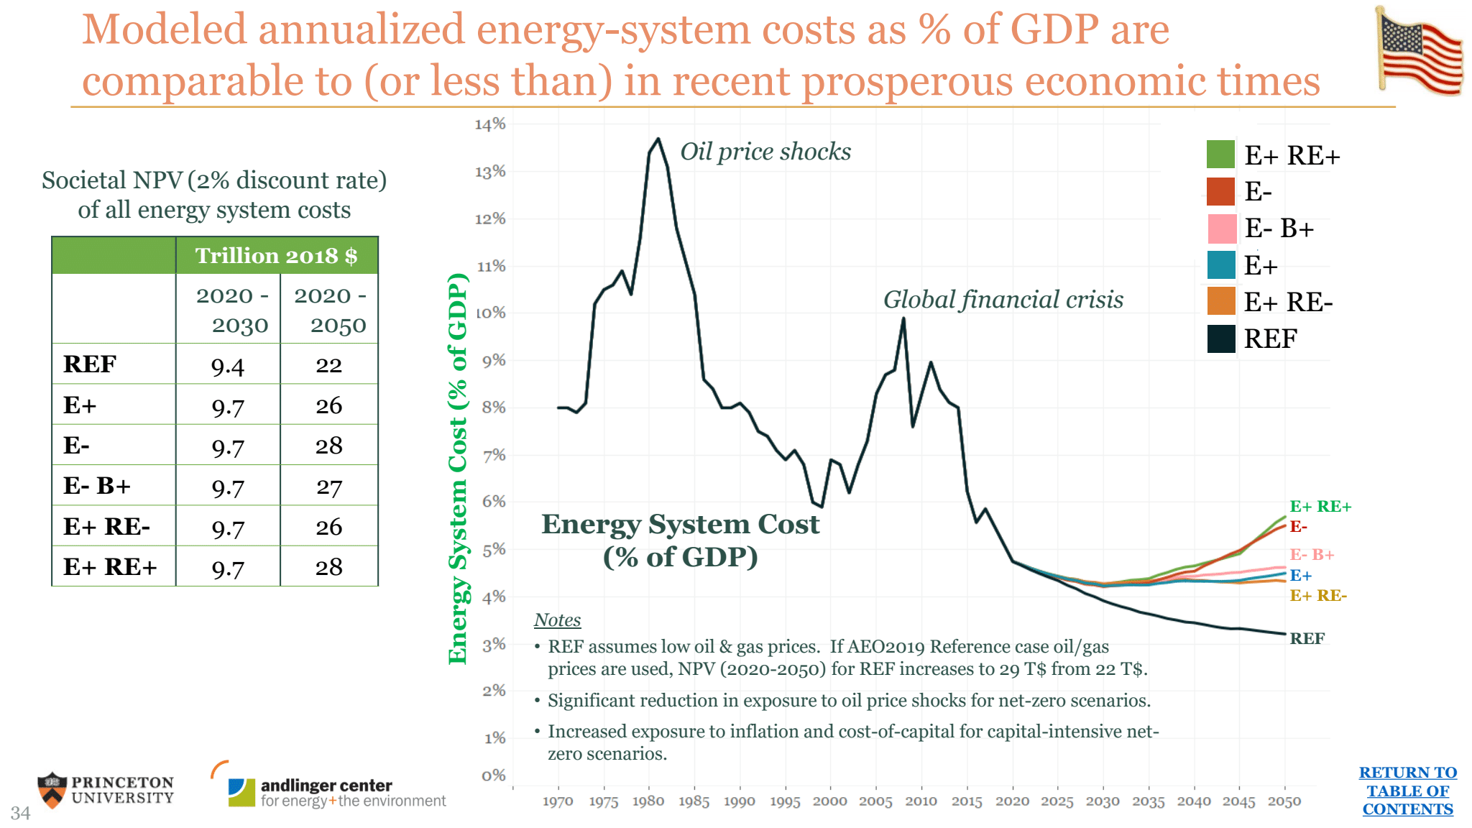

Figure 15.2 US energy costs (% of GDP). Image from Princeton.edu

72

16. Summary

Major points of the **Part 2** analyses and their citations can be summarized as follows:

* The **Paris Agreement** of 2015 set in motion the imperative of limiting the global atmospheric temperature increase to 1.5 C – 2.0 C by 2050.
* Subsequent **pathways** **to net-zero** CO2 eq emissions by 2050 resulted in strategies to attain this goal through the **transition** of replacing most fossil fuels with renewables, including solar, wind, water, and biomass with carbon capture.
* Similar findings of these pathways stated world energy demand projections of about 500 EJ per year and the requirements for **90% electrification** of all energy systems.
* **Part 2** of this guide presents a design for variable solar energy hypothetical **models.** The components of these models consisted of solar PV panels, electrolyzers, fuel cells, together with water sources and the geological storage of hydrogen. Global energy demand is assumed to be a constant level 500 EJ per year during the period of 2020-2050. Other renewable sources are excluded.
* The models are **scaled** for (1) various electrolyzer powers, (2) the four largest energy regions, China, the US, European-E5 countries, and India, and (3) a global system.

* Certain **simplifying assumptions** in analyzing these models are made.

1. Electric power would provide 90% of all energy needs with 10% of the energy input for green hydrogen. A capacity factor of 25% is used.
2. Individual sectors, electric, industry, transportation, and building, are

not analyzed in detail, but hydrogen is supplied for their applications.

1. It was acknowledged that with the building sector, for example, using 40% of the world’s energy, these models may be excessive in size by a factor of two if passive building and other renewable solutions were to become available in a timely manner.
2. The models show possible supply energy levels and to provide upper limits to the global demand for system components and their materials requirements.

73

The WSG models and Pathways are summarized in Table 16.1

Table 16.1

|  |  |  |
| --- | --- | --- |
|  | **Renewable Energy Production and Storage 2050** | **Pathways to Net-Zero CO2 Emissions 2050** |
|  | **World Solar Guide** | **IPCC and IEA**  **References** |
| **Features** | The World Solar Guide presents models for solar energy production and hydrogen storage with scalable  PV-EL-FC systems.  Hypothetical electric grids powered by PV-EL-FC  ______________________________________________  Part 1 World Model  PV area 348,000 km2  Part 2 World Model  Part 2 PV1  area 285,000 km2, Direct grid input  PV2 area 1,400,000 km2, EL power, H2, FC  PV3 area 207,000 km2, EL power, H2, sectors  PV total area 1.600,000 km2  (20% Sahara Desert area)  Total power = 3.0 x 1011 KW | IPCC and IEA pathways give means of eliminating CO2 emissions by 2050 through RE sources and carbon capture.  A reduced level of fossil fuels is also permitted.  PV area 469,000 km2, landartgenerator.com  IPCC IEA  CCUS (GtCO2) 15 7.5  BECCS (GtCO2) 3.5-16 1.9  Bio-energy(EJ) 200 100  World energy use(EJ) 300-550 340  Hydrogen (EJ) 18 33  (Mt) 150 275  RE (wind and solar) electric(%) 50 70  Fossil fuels (EJ) 155 120  Sahara Desert area 9,200,000 km2 |
| **Similarities** | World annual energy demand 500 EJ  Electrification fraction 90%, 450 EJ | Part 2, Table 14.7  World annual energy demand approx..500 EJ  Part 2, Table 14.x  Electrification fraction 90% (IEA) ??????????????? |
| **Differences** | Electric generation 100% RE, solar  Installed EL capacity 2050, 350 TW  Annual H2 production 9,600 Mt/yr, electric FC-grid  Annual H2 production 2,400 Mt/yr, sectors  Installed FC capacity 2050, 28 TW  PV-EL-FC system efficiency 20%  Input energy 2,500 EJ | Electric generation 50-70% RE, solar, wind  Installed EL capacity, 2050, 3-7 TW  Annual H2 production 500 Mt/yr |
| Results | The installed capacities of model electrolyzers and fuel cells as well as hydrogen production are one to two orders of magnitude (factors of 10-100) larger than those of the pathways.  Building sector energy analyses, which may involve 40%  of world energy use has not been included. This sector energy use will be significantly reduced by long-term (50-100 years) passive building measures.  These model estimates give potential sizes of the installations and provide upper limits for the required  critical materials such as rare earth elements. |  |

74

* These models are considered to provide insights into the **design** of variable renewable energy systems in the production of green hydrogen, storage of hydrogen, and utility-scale grids. The sections concerning energy regions, environmental and economic factors, land-use management, and commercial systems are also included for evaluations of potential sites.
* As with all segments of the **World Solar Guide website**, **Part 2** is intended to impart **pedagogical** benefits for students and instructors in the field of renewable energy. Calculations for the EL-FC processes are explicitly given with PV analyses covered in **Part 1**. Additional tutorial materials are presented in the **Parts 1, 2, 3, 4, 5,** and **8** of theAppendix sections.

75

17. Conclusions, and Subsequent Guide Segments

This analysis has addressed the critical issue of energy storage, a necessary development to mitigate the variability of solar PV power. The systems considered here consisted of dual PV arrays in which one array generates power directly to the grid during “day-time” hours and the second array powers a water electrolyzer producing hydrogen during the day time and with a fuel cell consuming hydrogen and generating power throughout the 18-hour “night-time” period. Three types of models were presented: (1) scaled PV-EL-FC systems, (2) similar global models for the four energy regions, (3) and a model for 90% electrification with 10% hydrogen production for use by sectors. Although the ratio of the “night-time” to “day-time” period is 18/6 =3 for a capacity factor of 0.25, the ratio of PV2 to PV1 array areas will be about five.

The calculated efficiencies of the scaled and world systems in this analysis were 20%, less than those of working systems and simulations which were 47-48% efficient. This difference was likely due, in part, to higher component efficiencies and supply-demand management in the simulations. The efficiency of the US system with 90% electrification and hydrogen production for the industrial, transportation, and building sectors was calculated to be 21 %.

Some water resources will rely on the direct electrolysis of seawater at various high-irradiant locations around the world. Utility-scale storage of hydrogen can best be achieved with existing salt caverns and the production of new caverns in salt deposits through brine mining. Both water and hydrogen will be utilized in closed-loop systems, allowing conservation of these resources.

On a worldwide scale, the following components would be required: 1.87 x106 km2 of solar PV panels, 310,000 1GW electrolyzers, 2.00 km3 of water (compared with the water volume of Lake Texoma in the US of 3.12 km3), 2.47x109 m3 of hydrogen at 150 bars, 4,940 salt caverns, and 7,639 1 GW fuel cells. The “Big Four” energy regions, China, the US, Europe-E5 countries, and India, would then require approximately 24%, 17%, 7%, and 6% respectively of these quantities.

Locations of PV, water, and hydrogen-storage facilities for utility-scale systems will occur in diverse regions. Therefore, connecting infrastructure such as gas pipelines, water pipelines, and grids will be important components of early solar installations. New infrastructure will include the direct electrolysis of seawater, hydrogen storage in salt caverns, and smart grids.

The environmental concerns of replacing fossil fuels with renewable sources, primarily solar PV,

have been addressed thoughtfully and comprehensively by references for the energy regions considered in this analysis. It was generally stated that the problem areas of hazardous materials, pollution, and disposal can be reduced by responsible practices. Increasing land areas for renewables relative to those utilized by fossil sources were cited as problematic.

76

Due to the extensive areas required for PV utility-scale installations, land use will be a critical issue. The Solar Farm areas with PV spacing and infrastructure will be two-to-four times the size of the arrays for efficiencies of 40% and 20%. These areas are likely to be larger by a factor of two-to-four than fossil fuel sources due to their lower power density. Except for the Europe-E5 countries which may consider installations in the Sahara Desert, all the other regions will require PV efficiencies approaching 40% for locations in the potential high-irradiance desert areas suggested here. Other PV locations and roof-top installations (with lower solar irradiance levels) will reduce the need for desert sites.

In the United States, the total required land area for “Solar Farms” will be in the range of approximately 600,000 to 1,200,000 km2. The current land-use area for energy production is about 300,000 km2.

GIS models were seen as important tools in site selections of utility-scale solar PV systems for energy regions around the world. When compared with arbitrary and conventional site-selection methods, GIS considers environmental, social, legal, technical, economic, and land-use factors more efficiently, but these models often omit energy requirements and related PV-area estimates.

In addition to land-use limitations, materials availability used in manufacturing PV, EL, and FC components of the large utility-scale systems may also face restrictions. These limitations will include silver used in PV arrays as well as catalytic-electrode and electrolyte materials required for EL and FC applications. Recycling will be necessary to conserve these materials. Also, continued R&D efforts will be essential in order to improve the performance of the devices.

Based on simplifying assumptions, the analysis included a linear scaling of system sizes and component efficiencies. Several uncertainties in this analysis have also been recognized. For example, the actual ratio of water-to-hydrogen will be in the range of 20 to 120 (60 in this analysis) rather than the stoichiometric value of nine. The resolution of this ratio will likely require the construction of actual systems from which this level of uncertainty can be reduced.

It is suggested that these models can be scaled up or down depending on their regions or countries, energy input and output variables, component characteristics such as efficiencies, and refinements of simplifications and assumptions. Other modifications might include fractions of electricity as produced by utility-scale installations versus distributed roof-top systems and power densities.

As a result of the assumptions and uncertainties contained within this analysis, initial dimensions of the real components relative to their design values may be determined to within a factor of only two. However, the primary purpose of the investigation has been to encourage early discussion of these systems. Before these installations can be initiated, time-consuming environmental assessments, government-business agreements and coordination, land allocations, water resource investigations, and hydrogen storage plans must be undertaken in parallel.

77 Most time tables for the limitation of global warming to 1.5-2.0 C through the replacement of fossil fuels with renewable sources occur during the period of 2020 to 2050. Renewables, including, solar, wind, and bio-fuels, will provide significant levels of energy. However, attainment of this goal will require a re-direction and acceleration of efforts during this transition period. While some countries will meet this deadline (for example, Costa Rica and Iceland), larger energy users may require longer periods. The “Big Four” regions are unique, but common site-selection criteria should exist. An international network of researchers, developers, business entities, and governments would facilitate a more rapid installation of utility-scale solar energy systems on a global scale.

The WSG Model C with 100% RE is consistent with IRENA pathway showing an average of 73% RE which calls for a 90% electrification as required for net-zero CO2 emissions. The resulting hydrogen levels for the sectors as given by Model C are also comparable to those seen in the IPCC and IEA pathways.

The various models discuss here in **Part 2** could be scaled and digitized for other applications which might include individual grids, regions, or countries.

The US achievement of net-zero by 2050 with 90% electrification, will require the installation

of storage-facility components, electrolyzer, fuel cell, and salt caverns, at very high annual rates of growth in the range of 20 % to 36 %.

In **Part 3** of this guide, electrolyzer and fuel-cell electrode reactions will be considered in relation to their primary electrolyte compositions. It is imperative that that these processes become better understood in order that the platinum group and other **critical** element in use be replaced by **earth-abundant** materials for global installations.

Because of the large PV-EL-FC systems required for the production and storage of hydrogen, their global installations will be limited by their materials availability. Material limitations on a global basis such as silver for PV arrays and the platinum group of metals for these electrodes will be analyzed in **Part 4**. Research in earth-abundant materials will also be presented here. Alternative methods of hydrogen production are next considered in **Part 5**.

As hydrogen is a critical medium in solar energy storage, three views of its use are given in **Part 6**. The natural resources available for global solar-hydrogen systems are the foci of **Part 7**. Subsequently, **Part 8** gives policies and strategies related to the difficult task of implementing the **transition** which will replace fossil fuels with renewables, primarily solar, by 2050. **Part 9** discusses the commercialization aspects of these resources. **Part 10** provides brief summaries of each segment.

78

18. References

1. [www.ipcc.ch](http://www.ipcc.ch)

2. [www.unfccc.int/the-paris-agreement](http://www.unfccc.int/the-paris-agreement)

3. [www.statista.com/energy-consumption-by-country](http://www.statista.com/energy-consumption-by-country)

4. [www.en.wikipedia.org/list-of-countries-by-CO2-emissions](http://www.en.wikipedia.org/list-of-countries-by-CO2-emissions)/solar-power-by-country

5. [www.irena.org/solar](http://www.irena.org/solar)

6. [www.irena.org/variable-renewable-energy](http://www.irena.org/variable-renewable-energy).

7. [www.eia.gov/tools/index/capacity_factor](http://www.eia.gov/tools/index/capacity_factor).

8. [www.irena.org/Power-to-Hydrogen/2019](http://www.irena.org/Power-to-Hydrogen/2019)

9. [www.techniscchechemie.tu-berlin/2019ACS_Letters_Soren_Direct_Electrolysis_Splitting_of_Seawater](http://www.techniscchechemie.tu-berlin/2019ACS_Letters_Soren_Direct_Electrolysis_Splitting_of_Seawater)

10. www.unece.org/sites/default/files/2021-04/09_Serge_van_Gessel_Hydrogen_  
Storage_and_UNFC_UNECE_CM_Week_2021

11. D. G. Caglayan, N. Weber, H. U. Heinrichs, J. Liuben, M. Robinius, P.A. Kulka, and P. A. Stolten, Intl. J. Hydrogen Energy, Vol. 45, Issue 11, Feb., 2020.

12. S. Dihrab, T. Khatib, K. Sopian, H. Al-Ani, and S. H. Zaidi, On the Performance of Hybrid PV/Unitized Regenerative Fuel Cell Systems in the Tropics, International J. Photoenergy/2012.

13. A. Ganguli, and S. Ghosh, Model and Analysis Solar Photovoltaic-Electrolyzer-Fuel Cell Hybrid Systems integrated with a Floriculture Greenhouse, Energy and Buildings 42(11) 2036-2043, 2010.

14. S. Pascuzzi, A. Anifantis, I. Blanco, and G. S. Mugnozza, Electrolyzer Performance Analysis of an Integrated Hydrogen Power System for Greenhouse Heating. A Case Study, MDPI, Sustainability, 2016.

15. S. Mubaraak, D. Zhang, L. Wang, M. Mohan, P. M. Kumar, C. Li, Y. Zhang, M. Li, Efficient Photovoltaics Integrated Fuel Cell Based on Hybrid Systems, AIP, J. Renewable and Sustainability Energy 133, 013502 (2021).

16. [www.irena.org/Digital/Articles/2019/Apr/-/](http://www.irena.org/Digital/Articles/2019/Apr/-/)

17. [www.stanford.edu/group/efmh/Jacobson/media/articles/USStates/WWS/2019](http://www.stanford.edu/group/efmh/Jacobson/media/articles/USStates/WWS/2019)

18. S. Teske, link.springer.com/book/10.1007/978-3-1030-6505843-2/2019.

19. D. Bogdanov, et. al., [www.nature.com/articles/s42467-019-0855-1/2019](http://www.nature.com/articles/s42467-019-0855-1/2019).

20. [www.world-solar-guide.com](http://www.world-solar-guide.com)

21. [www.energy.gov/sites/prod/files/2014/03f12/rev_fc_wkshp_report](http://www.energy.gov/sites/prod/files/2014/03f12/rev_fc_wkshp_report).

22. [www.irena.org/Green-Hydrogen-Cost-Reduction-2020](http://www.irena.org/Green-Hydrogen-Cost-Reduction-2020)

23. [www.nelhydrogen.com/products](http://www.nelhydrogen.com/products)

24. Shi, X., Liao, X., and L. Yanfei (2020) “Quantification of fresh water consumption and scarcity footprints of hydrogen from water electrolysis. A methodology framework.” Renewable Energy, Vol. 154, pp. 786-796, <https://doi.org/10.1016/j>. renene.2020.03.026.

Also, Green Hydrogen Cost Reduction, IRENA 2020.

25. [www.agupubs.onlinelibrary.wiley.com/doi/full/10.1029//2020GL090789](http://www.agupubs.onlinelibrary.wiley.com/doi/full/10.1029//2020GL090789).

Z. Lu, et.al., “Impacts of Large-Scale Sahara Farms on Global Climate and Vegetation Cover.

26. [www.nrel.gov/](http://www.nrel.gov/)

79

27. [www.mdpi.com/journal/nanomaterials/special_issues_nanocatalysts_electro_fuel_electro](http://www.mdpi.com/journal/nanomaterials/special_issues_nanocatalysts_electro_fuel_electro).

N. Jung, Guest Editor, Special Issue “Design of Nanocatalysts and Electrodes: Application to Fuel Cell Analysis.”

28. M. Tawalbeh, A. Al-Othman, R. Kafiah, E. Abdelsalem, and F. Almomani, Environmental impacts of solar photovoltaic systems: A critical review of recent progress and future outlook, Science of the Total Environment, Vol. 759, 10 March 2021, 143538.

29. G. M. Heggelund, China’s climate and energy policy: at a turning point? International Environmental Agreements; Politics, Law, and Economics, 21, 9-23 (2021).

30. [www.news.arizona.edu/story/agriphotovoltaics-proves-beneficial-across-food-water-energyh-nexus](http://www.news.arizona.edu/story/agriphotovoltaics-proves-beneficial-across-food-water-energyh-nexus)

31. [www.eea.eu/publications](http://www.eea.eu/publications)

32. [www.mdpi.com/](http://www.mdpi.com/%20)  H. Supe, et. al., Google Earth Engine for the Detection of Soiling on Photovoltaic Panels in Arid Environments, Remote Sensing, 2020.

33. M. Kumari and P.K. Singh, Impacts of Solar Power in India: A Review. Intl. J. Research and Review, Vol. 4, 2017.

34. I. Guiata-Pradas, I. Marques-Perez, A. Gallego, and B. Segura, Analyzing territory for the sustainable development of solar photovoltaic power using GIS databases, Environmental Monitoring and Assessment, 191, Article number 764, 2019.

35. M. A. Hassaan, A. Hassan, H. Al-Dashti, GIS suitability analysis for siting solar power plants in Kuwait, Egyptian J. of Remote Sensing and Space Science, 2020.

36. D.-J. van de Ven, I. Capellan-Perez, I. Arto, I. Patel, and M. Gonzalez-Equino, The potential land requirements and related land use change emissions of solar energy, Scientific Reports, 11, Article number: 2907, 2021.

37. S. Chen, Y. Zhang, and J. Zheng, Assessment on Global Urban Photovoltaic Carrying Capacity and Adjustment of Photovoltaic Spatial Planning, Sustainability, 2021, 13, 3149.

38. [www.blm.gov/programs/renewable-energy/solar-energy/permitting-and-development/land-use-planning](http://www.blm.gov/programs/renewable-energy/solar-energy/permitting-and-development/land-use-planning)

39. [www.ieefa.org/ieefa-us-land-agency-is-behind-the-times-on-utility-scale-solar-build-out-rules,2020](http://www.ieefa.org/ieefa-us-land-agency-is-behind-the-times-on-utility-scale-solar-build-out-rules,2020)

40. [www.princeton.edu/news/2020/12/15/big-affordable-effort-needed-for-america-to-reach-net-zero-emissions-by-2050](http://www.princeton.edu/news/2020/12/15/big-affordable-effort-needed-for-america-to-reach-net-zero-emissions-by-2050)

41. C. P. Castillo, F. B. e Silva, and C. Lavalle, An assessment of the regional potential for solar generation in EU-28, Energy Policy, Vol. 88, Jan., 2016, pp. 86-99.

42. [www.solarpowereurope.org/2020/SolarPoweer-Europe_Tunisia-Solar-Investment-Opportunities](http://www.solarpowereurope.org/2020/SolarPoweer-Europe_Tunisia-Solar-Investment-Opportunities).

43. J. Kiesecker, S. A. Baruch-Mordo, M. Heiner, D. Negandhi, J Oakleaf, C. Kennedy, and P. Chauhan, Renewable Energy and Land Use in India: A Vision to Facilitate Sustainable Development, Sustainability, 2020, 12, 281.

44. S. Ayalasomayajula, P. Kumar Das, R. Karthik, A. Kumar, and G. Giridhar, Site Suitability Analysis for Solar Potential mapping in South India, esri India, 2017.

45. [www.ec.europa.eu/growth/content/hydrogen-commission-launches-project-european-clean-hydrogen-alliance-investment-en](http://www.ec.europa.eu/growth/content/hydrogen-commission-launches-project-european-clean-hydrogen-alliance-investment-en).

46. [www.ballard.com](http://www.ballard.com)

47. [www.nsenergybusiness.com/features/renewable-hydrogen-infrasturcture](http://www.nsenergybusiness.com/features/renewable-hydrogen-infrasturcture)/ad-van-wijk.

48. [www.gcc.sg.org](http://www.gcc.sg.org)

80

49. [www.power.mhi.com/regions/amer/news/20210511](http://www.power.mhi.com/regions/amer/news/20210511)

50. [www.mtu-solutions.com](http://www.mtu-solutions.com)

51. [www.renewableenergyworld.com/hydrogen/mississippi-green-hydrogen-hub](http://www.renewableenergyworld.com/hydrogen/mississippi-green-hydrogen-hub)

52. [www.pv-magazine-australia.com/2021/massive-hydrogen-storage-potential](http://www.pv-magazine-australia.com/2021/massive-hydrogen-storage-potential)

53. [www.fuelcellstore.com](http://www.fuelcellstore.com)

54. [www.energy.gov/eere/fuelcells/h2scale](http://www.energy.gov/eere/fuelcells/h2scale)

55. [www.iea.org/Pathways-to-Net-Zero](http://www.iea.org/Pathways-to-Net-Zero)

56. [www.iea.org/reports/hydrogen](http://www.iea.org/reports/hydrogen)

57. [www.frost.com/news/global-green-hydrogen-production](http://www.frost.com/news/global-green-hydrogen-production)

58. [www.pwc.com/gx/en/industries/green-hydrogen](http://www.pwc.com/gx/en/industries/green-hydrogen)

59. [www.about.bnef.com/new-energy-outlook](http://www.about.bnef.com/new-energy-outlook)

60. [www.hydrogencouncil.com/en/clean-hydrogen-scale-up](http://www.hydrogencouncil.com/en/clean-hydrogen-scale-up)

61. [www.irena.org/world-energy-transition-outlook](http://www.irena.org/world-energy-transition-outlook)

62. [www.strategyand.pwc.com/en/reports/2020/the-dawn-of-green-hydrogen](http://www.strategyand.pwc.com/en/reports/2020/the-dawn-of-green-hydrogen)

63. [www.wri.org/news/statement/iea-releases-report-to-achieve-net-zero-emissions-2050](http://www.wri.org/news/statement/iea-releases-report-to-achieve-net-zero-emissions-2050)

64. [www.statistica.com/topics/green-hyrogen](http://www.statistica.com/topics/green-hyrogen)

65. [www.ieefa.org/DOE-hydrogen-cost/rising-natural-gas-prices-making-green-hydrogen-cheaper](http://www.ieefa.org/DOE-hydrogen-cost/rising-natural-gas-prices-making-green-hydrogen-cheaper)

66. [www.Lazard.com/levelized-cost-of-hydrogen-analyzed](http://www.Lazard.com/levelized-cost-of-hydrogen-analyzed)

67. [www.spglobal.com/green-hydrogen-costs](http://www.spglobal.com/green-hydrogen-costs)

68. [www.pv-mag.com/ETIP-PV/2021/pv-generated-hydrogen-cost-to-drop](http://www.pv-mag.com/ETIP-PV/2021/pv-generated-hydrogen-cost-to-drop)

69. Shaner M. R., Atwater, H. A. Lewis, N. S., and McFarland E. W., A comparative technoeconomic analysis of renewable hydrogen production using solar energy, Energy & Environmental Science 9(7), 2016.

70. Grimm, A., de Jong, W. A., and Kramer, G. J., Renewable hydrogen production: A techno-economic comparison of photoelectrochemical cells and photovoltaic-electrolysis., International Journal of Hydrogen Energy, 43(43), 2020.

71. James, B. D., Colella, W. G., Moton, J. M., Techno-Economic Analysis of Hydrogen Production Pathways, Hydrogen and Fuel Cell t Technology Advisory Committee Meeting, Boulder, CO, NREL, 2013.

72. [www.iea.blob.core/Net-Zero-by-2050-Road-Map-for-the-Global-Energy-Sector/](http://www.iea.blob.core/Net-Zero-by-2050-Road-Map-for-the-Global-Energy-Sector/) 2021

81

**19. Appendix**

Illustration of Solar Capacity Factor, CF, and PV Efficiency, e.

Consider the following solar PV panels with a solar irradiance,

I = 1,000 W/m2

**Input Power**  **Output Energy**

P = E/t E = Pt

= 1.39 x 1014 KWh/8,760 hours per year

= 15.9 x 1012 W = 15.9 TW

CF = 8,760/8,760 = 100%

e = 100%

Panel: A1 = P/I(CF)e = 15.9 TW/(1 KW-m-2)(100%)(100%)

area = 15,900 km2

E = 500 EJ/year

E = 1.39 x 1014 KWh/year

CF = 2,190/8,760 = 25%

e = 100%

Panel: A2 = P/I(CF)e = 15.9TW/(1KW-m-2)(25%)(100%)

area = 63,600 km2

CF = 2,190/8,760 = 25%

e = 20%

Panel: A3 = P/I(CF)e = 15.9 TW/(1 KW-m-2)(25%)(20%)

area = 318,000 km2