**World Solar Guide**

**Part 9**

**Commercialization of Solar Panels, Electrolyzers, and Fuel Cells**

**Jon D. Canaday, Ph.D.**

[jon.canaday@world-solar-guide.com](mailto:jon.canaday@world-solar-guide.com)

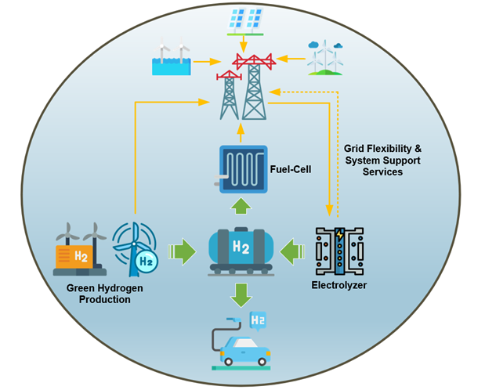

Image from IEEE Smart Grid

Copyright © Jon D. Canaday, 2023

2

**World Solar Guide**

**Part 9**

**Commercialization of Solar Panels, Electrolyzers, and Fuel Cells**

Page

Table of Contents

1. Introduction 3

2. Projections and Limitations 4

2.1 Definitions of Electrical Power and Power Limitations 4

2.2 Global Power Requirements 5

2.3 Electric Power Limitations 10

2.4 Cost Estimates 11

2.5 Growth Rates 12

2.6. Summary of Projections 12

3. Silos vs. Spectra 13

4. Manufacturers of Solar Panels, Electrolyzers, and Fuel Cells 14

5. Summary and Conclusions 20

6. References 22

3

World Solar Guide

Part 9

Commercialization of Solar Panels, Electrolyzers, and Fuel Cells

1. Introduction

The website, [www.World-Solar-Guide.com](http://www.World-Solar-Guide.com) (WSG), has been constructed as a resource for researchers and developers of solar energy and storage systems, primarily in the production of hydrogen and electric power. It is also intended for use by teachers and students of these fields. The Guide is based on IPCC recommendations and “pathways” to 2050 and similar “roadmaps.” Ultimately, the PV-EL-FC systems described here must be manufactured with large-scale commercial applications to meet global energy needs.

Risk assessments have been written, citing restrictions due to limitations of **critical elements** such as the platinum metals group (PMG). However, in these documents, probabilities were not calculated, nor were other quantitative measures given. In this guide, physical models, at the “macro,” “micro,” and “nano,” levels were developed to estimate the material and electric power requirements of the PV-EL-FC systems. The “macro” models refer to regional/country applications, while the “micro” models are cell components such as electrodes and electrolytes. “Nano” models are considered in relation to component catalytic activities and morphologies.

In the global model of **Part 2**, a large power requirement of 318 TW was calculated even though the annual energy use of 500 EJ was approximately the same as those of other reports. This value was the result incorporating a capacity factor of 25% and a system efficiency of 20% in a system of 90% electrical energy and 10% hydrogen production. The variable nature of the system was accounted for with this capacity factor and hydrogen storage.

**Part 4** considered material and electric power limitations imposed by the incorporation of critical elements in photovoltaic panels, electrolyzers, and fuel cells such as silver and the platinum metals group (PMG). Research advances obtained with earth-abundant elements were discussed as necessary developments to reach large-scale, global installation of these systems.

Although a detailed plan for commercialization is not given here, some of the conclusions in the earlier segments and projections in **Part 9** offer insights for this process.

4

2. Projections and Limitations

2.1 Definitions of Electrical Power and Power Limitations

The definitions of electrical power and its limitations due to materials availability as discussed in **Parts 2 and 4** of the World Solar Guide are given in Table 1.

Table 1.

|  |  |  |
| --- | --- | --- |
| **Description** | **Calculation** | **Reference** |
| General Definition  Power is defined as the rate of performing work or energy. | P = E  t | General |
| Watt-Hours  Electrical energy is normally monitored in units of watt-hours, KWh, or exa-joules, EJ, 1018 joules. | 1 KWh = 3.6 x 10-12 EJ  or  1 EJ = 2.78 x 1011 KWh | General |
| Ideal Power  Consider a large solar panel which could be placed in a space-based, earth-orbit with transmission of its electrical power to a global electrical grid. If this panel were continuously directed at the sun with 100% conversion efficiency, its power over one year would produce the necessary global energy of 500 EJ-yr-1 or 1.39x1014 KWh-yr-1 | Pi = E = 1.39x1014 hours-yr-1  t 8,760 hours-yr-1    Pi = 15.9 TW | WSG  Part 2 |
| Capacity Factor and Efficiency  Solar energy is known to be both variable and inefficient. The global, daily average of solar energy availability is measured by its “capacity factor” (CF) of 16% or 3.8 hours per day. The WSG models consider a CF of 25% or 6-hours per day in abundant solar areas and solar-panel conversion efficiency, (η) of 20%. With these values, a global power can be calculated. | P = Pi  = 15.9 TW  (CF)η (0.25)(0.20)  P = 318 TW | WSG  Part 2 |
| Annual Installation Power Limit  Annual installations of renewable sources may be limited by the production levels of certain materials. The WSG calculations of these power limits assume that 20% of certain elements or oxides would be available for the components of these sources. | PL,a = 0.20maDp  ρt | WSG  Part 4 |
| Long-Term Installation Power Limit  A long-term interval can be considered as the transition period for achieving “net-zero” or replacing fossil fuels with renewable, 30 years. The materials limits may be due to the world reserves of certain elements. Extreme caution should be exercised when impinging on these reserves as the sustainability time-period is indefinite. | PL,r = 0.20mrDp  ρt | WSG  Part 4 |

5

2.2 Global Power Requirements

Figure 1 shows a power grid with energy supplied by the renewable sources, solar and wind. It is significant to note that the electrolyzer is the alkaline type as it is currently the most likely means of hydrogen production on a global scale due to its ability to function with earth-abundant nickel-based electrodes.

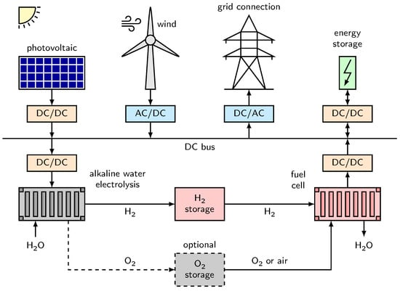

Figure 1. Renewable energy power grid. Image from J. Brauns [1,]

The localized grid may be conceptually compared to the “macro” models discussed in **Part 2** of the World Solar Guide. In these models, quantitative estimates were calculated based on an annual global energy demand of 500 EJ with 90% of the energy in the form of electricity an 10% for hydrogen production. The ideal power to produce this energy, 15.9 TW, is drastically increased to 303 TW resulting from of the assumed capacity factor of 25% and the PV-EL-FC system efficiency of 21%. The power of this model is compared with other estimates in Table 1.

This level of global power would produce 30 million tonnes (MT) of electrolytic hydrogen daily during the six-hour “day-time” period for storage which is then used by fuel cells in the 18-hour “night-time” period to power grids. In addition, 4.5 million tonnes (MT) of hydrogen would be produced daily for consumption by other sectors.

6

World Solar Guide as well as other reports consider that the annual global energy demand in 2050 will be approximately 500 EJ. Based on this projection and on other models, electric power levels may be determined. A few of these estimates are given in Table 2.

Table 2. Power requirements for world and regional energy demands.

|  |  |  |
| --- | --- | --- |
| **Source** | **2050 Estimates**  **Power, Terawatts**  **(TW, 1012 watts)** | **Ref.** |
| World Solar Guide considers global energy of 500 EJ per year,  with 90% electrical, 10% hydrogen production,  PV-EL-FC system efficiency of 21% and capacity factor of 25%.  P = 15.9 TW = 15.9 TW = 303 TW, possible over-estimate by x2  η(CF) (0.21)( 0.25) | 150-300 | World  Solar  Guide  Part 2 |
| Current infrastructure  Baseline (business as usual)  Total electrification | 180  100 +/- 20  37 | [2] |
| US NREL, Germany Fraunhofer Institute | 75 | [3] |
| Aluminum demand risk of TW PV  Require 486 million tonnes of aluminum (see WSG, **Part 4**) | 60 | [4] |
| PV polysilicon learning curve | 63 | [5] |
| BRICS (Brazil, Russia, India, China, South Africa, plus, (see Figure 2)  UAE, Saudia Arabia, Iran, Egypt, Ethiopia, Argentina)  G7 (Canada, France, Germany, Italy, Japan, UK, US, plus EU)  See Figure 4. | 11  10 | [6] |
| Report: Net Zero Australia, by Universities of Melbourne, Queensland,  and Princetion | 1.9 | [7] |
| India | 1.3-2.2 | [8] |

Although a consensus or a statistical average of these estimates is not warranted from this diverse set of estimates, it appears that a minimum of approximately 100 TW of global renewable electrical power will be required by 2050. The power requirements for the PV-EL-FC systems in the WSG model of **Part 2** will then be 100 TW, 100 TW, and 10 TW respectively for the installation projections given here in **Part 9**.

7

Silicon solar cells are considered in terms of their installed capacity [5] in Figures 2 and 3.

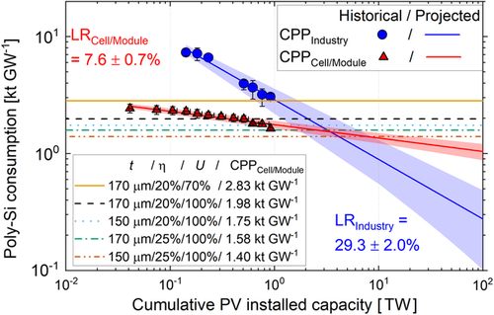

Figure 2. Poly-Si consumption vs. installed capacity. Image from [5]

Note in Figure 2 that cumulative PV installed capacity considered in the World Solar Guide ranges from 100 -300 TW.

8

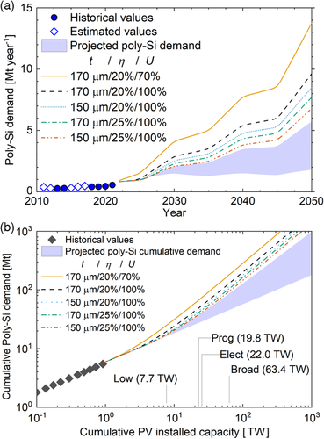

Figure 3. Poly-Si demand vs. year and installed capacity. Image from [5]

Note in Figure 3 (b) that the cumulative PV installed capacity considered in the

World Solar Guide ranges from 100 – 300 TW.

9

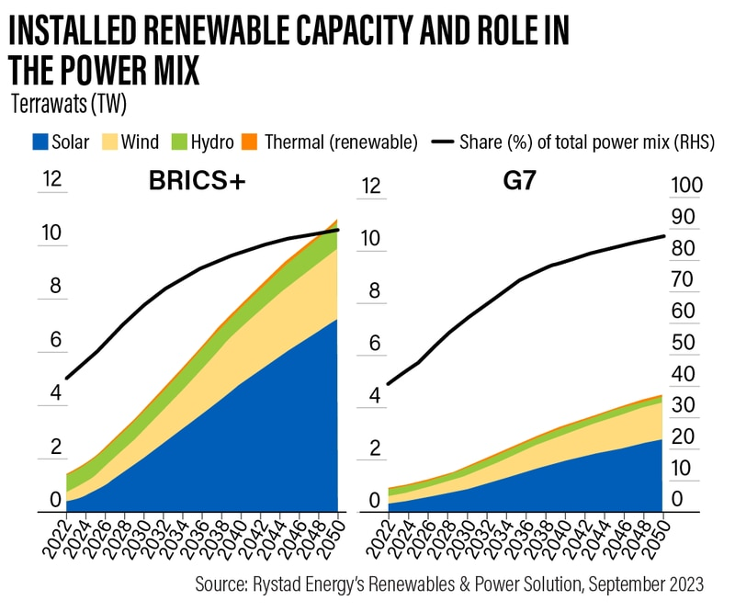

Figure 4. Projected renewable power levels of BRICS + and the G7. Image from [6]

See Table 2.

10

2.3 Electric Power Limitations

It is important to compare the required global power estimates to the power limitations imposed by the materials availabilities in the PV-EL-FC components. These power limits occur were considered earlier in **Part 4** of the World Solar Guide. A few of the limits for research materials and materials in current use are given in Table 3.

Table 3. Limiting power levels from **Part 4**.

|  |  |  |
| --- | --- | --- |
| **Photovoltaic Solar Cells PV** | **Water Electrolyzers EL** | **Hydrogen Fuel Cells FC** |
| Tables 3,4  Perovskite, Cs Sn0.5Ge0.5I3  Limited by Ge content  Thickness = 1μm  Power density = 200 W-cm-2  PL,r = 0.53 TW  ____________________________  Tables 5,6  Chalcogenide, Cu2ZnSnS4  Limited by Sn content  Thickness = 10 μm  Power density = 200 W-cm-2  PL,r = 18 TW    Tables 7, 8, 9  Limits for electrical conductors | Tables 20, 22  PEMEL  Thickness = 10 μm  Power density = 3.8 W-cm-2  Anode Cathode  IrO2 Pt  PL,r = 0.20 TW 0.47 TW  _____________________________  Tables 26, 27  SOEL Y2O3 in YSZ electrolyte  Thickness = 10 μm  Power density = 5.0 W-cm-2  PL,r = 688 TW  Page 37  Ni electrodes in ALKEL  Thickness = 100 μm  Power density = 2.0 W-cm-2  PL,r = 420 TW | Tables 21, 23  PEMFC  Thickness = 10 μm  Power density = 0.83 W-cm-2  Anode Cathode  Pt Pt  PL,r = 0.10 TW 0.10 TW  ____________________________  Tables 26,27  SOFC Y2O3 in YSZ electrolyte  Thickness = 10 μm  Power density = 1.0 W-cm-2  PL,r = 138 TW  Table 29  Perovskite LSCMN, electrodes  (La0.9Sr0.1)0.95Cr0.85MgN0.05O3  Thickness = 100 μm  Power density =  Limited by Sr content  PL,r = 402 TW  ____________________________  Table 31  Perovskite LSCMN, electrodes  Thickness = 10 μm  Power density =  Limited by La content  PL,r = 22 TW |

Although Y2O3, used as a stabilizer in the YSZ electrolyte for SOELs and SOFCs, is a **critical** material, its small concentration enables this oxide to be utilized for large power levels. Nickel, an **earth-abundant** metal, can be used effectively in both anodes and cathodes of alkaline electrolyzers, ALKELs. By contrast, IrO2 and Pt, as **critical** materials, will severely limit the installation of PEMELs and PEMFCs on the global scale. In addition, certain elements in perovskite and chalcogenide compositions will limit these products in solar PV installations.

11

2.4 Cost Estimates

Cost estimates of “Net-Zero by 2050” are given in Table 4.

Table 4.

|  |  |  |
| --- | --- | --- |
| Source | Cost Estimates  For 2020-2050. | Reference |
| McKinsey  with the Network for Greening Financial Systems (NGFS) | $275 trillion | [9] |
| IEA Net Zero by 2050  Review by Bruegel | $143 trillion | [10] |
| BNEF  Review by Bruegel | $93-173 trillion  Average $134 | [11] |
| IRENA  Review by Bruegel | $131 trillion | [12] |
| The Energy Transitions Commission | $110 trillion | [13] |
| One earth  Review of McKinsey | $45 trillion | [14] |
| Bruegel review of IEA, IRENA, BNEF scenarios | See above | [15] |

These costs refer to the “Net-Zero by 2050” scenarios which may not coincide with “total renewable energy source installations” because the fraction of renewable energy sources allowed in these “pathways” ranges from 70-100%.

Statistical-average and standard-deviation calculations of these costs give $140 +/- $75 trillion; (such measures are also used in investment portfolios with assets of the same class). Eliminating the highest and lowest values gives a cost of $130 +/- $13 trillion. It then appears likely that the total global cost of this transition will be in the range of $130-$140 over a 30-year period or $4.3-4.7 trillion per year, which is less than global annual fossil-fuel subsidies of $5 trillion.

12

2.5 Growth Rates

Projections of PV-EL-FC installations are given here based on model electric power levels and growth rates. These rates are derived using a financial calculator and the Time-Value-of-Money concept which is a form of exponential growth, where PV = Present Value and FV = Future Value. In **Part 2** of the World-Solar-Guide, the necessary power levels for these models arise from an assumed global energy use of 500 EJ per year, a capacity factor of 25%, and an overall system efficiency of 20%. The resulting powers for the PV, El, and FC components are approximately 300 TW, 300 TW, and 30 TW respectively. As discussed in the models and above, these values may be over-estimates, so that powers of 100 TW, 100 TW, and 10 TW may be more likely. The growth rates to meet 2050 power installed levels are given in Table 5.

Table 5.

|  |  |  |
| --- | --- | --- |
| PV | EL | FC |
| IEA report, global PV installations  1.18 TW, [16] | Reports of installed EL capacity  in 2022, 700 MW, [17] | Report of installed global FC  capacity: 900 MW, 2017, [18] |
| Projection  1,18 TW +/- PV, 2022  100 TW FV, 2050  28 n years  r = 17% annual growth rate | Projection  0.00070 TW +/- PV, 2022  100 TW FV, 2050  28 n years  r = 53% annual growth rate | Projection  0.00090 TW+/- PV, 2017  10 TW FV, 2050  33 n years  r = 33% annual growth rate |

From these projections, is appears that the required global installation of PV panels appears to be manageable. It may be extremely difficult to install the necessary capacities of electrolyzers and fuel cells by 2050. However, it has been reported [19] that electrolyzer growth rates for the period of 2022-2030 are expected to be 41-55%. In addition, the necessary growth rate for net-zero by 2050 is 63%. The color code of **Part 4** applies here.

2.6 Summary of Projections

The projections of earth-abundant materials development, installation rates, cost estimates, and transition plans from Tables 2, 3, 4, and 5 are summarized in Table 6.

Table 6. Summary of projections for global net-zero/solar-hydrogen installations

|  |  |  |  |
| --- | --- | --- | --- |
| Commitments and  Transition Plans | Some countries are well advanced in renewable energy sources.  Many countries have gaps in their NDC commitments and transition plans. | | |
| Cost estimates  and financial resources | $130-$140 trillion over 30 years, $4.3-$4.7 trillion annually  vs. $5 trillion annual fossil fuel subsidies  Out of $2.5 trillion current investment in energy only a fraction for renewables. | | |
| Systems/Components | PV/cells/panels | EL/electrodes/electrolytes | FC/electrodes/electrolytes |
| Minimum global power levels with earth-abundant materials | 100 TW | 100 TW | 10 TW |
| Required growth rates  for global installations | 17% | 53% | 33% |
| Overall assessment | Uncertainty concerning “net-zero,” 1.5 C limit, and 100% renewable energy installations by 2050.  Temperatures may reach 2.7 C, and renewable funding must increase substantially. | | |

13

3. Silos vs. Spectra

In pluralistic societies, organizations usually function separately and independently with exceptions such as regulations and financial funding. This arrangement may be considered here as a “silo” structure with reference to “grain silos” familiar in the agricultural sector. Schematically, these silos are represented in Figure 5.

Universities Governments Manufacturers

Figure 5. Organizations as “Silos”

By contrast, a “spectrum” is a continuum of “colors” as physically known by the Planck radiation distribution depicted in Figure 6.

Universities Governments Smaller Firms Larger Firms Larger Firms

|  |  |  |  |  |
| --- | --- | --- | --- | --- |
| Basic Research | Applied Research | Development | Manufacturing | Reclamation |

Figure 6. Organizations as “Spectral” components

Ideally, the functions of these organizations are integrated throughout the spectrum. One example of this arrangement is provided by university-industry-government collaborative programs of the US National Renewable Energy Laboratory, located in Boulder, Colorado which is part of the Department of Energy. It should be noted that governments may also contribute to the commercialization of technologies. Here, the “supply side” spectrum is considered in relation to the “demand side” of consumer energy use as discussed in previous segments of this guide.

An important addition to this spectrum is the Reclamation portion as a “feedback loop” because the development of earth-abundant materials for PV-EL-FC-EG systems will require vast amounts of these new materials on scales which may impact not only world annual production levels but also world reserves as shown in **Part 4**. Extreme caution should be exercised in these production and processing activities because not only are environment concerns important, but also the sustainability time-scale will be indefinite, unlike the fossil fuel era which will have lasted only about 300 years, less than 5% of recorded history.

In terms of land use as discussed in **Part 1**, the US requires a total PV area about the size of New Mexico, although these systems will likely be installed over numerous sections of the country. On a global scale, an area equal to 20% of the Sahara Desert will be utilized for solar PV installations. This area represents about 1% of the world land mass, but in certain regions of Europe with high population densities, for example, land use will become a major consideration in the location of these systems. Hydrogen energy storage in salt caverns and distribution by gas pipelines will also be necessary.

14

4. Manufacturers of Solar Panels, Electrolyzers, and Fuel Cells

The major manufactures of solar panels, electrolyzers, and fuel cells are shown in Table 7. These firms reside in Europe, Asia, and North America. Many countries of the G7 and G20 groups, the largest energy consumption regions, are represented here.

Table 7. Leading manufacturers of solar panels, electrolyzers, and fuel cells.

|  |  |  |
| --- | --- | --- |
| Solar Photovoltaic Panels [20] | Water Electrolyzers [21] | Hydrogen Fuel Cells [22] |
| LONGi Solar China  Kyocera Solar Japan  Trina Solar China  First Solar US  Sharp Corp. Japan  Sun Power US  Canadian Solar Inc. Canada  Junki Solar Holding China  SMA Solar Tech. Germany  Hanwha Q Cell S. Korea | Bloom Energy US  China Ship Building China  Cummins Inc. US  Enapter Italy  Green Hydrogen Systems Denmark  Haldor Topsoe A/S Denmark  H-TEC SYSTMS Germany  HydrogenPro ASA Norway  ITM Power PLC UK  John Cockerill Belgium  LONGi China  MAN Energy Solutions Germany  McPhy France  Nel ASA Norway  Ohmium Intl. Inc. US  Plug Power Inc. US  Siemens Energy AG Germany  Sunfire GmbH Germany  Sungrow Power Supply China  Thyssenkrupp nucera Germany | AFC Energy Plc UK  Ballard Power Systems Canada  Bloom Energy Corp. US  Doosan Fuel Cell Co. S. Korea  FuelCell Energy Inc. US  Intelligent Energy Ltd. UK  Panasonic Corp. Japan  Plug Power Inc. US  Power Cell Sweden Sweden  Toshiba Energy Japan |

Polycrystalline and mono-crystalline silicon continue to provide the major sources of solar PV materials. The most prominent types of stationary fuel cells are the high-temperature phosphoric acid, molten carbonate, and solid oxide (PAFC, MCFC, and SOFC) with others being the low-temperature, alkaline, anion exchange membrane, and proton exchange membrane (ALKFC, AEMFC and PEMFC). The PEMEL and PEMFC types will be limited by their electrode use of the **critical** elements, Ir and Pt. General “color rankings” of current and potential electrolyzer and fuel cell types, based on their use of critical and earth-abundant materials are shown in Table 8. The alkaline and solid-oxide electrolyzers will be prominent types.

Table 8. Electrolyzer and Fuel Cell Types.

Low Temperature High Temperature

|  |  |  |  |  |  |  |
| --- | --- | --- | --- | --- | --- | --- |
| Electorlyzer  Types | ALKEL | AEMEL | PEMEL | NA | NA | SOEL |
| Fuel Cell  Types | ALKFC | AEMFC | PEMFC | PAFC | MCFC | SOFC |

15

Additional properties of electrolyzers are shown in Table 9 [23].

Table 9.

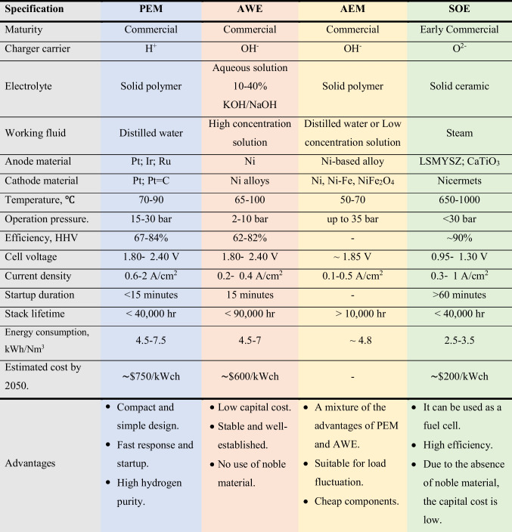

16

Table 9 (continued).

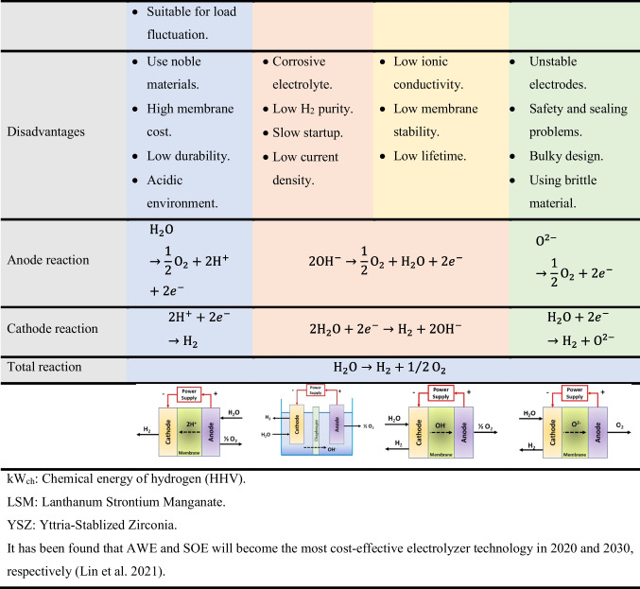

17

An electrolyzer is shown in Figure 7.

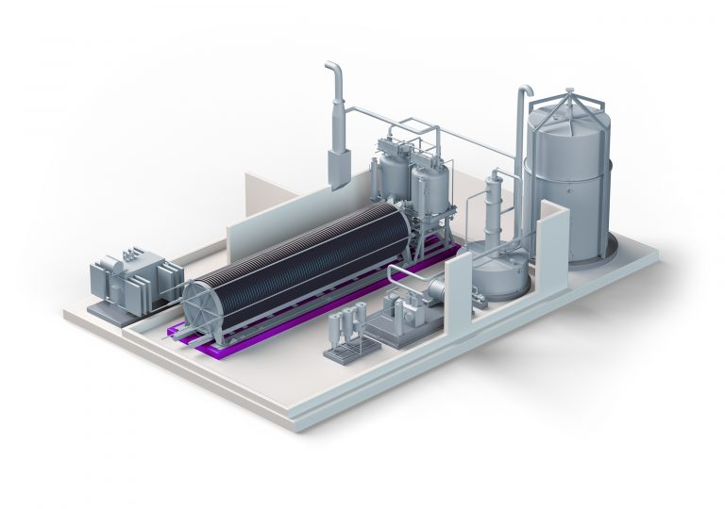

Figure 7. A water electrolyzer. Image from nelhydrogen.com

18

Manufacturers of SOFC, PEMFC, PAFC, MCFC, and ALKFC types are shown in Figure 8.

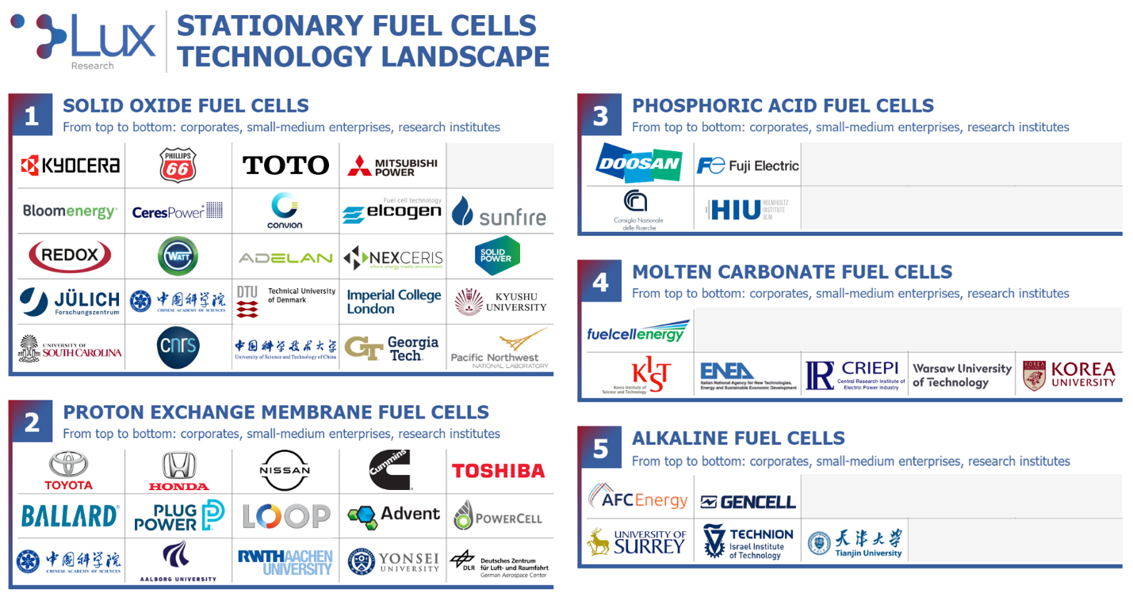

Figure 8. Fuel cell manufacturers. Image from Lux Research

19

5. Summary and Conclusions

Required electrical power levels for global PV-EL-FC installations are expected to be at least 100 TW, 100 TW, and 10 TW respectively to maintain an annual energy consumption of 500 EJ with 90% electrical and 10% hydrogen for other sectors. These estimates are less than the models discussed in **Part 2** of the WSG.

The necessary materials to construct global power levels for solar panels, electrolyzers, fuel cells, and electric grids will place extreme pressure on the production and processing of **earth-abundant** materials. A few **critical** elements and minerals such as Y2O3 will find applications in electrolyzers and fuel cells because of its low concentration, but most of these elements will be very limited in global use.

Not only will the world face pressures in the production and processing of these materials, but the time scale for energy and environmental sustainability will be indefinite, unlike the fossil-fuel era of 300 years which will have lasted less than **5%** of recorded history.

The global cost of achieving net-zero/solar-hydrogen installation by 2050 will likely be in the range of $130-$140 trillion over 30 years or $4.3-$4.7 trillion per year. The phase-out of annual fossil fuel subsidies of $5 trillion will facilitate this transition. However, as shown in **Part 7**, of the $2.5 trillion in financial transactions for energy development in 2022, only $178 million or 7% was spent on renewable sources, with the bulk of this funding going towards fossil fuels. Other sources in **Part 7** reported that of $2.2 trillion spent on energy development, $495 billion went towards renewables.

The current global installation of PV-EL-FC systems is less than 1% of the 100% required needs in 2050. A use-full “rule of thumb” for the minimum necessary annual **growth rate** of these installations over a 30-year period is 16.6%. This rate may be compared with inflation rates of 2-4%, GDP rates of 2-4%, investment portfolio rates of 5-10%. Thus, achieving this rate for solar panels alone and even high rates for electrolyzers and fuel cells over a 30-year period appears to be problematic.

Many firms, world-wide, currently produce these PV-EL-FC systems and are in good positions to expand their manufacturing capabilities to meet the 2050 requirements for net zero emissions and renewable energy on a global scale.

The research-development-production-reclamation spectrum should integrate functions of universities, governments, and manufacturers in the commercialization of renewable systems with earth-abundant materials.

Development of the materials to meet required power levels, the costs, and the necessary growth rates appear to be feasible. The primary challenge in replacing fossil fuels with renewables, as discussed in earlier segments, will be the development of the diverse and effective **transition** methods which will be specific to each country and region

20

A fundamental difference, not a distinction, should also be noted between the “net-zero CO2 emissions by 2050 pathways” and the “total (100%) renewable energy plans” as they employ different objectives, strategies, and time scales. Clearly, total renewable energy will also result in zero **excessive** **emissions** (we need a minimum of 300 ppm CO2 to avoid freezing the earth), but the converse, that net-zero will result in total renewable energy, is not true. This aspect was discussed in earlier segments. The greater uncertainties lie in the dates when these developments will be achieved which could occur in the latter half of this century.

A concluding statement regarding the global commercialization of these renewable energy resources is summarized as follows:

1. The current use of **critical elements** in electrochemical devices will severely limit these

global installations. Development of effective **earth-abundant materials** for PV-EL-FC

systems is technically feasible for estimated global power levels of these systems at 100 TW,

100 TW, and 10 TW with potential material and power limitations.

2. Public/private **financing** of the global renewable systems at a cost of $120-$140 trillion over

30 years or $4.3-4.7 trillion per year is possible with a phase-out of annual fossil-fuel

subsidies at $5 trillion facilitating this transition. However, current funding for renewable

sources is inadequate.

3. Installation of the required systems by 2050 will require **high annual growth rates** of about

16%, 50%, and 30% for the PV-EL-FC components.

4. Implementation of **effective** **transition plans** will necessitate collaboration among

universities, governments, and industries with energy and environmental sustainability for an

indefinite time-period in all countries.

21

6. References

1. Brauns, J., and Turek, T., Alkaline Water Electrolysis Powered by Renewable Energy: A Review, Processes, 2020, 8(2), 248

2. Kurtz, S., Leilaeioun, A. M., King, R. R., Peters, I. M., Heben, M. J., Metzger, W. K., and Haegel, N. M., Revisiting the Terawatt Challenge, MRS Bulletin, 45, 159-164, 2020   
3. Haegel, N. M., Verlinden, P., Victoria, M., Altermatt, P., and Bett, A. W., Photovoltaics at multi-terawatt scale: Waiting is not an option, Science, 2023, 380, 6640

4. Lennon, A., Lunardi, M., Hallam, B., and Dias, P. R., The Aluminum Demand Risk of Terawatt Photovoltaics for net-zero emissions by 2050, Nature Sustainability, 5, 357-363, 2022

5. Hallam, B., Kim, M., Underwood, R., Drury, S., Wang, L., and Dias, P., A Polysilicon Learning Curve and the Material Requirements for Broad Electrification with Photovoltaics by 2050, First published: 21 July 2022, <https://doi.org/10.1002/solr.2022022458>,

<https://onlinelibrary.wiley.com.doi/full/10.1002/solr.202200458>

6. [www.thenationnews.com/climate/the-road-to-net-zero/2023/09/23/brics-expansion-to-transform-bloc-into-a-global-renewable-leader](http://www.thenationnews.com/climate/the-road-to-net-zero/2023/09/23/brics-expansion-to-transform-bloc-into-a-global-renewable-leader)

7. [www.pv-tech.org/Australia-will-need-1-9tw-of-solar-to-reach-net-zero-by-2050-report-2022](http://www.pv-tech.org/Australia-will-need-1-9tw-of-solar-to-reach-net-zero-by-2050-report-2022)

8. [www.bp-com/central/dam/bp/by-site/energy-outlook-2023-india](http://www.bp-com/central/dam/bp/by-site/energy-outlook-2023-india)

9. [www.mckinsey.com/The-net-zero-transition/What-it-would-cost-what-it-could-bring](http://www.mckinsey.com/The-net-zero-transition/What-it-would-cost-what-it-could-bring) ,2022

10. [www.iea.org/reports/net-zero-by-2050](http://www.iea.org/reports/net-zero-by-2050) , 2021

11. [www.about.bnef.com/blog/getting-on-track-fornet-zero-by-2021-will-require-rapid-scaling-of-investment-for-energy-transition-in-next-ten-years](http://www.about.bnef.com/blog/getting-on-track-fornet-zero-by-2021-will-require-rapid-scaling-of-investment-for-energy-transition-in-next-ten-years) ,2021

12. [www.irena.org/global-renewables-outlook-2020](http://www.irena.org/global-renewables-outlook-2020)

13. Snieckus, D., <https://www.rechargenews.com/energy/transition/no-big-fundamental>- barriers-to-global-net-zero-but-$110trn-total-spending-needed-by-2050: Energy-Transitions-

Commission, 2023

14. [www.climateandcapitalmedia.com/no-mckinsey-it-will-not-cost-9-trillion-per-year-to-solve-climate-change-2022-(by-karl-burkart-one-earth)](http://www.climateandcapitalmedia.com/no-mckinsey-it-will-not-cost-9-trillion-per-year-to-solve-climate-change-2022-(by-karl-burkart-one-earth))

15. Wolff, G. B., Tagliapietra, S., and Lenaerts, K., <https://www.bruegel.org/blog-post/how-much-investment-do-we-need-to-reach-net-zero> , 2021

16. [www.iea-pvps.org/snapshot-reports/snapshot-2023](http://www.iea-pvps.org/snapshot-reports/snapshot-2023)

17. [www.hydrogencouncil.com/gap/2022/(McKinsey)](http://www.hydrogencouncil.com/gap/2022/(McKinsey))

18. Weidner, E., Global Deployment of Large-Scale Stationary Fuel Cells, JRC Technical Report/EC, 2019

19. [www.iea.org/energy-systems/low-emission-fuels/electroyzers](http://www.iea.org/energy-systems/low-emission-fuels/electroyzers) , 2022

20. [www.history-computer.com/the-largest-solar-panel-companies-in-the-world-and-what-they-do](http://www.history-computer.com/the-largest-solar-panel-companies-in-the-world-and-what-they-do) ,2022

21. www:blackridgeresearch.com/blog/list-of-global-top-hydrogen-electrolyzer-manufactureres-companies-makers-suppliers-in-the-world, 2022

22. [www.blackridgeresearch.com/blog/list-of-global-top-hydrogen-fuel-cell-hfc-companies-manufactureres-suppliers-in-the-world](http://www.blackridgeresearch.com/blog/list-of-global-top-hydrogen-fuel-cell-hfc-companies-manufactureres-suppliers-in-the-world) , 2022

23. Nasser, M., A review of water electrolysis-based systems for hydrogen production using hybrid/solar/wind energy systems, [www.ncbi-nim-nih.gov/pmc/articles/PMC 9671993](http://www.ncbi-nim-nih.gov/pmc/articles/PMC%209671993)

.