1

**World Solar Guide**

**Part 4**

**Critical Material Limitations and Research in Earth-Abundant Elements**

**Jon D. Canaday, Ph.D.**

[jon.canaday@world-solar-guide.com](mailto:jon.canaday@world-solar-guide.com)

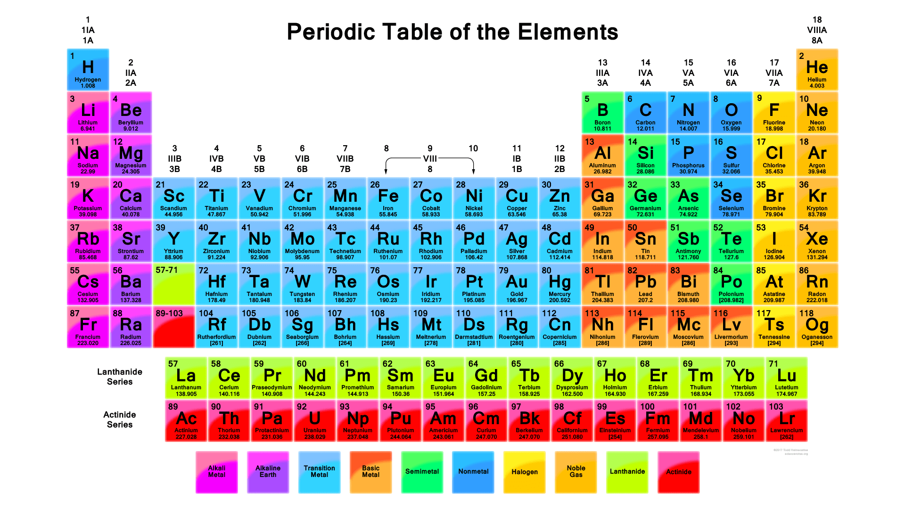

Image from sciencenotes.com

Copyright 2023 © Jon D. Canaday

2

**World Solar Guide**

**Part 4**

**Critical Material Limitations and Research in Earth-Abundant Elements**

Table of Contents Page

1. Introduction 3

2. Review of World Solar Guide Part 1 and Part 2 3

3. Methodology 4

3.1 World Energy Consumption 4

3.2 PV-EL-FC Models 4

3.3 Calculation Methods 5

3.4 Color Code 7

4. General Abundances of Earth Elements 8

4.1 Elemental Abundances 8

4.2 Geographical Abundances 10

5. Solar Photovoltaic (PV) Devices 13

5.1 Types of Devices 13

5.2 Electrical Conductors for PV Cells 16

5.3 Import/Export Factors for PV Devices 18

5.4 Research Areas 19

6. Electrolyzers (EL) and Fuel Cells (FC) 20

6.1 Elemental Abundances and Limitations 20

6.2 Import/Export Factors 24

6.3 Types of EL and FC Devices 27

6.4 Examples 28

6.5 Research Areas 39

7. Electric Grids (EG) 44

7.1 Elemental Abundances and Limitations 44

7.2 Grid Management – Smart Grids 46

8. Environmental Considerations 49

9. Materials and Devices Summaries 51

10. Projected Installation Growth Rates 56

11. Country/Region Viabilities for PV-EL-FC-EG Systems 61

12. General Summary and Conclusions 62

13. References 65

14. Appendix and Tutorial 68

3

**World Solar Guide**

**Critical Material Limitations and Research in Earth-Abundant Elements**

**Part 4**

1. Introduction

In addition to the technological and economic requirements of renewable energy as the replacement for fossil fuels to mitigate global warming, the scale of this transition necessitates careful consideration of the materials incorporated into these large systems. Not only are the elemental abundances within the earth’s crust of great importance, but their geographical locations and import/export vulnerabilities/availabilities are also significant.

2. Review of World Solar Guide **Part 1** and **Part 2**

In **Part 1** of this guide, a hypothetical world model was presented in which a photovoltaic, PV, system provided “day-time” solar power at the annual level of 2,000 hours, corresponding to a capacity factor, CF, of 23%. It was assumed that the world’s annual energy demand remained constant at 500 EJ. The geometrical area of this installation was approximately 325,000 km2.

As solar energy is variable, additional measures must be considered in order to provide a continuous, 24-hour source. **Part 2** gave a US model, as seen in Figure 9.1, with two PV input sources to a hypothetical world electric grid and a third PV source to produce hydrogen for other sector uses. This model was scaled up by a factor of five to give the world energy demand of 500 EJ per year. PV1, analogous to the PV array in **Part 1**, used a CF of 25% corresponding to six hours of solar power per day. Following a “net-zero emissions pathway” [iea] by 2050, 90% of the world’s energy electrical fraction was taken to be 90%.

The remaining energy, 75% if the total energy, was produced by two solar sources, PV2 and

PV3. PV2 developed enough power during the six-hour “day-time” period for the electrolyzer to produce hydrogen for the fuel cell in the 18-hour “night-time” period. Simultaneously, PV3 provided power for a second electrolyzer during the “day-time” to produce hydrogen for the industrial, transportation, and building sectors. The total PV area of these installations would be about 1.8 x 106 km2.

It is difficult to compare the various “net-zero emissions pathways” discussed in **Part 1** as they contain different goals and assumptions. Furthermore, it is invalid to compare these pathways to the World Solar Guide Models. Nevertheless, certain pathway criteria and projections have been adopted in the WSG Models. For example, several sources in **Part 1** have shown that the world’s annual energy demand will be approximately 500 EJ. An important consensus among the pathways is the requirement for the world’ electrification fraction to be 90% of the total energy usage. This requirement was used in the Models of **Part 2**. On the other hand, pathway projections for electrolyzer installed capacities and their associated annual green hydrogen production are much less than the values calculated in the WSG Models.

4

In economic terms, supply and demand are related through prices and quantities. Utilities attempt to “balance” or “optimize” supplies and demands for their operations. In physical terms, the supply, S, and demand, D, for energy resources were considered in **Part 2** with the concept of efficiency, where e = output/input. For a world annual energy demand output of 500 EJ, the required supply input energy is about 2,500 EJ per year when the efficiency is 20%.

3. Methodology

3.1 World Energy Consumption

During the **transition period** of 2020-2050, the world consumption of energy is taken to be a constant level 500 EJ per year. This assumption is consistent with analysis discussed in **Part 1** of this guide.

An increase in population growth, particularly among developing countries, could increase this demand. It is known that the building sector accounts for about 40% of total energy use, and the implementation of passive building measures, not considered in this guide, could significantly lower energy demand. However, this measure, like the planting of trees, would not have a large effect until the end of this century.

3.2 PV-EL-FC Models

The analyses in the World Solar Guide have been limited to PV-EL-FC systems. Other energy production methods, for example, wind, and storage devices such as batteries have not been considered. In addition, the alterative hydrogen production methods of **Part 5** have been excluded as currently insufficient for the large-scale production of hydrogen. For the purpose of estimating the natural resources required to produce the replacement of fossil fuels to renewable sources, these systems have been linearly scaled up from laboratory experiments to hypothetical regional and world levels of **Part** 1 and **Part 2**.

Macro Models – Part 1 and Part 2

In **Part 1**, a “day-time” global model was presented. Due to the variability of solar energy, hydrogen production and storage models based on electrolyzers and fuel cells were discussed in **Part 2** with scalable systems and for country/regional systems based on their assumed energy demand levels. A global model considers an annual electrical energy demand of 450 EJ and a hydrogen demand level of 50 EJ.

Micro Models – Part 4

Micro models are considered here in **Part 4** with reference to cell components. For solar PV cells, the components are the silicon irradiance absorbers and electrical contacts. Electrodes and electrolytes are discussed as utilized in water electrolyzers and hydrogen fuel cells. While a few basic cell reactions were given in **Part 2** and **Part 3**, the focus here is critical-materials limitations for these components on a global scale.

5

3.3 Calculation Methods

A serious concern of renewable energy sources is the limitation imposed by the availability of critical materials such as silver, the platinum group of metals, and the rare earth elements used in the PV cell components of photovoltaic devices and electrode components of EL and FC devices. The derivation of installation-capacity limits of electrical power considers the world’s annual production levels and/or reserves of these scarce elements. These calculations are based on basic properties of the components including chemical compositions, areas, thickness, densities, power densities, and installation powers as given in the following sections. Derivations of relevant equations are given here for the hypothetical models developed in **Part 2**. Materials used in components such as PV frames and electrochemical stacks are not considered. These components often contain earth-abundant elements such as aluminum or stainless steel.

Component material density is defined as

ρ = m (1)

V

V = At (2)

where m, V, A, and t are the component mass, volume, area, and thickness.

The density of a particular element, e, within a compound, c, such as a perovskite or oxide is

ρe = feρc

where f is the amu fraction of the element within the compound.

Consider, for example, the earth-alkaline element, Sr, in the multi-element perovskite [1],

(La0.9Sr0.1)0.95Cr0.85Mg0.1Ni0.05O3, (LSCMN), as used in solid-oxide fuel cell (SOFC) electrodes.

The concentration or density of Sr within the perovskite may be calculated by taking the ratio of atomic mass units, amu, for Sr and the perovskite. The total formula mass for this perovskite is

0.855(138.91) + 0.095(87.62) + 0.85(51.996) + 0.1((24.312) + 0.05(58.71) + 3(15.999) = 224.652 amu.

The elemental fraction of Sr within this perovskite is then,

fe = sMe 0.095(87.62) = 0.0370

Mc 224.652

where s is the site occupancy of the element. Me and Mc are the atomic masses of the element and compound respectively.

6

The densities of the perovskites, LSCMN, LM, and LSFC, are 6.40, 6.59, and 6.36 from which the average density is 6.45 +/- 0.012 g-cm-3, and the density of Sr within the perovskite is then,

ρe = feρp, or ρSr = 0.0370(6.45) = 0.239 g-cm-3.

It is also known that the electrode area is

A = P, where (3)

Dp

P is the electrical power (W), and Dp is the electrical power density (W-cm-2) of the electrode.

Combining equations (2) and (3) gives a relationship between the elemental material requirement, me, the associated electrical power,

me = ρetP (4)

Dp

Equation (4) can be utilized on the bases of annual material requirements and total material installations over a time period, for example, 30 years.

The limiting annual power installation and long-term (30-year) installations for these multi-element components can be determined by rearranging equation (4) as

PL = meDp (5)

ρet

where me is limited by available fractions (20% assumed in this guide) of the world’s annual production or total reserves. For single-element components such as nickel electrodes,

PL = mDp  (6.1)

ρt

where m is the world’s annual production or reserve fraction, and ρ is the density of the metal.

The annual and long-term power installation limits as determined by the world annual production levels and world reserves are given by (TW = terawatts, 1012 W):

PL,a = maDp, TW-yr-1 (6.2)

ρt

PL,r = mrDp, TW (6.3)

ρt

where ma and mr are the annual production level and world reserves of the metal.

7

3.4 Color Codes

A semi-quantitative color code has been employed based on the ratios of required component materials to the world 30-year annual production levels and world reserves of the chemical elements. Sector (energy, industrial, transportation, and building) analyses of material requirements have not been undertaken, but rather an arbitrary amount, 20%, of elemental usage has been allocated to the electrical energy sector, specifically, the PV-EL-FC systems. This code will also be used in later sections for electric grids (EG). The ratio of required material to the world annual production level is given in Table 1 by:

RA = annual mass of required material per year over a 30-year installation period,

20% of world annual production level

and the ratio of total required material to the world reserves is given by

RW = total mass of required material over a 30-year period.

20% of world reserves

A similar color code is provided for electrical powers in terms of potential 30-year annual installations, PA, and total world installations over a 30-year period, PW, relative to the power of 15.9 TW corresponding to the world energy annual demand of 500 EJ described in the hypothetical world model from **Part 2** of this guide. The term “critical elements” refers to scarce elements such as the rare-earths and platinum group of metals (PGM) which may also have import restrictions from other countries that affect the supply-chain of materials for solar photovoltaic cells, electrolyzers and fuel cells.

Table 1. Color code for elemental abundances and potential electric power installations.

|  |  |  |  |
| --- | --- | --- | --- |
| **Scarcity-abundance**  **of the elements** | **Materials**  **color code** | **Electric power**  **color code** | **Electric power**  **Installations** |
| Extremely scarce | RA and RW > 1.0 | PA and PW | Inadequate |
| Moderately scarce | RA and RW = 0.10 – 1.0 | PA and PW | Partially adequate |
| Moderately abundant | RA and RW = 0.010 – 0.10 | PA and PW | Generally adequate |
| Generally abundant | RA and RW < 0.010 | PA and PW | More than adequate |

8

4. General Abundances of Earth Elements

4.1. Elemental Abundances

Among the limiting factors for the replacement of fossil fuels with the renewable systems of

PV-EL-FC installations are land, materials, and cost. Certain materials in their elemental forms are considered critically limited. These limitations will occur because of their natural abundance within the earth’s mantle and because of possible export/import limits between countries. This section will discuss briefly potential limits due to export/import restrictions and then, in more detail, the limitations of PV-EL-FC components. The Earth’s most abundant elements are shown in Table 2.

Table 2. Earth’s most abundant elements.

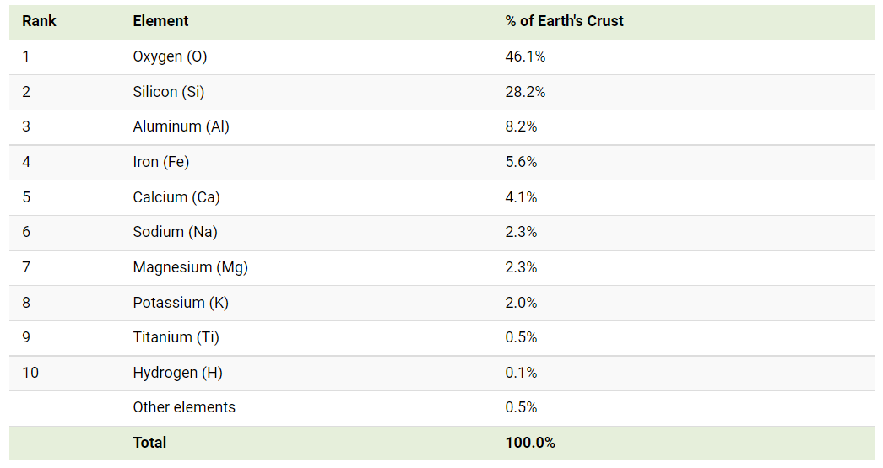

Image from World Economic Forum

9

“Rare-earth” elements have abundances comparable to the transition metals. The “rarest metals,” including the “precious metals” and “platinum group of metals” (PGM) have a lower abundance than the “rare-earths” as shown in Figure 1.

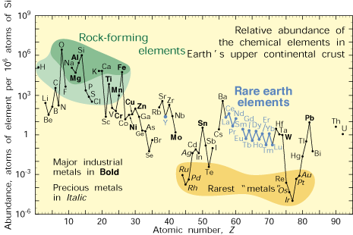

Figure 1. Comparative abundance of elements. Image from USGS.gov

A relationship between the earth’s crustal abundance of the elements and the world’s annual production of these metals [2] is shown in Figure 2.

6

Scarce Less Abundant O

elements abundant elements Si

elements Al Na

Ca Fe

Mg K

Ti Trend Line

Y Nd Ce V Sr Mn P

Li Co Zr C Ba

Ga Sm Pr Nb Ni Cr

Sc Yb Gd Zn Cu

Ge Dy Sn

Ta W Mo Pb

In Cd Bi Sb

Os Pd Ag

Pt Au

Rh Ru

5

4

3

Log 2

Crustal 1

Abundance 0

(ppm) -1

-2

-3

-4

-5

-6

0 1 2 3 4 5 6 7 8 9 10

Figure 2. Log Annual World Production (tonnes/yr)

Adapted from the Royal Society of Chemistry, 2012 [2]

These production rates can be related to the annual installation limits of PV-EL-FC components during the transition period required to achieve net-zero CO2 emissions and then to the

subsequent intervals during which fossil fuels are completely replaced by larger amounts of renewables.

10

4.2 Geographical Abundances

A map of major minerals and metals is shown in Figure 3. These deposits range in abundance from generally abundant to extremely scarce as used in PV-EL-FC systems, and their geographical distribution is clearly world-wide.

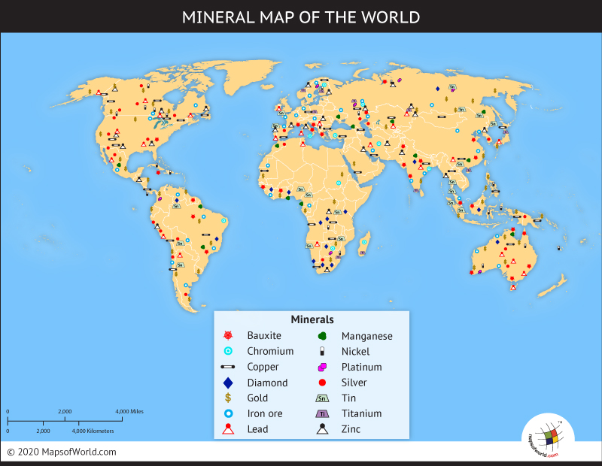

Figure 3. Map of major minerals and metals. Image from MapsofWorld.com

11

A map of rare earth deposits is shown in Figure 4.

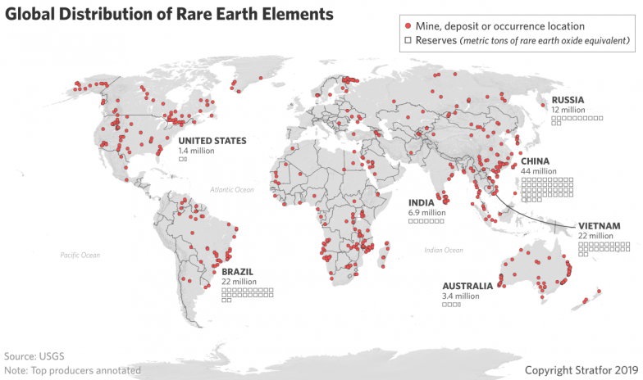

Figure 4. Rare earth deposits. Image from Stratfor.com

12

Figure 5 shows locations of the platinum group of metals.

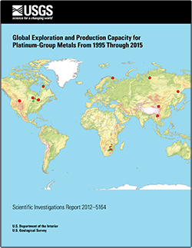

Figure 5. Platinum group of metals. Image from usgs.gov

13

5. Solar Photovoltaic Devices

5.1 Types of Photovoltaic Devices

Historically, the earliest type of cell is based on silicon in mono-and-poly-crystalline forms; they constitute 80-90% of world installations and markets.

The second type of cell is based on thin films with compositions of CdTe, copper indium gallium selenium (CIGS), or amorphous silicon which were less expensive than crystalline silicon cells. These films exhibited improved mechanical properties, although with less conversion efficiency.

A large range of cells, including perovskites, chalcogenides, dye-sensitized, organics, multijunction, quantum dots, multijunction and others form a third type of solar cell, referred to as “emerging concepts.”

In addition to materials development, other factors such as production costs play important roles in the installation of PV panels. These costs declined dramatically over the past decade, making the electrolysis of water for hydrogen production more feasible.

The US National Renewable Energy Laboratory [3,NREL] has developed a detailed graph showing the conversion efficiencies of several types of solar PV cells as shown in Figure 6. The basic classes of these cells are multijunction, single junction, crystalline silicon, thin film, and emerging. Sub-classes within these groups are also given. It is seen that the efficiencies of all classes have increased substantially since 1975.

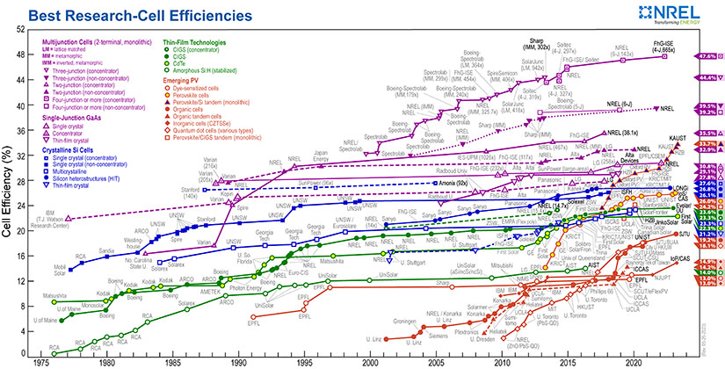

Figure 6. Conversion efficiencies of solar-cell types. Image from NREL

14

Two examples of solar cells are shown from the perspective of materials availability.

The general chemical formulation of perovskites is ABX3. This class of solar PV cells has been described as exhibiting higher efficiencies and lower costs that its silicon counterparts. However, these materials, with efficiencies in the range of about 20-25% may contain lead, an environmentally unacceptable element. Lead-free perovskite materials have been reviewed for use in solar cells [4 m wang].

The perovskite, CsSn0.5Ge0.5I3, has been described as a stable and efficient, inorganic, lead-free perovskite [5]. Using amu ratios, the elemental material requirements can be calculated for this world-size panel as shown in Table 3.

Table 3. Ratios of annual requirements and reserves for perovskite solar cells.

|  |  |  |  |  |  |  |
| --- | --- | --- | --- | --- | --- | --- |
| Element | World  requirement  (tonnes) | Annual world  requirement  per 30 years  (tonnes-yr-1) | Annual  world  production  (tonnes-yr-1) | World  reserves  (tonnes) | Ratio of annual world requirement  to one-year world production | Ratio of world requirement to world reserves |
| Cesium | 2.14 MT | 71KT | 45 T | 350 KT | 1.6 | 6.1 |
| Tin | 0.96 MT | 32KT | 378 KT | 5.5 MT | 0.085 | 0.17 |
| Germanium | 0.58 MT | 19KT | 140 T | 8.6 KT | 137 | 67 |
| Iodine | 6.11 MT | 204KT | 32 KT | 6 MT | 6.3 | 1.0 |
| T = tonnes  KT = kilo-tonnes  MT = mega-tonnes |  |  |  |  |  |  |

From Table 4, it can be seen, that with the exception tin, this perovskite is not readily available on the bases of both annual world production and world reserves. In addition, tin itself would not be fully available relative to its annual world production.

Equation (6.3) can be used to estimate the electrical power produced as limited by this perovskite with an elemental amu fraction of 0.103, density of 6.5 g-cm-3, and thickness of 100 μm as limited by its world reserves of germanium element and shown in Table 4.

PL,r = mrDp = (0.20) (8.6 KT) (200 W-m-2) = 5.3x10-3 TW. (7)

ρet (0.65 g-cm-3) (100 μm)

The limiting powers for other thickness are shown in Table 4.

Table 4. 30-year power, P30(TW) for the perovskite limited by its germanium content.

|  |  |  |  |
| --- | --- | --- | --- |
|  | t = 1μm | t = 10μm | t = 100μm |
| Dp = 200 W-cm-2 | 0.53 TW | 0.053 TW | 0.0053 TW |

Therefore, this perovskite would not be able to provide the necessary global solar PV power of about 100 TW for electrolyzers even at the thickness of 1μm.

15

The chalcogenide group of perovskites which is lead-free has also been investigated for PV use. Consider a world solar panel area of 1.5 x 106 km2 with a 1μm thick perovskite absorber layer. The volume of this material is 1.5 x 106 m3. Taking the value of 6.5 g-cm3 as an average perovskite density, the required global material is 9.8 x 106 tonnes. Using amu ratios of the compositions as shown in Section 3.3, elemental mass requirements can be calculated.

The chalcogenide, Cu2ZnSnS4 (CZTS), is an earth-abundant composition, except for tin, used for thin-film solar cells [6]. Again, using world panel properties from above and amu ratios, the required elements and ratios are given in Table 5.

Table 5. Abundance of chalcogenide, CZTS, elements.

|  |  |  |  |  |  |  |
| --- | --- | --- | --- | --- | --- | --- |
| Element | World  Requirement  (tonnes) | Annual  world  requirement per 30 years  (tonnes-yr-1) | Annual  world  production  (tonnes-yr-1) | World  Reserves  (tonnes) | Ratio of  annul world  requirement  to one-year  world  production | Ratio of  world requirement  to world  reserves |
| Copper | 1.67MT | 0.056MT | 21MT | 870MT | 0.0027 | 0.0019 |
| Zinc | 1.78MT | 0.059MT | 12MT | 250MT | 0.0049 | 0.0071 |
| Tin | 3.12MT | 0.10MT | 378KT | 5.5MT | 0.26 | 0.57 |
| Sulfur | 3.32MT | 0.11MT | 63MT | 600MT | 0.0017 | 0.0055 |
| T = tonnes  KT = kilo-tonnes  MT = mega-tonnes |  |  |  |  |  |  |

This chalcogenide has a power limited by the world reserves of its tin composition with an elemental amu fraction of 0.270, density of 4.5 g-cm-3, and thickness of 100 μm.

From Equation (6.3),

PL,r = mrDp = (0.20)(5.5 MT)(200 W-m-2) = 1.8 TW.

ρet (1.22 g-cm-3) (100 μm)

As seen in Table 6, about one quarter of the annual tin production and one half of the world’s tin reserves would be required for this chalcogenide to be used as a global solar absorber. The other elements would be earth abundant. Power limitations for other thicknesses of tin are shown in Table 6.

Table 6. 30-year power for the chalcogenide, CZTS, limited by its tin content and thicknesses.

|  |  |  |  |
| --- | --- | --- | --- |
|  | T = 1μm | t = 10μm | t = 100μm |
| Dp = 200 W-m-2 | 180 TW | 18 TW | 1.8 TW |

**The important result from Table 6 is that the chalcogenide, CZTS, would be able, based on its elemental earth-abundances, to provide the necessary global solar PV power (minimum of 100 TW) to operate the water electrolyzers for hydrogen production.**

16

5.2 Electrical Conductors for PV Cells

Silver is a scarce precious metal with known world reserves only 7.5 times those of platinum. The areal density of silver required for PV electrical contacts is about DM = 10 gm-m-2 or 10 tonnes-km-2 [7 we recycle]. With 20% of the world’s annual production level of 27,000 tonnes over a period of 30 years, the mass of silver used is M = 162,000 tonnes, giving a panel area limited to:

AL = M = 162,000 T = 16,200 km2 (9)

DM 10 T-km-2

This area represents only about 1% of the global PV area of 1.8 x 106 km2,uses 18 million tonnes and would use one-third of the world’s total silver reserves. A density of 10 tonnes-km-2 over 1.5x106 km2 results in a world requirement of 15M tonnes. Clearly, alternative metals such as copper and/or aluminum must be utilized as shown in the following calculations.

The masses of copper and aluminum as used for PV electrical contacts can be determined from their conductivities, σ, and densities, ρ, relative to those of silver as follows:

mCu = mAg σAgρCu = mAg(6.30x107 S-m-1) (8.96 g-cm-3) = mAg(0.903) = 15 MT( 0.903) =14 MT

σCuρAg  (5.96x107 S-m-1) (10.49 g-cm-3)

with a similar relation for aluminum, giving mAl = mAg(0.463) = 6.9 MT

These results, together with requirement ratios to 20% of annual world production and world reserves are given in Table 7.

Table 7. Comparison of metal abundances for PV electrical contacts.

|  |  |  |  |  |  |  |
| --- | --- | --- | --- | --- | --- | --- |
| Metal  Conductors | Annual world  requirement  Per 30 years  (tonnes-yr-1) | Total world  requirement  over 30 years  (tonnes) | Annual world  production  (tonnes-yr-1)  20%  allocation | World  reserves  (tonnes)  20% allocation | Ratio of annual requirement  to one-year annual world  production | Ratio of  world  requirement  to  world  reserves |
| Silver | 0.50MT | 15 MT | 27KT | 530KT | 93 | 142 |
| Copper | 0.45MT | 14 MT | 20MT | 870MT | 0.12 | 0.080 |
| Aluminum | 0.23 MT | 6.9 MT | 65 MT | 50 BT | 0.018 | 0.00070 |
| T = tonnes  K = kilo  M = mega  B = giga |  |  |  |  |  |  |

17

The potential replacement of copper by aluminum is shown in Table 8.

Table 8. Copper and aluminum projections for electrical contacts in PV arrays.

|  |  |  |  |  |  |  |
| --- | --- | --- | --- | --- | --- | --- |
| Metal | Annual world  requirement  per 30 years  (tonnes-yr-1) | Total world  requirement  over 30 years  (tonnes) | Annual world  production  (tonnes-yr-1) | World  reserves  (tonnes) | Ratio of  annual requirement to  annual world  production | Ratio of  world  requirement  to world reserves |
| Copper | 1.4 MT | 10-20 MT | 20 MT | 870 MT | 0.070 | 0.011-0.022 |
| Aluminum | 5.7 MT | 100-190 MT | 65 MT | 50 BT | 0.088 | 0.0020-0.0038 |

Additional metals may be considered and are shown with assumed smaller world requirements of 30 M tonnes and 20% allocations as ranked by their electrical conductivities in Table 9 [8].

Table 9. Properties of potential PV electrical conductors.

|  |  |  |  |  |  |  |  |
| --- | --- | --- | --- | --- | --- | --- | --- |
| **Metal** | **Electrical**  **conductivity**  **σ (S/m)** | **Annual**  **Requirement**  **per 30 years**  **(tonnes-yr-1)** | **World**  **requirement**  **(tonnes-)** | **Annual**  **world**  **production**  **(tonnes-yr-1)** | **World**  **reserves**  **(tonnes)** | **Ratio of**  **annual**  **requirement**  **to annual**  **production** | **Ratio of world requirement to world reserves** |
| Silver | 6.30x107 | 1M | 30M | 27K | 530K | 185 | 285 |
| Copper* | 5.96x107 | 1M | 30M | 20M | 870M | 0..25 | 0.17 |
| Gold | 4.10x107 | 1M | 30M | 3.5K | 54M | 1,430 | 2.8 |
| Aluminum | 3.50x107 | 1M | 30M | 65M | 50B | 0.075 | 0.0030 |
| Tungsten* | 1.79x107 | 1M | 30M | 84K | 3.7M | 60 | 41 |
| Molybdenum* | 1.79x107 | 1M | 303M | 275K | 25M | 18 | 6.0 |
| Cobalt* | 1.70x107 | 1M | 30M | 140K | 7M | 36 | 0.70 |
| Zinc* | 1.69x107 | 1M | 30M | 13M | 250M | 0.39 | 0.60 |
| Nickel* | 1.43x107 | 1M | 30M | 2.5M | 94M | 2.0 | 1.6 |
| Iron* | 1.00x107 | 1M | 30M | 2.4B | 170B | 0.0021 | 0.00090 |
| Tin* | 9.17x106 | 1M | 30M | 378K | 5.5M | 13 | 28 |
| Chromium* | 7.90x106 | 1M | 30M | 41M | 200M | 0.12 | 0.75 |
| Titanium* | 2.38x106 | 1M | 30M | 8M | 690M | 0.65 | 0.22 |
| Stainless steel  90% iron  10% chromium | 1.45x106 | 0.9M  0.1M | 27M  3M | 2.4B  41M | 170B  200M | 0.0019  0.012 | 0.00080  0.075 |
| *These metals are  also used for EL, FC  electrodes in  different quantities. |  |  |  |  |  |  |  |

As seen in Table 9, even with lesser amounts of these conductors, only a few of these metals will provide sufficient abundances for global PV installations. Their conductivities are also much less than those of silver, copper, and aluminum. Electrical conductors are discussed further for electric grid applications in Section 7.

18

5.3 Import/Export Factors for PV Devices.

The International Energy Agency addressed the issue of ensuring the solar PV security of supply on a global basis [9]. Policy action areas (WSG strategies **Part 8**) are summarized in Table 10.

Table 10. Solar PV global supply chain policy action areas.

**Diversify manufacturing and raw materials supplies**

- Move solar PV supply chain diversification up the policy agenda.

- Consider industrial policy for open markets which avoids trade barriers.

- Locate manufacturing facilities in industrial clusters to lower energy demand.

- Diversify material and PV import routes to reduce supply chain vulnerabilities.

**De-risk Investment**

* Facilitate manufacturing investment through finance and tax policies.
* Tailor demand policies for sustainability across supply chains.
* Encourage public-private collaborations with research labs to catalyze investments.

**Ensure environmental and social sustainability**

* Strengthen international cooperation for environmental standards.
* Focus on skills development and employment standards.
* Ensure manufacturing facilities adopt low-carbon, material-efficient practices.

**Continue innovation**

* Expand R&D funding to improve PV conversion efficiency and reduce cost.
* Promote process technology that reduces critical materials use of silver and copper.

**Develop and strengthen recycling capabilities**

* Establish requirements for reclamation and recycling.
* Support efforts to improve panel design for recycling, reuse, and greater durability.

19

5.4 Solar PV Research

Solar PV research is discussed in **Part 1** of this guide. A brief further discussion is given here.

As presented in **Part 2** of this guide, the global solar PV requirement by 2050 will be approximately 300 TW. This level may be an over-estimate by a factor of two as energy-savings measures such as passive buildings and other supply/demand factors were not considered. However, another estimate [10] gives a power of **100 TW** for a meaningful contribution to renewable energy sources and the reduction of atmospheric warming. Therefore, it seems likely that the global power requirement will be within the range of 100-150 TW.

Crystalline silicon was found to be a feasible panel material if silver contacts can be replaced by copper or aluminum. Calculations of these factors were given in Section 5.2.

Other compositions such as CdTe and CIGS were considered as problematic. Here, cadmium is a toxic element and tellurium is extremely scarce. Similarly, indium and gallium are scarce elements.

It was concluded that the only current technology capable of producing 100 TW of electrical power is amorphous silicon.

Suggestions for additional materials was given in terms of earth-abundant elements as seen in the periodic table as reconstructed in Table 11. Perovskites and metal chalcogenides were considered as feasible compositions for TW-scale installations. Examples of such an application ware given in Section 5.1 above.

Table 11. Earth-abundant elements for solar-cell applications.

|  |
| --- |
| Earth-abundant elements for solar-cell applications [10] |
| IA IIA IVB VB VIB VIIB VIIIB VIIIB IB IIB IIIA IVA VA VIA VIIA |
| H  B C N O F  Na Mg Al Si P S Cl  K Ca Ti V Cr Mn Fe Ni Cu Zn Br  Zr  Ba Pb  Perovskite  Pb-free  screened Mn Ni  elements M wang []  Transition  elements Fe Cu |

20

6. Electrolyzers (EL) and Fuel Cells (FC)

6.1 Elemental Abundances and Limitations

Critical and earth-abundant elements used in renewable energy devices are shown in Table 12.

Table 12. Periodic table of the elements for US PV-EL-FC materials

with earth-crust concentrations in ppm and color code.

Table from en.wiki.org/abundance of elements [11].

IA IIA IIIB IVB VB VIB VIIBVIIIBVIIIB VIIIB IB IIB IIIA IVA VA VIAVIIAVIIIA

|  |  |  |  |  |  |  |  |  |  |  |  |  |  |  |  |  |  |
| --- | --- | --- | --- | --- | --- | --- | --- | --- | --- | --- | --- | --- | --- | --- | --- | --- | --- |
| H2 |  |  |  |  |  |  |  |  |  |  |  |  |  |  |  |  |  |
|  |  |  |  |  |  |  |  |  |  |  |  |  | C-G*  200 |  | O2 | F  590 |  |
|  |  |  |  |  |  |  |  |  |  |  |  | Al  82k | Si-C  282k |  |  | Cl  100 |  |
|  |  |  | Ti  5700 |  | Cr  100 | Mn  950 | Fe  56k | Co  25 | Ni  100 | Cu  60 |  |  |  |  |  |  |  |
|  | Sr*  370 | Y*  33 | Zr  170 |  | Mo  1.2 |  |  |  |  | Ag  0.075 |  |  |  |  |  | I  0.45 |  |
|  | Ba | La*  39 |  |  |  |  |  | Ir*  0.0010 | Pt*  0.0050 |  |  |  | Pb  14 |  |  |  |  |
|  |  |  |  |  |  |  |  |  |  |  |  |  |  |  |  |  |  |
|  |  |  | Ce |  |  |  |  |  |  |  |  |  |  |  |  |  |  |
|  |  |  |  |  |  |  |  |  |  |  |  |  |  |  |  |  |  |

|  |  |  |  |  |  |  |
| --- | --- | --- | --- | --- | --- | --- |
|  | Rare, expensive,  or import  vulnerability;  C-G = carbon  and graphite;  Si-C = crystalline  Silicon;  *DOE  EL/FC supply chain  critical materials [DOE] | High  import  vulnerability | Low  import  vulnerability | H2 and O2  from water  electrolysis;  H2 as  fuel-cell  input | Pb toxic and  unusable in  PV-EL-FC  Perovskites | Halogens  for EL/FC  perovskites |
| Color  Code |  |  |  |  |  |  |

21

The US Department of Energy presented supply-chain consumption levels of elements as a function of import reliance [12] as reproduced in Figure 6.

10,000 Critical materials

Ir

Y

Pt La

Graphite

Sr

1,000

100

Projected

annual

demand 10

as percentage

of annual Ti Zr

consumption 1 Ni

0.1

S.S. Co Fe

0.01

Mn

0.00

0 20 40 60 80 100

2020 import reliance as a percentage of apparent consumption

Figure 6. Ranges of projected material demand as a percentage

of annual U.S. consumption and U.S. import reliance

for key electrolyzer (EL) and fuel cell (FC) materials.

Image reconstructed from US DOE supply chain report [12].

22

Table 13 gives estimates of power requirements for US and world models.

Table 13.

|  |  |  |  |  |
| --- | --- | --- | --- | --- |
| Models | Total Power  (TW) | PV Power  (TW) | EL Power  (TW) | FC Power  (TW) |
| WSG, Part 2, World Model | 290 | 290 | 290 | 28 |
| WSG, Part 2, US Model (20% world) | 58 | 58 | 58 | 5.7 |
| Other World Models (“Consensus”) | 100 | 100 | 100 | 10, estimate |
| Other US Models (20% of world) | 20 | 20 | 20 | 2, estimate |
| DOE World Model [] | NA | NA | 6.10 | 0.90 |
| DOE US Model [] | NA | NA | 1.04 | 0.053 |

In Table 14, ratios of annual use and cumulative use over 30 to world annual production levels and reserves for **critical** and **earth-abundant** elements are calculated.

Table 14. US DOE electrolyzeer and fuel cell supply chain [13]

|  |  |  |  |  |  |  |  |  |
| --- | --- | --- | --- | --- | --- | --- | --- | --- |
| Element | DOE US  Model  Annual Use  US  US  Tons-yr-1 | DOE US  Model  Cum. Use, US  30 years  Graphical  Data [doe]  US by 2050  Tons | Annual  World Prod.  Metric  Tonnes-yr-1 | World  Reserves  Metric  Tonnes | 20% Ann.  World Prod  To EL&FC  20% Ann.  World Prod  To US  4% total to EL&FC | 20% World  Reserves  To EL&FC  20% World  Reserves  To US  4% total to  EL&FC | Ratio  Annual use  To 4%  EL&FC | Ratio  Cum. Use  30 years  To-4%  EL&FC |
| Titanium | 4,000 | 120,000 | 9.9 M | 650 B | 396 K | 40 M | 0.010 | 0.0030 |
| **Iridium** | 10 | 300 | 8 | 1,300 | 0.32 | 52 | 31 | 5.8 |
| **Platinum** | 37 | 1,100 | 190 | 34,000 | 7.6 | 136 | 0.67 | 1.1 |
| Graphite | 667 | 20,000 | 1,330 K | 330 M | 53 K | 13 M | 0.013 | 0.0015 |
| Nickel | 1,000 | 30,000 | 2.8 M | 100 M | 112 K | 4 M | 0.0059 | 0.0050 |
| Iron | 20 | 600 | 2.6 B | 209 B | 100 M | 8.4 B | 2.3x10-7 | 8.3x10 -8 |
| S.S.  90% Fe  10% Cr | 20,000  18,000  2,000 | 600,000  540,000  60,000 | 2.6 B  41 M | 209 B  200 M | 100 M  1.6 M | 8.4 B  8.0 M | 1.8x10-4  1.3x10-3 | 6.4x10-5  7.5x10-3 |
| **Lanthanum** | 100 | 3,000 | 12.5 K | 6 M | 500 | 240 K | 0.13 | 0.0083 |
| Strontium | 17 | 500 | 140 K | >1 B | 5.6 K | 40 M | 0.00342 | 1.8x10-5 |
| Cobalt | 7 | 200 | 190 K | 8.! B | 7.6 K | 324 M | 9.2x10 -4 | 6.2x10-7 |
| **Yttrium** | 67 | 2,000 | 12 K | 500 K | 480 | 20 K | 0.14 | 0.10 |
| Zirconium | 370 | 11,000 | 1.2 M | 64 M | 48 K | 2.6 M | 7.7x10-3 | 4.2x10 -3 |
| Manganese | 23 | 700 | 19 M | 1.7 B | 760 K | 68 M | 1.7x10-5 | 5.7x10 -6 |

From Table 14, all the elements for electrolyzers and fuel cells would be generally abundant in terms of US annual use and cumulative use over a 30-year period with the following exceptions:

1. **Iridium** is extremely scarce annually and over 30 years.
2. **Platinum** is moderately scarce annually and extremely scarce over 30 years.
3. **Lanthanum** is moderately scarce annually.
4. **Yttrium** is moderately scarce annually and over 30 years

Similar calculations at the global level are given in Tables 20-38.

23

Minor discrepancies arose in the analysis of Table 14. The US DOE data were given graphically, and interpolation was employed to obtain digital results. Also, these data were also presented in terms of US tons (2,000 pounds), while annual world production and reserves data were in metric tonnes (1,000 kilograms or 2,200 pounds). Annual world production and reserves data are also estimates. These data may be given in terms of their oxides or ores rather than elemental values. The 20% allocation of annual production levels and reserves to electrolyzer and fuel-cell use is an arbitrary number. Nevertheless, some critical elements are clearly large fractions relative to annual productions and reserves; the world ratios will be about five times the US values. It is evident that the PEM cells with PGM catalysts cannot be produced at the required levels. As will be shown in Table 23, PEMFCs with PGM catalysis can power only approximately 5% of new vehicles. In addition, yttria as a stabilizer for zirconia SOELs and SOFCs will be unavailable for large-scale installations of these solid oxide cells. The US import reliance of most elements in Table 16 (and other similar references) as shown in Figure 6 was not considered as a limiting factor in these calculations.

Thus, the only device which appears to contain earth-abundant elements for large-scale installation is the alkaline electrolyzer with nickel electrodes. These results are consistent with the DOE graph reproduced in Figure 6 except graphite and strontium which appear to be generally abundant for these applications.

24

6.2 Import/Export Factors for the US

The import reliance of the US for its critical elements based on the elemental grouping of Figure 2 is shown in Table 15 [14].

Table 15. US import reliance of renewable-energy chemical elements.

|  |  |  |
| --- | --- | --- |
| Elements | US Net Import Reliance as a  Percentage of Consumption | Primary Import Source |
| **Critical/Scarce** |  |  |
| Arsenic | 100 | China |
| Gallium | 100 | China |
| Germanium | 50 | China |
| Graphite (natural) | 100 | China |
| Indium | 100 | Republic of Korea |
| Palladium | 26 | Russia |
| Platinum | 66 | South Africa |
| Rare Earths | 95 | China |
| Scandium | 100 | Europe |
| Tantalum | 100 | China |
| **Less Abundant** |  |  |
| Cobalt | 76 | Norway |
| Lithium | 25 | Argentina |
| Niobium | 100 | Brazil |
| Yttrium | 100 | China |
| **Abundant** |  |  |
| Aluminum | 75 | Jamica |
| Antimony | 83 | China |
| Bismuth | 96 | China |
| Chromium | 83 | South Africa |
| Magnesium | 50 | Israel |
| Manganese | 100 | Gabon |
| Nickel | 56 | Canada |
| Tin | 77 | Peru |
| Titanium | 95 | Japan |
| Tungsten | 50 | China |
| Zinc | 76 | Canada |
| Zirconium | 50 | South Africa |

From Table 15, it is seen that replacement of the critical elements with those which are earth-abundant still results in a large import dependence. This dependance will be similar for countries other than the US.

25

Rare-earth production by country [15] is given in Table 16.

Table 16. Countries producing rare earth metals

|  |  |  |  |
| --- | --- | --- | --- |
| Countries producing rare-earth metals  Rank by  World Reserves | Country | Annual Production  (Tonnes-year-1) | World Reserves  (Million tonnes) |
| 1 | China | 210,000 | 44 |
| 2 | Viet Nam | 400 | 22 |
| 3 | Brazil Russia | 80  2,700 | 21 |
| 4 | India | 2,900 | 6.9 |
| 5 | Australia | 18,000 | 4.0 |
| 6 | United States | 43,000 | 1.8 |
|  | Myanmar | 12,000 | NA |
|  | Thailand | 7,100 | NA |
|  | Madagascar | 960 | NA |
|  | World totals | 297,140 | Approx 100 |

The geographical production of the platinum group of metals (PGM) is shown in Table 17.

Table 17. Countries producing platinum group of metals (PGM) [16].

|  |  |  |  |
| --- | --- | --- | --- |
| Rank by  World Reserves | Country | Annual Production  (Tonnes-year-1) | World Reserves  (Tonnes) |
| 1 | South Africa | NA | 63,000 |
| 2 | Russia | NA | 3,900 |
| 3 | Zimbabwe | NA | 1,200 |
| 4 | United States | NA | 900 |
| 5 | Canada | NA | 310 |
|  | Others | NA | NA |
|  | World totals | NA | 70,000 |

From Tables 16 and 17, as well as Figures 1 and 2, it is apparent that the abundance of the PGM is much less than that of the rare earths.

26

Figure 7 illustrates countries which produce the largest amounts of fossil fuels and selected minerals which are used in renewable energy.

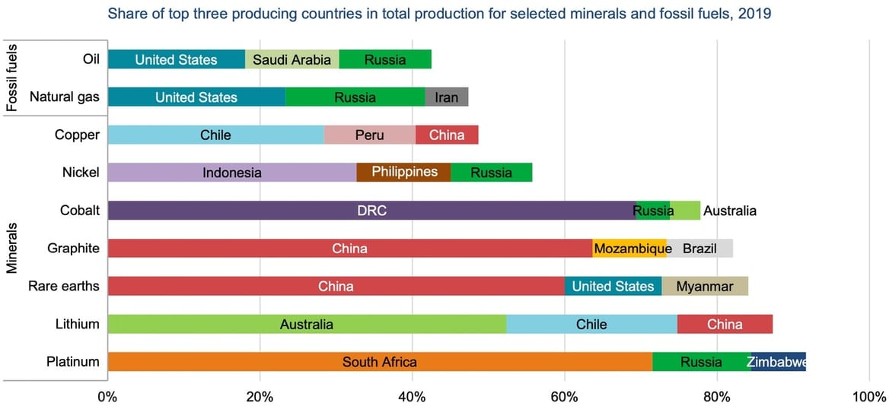

Figure 7. Figure from canarymedia.com/clean-energy-minerals

27

6.3. Types of EL and FC Devices

Electrolyzers and fuel cells can be classified according to their electrolyte types

The abundances or scarcity of electrolyte and electrode materials as used in current ELs and FCs are shown in Table 18.

Table 18. Electrolyzer and fuel cell properties (Part 2).

|  |  |  |  |  |  |  |  |  |
| --- | --- | --- | --- | --- | --- | --- | --- | --- |
| **Electrolyzer**  **Systems** | **ALKEL** | **AEMEL** | **PEMEL** | **PAEL** | **MCEL** | **0-SOEL** | **H-SOEL** | **H-O-SOEL** |
| Temperature | 100 | 80 | 80 | NA | 650 L Barelli | 800-1,000 | 300-600 | 300-600 |
| Mobile ions | OH- | OH- | H+ |  | CO3 -2 | O2- | H+ | H+ , O2- |
| Electrolyte | KOH | Ionomers | Nafion types |  | Li2CO3/K2CO3 | YSZ | Rare earths* | Rare earths* |
| Anode | NiCo | Ni-Fe-Mo | IrO2, Ru |  | Ni allays | LSCF | Rare earths* | NA |
| Cathode | NiMo | Ni-Fe-Co | Pt |  | Li-NiO | Ni-YSZ | Rare earths* | NA |
|  |  |  |  |  |  |  |  |  |
| /////////////// |  |  |  |  |  |  |  |  |
| **Fuel cell**  **Systems** | **ALKFC** | **AEMFC** | **PEMFC** | **PAFC** | **MCFC** | **O-SOFC** | **H-SOFC** | **H-O-SOFC** |
| Temp | 100 | 60-80 | 80 | 200 | 650 | 800-1,000 | 300-600 | 300-600 |
| Mobile ions | OH- | OH- | H+ | H + | CO3 2- | O2- | H+ | H+, O2- |
| Electrolyte | KOH | Ionomers | Nafion types | H3PO4 | LiCO3/K2CO3 | YSZ | Rare earths* | Rare earths* |
| Anode | Pt | Pt | Pt | Pt | Ni alloys | Ni-YSZ | Rare earths* | NA |
| Cathode | Pt | Pt | Pt, PtNi, PtCo | Pt alloys | NiO | Rare earths* | Rare earths* | NA |
|  |  |  |  |  |  |  |  |  |

Features of ELs and FCs are shown in Table 19. It can be noted that the ALKEL (alkaline electrolyzer) is the only current type which has a significant hydrogen production rate and is also at the commercial stage of development.

Table 19. Comparison of EL and FC features (Part 2).

|  |  |  |  |  |  |
| --- | --- | --- | --- | --- | --- |
| **Electrolyzer systems** | **ALKEL** | **AEMEL** | **PEMEL** | **MCEL** | **0-SOEL** |
| Efficiency (%) | 63 |  | 65 | 70 | 80 |
| Energy consumption  (KWh-Nm-3) (H2) | 4.5-6.6 |  | 4.2-6.6 | >3.4 | >3.7 |
| Available H2 production rate  (Nm3-h-1) | <760 |  | <40 | - | <40 |
| TRL/CRI rank [Oxford] (4 = AEMEL) | 1 | 4 | 2 | 5 | 3 |
| /////////////////////////////////////// | /////////////////// | //////////////// | /////////////////// | //////////////// | ////////////////// |
| **Fuel cell systems** | **ALKFC** | **AEMFC** | **PEMFC** | **MCFC** | **O-SOFC** |
| Efficiency (%) | 60 |  | 48 | 55 | 56 |
| Power density (W-m -2) | 1,500-4,000 |  | 3,000-10,000 | 1,000-3,000 | 2,500-3,500 |
| Capital costs (Euro-KW-1) | 1,000-2,000 |  | 1,860-2,300 | >1,500 | >2,000 |

Based on considerations of both current critical materials limitations and operations as shown in Tables 89 and 19, the following results appear:

1. The only currently viable water electrolyzer for net-zero applications is the ALKEL system.
2. The only currently viable hydrogen fuel cell for net-zero applications is the MCFC system.

28

6.4 Examples

In order to consider material requirements for the world-scale installation of EL-FC systems, hypothetical cell components were evaluated from the models of **Part 2**. The ratios were based on the assumed availability of 20% annual world production and 20% world reserves.

6.4.1 Platinum Group of Metals

Examples of material limits for the PGM in electrolyzers and fuel cells are shown in Tables 20 and 21.

Table 20. Electrolyzer PEMEL

|  |  |  |
| --- | --- | --- |
|  | Anode | Cathode |
| Electrode composition | IrO2 | Pt |
| Electrode loading, L (mg/cm2) | 2.0 | 1.0 |
| Cell voltage, V (V) | 1.9 | 1.9 |
| Current density, J (A/cm2) | 2.0 | 2.0 |
| Power density, Dp = JV (W/cm2) | 3.8 | 3.8 |
| EL input power, Pin, EL, (KW) * | 2.8 x 1011 | 2.8 x 1011 |
| Total EL electrode area, AT = Pin, EL/Dp, (cm2) * | 7.3 x 1013 | 7.3 x 1013 |
| Total electrode material, M = LAT, (tonnes), approx. in 2050 | 1.5 x 105 | 7.5 x 104 |
| Annual electrode material over 30-year period (tonnes) | 5.0 x 103 | 2.5 x 103 |
| 20% annual world production (tonnes) | 0.6-0.8 | 36 |
| RA = Ratio of annual required electrode material to annual world production | 8,500 | 70 |
| 20 % world reserves (tonnes) | Assume 10% of Pt abundance,  1,400 | 14,000 |
| RW = Ratio of required electrode material to world reserves | 105 | 5.5 |
| * Part 2, Table 14.7, EL = Electrolyser |  |  |

Table 21. Fuel cell PEMFC

|  |  |  |  |
| --- | --- | --- | --- |
|  | Anode | Cathode | Total |
| Electrode composition | Pt | Pt | Pt |
| Electrode loading, L (mg/cm2) | 0.050 | 0.10 | 0.15 |
| Cell voltage, V (volts) | 0.55 | 0.55 | 0.55 |
| Current density, J (A/cm2) | 1.50 | 1.50 | 1.50 |
| Power density, Dp = JV, (W/cm2) | 0.83 | 0.83 | 0.83 |
| FC power input, Pin, FC, (KW)* | 2.8 x 1010 | 2.8 x 1010 | 2.8x1010 |
| Total FC electrode area, AT = Pin, FC/Dp, (cm2) * | 3.4 x 1013 | 3.4 x 1013 | 6.8x1013 |
| Total electrode material, M = LAT, tonnes, approx. in 2050 | 1.7 x 103 | 3.4 x 103 | 5.1x103 |
| Annual electrode material over 30-year period (tonnes) | 57 | 114 | 171 |
| 20% (annual world production, 180 tonnes-yr-1) | 36 | 36 | 36 |
| RA = Ratio of annual electrode material to annual world production | 1.6 | 3.2 | 4.8 |
| 20% (world reserves, 70,000 tonnes) | 14,000 | 14,000 | 14,000 |
| RW = Ratio of total electrode material to world reserves | 0.12 | 0.24 | 0.36 |
| *Part 2, Table 14.7, FC = Fuel Cell |  |  |  |

29

The required platinum mass, m, for the cathode in Tables 20 and 21 can also be calculated by an alternative method. The thickness of the porous cathode is related to its platinum loading, L, and density by the equation,

t = L, where

ρa

L = m and ρa = pρPt

A

The terms, ρa, p, and ρPt are the actual electrode density, platinum porosity, and platinum elemental density. Taking a typical porosity of 50%, and the platinum density of 21.45 g-cm-3,

the actual electrode density is 10.73 g-cm-3, giving the cathode thickness as

t = 1.0 mg-cm-2 = 0.93 μm

(0.50) (21.45 g-cm-3)

Next, the required platinum cathode mass for a global installation of water electrolyzer is

m = ρatPL = (10.73 g-cm-3) (0.93 μm) (288 TW) = 75,600 tonnes,

Dp 3.8 W-cm2

which is more than the total of all PGMs as previously given in these Tables.

From Tables 20 and 21, IrO2 and Pt should be considered as extremely scarce materials which would not be globally available as electrode catalysts for PEMELs. Platinum would be limited for PEMFC systems on a world scale.

30

Equations (6.2) and (6.3) can be used to calculate the power limits imposed by the annual global production levels and world reserves of IrO2 and Pt for the PEMEL and PEMFC which are given in Tables 22 and 23. The world annual production of IrO2 and Pt are 7 tonnes and 190 tonnes respectively. The total world reserve of the PGM is 70,000 tonnes. Taking the individual earth abundances of the individual PGM elements, the reserves of IrO2 and Pt was calculated to be 3,000 tonnes and14,000 tonnes. From these data, electrode thicknesses of 10 μm, known densities, and data from Tables 20 and 21, annual power installations and long-term installations were determined with 20% materials availability from the relations:

PL,a = 0.20maDp (6.2)

ρt

and

PL,r = 0.20mrDp  (6.3)

ρt

Table 22. PEMEL

|  |  |
| --- | --- |
| Anode IrO2 OER | Cathode Pt HER |
| PL,a = 0.20(7x106 g-yr-1)(3.8 W-cm-2)  (11.66 g-cm-3)(1.0 x 10-3 cm)  PL,a = 4.6 x 10-4  TW-yr-1 | PL,a  = 0.20(190x106g-yr-1)(3.8 W-cm-2)  (22.56 g-cm-3)(1.0x10-3 cm)  PL,a = 6.9 x 10-3 TW-yr-1 |
| PL,r = 0.20(3,000 x 106 g)(3.8 W-cm-2)  (11.66 g-cm-3)(1.0 x 10-3 cm)  PL,r =0.20 TW | PL,r = 0.20(14,000 x 106 g)(3.8 W-cm-2)  (22.56 g-cm-3)(1.0 x 10-3 cm)  PL,r =0.47 TW |

Table 23. PEMFC

|  |  |
| --- | --- |
| Anode Pt HOR | Cathode Pt ORR |
| PL,a =0.20(190 x 106 g)(0.83 W-cm-2)  (22.56 g-cm-3)(1.0 x10-3 cm)  PL,a = 0.0014 TW-yr-1 | PL,a = 0.0014 TW-yr-1 |
| PL,r = 0.20(14,000 x 106 g)(0.83 W-cm-2)  (22.56 g-cm-3)(1.0 x 10-3 cm)  PL,r = 0.10 TW | PL,r = 0.10 TW |

31

An example of platinum use for PEMFCs in passenger vehicles is given in Table 24.

Table 24. US and world Pt requirements for PEMFCs.

|  |  |  |
| --- | --- | --- |
| **PEMFCs in vehicles**  Platinum loading  per 100KW vehicle (V) = 10g  = 10-5 T | **Annual world Pt production 188 T-yr-1**  20% world allocation 38 T-yr -1  to FCs | **World PGM reserves 70,000 T**  20% world allocation 14,000 T  to FCs |
| United States (20% of world)  N = 7.6 T-yr-1 = 760 K V-yr-1  10-5 T -V-1  N = 2800 T = 280 M V  10-5 T-V-1 | Annual US Pt availability 7.6 T-yr-1  Number US FC vehicles 760 K V-yr-1  Annual US sales 14 M V-yr -1  Ratio: FC Vehicles = 5.4%  Sales | 30-yr US Pt availability 2800 T  30-yr FC vehicles 280 M  Total US sales 420 M  Ratio: FC Vehicles = 67%  Sales |
| World  N = 38 T-yr -1 = 3.8 M V-yr-1  10-5 T-V-1  N = 14,000T = 1.4 B V  10-5 T-V-1 | Annual world Pt availability 38 T-yr-1  Number world FC vehicles 3.8 M V-yr-1  Annual world sales 70 M V-yr-1  Ratio: FC Vehicles = 5.4%  Sales | 30-yr Pt availability 14,000 T  30-yr vehicles 1,400 M  Total world sales 2,100 M    Ratio: FC Vehicles = 67%  Sales |

The data in Table 24 may be compared with those for lithium in electric vehicle batteries as shown in Table 25.

Table 25. Lithium batteries.

|  |  |  |
| --- | --- | --- |
| **Lithium in EV batteries**  Lithium content 8-63 kg  Nominal content 20 kg= 2x10-2T  per vehicle (V) | **Annual world Li production 130 KT-yr-1**  20% world allocation 26 KT-yr-1  to EVs | **World Li reserves 89 MT**  20% allocation 18 MT  To EVs |
| United States (20% of world)  N = 5.2 KT-yr-1  = 260 K V-yr-1  2x10-2T-V-1  N = 3.6MT = 180 M  2x10-2T-V-1 | Annual US Li availability 5,2 KT-yr -1  Number US EVs 260 K V-yr-1  Annual US sales 14 M V-yr-1  Ratio: EVs = 1.9%  Sales | 30-yr Li availability 3.6MT  30-yr vehicles 180 M  Total US sales 420 M  Ratio: EVs = 43%  Sales |
| World  N = 26KT-yr-1 = 1.3 M V-yr-1  2x10-2T-V-1  N = 18 MT = 900 M  2x10-2T-V-1 | Annual world Li availability 26 KT-yr-1  Number world EVs 1.3 M V-yr-1  Annul world sales 70 M V-yr-1  Ratio: EVs = 1.9%  Sales | 30-yr Li availability 18MT  30-yr Vehicles 900 M  Total world sales 2,100  Ratio: EVs = 43%  Sales |

The annual production of platinum will allow only about 5% of new vehicles to be powered by PEMFCs. World reserves of platinum could provide two-thirds of vehicles with PEMFCs. Less than 2% of vehicles could be powered by lithium batteries based on annual world production. Increased mining would increase the implementation of these systems, but with higher levels of environmental concerns.

32

6.4.2 YSZ Solid Oxides

The oxide, YSZ or yttria-stabilized zirconia, 8%-Y2O3-ZrO2, is a common formulation of electrolyte and electrode components in solid oxide electrolyzers and fuel cells.Although yttria is an extremely scarce earth oxide, its low concentration within YSZ may render this formula suitable for certain applications on a world-wide scale. Component thicknesses range from about 1μm to 100μm. For this example, a component thickness of 10 μm will be used. The density of zirconia is ρ = 5.68 g-cm-3. A relationship which determines the component mass is given by:

m = CtP , where

Dp

C = fρ, concentration, and f is the amu fraction of Y2O3 within YSZ

t = component thickness

P = power; P = 310 TW for electrolyzers and P = 28.1 TW for fuel cells, **Part 2**

Dp = component power density = 5.0 W-cm-2 for electrolyzers and 1.0 W-cm-2 for fuel cells.

In amu terms, YSZ is 0.08[(89)2 + (16)3] + [91 + (16)2] = 141 amu, and the fraction of Y2O3 in the YSZ oxideis f = 0.128. The required total masses and annual masses over 30 years of Y2O3 in electrolyzers and fuel cells are

mreq,EL = 0.128(5.68 g-cm-3) (1.0x10-3 cm) (3.10x1011 KW) = 45,100 tonnes or 1,503 tonnes-yr-1

5.0 W-cm-2

mreq,FC = 0.128(5.68 g-cm-3) (1.0x10-3 cm) (28.1x10 TW) = 20,400 tonnes or 681 tonnes-yr-1.

1.0W-cm-2

The annual world production of Y2O3 is 9,000 tonnes-yr-1, and the world reserve is 500,000 tonnes. It is assumed that 20%, of this oxide is available annually and in terms of world reserves. The ratios of required masses are shown in Table 26. Power limits obtained from equations (6.2) and (6.3) are given in Table 27.

Table 26. Annual production and reserve ratios of Y2O3 in YSZ for **Part 2** models.

|  |  |  |
| --- | --- | --- |
| Mass Ratios | Electrolyzers | Fuel Cells |
| RA = Required annual mass  20% annual production | 1,503 = 0.835  0.20(9,000) | 681 = 0.378  0.20(9,000) |
| RW = Required total mass  20% world reserves | 45,100 = 0.451  0.20(500,000) | 20,400 = 0.204  0.20(500,000) |

Table 27. Power limits of Y2O3 in YSZ.

|  |  |  |
| --- | --- | --- |
| Power Limits | Electrolyzers | Fuel Cells |
| PL,a = 0.20maDp , TW-yr-1  Ct | 12 | 2.4 |
| PL,r = 0.20mrDp , TW  Ct | 688 | 138 |

From Tables 26 and 27, YSZ can be utilized to produce significant amounts of power in both electrolyzers and fuel cells.

33

6.4.3 Perovskites in solid oxides

The rare-earth elements, La, Ce, Pr, Nd, Sm, Gd, Tb, Dy, and Yb have been used in perovskite structures, ABO3, of solid-oxide electrolyzer and fuel-cell electrodes. The elements, Sc and Y, are not rare-earths but are found in their mineral deposits. A few examples of the mass and/or power limits will be given here following the calculation method of Section 3.3 and the **Part 2** models. The alkaline-earth metal, Sr, has also been used in perovskites.

Consider the perovskite, (La0.9 Sr 0.1)0.95Cr0.85Mg0.1Ni0.05O3, (LSCMN). The total formula mass is 224.652 amu., and the fraction, f, of amu for Sr to the perovskite is f = 0.095(87.62)/224.652 = 0.03705.

The three perovskites, LSCMN, LM, AND LSFC [1] have an average density, ρ, of 6.45

+/- 0.12 g-cm-3. These perovskites, when used as cathodes, must have a porosity of about 70% for gas flow so that the density is 4.50 g-cm-3. The Sr content, C = fρ, within this porous perovskite is then 0.03705(4.50) = 0.167 g-cm-3. SOFCs have a power density, Dp, of about 1.0 W-cm-2 and a cathode thickness, t, of 100 μm. Assuming a 20% availability of the annual world production, m, of 160,000 tonnes-yr-1, the power limit, PL, can be determined from the relation,

PL,a = maDp = (0.20)(1.60 x 1011 g-yr-1)(1.0 W-cm-2) = 19.2 TW-yr-1

Ct (0.167 g-cm-3)(1.0 x 10-2 cm)

This power level approaches the projected required input fuel cell world power of 28 TW calculated in **Part 2**. The perovskite, LSCMN, can then be considered as a viable material for fuel cell cathodes.

Table 28. Limiting annual installation powers, PL (W-yr-1), for cell power densities and

component thicknesses based on a **strontium** concentration in the LSCMN perovskite.

|  |  |  |  |  |
| --- | --- | --- | --- | --- |
|  | **t = 1 μm** | **t = 10 μm** | **t = 100 μm** | **t = 1,000 μm** |
| **Dp = 1.0 W-cm-2** | 1.92 x 1015 | 1.92 x 1014 | **1.92 x 1013**  **(see Appendix)** | 1.92 x 1012 |
| **Dp = 0.10 W-cm-2** | 1.92 x 1014 | 1.92 x 10 13 | 1.92 x 1012 | 1.92 x 1011 |

Table 29. Limiting 30-year installation powers, P30 (W), for cell power densities and

component thicknesses based on a **strontium** concentration in the LSCMN

perovskite.

|  |  |  |  |  |
| --- | --- | --- | --- | --- |
|  | **t = 1 μm** | **t = 10 μm** | **t = 100 μm** | **t= 1,000 μm** |
| **Dp = 1.0 W-cm-2** | 4.02 x 1016 | 4.02 x 1015 | 4.02 x 1014 | 4.02 x 1013 |
| **Dp = 0.10 W-cm-2** | 4.02 x 1015 | 4.02 x 1014 | 4.02 x 1013 | 4.02 x 1012 |

34

Equation (6.1) can be rearranged to calculate the required annual **lanthanum** material,

ma = ρLatPL,a , where

Dp

ρLa = 3.41 g-cm-3

t = 100 μm

PL,a = 7.33 x 1010 W-yr-1

Dp 1.0 W-cm-2

which gives m = 2,500 tonnes

The annual world production of **lanthanum** is 12,500 tonnes, giving a ratio of the required amount to 20% of this production, RA, as 1.0, shown in Table 30, together with other configurations

Table 30. Limiting annual installation powers, PL (W-yr-1), for cell power densities and

component thicknesses based on a **lanthanum** concentration in the LSCMN

perovskite.

|  |  |  |  |  |
| --- | --- | --- | --- | --- |
|  | **t = 1 μm** | **t = 10 μm** | **t = 100 μm** | **t = 1,000 μm** |
| **Dp = 1.0 W-cm-2** | 7.33 x 1012 | 7.33 x 1011 | **7.33 x 1010** | 7.33 x 109 |
| **Dp = 0.10 W-cm-2** | 7.33 x 1011 | 7.33 x 1010 | 7.33 x 109 | 7.33 x 108 |

Over a period of 30 years, the total installation powers are given in Table 31.

Table 31. Limiting 30-year installation powers, P30 (W), for cell power densities and

component thicknesses based on a **lanthanum** concentration in the LSCMN

perovskite.

|  |  |  |  |  |
| --- | --- | --- | --- | --- |
|  | **t = 1 μm** | **t = 10 μm** | **t = 100 μm** | **t = 1,000 μm** |
| **Dp = 1.0 W-cm-2** | 2.20 x 1014 | 2.20 x 1013 | **2.20 x 1012** | 2.20 x 1011 |
| **Dp = O.10 W-cm-2** | 2.20 x 1013 | 2.20 x 1012 | 2.20 x 1011 | 2.20 x 1010 |

35

Equation (6.1) can be rearranged to calculate the required annual **lanthanum** material,

The annual world production of **lanthanum** is 12,500 tonnes, giving a ratio of the required amount to 20% of this production, RA, as 1.0, shown in Table 32, together with other configurations.

Table 32. Ratio of annually required material to annul production level of lanthanum.

|  |  |  |  |  |
| --- | --- | --- | --- | --- |
|  | t = 1 μm | t = 10 μm | t = 100 μm | t = 1,000 μm |
| Dp  = 1.0 W-cm-2 | 0.010 | 0.10 | RA = 1.0 | 10 |
| Dp = 0.10 W-cm-2 | 0.10 | 1.0 | 10 | 100 |

This annual installation over a period of 30 years requires 75,000 tonnes. It is estimated that the world reserves of **lanthanum** are about six million tonnes. Assuming 20% of this reserve is allocated to electrochemical cells, the reserve is 1.2 x 106 tonnes. The ratios of the 30-year requirement to world reserves for various component thicknesses and power densities are shown in Table 33.

Table 33. Ratio of 30-year material requirement to 20% of world reserves for cell power

densities and component thicknesses based on **lanthanum** concentration in the

LSCMN perovskite.

|  |  |  |  |  |
| --- | --- | --- | --- | --- |
|  | **t =1 μm** | **t = 10 μm** | **t = 100 μm** | **t = 1,000 μm** |
| **Dp = 1.0 W-cm-2** | 0.000625 | 0.00625 | RW = 0.0625 | 0.625 |
| **Dp = 0.10 W-cm-2** | 0.00625 | 0.0625 | 0.625 | 6.25 |

From Tables 32 and 33, these material allocations will favor thinner components and higher power densities. It follows that other rare-earth elements will face similar restrictions. This example also illustrates the need for reclamation and recycling of these component materials.

36

6.4.4 Transition Metals

The transition metals, Cr, Fe, Co, Ni, and Mo are currently under investigation as electrode catalysts for alkaline electrolyte water electrolyzers (ALKEL). Their global material requirements can be estimated from the relation,

mr  = PL,rρt , where

Dp

PL,r  = power limit, TW

ρ = catalyst material density, value of 9.0 g/cm3 used for all estimates

t = catalyst thickness

Dp = electrolyzer cell power density, 2.0 W/cm2 (1.0 A/cm2 @ 2.0 V)

The results of these calculations are shown in Table 34.

Table 34. Material requirements, m, (tonnes) for world power levels and catalyst thicknesses.

|  |  |  |  |
| --- | --- | --- | --- |
| **Catalyst thickness** | **P = 1 TW** | **P = 10 TW** | **P = 100 TW** |
| t = 100 μm | 45,000 | 450,000 | 4,500,000 |
| t = 10 μm | 4,500 | 45,000 | 450,000 |
| t = 1 μm | 450 | 4,500 | 45,000 |

Annual world production levels and world reserves are given in Table 35.

Table 35. Annual world production and world reserves of some transition metals.

|  |  |  |  |
| --- | --- | --- | --- |
| **Element** | **Density, ρ**  **(g-cm-3)** | **Annual world**  **production, (tonnes-yr-1)** | **World reserves**  **(tonnes)** |
| Iron, Fe | 7.87 | 2.4 B | 170 B |
| Chromium, Cr | 7.19 | 41 M | 200 M |
| Nickel, Ni | 8.9 | 2.5 M | 94 M |
| Molybdenum, Mo | 10.22 | 275 K | 25 M |
| Cobalt, Co | 8.9 | 140 K | 7 M |

From Tables 34 and 35, a power level of 100 TW and catalyst thickness of 100 μm could be installed with iron or chromium in the unlikely period of one year. Such a system could be constructed over a longer period with all these transition metals.

37

For a power level of 10 TW and a component thickness of 10 μm as given in Table 32 the following abundance ratios are calculated for these transition elements in Table 36.

Table 36. Abundance ratios of electrolyzer transition elements.

|  |  |  |  |  |  |  |  |
| --- | --- | --- | --- | --- | --- | --- | --- |
| **Element** | **World**  **requirement**  **(tonnes)** | **Annual world**  **requirement**  **over 30 years**  **(tonnes-yr-1)** | **Annual world production**  **(tonnes-yr-1)** | **World**  **reserves**  **(tonnes)** | **Ratio**  **world**  **res.**  **to**  **annual**  **world**  **prod.**  **(years)** | **Ratio of annual require. over 30 years to 20% ann. world production** | **Ratio of**  **world require.**  **to 20% world reserves** |
| Iron | 45,000T | 1,500T | 2.4BT | 170BT | 71 | 0.0000032 | 0.0000013 |
| Chromium | 45,000T | 1,500T | 41MT | 200MT | 4.9 | 0.00019 | 0.00012 |
| **Nickel** | **45,000T** | **1,500T** | **2.5MT** | **94MT** | **38** | **0.0030** | **0.0024** |
| Molybdenum | 45,000T | 1,500T | 275KT | 25MT | 91 | 0.028 | 0.0090 |
| Cobalt | 45,000T | 1,500T | 140KT | 7MT | 50 | 0.055 | 0.032 |
| T = tonnes  K = kilo  M = mega  B = giga |  |  |  |  |  |  |  |

An important device is the alkaline (KOH) electrolyzer with **nickel** electrodes. Table 36 shows a range of RA and RW values for various component thicknesses and power densities. From the **Part 2** hypothetical world model of Table 14.7, an input power of about 300 TW is necessary to power hydrogen production for storage and fuel cell usage. This range of feasible ratios favors thinner components and higher power densities.

Although the transition metals are generally earth-abundant, it is emphasized that they are not indefinitely sustainable as the ratios of world reserves to annual production rates are less than 100 years. Therefore, in addition to the criteria of **performance** (overpotential, Tafel slopes, etc.) and **durability**, **sustained availability** should also be considered as a key evaluation parameter.

The annual power installation limit for electrolyzers with nickel electrodes of 100 μm thickness, 2.0 W-cm-2 power density, and 20% of the available annual world production from equation (6.2) a is given by:

PL,a = maDp = 0.20(2.5 x 1012 g-yr-1)(2.0 W-cm-2) 11 TW-yr -1

ρt (8.9 g-cm-3)(1.0 x10-2 cm)

and the long-term power installation limit based on 20% of the world reserves of nickel from equation (6.3) is:

PL, r = mrDp = 0.20(94 x 1012 g)(2.0 W-cm-2) = 420 TW

ρt (8.9 g-cm-3)(1.0 x 10-2 cm)

38

It can be also recalled that the necessary continuous power, Pc, for a world energy demand of 500 EJ/yr or 1.39x1014 KWh/yr during this 8,760-hour period is **15.9 TW** (Capacity Factor = 100%).

If the Capacity Factor, CF, is 25% for a daily 6-hour period of solar energy, the required power, Pr, is **63.6 TW** to produce this annual energy. When the energy-system efficiency, η, is 20%, this power becomes **318 TW**. These terms are related as,

Pin = Pout

CF(η)

The total required mass of **nickel** for an electrode thickness of 100 μm and a power density of

2.0 W-cm-2 is

mr = ρtPin = (9.0 g-cm-3) (1.0x10-2 cm) (318 TW) = 13.5 M tonnes

Dp 2.0 W-cm-2

which is 0.45 M tonnes annually over a 30-year period.

Ratios, RA and RW, with 20% allocations of the required **nickel** masses to annual production levels and world reserves for this configuration, as well as for other thicknesses and a power density of 0.20 W-cm-2 are given in Table 37.

Table 37. Abundance ratios of **nickel.**

|  |  |  |  |  |
| --- | --- | --- | --- | --- |
|  | **t = 1 μm** | **t = 10 μm** | **t = 100 μm** | **t = 1,000 μm** |
| **Dp = 2.0 W-cm-2** | **RA = 0.0090**  **RW = 0.0072** | **0.090**  **0.072** | **0.90**  **0.72** | **9.0**  **7.2** |
| **Dp = 0.20 W-cm-2** | **0.090**  **0.072** | **0.90**  **0.72** | **9.0**  **7.2** | **90**  **72** |

From Table 37, **nickel** is globally abundant as alkaline-electrolyzer electrodes only for certain component-thickness and power-density values.

The required **cobalt** mass is the same as for nickel. Abundance ratios are shown in Table 38.

Table 38. Abundance ratios of **cobalt.**

|  |  |  |  |  |
| --- | --- | --- | --- | --- |
|  | **t = 1 μm** | **t = 10 μm** | **t = 100 μm** | **t = 1,000 μm** |
| **Dp = 2.0 W-cm-2** | **RA = 0.16**  **RW = 0.096** | **1.6**  **0.96** | **16**  **9.6** | **160**  **96** |
| **Dp = 0.20 W-cm-2** | **1.6**  **.96** | **16**  **9.6** | **160**  **96** | **1,600**  **960** |

The annual power installation is 0.62 TW-yr-1 and 19 TW over 30 years.

The world installation power level is 31 TW, or about 10% of the necessary electrolyzer input power.

39

6.5 Research Areas

Many research projects for electrolyzers and fuel cells are concerned with the replacement of scarce materials such as the platinum group of metals with earth-abundant species. Figure 8 shows electrode reactions for electrolyzers and fuel cells. Figure 9 depicts methods of increasing catalytic activities of electrodes.

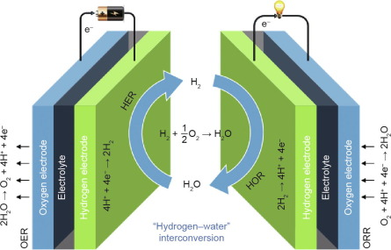

Figure 8. Electrode reactions for electrolyzers and fuel cells.

Image from L Peng Catalyst Engineering [17]

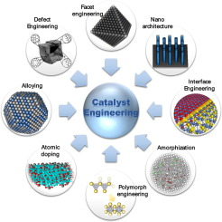

Figure 9. Catalyst Engineering. Image from ScienceDirect.com

L. Peng, Catalyst Engineering for Electrochemical Energy Conversion

Engineering [17]

40

Several recent review papers concerning research in electrolyzers and fuel cells have been prepared. This section gives a “review of reviews” in which the performance and durability of devices consisting of critical and earth-abundant materials are compared.

The following tables compare properties of various electrolyzers and fuel cells in different formats. These properties are shown for cells consisting of **critical** and **earth-abundant** elements.

In a review paper [18], direct comparisons of performance and stability were given for several electrolyzer systems. The alkaline media have applications for ALKELs and AEMELs, while the acid media are relevant for PEMELs. From these data, averages and standard deviations were calculated as shown in Table 39. Although the data were limited in scope, it was apparent that the systems consisting of earth-abundant elements were comparable to those composed of critical elements. Cathodic overpotentials in alkaline media were larger for earth-abundant materials than for the critical elements, but were nearly the same for anodic overpotentials. It can be noted that OER processes are more sluggish than their HER counterparts. Such comparisons were not possible for acid media.

Table 39. Performance and durability evaluations of electrolyzers in alkaline and acid media.

|  |  |
| --- | --- |
| **Anode/OER**  η Tafel slope Stability  mV mV-dec-1 hours cycles | **Cathode/HER**  η Tafel slope Stability  mV mV-dec-1 hours cycles |
| Alkaline  Media 175 65 1 NA  Critical  Elements | 30 50 37 NA  +/- 15 +/-26 +/-46 |
| Alkaline  Media 157 52 136 2000  Earth-abundant +/- 38 +/-17 +/-242  Elements | 158 98 NA 4,000  +/-87 +/-15 +/-1,000 |
|  |  |
| Acid  Media 280 56 102 6,300  Earth-abundant +/- 46 +/9 +/-139 +/- 3,300  Elements | NA |
| Acid  Media NA  Earth-abundant  Elements | 153 55 16 2,100  +/-38 +/- 6 +/-22 +/- 1600 |

41

Carbon shell-encapsulated metal nano-catalysts for electrolyzers and fuel cells have been investigated [19]. A portion of these results are given in Table 40.

Table 40.

|  |  |
| --- | --- |
| **Anode**  η Tafel slope Stability  mV mV-dec-1 hours cycles | **Cathode**  η Tafel slope Stability  mV mV-dec-1 hours cycles |
| Electrolyzer NA  Alkaline  Media  Critical  Elements | Electrolyzer/HER 27 50 12 NA  Alkaline  media  Critical  elements |
| Electrolyze/OER 375 71 28 3,600  Alkaline +/-95 +/-32 +/-26 +/-3,800  Media  Earth-abundant  Elements | Electrolyzer/HER 171 101 10 4,300  Alkaline +/-93 +/-50 +/-4,200  media  Earth-abundant  Elements |
|  |  |
| NA | Electrolyzer/HER 51 30 NA 7,000  Acid +/-28 +/-7 +/-5,200  media  Critical  Elements |
| NA | Electrolyzer/HER 144 174 16 3,700  Acid +/-74 +/-20 +/- 1 +/-3,700  media  Earth-abundant  Elements |
|  |  |
| NA | Fuel Cell/ORR 89 49 6 5,000  Alkaline  Media  Critical  Materials |
| NA | Fuel Cell/ORR 94 63 7 2,000  Alkaline +/-33 +/- 13 +/- 3  media  Earth-abundant  Materials |
|  |  |
| NA | Fuel Cell/ORR 85 NA NA 5,200  Acid +/-10 +/-6,900  media  Critical  materials |
| NA | Fuel Cell/ORR 49 NA NA 1,000  Acid +/-22  medi  Earth-abundant  materials |

42

A summary of fuel cell data is given in Table 41.

Table 41. Conventional and research-level fuel cell properties.

|  |  |  |
| --- | --- | --- |
| **Fuel Cell Type** | **Anode Electrolyte Cathode Power Density**  **HOR ORR W-cm-2** | **Ref.** |
| Alkaline | Ni-based KOH Ni-based 0.150 | [20] |
| Alkaline | Ni@CNx Alkaline polymer Pt/C 0.480  Ni@CNx membrane MnCo2O4 0.210 | [21] |
| Alkaline | NA AEMFC Metal encapsulated 0.412  graphene    PGM-free AEMFC Pt/C 0.275 +/- 0.289 | [22]  [23] |
| Acid | NA PEMFC Pt/C 1.30  NA ZIF-8 (MNC) 1.18  Pt nanoparticles PEMFC Pt nanoparticles 0.16-0.75  Carbon black MWNT support  support  20%Pt/C PEMFC 20%Pt/C 1.05  20%Pt/C Fe/N/CF 0.90    40%Pt/C PEMFC NBC 15% Fe 0.20  Pt/C PEMFC ZIF-Co-N-C 0.92  References 0.135-0.870    Pt/C PEMFC Fe-N-C 1.20 | `  [24]  [25]  [26]  [27]  [28]  [29] |
| Solid Oxide | LiNiCuZn-Oxide CNFC LaSrCoFe 1.03  (SOFC-MCFC) perovskite  CaSm-doped CeO2  (NaLiK)2CO3  550 C    NA SOFC (YSZ) Bi 0.5Sr0.5Fe0.95Mo0.05O3-δ 1.07  NA SOFC (YSZ) Bi 0.5Sr0.5Fe0.95Nd0.05O3-δ 1.10 | [30]  [31]  [32] |

Table 41 shows that alkaline fuel cells can operate with earth-abundant electrodes but that the power densities are relatively low. Acid cells, usually PEMFCs, have research-level earth-abundant cathodes but still rely on Pt anodes to produce high power densities. Solid oxide fuel cells produce high power densities at moderate-to-high temperatures. However, their components, electrodes and/or electrolytes, require critical elements.

43

Several classes of catalytic materials as used in electrolyzer and fuel-cell electrodes have received considerable attention during the past half century. Three classes are reviewed here:

1. Platinum group of metals (PGM), Pt, Ir, Rh, Ru, others, together with their hybrids.
2. PGM-free transition group of metals (TM), Fe, Co, Ni, Mn.
3. PGM-free, TM-free, carbon based.

Historically, the PGM has been the most prominent set of catalysts with the highest level of catalytic activity. However, its scarcity within the earth’s crust and associated high cost will render this class unfeasible for TW-scale installations. The TM group, with N and C components, exhibits lower activity, but is available at less cost because of its earth abundance. The carbon group has shown encouraging results and will become increasingly used as catalysts. All three groups are unstable to various degrees. Table 40 presents a semi-quantitative view of these four criteria for each class. It appears that the PGM will be replaced by the TM and carbon groups, most likely after the projected “net-zero CO2 emissions” date of 2050. These replacements with less activity will require larger amounts of material (thicker electrodes, for example) which may present additional problems such as diffusion limitations.

It is emphasized that this goal can be achieved, according to “pathway” analyses, with a portion of world energy produced by fossil fuels. In addition, the “net-zero” achievement will still require a large increase in energy with a global power level in the range of 100-150 TW for hydrogen production and its storage as discussed in other portions of the World Solar Guide. These power levels will apply to solar PV, electrolyzer, and fuel-cell installations.

Tradeoffs have been observed between electrocatalytic properties as illustrated schematically in Figures 10 and 11 [33]. A semi-quantitative evaluation of EL-FC material types is given in Table 42.

High High

Pt

Cost Activity IrO2

Low Fe Low Ni

Critical Earth-Abundant Short Long

**Availability** **Stability**

Figure 10 Figure 11

Table 42. Semi-quantitative evaluation of electrolyzer and fuel-cell electrode material types.

|  |  |  |  |  |  |
| --- | --- | --- | --- | --- | --- |
| **Electrode**  **Material**  **Groups** | **Availability**  **Critical vs.**  **Earth-Abundant** | **Low Cost** | **Activity/**  **Performance** | **Stability/**  **Durability** | **Total Points** |
| 1. PGM/Hybrids | 1 | 1 | 4 | 3 | 9 |
| 2. M-N-C | 4 | 3 | 3 | 2 | 12 |
| 3. Carbon-Based | 4 | 4 | 2 | 3 | 13 |

|  |  |  |  |  |
| --- | --- | --- | --- | --- |
| Evaluation  Color Code | 1 Point | 2 Points | 3 Points | 4 Points |

44

7. Electric Grids (EG)

A detailed analysis of electric grids is beyond the scope of this guide, but a few points will be included in this section.

7.1 Elemental Abundances and Limitations

Copper is presently the primary metal used in electric transmission and distribution lines.

With reference to Table 8, the world annual production and reserves of copper appear to accommodate the electrical requirements of PV-panel expansion. For grid expansion, copper is only marginally abundant. The electrical conductivity of aluminum is somewhat less than that of copper, meaning that larger cables would be require. However, the abundance of aluminum is much higher than that of copper. A grid incorporating renewable energy is shown in Figure 12.

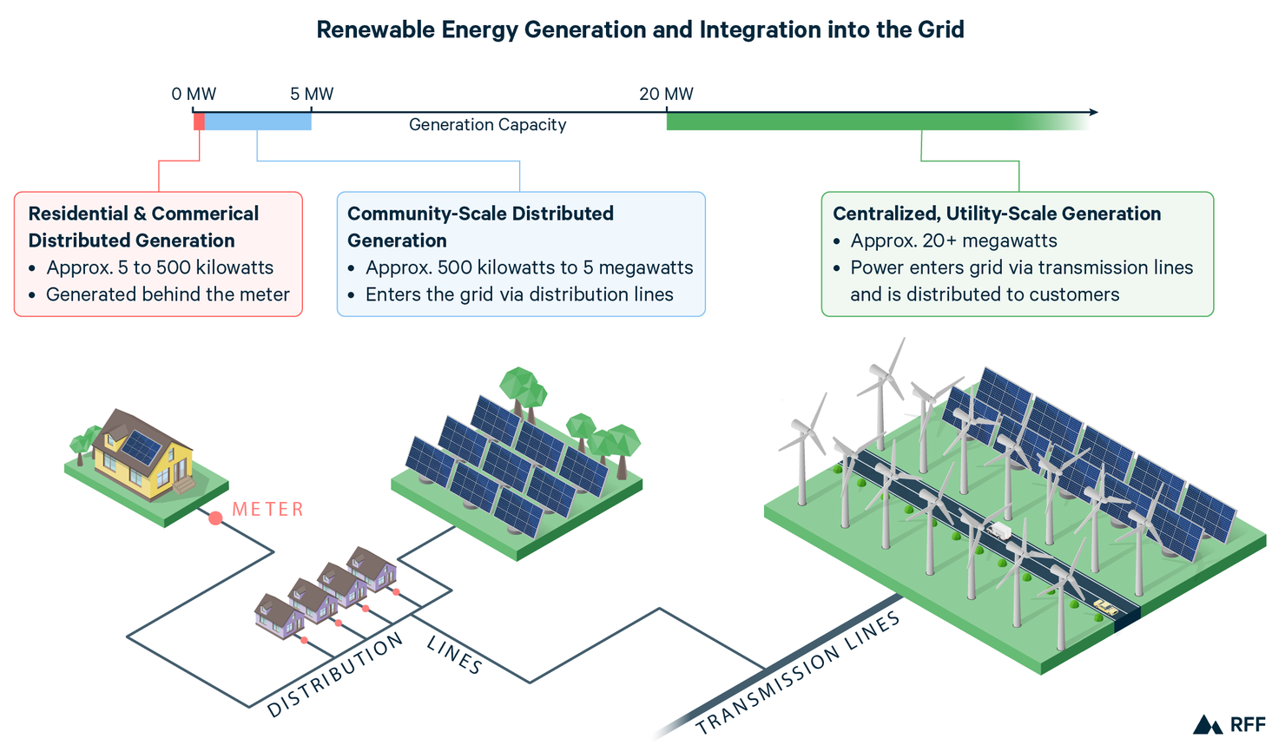

Figure 12. Renewable energy for the grid. Image from rrf.org

45

The material requirement for grids has been considered, and two examples are shown here in Table 43.

Table 43. Conductors for electric grids

|  |  |  |  |  |  |  |
| --- | --- | --- | --- | --- | --- | --- |
| Metal | Annual world  requirement  per 30 years  (tonnes-yr-1) | World  requirement  over 30 years  (tonnes) | Annual world  production  (tonnes-yr-1)  20%  allocation | World  reserves  (tonnes)  20%  Allocation | Ratio of  annual  requirement  to 20% one-year annual  world  production | Ratio of world  requirement  to 20% world  reserves |
| [34] |  |  |  |  |  |  |
| Copper | 9.0 MT | 270 MT | 20 MT | 870 MT | 2.3 | 1.6 |
| Aluminum | 17 MT | 510 MT | 65 MT | 50 BT | 1.3 | 0.051 |
|  |  |  |  |  |  |  |
| [35] |  |  |  |  |  |  |
| Copper | 5.0 MT, inflow | 91 MT | 20 MT | 870 MT | 1.3 | 0.52 |
| Aluminum | 16 MT, inflow | 319 MT | 65 MT | 50 BT | 1.2 | 0.032 |
|  |  |  |  |  |  |  |

From Table 43, it is evident that copper will not be solely adequate for grid expansion up to 2050. Aluminum is abundant based on world reserves, but it will require accelerated annual production to meet replacement and new installation needs.

Copper and aluminum are the most prominent metals for transmission and distribution lines,

but other conductors have been under development during the past two decades. These materials are carbon fibers and composites which will be used as core conductors within aluminum sleeves. Although their electrical conductivities are only about 0.1% and 1% for untreated and treated materials compared with metallic conductors, other properties are favorable [36].

46

7.2 Grid Management – Smart Grids

In addition to materials limitations, electric utility providers are concerned with maintaining balances between the **supply** and **demand** of electric power. Keeping this balance becomes more difficult with the increasing integration of variable renewable energy (VRE) sources such as solar and wind due to their variabilities over periods of hours, days, and seasons. Whereas fossil-fuel and nuclear are “dispatchable” sources by “turning on a switch,” VRE sources cannot be controlled. This variability can be mitigated to some extent by storage, hydrogen, for example, but the “balancing act” remains complex. This process will also result in lower materials requirements on the supply side and lower costs from reduced demands.

The block-diagram developed for the US PV-EL-FC system in **Part 2**, Figure 9.1 as input to the electric grid (EG) and sector hydrogen production is shown here in Figure 13 as a hypothetical world model scaled up by a factor of five from the US model.

Input Energy Output Energy

E1, in E1, out

Electric

Grid

EG

Inverter

PV1

E 2, in, electric

PV2

URFC

DRFC

E2, out, electric

EL

Grid

FC

Grid

1 8 18 hours

EL, H2

Sectors

World E out = 500 EJ/year

PV3

(90% electrification)

Sectors (Section 14.4)

E3, in, sectors

Water/Grid

Industry

Ein

Water/Sectors

6 hours

WSG E2, out, sectors

Transportation

World Model

Ein = 2,375 EJ/year

H2 Storage/Grid

(Section 14.4)

Buildings

H2 Storage/Sectors

10% energy,325Mt/yr

Figure 13. Components of the PV-EL-FC system

47

Various means have been proposed and developed to manage this balance with hydrogen storage and “smart grids.” Although the normal power range for hydrogen storage is MW to GW, smaller “smart grids” including laboratory models [37] and micro-grids [38], as well as grid-scale [39,40] and large grids with salt-cavern storage [41,42] have been investigated. Following management tasks described in previous parts of this guide, a similar schematic diagram is shown here in Figure 14 for the scalable, hypothetical world model in **Part 2,** Figure 9.

Management

Smart Grids

Supply/Input

Ein = E out = 500 EJ-yr-1 = 2,375 EJ-yr-1

η 0.21

24 hours per day

Pin = Pout = 15.9 TW = 302 TW

CF(η) (0.25) (0.21)

6 hours per day

Demand/Output

E out = 500 EJ-yr-1 (90% electric)

(10% hydrogen)

24 hours per day

Pout = 15.9 TW 24 hours per day

If capacity factor, CF = 100%

If system efficiency, η = 100%

24

Electric grid 112.5 EJ-yr-1

EG= 14 TW daytime

6 hours

Direct power to electric grid

PV1 = 14 TW 🡪

daytime, 6 hours

🡨 Balance 🡪

Grid hydrogen

production

ELG = 279TW🡪

6 hours

PV2 = 279 TW 🡪

daytime

6 hours

Electric grid

EG=14 TW

337.5 EJ-yr-1

nighttime

18 hours

Hydrogen

utilization-input

FCG = 28 TW 🡪

nighttime

18 hours

Hydrogen

production

ELH = 9 TW 🡪

6 hours

PV3 = 9 TW 🡪

daytime

6 hours

PVtot = 302 TW

Hydrogen to sectors: 50 EJ-yr-1

Industry

Transportation

Buildings

Figure 14. Schematic supply-and-demand diagram of electric grid and hydrogen management.

In **Part 2**, the PV-EL-FC system is shown as an Input to the electric grid. Here in **Part 5**, the FC device is shown as a portion of the Demand/Output. It is emphasized that the energy and power inputs to these PV-EL-FC-EG model systems developed in **Part 2, Figure 9.1, Tables 14.6 and 14.7** are much larger than the requirements of the “pathways” advocating net-zero CO2 emissions by 2050. These models assume a world annual energy demand/output of 500 EJ per year with 90% of energy for the industrial, transportation, building, and electrical sectors is electrical with 10% for hydrogen production. These models also omit other renewable sources and passive building measures, meaning that the models may be an over-estimate of required energy and power. Due to the availability of daily solar power, around six hours or less, also known as the Capacity Factor of 25%, and the (in)efficiencies of the PV-EL-FC devices with a system efficiency of 20%, the required input energy is about 2,375 EJ per year.

48

Hydrogen is clearly the most viable means of energy storage for large-scale electrical systems as seen in Figures 15 and 16.

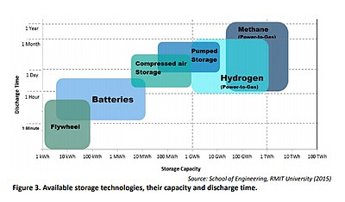

Figure 15. Image from Wikipedia.

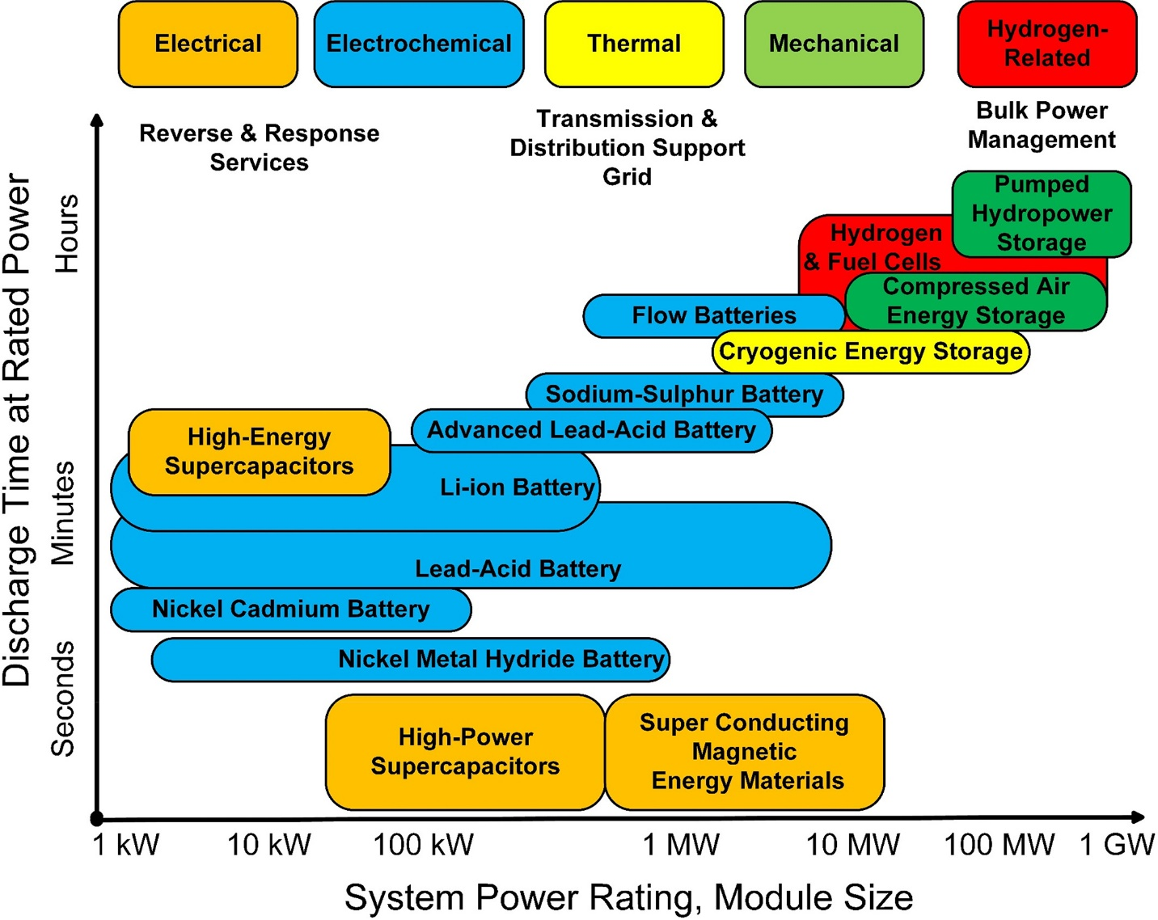

Figure 16. Image from Wiley Online Library

49

8. Environmental Considerations

The “energy crisis,” that is the **transition** from fossil fuels to renewables, for the purpose of removing (**excess**) CO2 from the atmosphere, thus limiting its temperature increase to

1.5 to 2.0 C could become a “materials crisis” during the transition period of 2020 to 2050. Around 2020, or five years after the Paris Agreements, it became clear that vast quantities of some chemical elements, many limited within the earth’s crust, will become essential for the implementation of this transition. Several of these elements including the platinum group of metals, the precious metals, rare earths, and some perovskite elements will not be available for the global installation of renewables. In fact, even some “earth-abundant” elements such as copper and aluminum may also restrict these installations. **Part 4** of the World Solar Guide has attempted to illustrate a few of these limitations by referring to the hypothetical models developed in **Part 2**.

The scale of these renewable installations is magnified by several factors:

1. Solar energy is variable.
2. This variability limits the solar irradiance to less than about six hours per day resulting in a capacity factor, CF, of less than approximately 25% (this valued is assumed here).
3. The individual efficiencies of PV, EL, and FC systems ranges from 20-70%.
4. The overall PV-EL-FC system efficiency, η, is around 20%.
5. The product of the capacity factor and efficiency means that the input power is required to be 20 times the output power.

A few energy supply/demand characteristics are shown in Table 44.

Table 44.

|  |  |
| --- | --- |
| **Supply/Production/Grid Input** | **Consumer Demand/Grid Output** |
| Natural resources (**Part 6**):  Solar irradiance, 1,000 W-m-2  Water for EL hydrogen production  Salt deposits for hydrogen storage and FC use  Land use for solar PV panels  Critical materials for PV-EL-FC systems  Earth-abundant materials for PV-EL-FC systems  **Part 2 and Part 5**  Actual input power Pin = Pout = 15.9 TW = 302 TW  CF(η) (0.25) (0.21)  Investment  Supply chain resilience  Replace scarce materials with earth-abundant elements  R&D spectrum  Environmental and sustainability standards  Increased reclamation and recycling | **Part 1 and Part 2**  Annual world energy demand/output 500 EJ  Pout = 15.9 TW for CF = 100%, efficiency = 100%  Material requirements to meet energy demand  Reduction of energy demand  National energy and materials security  International collaboration: producers and consumers |

50

Although the earth has abundant natural resources for the implementation of renewable energy as seen in Table 44, not only are many of the chemical elements limited within the earth’s crust, but the abundant elements such as silicon, copper, and aluminum will be required in larger quantities. This need will become manifested through increased mining and processing operations around the world.

It can be said that “Phase One” of the transition from fossil fuels to renewable energy is currently in progress during which period solar installations have increased significantly. The International Energy Association [30] developed a report which describes the material requirements for clean energy transitions. In this section, some of these requirements will be discussed. Selected minerals used in PV-EL-FC-EG systems and their recycling rates are shown in Table 45.

Table 45. Mineral needs and recycling rates for selected renewable energy sources.

|  |  |  |  |  |  |  |  |
| --- | --- | --- | --- | --- | --- | --- | --- |
|  | Copper | Cobalt | Nickel | REEs | Chromium | PGMs | Aluminum |
| Solar PV |  |  |  |  |  |  |  |
| Hydrogen EL & FC |  |  |  |  |  |  |  |
| Grids EG |  |  |  |  |  |  |  |
|  |  |  |  |  |  |  |  |
| Color code: |  |  |  |  |  |  |  |
| High |  |  |  |  |  |  |  |
| Moderate |  |  |  |  |  |  |  |
| Low |  |  |  |  |  |  |  |
|  |  |  |  |  |  |  |  |
| Recycling % | 46 | 32 | 60 | <1 | 35 | 60 | 42 |

51

9. Materials and Devices Summaries

Material limitations of the four systems, PV-EL-FC-EG, are summarized in terms of the present utilization of scarce materials and future systems with earth-abundant materials as shown in Table 46. World-wide installation of these systems will depend critically on the development of component earth-abundant materials.

Table 46. General summary of materials availabilities for PV-EL-FC-EG systems.

|  |  |  |  |  |
| --- | --- | --- | --- | --- |
|  | **Solar Photovoltaic** | **Electrolyzers** | **Fuel Cells** | **Electric Grids** |
| **Current**  **Status**  **Limited**  **Installations** | Solar panels  Silicon: amorphous  crystalline (mono, poly)  Electrical conductors  Silver | Alkaline (1*)  Nickel-based electrodes  AEMEL (4*)  Transition elements  PEMEL (2*)  PGM electrodes  MCEL (5*)  Ni alloys  SOEL (3*)  YSZ  Perovskites | Alkaline  PGM electrodes  AEMFC  PGMelectrodes    PEMFC  PGM electrodes  PAFC  Pt electrodes  MCFC  Ni alloys  SOFC  YSZ  Perovskites | Conductors  Copper  Aluminum |
| **Future Developments**  **World-wide**  **Systems** | Solar panels  Silicon -amorphous  Perovskites, lead-free  Chalcogenides  Thin films  Multi-junction  Electrical conductors  Copper  Aluminum  Other metals | Alkaline  Transition elements  PEM  Earth-abundant electrodes  Solid oxide  Earth-abundant components | Alkaline  Earth-abundant electrodes  PEM  Earth-abundant electrodes  Solid oxide  Earth-abundant components | Conductors  Copper  Aluminum  Carbon  Composites |
| **Ranking** |  | **TRL/CRI [43]**  **Ranking**  **Part 6, World Solar Guide** |  |  |

52

Several quantitative examples of material limitations for the PV-EL-FC-EG systems were given in Sections 5,6, and 7; Table 47 summarizes these results.

Table 47. Summary of materials-limitation examples and calculations.

|  |  |  |  |
| --- | --- | --- | --- |
| **Photovoltaic Cells**  **(PV)** | **Electrolyzers**  **(EL)** | **Fuel Cells**  **(FC)** | **Electric Grids (EG)** |
| 5.Silicon  Si crystalline  amorphous  Perovskite, lead-free  Table 4  Cs Sn0.5 Ge 0.5 I | 6.3 Table 14, 15 Current devices    ALKEL  AEMEL  PEMEL  MCEL  O-SOEL | 6.3 Table 14, 15 Current devices    ALKFC  AEMFC  PEMFC  MCFC  O-SOFC |  |
|  |  |  |  |
| 5. Perovskite  Chalcogenide  Table 5  Cu2 Zn Sn S4 | 6.4.1 PGM Table 16  Anode Cathode  IrO2  Pt  RA 8,500 70 | 6.4.1 PGM Table 17  Anode Cathode  Pt Pt  RA  1.6 3.2 |  |
| 5. Electrical  conductors  Table 8  Ag  Cu  Al | 6.4.1 PGM Table 16  Anode Cathode  IrO2  Pt  RW  105 5.5 | 6.4.1 PGM Table 17  Anode Cathode  Pt Pt  RW 0.12 0.24 | 7. Electrical  conductors  Table 31  Cu  Al |
|  |  |  |  |
|  | 6.4.2 Y2O3, YSZ Table 18  RA = 0.835 Electrolyte  RW = 0.451 | 6.4.2 Y2O3, YSZ Table 18  RA =0.378 Electrolyte  RW = 0.204 |  |
|  |  |  |  |
|  |  | 6.4.3 Perovskite electrodes  Tables 19-24 |  |
|  |  | Sr, La |  |
|  |  | Sr, La |  |
|  |  | Sr. La |  |
|  |  | La |  |
|  |  |  |  |
|  | 6.4.4 Transition metal electrodes  Tables 25-29 |  |  |
|  | Fe, Cr, Ni |  |  |
|  | Cr, Ni |  |  |
|  | Ni, Mo |  |  |
|  | Ni, Mo, Co |  |  |

53

The limitations of the example materials can also be viewed in terms of the electrical power required or produced by their systems and components as shown by Equation (6) in Section 3.3:

PL = mDp

ρt

where m is 20% of the known world reserves, and the component thickness, t, is measured through microscopic means or is determined, as in the case of PV electrical contacts or electrode Pt catalyst deposition, by

t = L, ρ = pρe

ρ

with L, p and ρe as the contact or catalyst loading, porosity, and elemental density.

As an example of these calculations, consider **yttria** in the YSZ electrolyte:

PL = (0.20) (500,000 tonnes) (5.0 W-cm-2)= 88 TW

(5.68 g-cm-3) (10 μm)

Calculations of limiting power levels for examples in Sections 5 and 6 are summarized below in Table 48.

54

Table 48. Power limitations of example component compositions.

|  |  |  |  |  |
| --- | --- | --- | --- | --- |
| **Systems and**  **Components** | **Power limited by**  **mass, m, as**  **20% of world reserves**  **PL = mDp**  **ρt**  **(TW)** | **Required power of**  **PV-EL-FC**  **system**  **Part 2**  **300, 30**  **(TW)** | **Ratios**  **20% reserves**  **Required power**  **300. 30 TW**  **Calculated** | **Ratios**  **20% reserves**  **Required power**  **150, 15 TW**  **Assumed** |
| **Photovoltaic (PV)** |  |  |  |  |
| 5.1 Solar panel silicon  Crystalline, amorphous Si | Unlimited  28% earth crust | 300, 150 | Unlimited | Unlimited |
| 5.1 Solar panel perovskite, 1 μm  CsSn0.5Ge0.5I3 (Ge limit) | 5.3x10-3 | 300, 150 | 1.8x10-5 | 3.6x10-5 |
| 5.1 Solar panel chalcogenide 1 μm  Cu2ZnSnS4 (Sn limit) | 1.8 | 300, 150 | 0.000060 | 0.00012 |
| 5.3 Silver, Ag contacts | 2.2 | 300, 150 | 0.0073 | 0.015 |
| 5.3 Copper, Cu contacts | 3,500 | 300, 150 | 12 | 24 |
| 5.3 Aluminum, Al contacts | 2.0x105 | 300, 150 | 670 | 1,340 |
|  |  |  |  |  |
| **Electrolyzers (EL)** |  |  |  |  |
| 6.4.1 PEM, PGM, cathode. Pt | 50 | 300, 150 | 0.17 | 0.34 |
| 6.4.1 PEM, PGM, anode, IrO2 | 5.0 | 300, 150 | 0.017 | 0.034 |
| 6.4.2 YSZ, electrolyte, Y2O3 | 88 | 300, 150 | 0.29 | 0.58 |
| 6.4.4 Transition metal,  electrode, Ni | 420 | 300, 150 | 1.4 | 2.8 |
| 6.4.4 Transition metal,  electrode, Co | 31 | 300, 150 | 0.10 | 0.20 |
|  |  |  |  |  |
| **Fuel Cells (FC)** |  |  |  |  |
| 6.4.2 YSZ, electrolyte, Y2O3 | 18 | 30, 15 | 0.60 | 1.2 |
| 6.4.3 Perovskite, LSCMN,  electrolyte, Sr | 400 | 30, 15 | 13 | 26 |
| 6.4.3 Perovskite, LSCMN,  electrolyte, La | 2.2 | 30, 15 | 0.073 | 0.15 |
|  |  |  |  |  |
|  |  |  | Ratio color code |  |
|  |  |  | >1.0 |  |
|  |  |  | 0.10-1.0 |  |
|  |  |  | 0.010-0.10 |  |
|  |  |  | <0.010 |  |

From Table 48, reducing the required electric power levels from 300 TW and 30 TW by a factor of two to 150 TW and 15 TW results in only marginal increases of PV silver, FC yttria, and FC lanthanum as components.

55

As discussed earlier, the **Part 2** determinations of EL and FC required global powers of approximately 300 TW and 30 TW may be overestimates by a factor of two because of other renewable sources. However, it can also be recalled that

Pin = Pout = 15.9 TW = 302 TW

(CF)(η) (0.25) (0.21)

where the capacity factor, CF, and system efficiency, η, were considered. A global power estimate in excess of 100 TW was also given [m tao]. In any case, it is reasonable to suggest that the range for global power will be at least 100 - 150 TW. Assuming the lower required levels from Table 47 results in marginally increased availability of only **silver** for PV electrical contacts as well as **yttria** in YSZ and **lanthanum** in the LSCMN perovskite.

In Table 47, it is also seen that the most critically limited element is **silver** as utilized in PV electrical contacts. Both **copper and aluminum** are fully abundant for this purpose, but they will be required for grid conductors.

For electrolyzers, only **nickel** is abundant; this element is presently used as electrodes in large-scale alkaline cells.

The perovskite, LSCMN, as a fuel cell electrolyte, is severely limited by its **lanthanum** element.

**Platinum** in PEM electrolyzers could provide a power level of 50 TW. **Yttria** in YSZ could supply substantial power levels for both electrolyzer and fuel-cell electrolytes.

In summary, the only fully-available earth-abundant elements in the present PV-EL-FC systems are **copper/aluminum** electrical contacts and **nickel** in alkaline electrolyzers. Some scarce elements as used in their components can produce significant power levels on the world scale.

Continued R&D efforts will be required to produce earth-abundant elements as components in these systems. These new components will likely exhibit inferior performance relative to the scarce elements as measured by their catalytic activity, efficiency, and durability. As a result of the lesser performance, larger quantities may be required. From this perspective, ecologically responsible mining practices followed by end-of-life reclamation and recycling will also be essential.

56

10. Projected Growth Rates of Electrolyzers and Fuel Cells

In order to estimate the installation growth of electrolyzers and fuel cells, not only will the present scarce materials and future earth-abundant materials require assessment, but their power levels must also be known. It should also be noted that the World Solar Guide models shown in **Part 2** far exceed projections given, for example, by IEA in its Net Zero by 2050 pathway which calls for a power of 3.5 TW.

By way of review, the WSG models considered a world annual energy demand of 500 EJ which could be provided by solar radiation of 15.9 TW with a capacity factor and system efficiency each of 100%. For the CF of 25% and efficiency of 20% of the EL-FC storage system, this power must be about 300 TW. This model may be an overstatement by a factor of two or three as other forms of renewables were not considered. However, a power level of 100 TW still far exceeds the IEA value. The difference comes primarily from the IEA net-zero CO2 emission level versus the need to supply the global energy demand.

The growth of electrolyzer and fuel cell installations have been made [44].

Table 49. Growth rates, r, of electrolier installations (GW)

|  |  |  |  |  |  |  |
| --- | --- | --- | --- | --- | --- | --- |
| **Year** | **ALKEL** | **AEMEL** | **PEMEL** | **SOEL** | **Other** | **Total** |
| 2019 | 0.164 | NA | 0.065 | NA | 0.013 | 0.242 |
| 2023 | 1.459  r = 73% |  | 1.125  r = 104% |  | 2.933  r = 288% | 5.517  r = 119% |
| 2030 – NZE |  |  |  |  |  | 720  r = 107% |
| 2050 – NZE |  |  |  |  |  | 3,500  r = 36% |
| World Solar  Guide model |  |  |  |  |  | 300,000 GW  r = 57% |
| TRL [26]  CRI | 9  3-6 | 2-5  1 | 7-8  1-2 | 5-7  1 |  |  |
|  |  |  |  |  |  |  |
| Electrode  Materials | Nickel  Based | Nickel  Based | PGM | YSZ  Perovskites |  |  |
| Projected  power ranges | MW-GW | MW-GW | MW-GW | MW-GW |  |  |
| Overall grid potential with  present materials and powers |  |  |  |  |  |  |
| Overall grid  potential with  earth-abundant  materials  and powers |  |  |  |  |  |  |

57

Table 50. Annual net-zero electrolyzer installation (GW-yr-1) by countries in 2026 (iea).

|  |  |  |  |  |  |
| --- | --- | --- | --- | --- | --- |
| Europe | China | North America | India | Unspecified | Total |
| 19 | 22 | 2 | 3 | 14 | 60 |

From Table 50, the total net-zero electrolyzer installation from these countries during 2026-2050 will be 1,440 GW or 1.44 TW for a constant rate. This installation is much less than the estimates given in this guide for total replacement of fossil fuels by solar power and hydrogen storage.

58

The world-wide installation of fuel cells is in the range of about 1-2 GW per year among applications for transportation, portable use, and stationary applications. The primary types of fuel cells are alkaline, anion exchange membrane, polymer exchange membrane, phosphoric acid, molten carbonate, and solid oxide. Taking 1GW as the installed power in 2020, and the WSG **Part 2** requirement of 28,000 GW by 2050, the necessary annual growth rate to achieve this goal is 40%. Power ranges of fuel cells are shown in Figure 17 [45].

Table 51. Major fuel cell types.

|  |  |  |  |  |  |  |  |
| --- | --- | --- | --- | --- | --- | --- | --- |
|  | **ALKFC** | **AEMFC** | **PEMFC** | **PAFC** | **MCFC** | **SOFC** |  |
|  |  |  |  |  |  |  |  |
| World Solar  Guide model  required input |  |  |  |  |  |  | 28,000 GW  WSG  r = 40% |
| Electrode  Materials | Nickel | PGM  Abundant | PGM | PGM | Nickel | YSZ  Perovskites |  |
| Number of installed units  2020 (000) [27] | Min | NA | 54 | Min | Min | 25 |  |
| Installed power  2020 (MW) [27] | Min | NA | 1,030 | 120 | 80 | 150 |  |
| Potential power  Range  Figure 13 | 100 W-  100 KW | Assumed  KW-MW | 10 KW-  1MW | 100 KW-  100 MW | 100 KW-  1 GW | 1 KW-  1 GW |  |
| Overall grid potential with  present materials and powers |  |  |  |  |  |  |  |
| Overall grid  potential with  earth-abundant  materials  and powers |  |  |  |  |  |  |  |

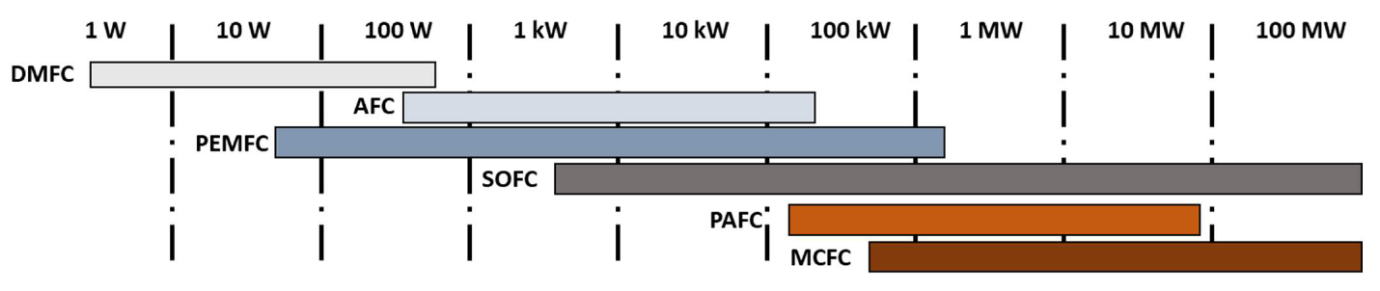

Figure 17. Power ranges of fuel-cell types [45].

59

Material properties of sub-systems and components, together with energy and power levels are summarized in Table 52. Parameter are from the hypothetical world model **Part 2**, Table 14.7, component, and device potentials.

Table 52. Material properties.

|  |  |  |  |  |
| --- | --- | --- | --- | --- |
| **PV-EL-FC System** | **PV** | **EL** | **FC** | **EG and Hydrogen Production** |
| System  Capacity Factor (CF) = 25%  Efficiency (η) = 21%  Pin = Pout = 15.9 TW  CF(η) (0.25) (0.21)  Pin = 302 TW | Output power  Direct to grid  PV1 = 14 TW  EL for grid  PV2 = 279 TW  EL for H2  PV3 = 9 TW  PVtot = 302 TW | Input power  PEL = 279 TW  PEL = 279 TW  PFC = 28 TW  PEL + FC = 302 TW | Input power  PFC = 28 TW | Annual world energy  demand, 500 EJ  Grid energy, 450 EJ  Hydrogen energy, 50 EJ  Power, 15.9 TW  PG =14 TW  assuming  Capacity Factor = 100%  Efficiency = 100% |
| Component and device potentials based on  **present materials**,  developed technology,  and sufficient electrical  powers | PV cells  Si  Conductors  Ag  Cu  Al | ALKEL  AEMEL  PEMEL  SOEL | ALKFC  AEMFC  PEMFC  PAFC  MCFC  SOFC | Conductors  Cu  Al |
| Component and device potentials based on  **earth-abundant materials**,  developed technology,  and sufficient electrical  powers | PV cells  Si, others  Conductors  Cu  Al | ALKEL  AEMEL  PEMEL  SOEL | ALKFC  AEMFC  PEMFC  PAFC  MCFC  SOFC | Conductors  Cu  Al  Carbon/composites |

The global PV-EL-FC-EG system described by this World Solar Guide requires a “series connection” of its components in which a restriction of one component will limit the entire system. As seen in Table 39, certain components and devices may pose serious limitations.

Ironically, the earth-abundant metals, copper and aluminum, may restrict the global installation of PV devices and EG conductors.

Photovoltaics (PV)

Within the PV devices, silicon and likely other semiconductors will provide the necessary power for grid and hydrogen production if located in areas of high solar irradiance. However, collecting this current and transferring it to the EL components may be limited by the availability of electrical conductors. Silver is clearly a scarce metal with limited access. Copper and aluminum are the most likely replacements for silver, but their utilization may be limited at the global level. Other conductors should be evaluated.

Electrolyzers (EL)

Alkaline electrolyzers are a mature technology with abundant materials such as nickel-based alloys as electrodes. Other candidates are under development with earth-abundant materials

60

Fuel Cells (FC)

At the present time the MCFC and SOFC are the most advanced commercial components. Other types of FCs will be produced.

Electric Grid (EG)

As with PVs, copper and aluminum may be limited for grids on a global scale. The incorporation of additional conductors such as carbon/composites will become necessary.

The supply of copper on a global scale will become inadequate as transmission and distribution conductors by around 2030. Its most likely replacements will be aluminum and carbon/composites.

A diversity of EL and FC device types will ensure that a range of materials can be utilized, thus reducing the required masses for each element. As earth-abundant elements may exhibit inferior performance in terms of catalytic activity, efficiency, and durability, larger masses may be required than for the scarce elements. These larger-mass requirements will likely be more than offset by their higher abundances.

61

11. Country/Region Viabilities for PV-EL-FC-EG Systems

Table 53 compares semi-quantitative viabilities of the world’s four largest energy-consumption countries/regions based on six installation factors. Solar irradiance maps for these areas are shown in **Part 1**. Import/export activities are not considered as rate-determining factors relative to elemental abundances in materials availability. Grid stability is seen to be an area of vulnerability in all regions. The improvement and growth of this infrastructure will become mandatory to accommodate increased PV installations. Tables 9.7 and 9.8 in **Part 1** present similar comparisons.

Table 53. Country/region comparison of general viabilities for large-scale

PV-EL-FC-EG power.

|  |  |  |  |  |  |  |  |  |
| --- | --- | --- | --- | --- | --- | --- | --- | --- |
| **Country/**  **Region** | **World**  **annual**  **energy use**  **500 EJ.**  **Country/Region**  **Part 1,**  **Figure 7.2**  **Part 2**  **Table 2.1** | **Population**  **density**  **(No./km2)**  **for PV land**  __________  **Part 2**  **Table 9.6** | **Solar**  **irradiance**  **for PV in**  **certain**  **areas**  **Part 1**  **Figure 8.8**  **Part 2**  **Figures**  **10.1-10.16** | **Water**  **availability**  **for EL**  **__________**  **Part 2**  **Figure 6.1** | **Salt caverns**  **for H2**  **storage**  **and FC**  **Part 2**  **Figures**  **7.1, 7.2** | **PV-EL-FC**  **material**  **import**  **liability**  **__________**  **Part 4** | **EG**  **grid**  **stability** | **General**  **Viability** |
| China | 24% | (149) 1 | 3 | 3 | 2 | 3 | 2 | 14/18 |
| US | 17% | (34) 3 | 3 | 3 | 3 | 2 | 2 | 16/18 |
| Europe  E-5  UK  Germany  France  Italy  Spain | 7% | (184) 1  Average | Northern  Europe 1 _________  Southern  Europe, 3 | 3 | 3 | 2 | 2 | Northern  Europe, 12/18  ___________  Southern  Europe, 15/18 |
| India | 6% | (411) 1 | 3 | 3 | 1 | 2 | 1 | 11/18 |
| Total | 54% |  |  |  |  |  |  |  |
| Ranking  code |  | Low 3  Med 2  High 1 | High 3  Med 2  Low 1 | High 3  Med 2  Low 1 | High 3  Med 2  None 1 | Low 3  Med 2  High 1 | Excellent 3  Good 2  Fair1 1 | Totals  Maximum=18 |

From Table 53, China’s most vulnerable characteristic is its population density. The US is fortunate to have favorable factors in most areas and is the only country/region with a low population density.

The population density of the European E-5 region is higher than that of China. Northern Europe may find it necessary to import electricity and/or hydrogen from Southern Europe, Africa, or the Middle East as its solar irradiance is limited. Southern Europe may become self-sufficient in producing these energy sources. Europe has a high concentration of salt deposits for hydrogen-storage caverns.

India appears to be the least viable country/region in this group of four because of its high population density, lack of salt deposits, and marginal grid.

As these countries and regions consume more than half of the world’s energy, it is essential that they proceed with the timely **transition** of fossil fuels to renewables.

62

12. General Summary and Conclusions

A few historical points and projections can be summarized from earlier **World Solar Guide** discussions:

* The fossil-fuel period will have endured for about **300 years**, 1750 - 2050.
* Renewable sources of energy and climate models have been known for **200 years**.
* Photovoltaic and electrochemical concepts have been known since the early 19th century.
* An early atmospheric-warming model was developed in 1897.
* Increased atmospheric CO2 emissions have been documented since the 1870s.
* UN negotiations beginning in 1988 resulted in the Paris Agreement of 2015 during which time period, the earth’s temperature increased by nearly 1.0 C.
* The IPCC goal for limiting global warming to 1.5-2.0 C by replacing fossil fuels with renewables is to be completed by 2050. This goal may not be attainable.
* Energy requirements in 2050 and beyond far exceed net-zero CO2 energy levels.
* While many countries have made major commitments to this goal, others are lagging and some have increased their use of fossil fuels, including coal for producing solar cells.
* Renewable sources, primarily solar, with hydrogen storage, will require large amounts of earth-abundant materials as scare elements will become inadequate for this transition.
* Some scarce elements, while providing an inadequate supply on the world scale, may find limited use in devices at municipal, regional, or national levels.
* Major research and development efforts will be required for these new materials to become functional and economical. The recent annual number of research papers in various areas of renewable energy exceeds 10,000.
* The large-scale production and processing of the earth-abundant materials may cause environmental damage.
* Reclamation and recycling of these materials will be essential for sustainability.

As will be seen in **Part 5** of this guide, it is unlikely that the other methods of hydrogen production such as photoelectrochemical (PEC) or photocatalytic (PC, artificial photosynthesis) will become globally viable by 2050, although they may find limited applications. Therefore, the traditional electrolysis of water, powered by solar PV panels on a global scale will be necessary for the initial stage of fossil-fuel replacement. These PV-EL systems will produce hydrogen for fuel-cell electric power and other processes in the industrial, transportation, and building sectors.

Solar PV development has become a mature technology with production advances and cost reductions that will assist in making hydrogen production economically feasible during the next several years with projected costs approaching $1.00 per kg. Although silicon is one of the earth’s most abundant elements, the commercial production of silicon panels is currently concentrated in a few countries.

63

Two current solar PV materials appear to be feasible at the 100-TW level. Crystalline silicon (20% efficient) installations can be expanded to global levels if silver contacts are replaced with copper and/or aluminum. It should be noted that these two metals will also be required in large quantities for electric grid systems. Conductors for these grids may also consist, in part, of carbon-based materials. Additionally, amorphous silicon (10% efficient) will also become a prominent PV component. In its R&D stage, the perovskite sub-type chalcogenide, CZTS, (10-20% efficient) will be available in thin-film (1μm) form as an earth-abundant material, limited by its tin (non-earth-abundant) content, for 100-TW power production. It is emphasized that solar PV panels with a10% conversion efficiency will require twice the “solar farm” areas compared with the calculated silicon, 20% efficient, PV arrays in **Part 2** of this guide. Analyses of materials availability should be based on complete PV-EL-FC-EG systems.

**Part 4** of the World Solar Guide has considered a few research results for three classes of electrolyzer and fuel cell components. Historically, the platinum group of metals has shown the highest levels of catalytic activity, but the scarcity of these metals and their costs will prohibit global-scale, TW installations. The transition group has recently exhibited promising results which make their installations feasible, although at rather high costs. Carbon-based materials, including graphene types also show encouraging results and potentially lower costs for large-scale use.

In addition to **performance** (overpotentials, Tafel slopes, power density, etc.) and **durability**, materials **availability** should also be considered as a primary parameter in the evaluation of PV-EL-FC-EG components. Material limitations should be determined relative to the needs of other sectors, annual world production levels, and world reserves with a focus also on reclamation and sustainability over indefinite and unlimited time periods, unlike the fossil fuel era which will have lasted 300 years.

At the present time, the alkaline type electrolyzer with its reliance on nickel electrodes is the most advanced device for the commercial production of hydrogen. Fuel cells are in production by several firms, and their capacities will be increased. Global-scale solar PV, water- electrolyzer, and hydrogen fuel-cell systems will be required with a likely total power in the range of 100-150 TW.

Only about 5% of new passenger vehicles in the US and abroad can be powered by the PEM fuel cell with its current reliance on 10 mg platinum and other PGM elements per vehicle. In addition, less than 2% of new vehicles will have batteries containing 20 kg of lithium. These restrictions are based on the world-wide annual production of the elements. The percentages of vehicles powered by PGM PEMFCs and lithium batteries over a 30-year period can be increased if world reserves of the elements are deleted. These expansions will require increased mining, import/export activities, and environmental concerns.

It is emphasized that although most **earth-abundant** materials will be available for global installations of PV-EL-FC-EG systems, **import restrictions** in many countries may limit the development of these facilities

64

A major limitation of PV-EL-FC systems will be materials availability. **Part 7** of the **WSG** places these materials limitations as the most critical limitation among solar-energy-related natural resources: (1) solar irradiation, (2) water for electrolysis, (3) hydrogen storage sites, (4) land use of PV farms, (5) earth-abundant materials, and (6) critical materials. For PV electrical contacts, silver must be replaced by copper and/or aluminum. The annual production of these two metals must be substantially increased. In the case of electrolyzers and fuel cells, the platinum group of metals (PGM) must be replaced by earth-abundant elements. Some of the rare earths, although scarce, may be utilized on a global scale due to their low concentrations in electrolyte and electrode components. Materials availability will be determined by both elemental abundances and geographical locations, with the former constraint more restrictive

It is now well understood that the critical/scarce elements are insufficient in quantity for the global installation of PV-EL-FC systems. The development of earth-abundant materials will diminish the need for critical elements but will reduce their import vulnerabilities in many countries only slightly. Increased use of some earth-abundant materials such as copper and aluminum used as conductors in electric grids may require replacements by carbon materials.

As elemental materials availability is the most critical factor in these world-wide PV-EL-FC-EG systems, basic research, development, production, and reclamation of the device components will be imperative as the scarce elements must be replaced by more earth-abundant materials. The performance of these more abundant materials may be less than that of the scarce elements, meaning that larger quantities may be required. The activity, efficiency, and durability of these elements must be improved. Fortunately, this urgency is currently appreciated by educational institutions, researchers, businesses, and governments in most countries. Pluralistic partnerships will be crucially important. Economies of scale will result in reduced costs. Recycling and reclamation, together with environmental standards, will be essential for long-term sustainability.

It may be instructive to conclude this segment by considering era time-scales in Table 54:

Table 54.

Era Time-scale (years)

1. Astronomical (Milky Way Galaxy) 13.77 billion

2. Planetary (Solar System and Earth) 4.567 billion

3. Geological 4 billion

4. Biological 1 billion

5. Fossil formation 300 million

6. Humans 1 million

7. Recorded history 5,000

8. Fossil fuel energy (Industrial Revolution) 300

9. Renewable/sustainable energy future unknown

On a logarithmic time-scale, these eras in years appear as:

Past Present Future

1 2 3 4 5 6 7 8 9

|  |  |  |
| --- | --- | --- |
|  |  |  |

-1010 -109 -108 -107 -106 -105 -104 -103 -102 -10 1 +10 + 102 +103 +104

Time (years)

65

13. References

1. Rosten, R., Koski, M., and Koppana, E., A Guide to the Calculation of Theoretical Densities

of Crystal Structures for Solid Oxide Fuel Cells, JUMR, Michigan Technical University, 2006.

2. [www.wiki.org/Log-of-Annual-World-Production-and-Earth-Crystal-Abundance](http://www.wiki.org/Log-of-Annual-World-Production-and-Earth-Crystal-Abundance) RSC Fig 2

en.wiki.org/wiki/Abundance-of-Elements-in-Earth’s-Crust, 2022.

3. www/nrel.gov/pv/cell-efficiency, 2021

4. Wang M., Ma, B., Shen, W., Liu, L., Cao, K., Chen, S., and Huang, W., Lead-Free

Perovskite Material for Solar Cells, Springer, 2020.

5. Chen, M., Highly Stable, Lead-Free Perovskite Solar Cells, Nature Comm., 10, 16, 2019.

6. Le Donne, A., Tritiletti, V., and Binetti, S., New Earth-Abundant Thin Film Solar Cells

based on Chalcogenides, Frontiers in Chemistry, 2019.

7. www.werecycle.com/How-Much-Silver-is-Used-in-Solar-Cells? 2020.

8. [www.engineeringtootbox.com/conductors](http://www.engineeringtootbox.com/conductors)

9. [www.iea.blob.core.windows.net/assets/Special-Report-on--Solar-PV-Global-Supply-Chains/2022](http://www.iea.blob.core.windows.net/assets/Special-Report-on--Solar-PV-Global-Supply-Chains/2022)

10. Tao, M., et. al., Review-Earth Abundant Elements for Solar Cell Applications,

Research Needs for Photovoltaics in the 21st Century.

11. [www.en.wiki.org/abundance-of-elements/periodic-table-of-the-elements-earth-crust-concentrations-ppm](http://www.en.wiki.org/abundance-of-elements/periodic-table-of-the-elements-earth-crust-concentrations-ppm).

12. [www.doe.gov/American-Strategy-to-Secure-the-Supply-`for-a-Robust-Clean-Energy-Transition](http://www.doe.gov/American-Strategy-to-Secure-the-Supply-%60for-a-Robust-Clean-Energy-Transition), US Department of Energy, 2022.

13. [www.energy.gov/fuel-cells-and-electrolyzers-supply-chain-2022](http://www.energy.gov/fuel-cells-and-electrolyzers-supply-chain-2022)

14. [www.elements.visualcapitalist.com/american-reliance-on-critical-minerals-2023](http://www.elements.visualcapitalist.com/american-reliance-on-critical-minerals-2023)

15. [www.investingnews.com/rare-earths-2023](http://www.investingnews.com/rare-earths-2023)

16. [www.nrcan.gc.ca/countries-producing-platinum-group-of-metals](http://www.nrcan.gc.ca/countries-producing-platinum-group-of-metals)

17. Peng, L. and Wei, Z., Catalyst Engineering for Electrochemical Energy Conversion from Water to Water: Water Electrolysis and the Hydrogen Fuel Cell, Engineering 6, 6, 2020, 653-679

18 Wang, S., Lu, A., and Zhong, C.-J., Hydrogen production from water electrolysis: role of catalysts, Nano Converg. 2021

19. Jang, J. H., Jeffery, A. A., Min, J., Jung, S., and, Yoo, S. J., Emerging carbon shell-encapsulated metal nano-catalysts for fuel cells and water electrolysis, Nanoscale, 2021, 13, 15116-15141.

20. Henne, R. H. and Friedrich, Encyclopedia of Electrochemical Power Sources, 2009

21. X Gao, Y., Yang, Y., Schminenti, R., and Zhuang,L. A completely precious metal-free alkaline fuel cell with enhanced performance using a carbon-coated nickel anode, PNAS, 2022, 119(13).

22. Sharma, M., Jang, J.-H., Shin, D. Y., Kwon, J. A., Lim, D. H., Choi, D. Sung, H., Jang, J., Lee, S.Y., Park, H.-Y., Jung, N., an You, S. J., Work function-tailored graphene via transition metal encapsulation as a highly active and durable catalyst for the oxygen reduction reaction, Energy & Environmental Science, 7, 2019.

23. Zhang, J., Zhu, W., Huang, T., Zheng, C., Pei, ., Shen, G., Nie, Z., Xiao, D/. Yin, Y., and Buiver, M. D., Recent Insights on Catalyst Layers for Anion Exchange Membrane Fuel Cells,

Adv. Sci. 2021 8 22100284

66

24. Kim, S., Her, M., and Sung, Y.-E., PGM and PGM-free Catalysts for Polymer Electrolyte Membrane Fuel Cells, Materials Matters, 2022, 17.1.

25. Yaldagard, M., Jahanshahi, M., and Seghatoleslami, N., World Journal of Nano Science and Engineerging, 3, 4 2013.

26. Shui, J., Chen, C., Grabstanowicz, L., and Liu, D.-J., Highly efficient nonprecious metal catalyst prepared with metal-organic framework in a continuous carbon nanofibrous network, PNAS, 2015, 112 (34) 10629-10634.

27. Pyanbasuren, U., Jeon, Y., and Dorjgotov, A., Doping effect of boron and phosphorus, on nitrogen-based mesoporous carbons as electrocatalysts for oxygen reduction eaction in acid media, Journal of Solid State Chemistry, 2016, 20 (3).

28.Wang, R., Zhang, P., Wang, Y., Zaghib, K., and Zhow, Z., ZIF-derived Co-N-C ORR catalyst with high performance in proton exchange membrane fuel cells, Progress in Natural Science: Materials International 30, 6, 2020.

29. Sun, Y., Polani, S., Luo, F., Ott, S., Strasser, P., and Dionigi, F., Advancements in cathode catalyst and cathode layer design for proton exchange membrane fuel cells, Nature Communications 12, 5984, 2021.

30. Asghar, M. J., Joittijurvi, S., and Lund, P. D., High performance ceramic nanocomposite fuel cells utilizing LiNiCuZn-oxide anode based on slurry, Internationa Journal of Hydrogen Energy, 43, 28, 2018, pp. 12797-12802.

31. Guo, M., Li, Q., Gao, J., Sun, L., Huo, L., and Zhoo, H., Highly electrocatalytic active and durable Fe-based perovskite oxygen reduction electrode for solid oxide fuel cells, Journal of Alloys and Compounds, 858, 2020, 158265.

32. Bai, J., Zhow, D., Zhu, X. Wang, N., Liang, Q, Chen, R., Lu, H., Li, J., and Yan, W.,

Bi0.5Sr0.5FeO3-δ perovskite B-site doped Ln (Nd, SM) as cathode for high performance Co-free intermediate temperature solid oxide fuel cell, Ceramics International 49, 17, 2025, pp. 28682-28692.

33. Wohlgemuth, M., Weber, M. L., Heymann, L., Baeumer, C., and Gunkel, F., Activity-Stability Relationships on Oxide Electrocatalysts for Water Electrolysis, Front. Chem. 10 2022

34. [www.iea.org/2022/Demand-for-copper-and-aluminum-for-electric-grids](http://www.iea.org/2022/Demand-for-copper-and-aluminum-for-electric-grids).

35. Deetman, S., de Boer, H. S., Van Engelenburg, M., van der Voet, E., and van Vuuren, D. P.,

Projections-of-material-requirements-for-global-electric-infrastructure-generation-

transmission-storage, Resources, Conservation, and Recycling, 164, 2021.

36. Caspary J. and Schneider, J., Advanced Conductors on Existing Transmission Corridors to

Accelerate Low-Cost Decarbonization, ACORE, 2022.

37. Valverde, L. et.al., Energy Management Strategies in Hydrogen Smart Grids, A Laboratory

Experience, Intl. J. Hydrogen Energy, 05, 2016, 279.

38. Bartels, E. A., Pippia, T., and De Schutter, B., Influence of Hydrogen on Grid Investment for

Smart Grids, Intl. J. Electric Power and Energy Systems, 141, 2022, 107968.

39. Hopper, M., Grid Scale Hydrogen Energy Storage: A Techno-Economic Cost-Benefit

Analysis for Sweden, kth.diva-portal.org, KTH School of Industrial Engineering and

Management., 2017.

40. Lazarou, S. and Machridis, S., Hydrogen Storage Technologies for Smart Grid Applications,

Challenges, 8(1), 13, 2017.

67

41. [www.snclavolin.com/en/markets-and-services/power-and-renewables-2023](http://www.snclavolin.com/en/markets-and-services/power-and-renewables-2023)

42. [www.hyunder.eu/wp-content/uploa/Benchmarking-of-large-scale-seasonal-hydrogen-underground-storage-with-competing-options-2016](http://www.hyunder.eu/wp-content/uploa/Benchmarking-of-large-scale-seasonal-hydrogen-underground-storage-with-competing-options-2016)

43. [www.oxfordenergy.org/cost-competitive-green-hydrogen-how-to-lower-the-cost-of-electrolysis-2022](http://www.oxfordenergy.org/cost-competitive-green-hydrogen-how-to-lower-the-cost-of-electrolysis-2022)

44. International Energy Agency, Net-Zero by 2050

45. Cigolotti, V., Genovese, M., and Fragiacomo, P., Comprehensive Review of Fuel Cell

Technology for Stationary Applications as Sustainable and Efficient Poly-Generation Energy

Systems, Energies, 14(16), 2021.

68

14. Appendix and Tutorial

Scaling of hydrogen laboratory experiments to commercial levels

The scaling of laboratory experiments with small (cm2) sample sizes to large-scale (km2) commercial systems is not a simple nor a linear process. However, for the purpose of comparing potential global hydrogen production levels among various methods, linear scaling has been assumed to hold. A few example calculations will illustrate the point.

Laboratory experimental samples are typically a few cm2 in size with catalyst loadings measured in milli-grams per cm2 or grams per cm2.

The thicknesses of electrode and electrolyte components were taken to be 1 μm, 10 μm, 100 μm or 1,000 μm.

Hydrogen production rates are usually given in μ-moles or m-moles per hour. Where possible, areal dimensions were also recorded such as μ-moles-hour-1-cm-2.

The commercial units for these comparisons can be given for electrode areas in terms of hydrogen masses per unit time and unit area (tonnes H2-day-1-km-2) or for photocatalytic systems in hydrogen masses per unit time and grams of catalyst (tonnes H2-day-1-g-1).