1

**World Solar Guide**

**Part 6**

**Three Views of Hydrogen**

**Jon D. Canaday, Ph.D.**

[jon.canaday@world-solar-guide.com](mailto:jon.canaday@world-solar-guide.com)



Image from DXP Enterprises

Copyright © Jon D. Canaday, 2023

2

**World Solar Guide**

**Part 6**

**Three Views of Hydrogen**

Table of Contents Page

1. Introduction 3

2. Economic View 4

3. Physical View 5

4. Management View 7

5. Examples of Solar-Hydrogen Systems 14

6. Summary and Conclusions 19

7. References 20

3

1. Introduction

Hydrogen is the most abundant element in the universe, yet it is available on Earth only through the electrolysis of water or other similar processes. Because hydrogen production and storage are critical due to the variability of direct solar energy, knowledge of its characteristics becomes essential. A few properties and applications of hydrogen are given here in **Part 6**.

These views include the **economic** perspective of hydrogen as a commodity and the **physical** properties of hydrogen as seen in photovoltaic (PV), electrolyzer (EL), fuel cell (FC), and electric grid (EG) devices. Here, solar-powered water electrolyzers produce hydrogen which is stored and then used in fuel cells to produce electricity for grids, as discussed in **Part 2** of this Guide. A third characteristic is grid **management** through the utilization of hydrogen storage and “smart grids**.”** Excluded from these discussions are environment and regulatory matters as these aspects have received considerable attention in other venues.

“Green hydrogen,” the most environmentally preferred form, is produced by the solar-powered electrolysis of water with oxygen as the only other product, as CO2 is avoided. Hydrogen can then be stored in salt caverns and transported through existing gas pipeline infrastructures to fuel cells for electricity production which will be fed to electric grids. This form of hydrogen may also be produced for the industrial and transportation sectors. These processes are shown in Figure 2.

4

2. Economic View

As an economic commodity, hydrogen will have a market price and quantity as determined by its two-party, supply and demand characteristics, which are comparable to the pricing of fossil fuels. However, certain differences will occur. Whereas fossil fuels are produced in large quantities by only a few countries, as described in **Part 1,** hydrogen production by solar PV-EL systems will be available in many countries due to the general availability of solar irradiance in lower latitudes with capacity factors (CF) approaching 25%, making the market more efficient and the participating countries more energetically secure.

The equilibrium prices and quantities of commodities are determined by the intersections of supply and demand curves as seen in Figure 1.

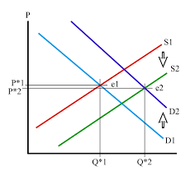

Figure 1. Equilibrium price and quantity points (P,Q) for two supply and two demand

curves.

Image from “Introduction to Energy and Earth Science Economics,”

Pennsylvania State University.

In examples of PV-EL-FC-EG models considered in the World Solar Guide, green hydrogen will be produced by the electrolysis of water and utilized in fuel cells as an energy source for electric grids. In these models, hydrogen is neither sold or purchased. Some industries, utilities, or countries, however, will find it necessary to purchase hydrogen rather than producing it. Alternatively, other entities in regions of high solar irradiance will produce hydrogen by solar-powered electrolysis for export.

5 3. Physical View

If solar energy could be converted with 100% efficiency continuously throughout a 24-hour daily period during, a power level of 15.9 TW over one year would produce energy to meet world demand of 500 EJ-yr-1. A hypothetical 100% efficient solar photovoltaic array in earth orbit with continuous transmission to a global electric grid could produce these results. In fact, earth-based PV-EL-FC-EG systems with efficiencies of 20%, can operate only about six hours per day, (capacity factor of 25% assumed in this Guide). Solar energy is also variable on a latitudinal basis as well as on daily and seasonal time scales, making energy storage necessary.

Renewable energy currencies in PV-EL-FC-EG systems will consist of solar photons, electrons and holes, positive and negative ions, and hydrogen gas. The processes governing these currencies have been described in **Parts 2, 3, and 4** of this Guide, with a flow diagram for a **hypothetical US model** given in **Part 2, Figure 9.1**, which is shown here as Figure 2**.**

Input Energy Output Energy

E1, in E1, out

Electric

Grid

Inverter

PV1

E 2, in, electric

PV2

URFC

DRFC

E2, out, electric

EL

Grid

FC

Grid

1 8 18 hours

EL, H2

Sectors

US, E out = 100 EJ/year

PV3

(90% electrification)

Sectors (Section 14.4)

E3, in, sectors

Water/Grid

Industry

Ein

Water/Sectors

6 hours

WSG E2, out, sectors

Transportation

US Model C

Ein = 475 EJ/year

H2 Storage/Grid

(Section 14.4)

Buildings

H2 Storage/Sectors

10% H2 energy, 325 Mt/yr

Figure 2. Components of a PV-EL-FC energy system with water source and hydrogen storage.

This model can be scaled from small off-grid installations to large-scale utility grids, regions, and nations. Component calculations are given in Table 1, and examples are shown in Section 5.

6

The physical properties of the PV-EL-FC-EG system can also be related in terms of inputs and outputs as shown in Figure 3. Here, in addition to the two parties of suppliers and consumers, a third party, management, in this case, the utility company, will balance the inputs and outputs.

Management

Smart Grids

Supply/Input

Ein = E out = 500 EJ-yr-1 = 2,375 EJ-yr-1

η 0.21

24 hours per day

Pin = Pout = 15.9 TW = 302 TW

CF(η) (0.25) (0.21)

6 hours per day

Demand/Output

E out = 500 EJ-yr-1 (90% electric grid)

(10% hydrogen)

24 hours per day

Pout = 15.9 TW 24 hours per day

If capacity factor, CF = 100%

If system efficiency, η = 100%

24

Direct power to electric grid

PV1 = 14 TW 🡪

daytime, 6 hours

Electric grid 112.5 EJ-yr-1

EG= 14 TW daytime

6 hours

🡨 Balance 🡪

Hydrogen to sectors: 50 EJ-yr-1

Industry

Transportation

Buildings

PV2 = 279 TW 🡪

daytime

6 hours

Grid hydrogen

production

ELG = 279TW🡪

6 hours

PV3 = 9 TW 🡪

daytime

6 hours

PV tot = 302 TW

Hydrogen

production

ELH = 9 TW 🡪

6 hours

Hydrogen

utilization-input

FCG = 28 TW 🡪

nighttime

18 hours

Electric grid

EG=14 TW

337.5 EJ-yr-1

nighttime

18 hours

Figure 3. Energy inputs and outputs. Image from World Solar Guide, **Part 4**, **Figure 12.**

It can be recalled from the world-model table in **Part 2** that the ratio of total PV panel area to that of PV1 is 4.7. The product of this ratio and the annual world energy demand/output of 500 EJ-yr-1 is 2,350 EJ-yr-1 which is also the necessary energy supply/input shown in Figure 3.

7

4. Management View

Three-party interactions are encountered again, this time exemplified by energy storage as a means of mitigating the California “Duck Curve” [1].

Utility companies will pay the market price for hydrogen, and it is their interest to minimize the cost of this commodity by balancing its use with customer demand.

It should be recalled that throughout this guide, simplifying assumptions have been used in the models. For example, energy and power levels were taken as constant amounts during diurnal, seasonal, and annual period.

In fact, these quantities are variable over both short-term and long-term intervals. In the case of electric utilities, consumer demand can be modelled by the “duck-curve” shown in Figure 4.

8

Figure 4 shows the “Duck Curve” during the day of March 31 [1]. The vertical axis is the “net load” which is the difference between the total consumer demand and the renewable energy supply to the grid, that is,

Net Load = Demand - Supply

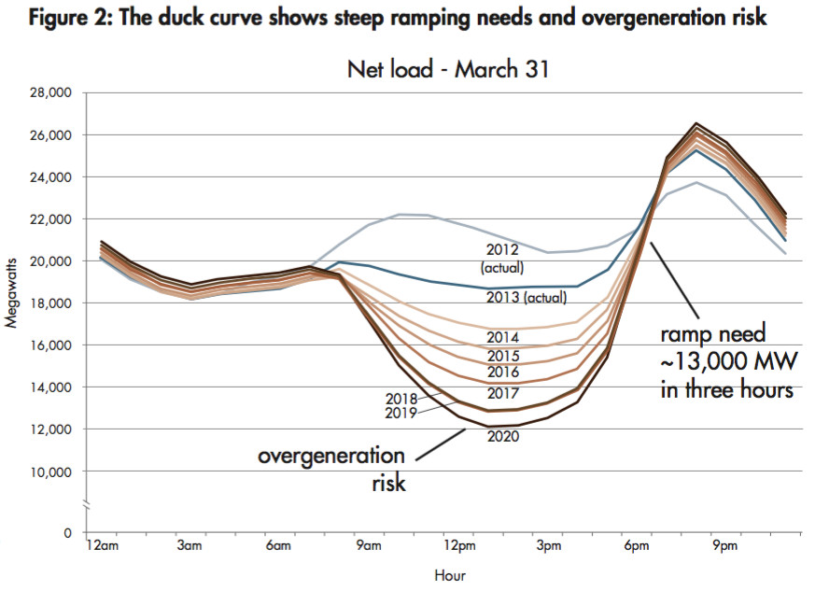

Figure 3. The “Duck Curve.” Image from CAISO, California Independent System Operator.

Methods of flattening the “duck curve” have been proposed [2] with the original curve as seen in Figure 5. Following 10 steps, this curve revised as shown in Figure 6.

9

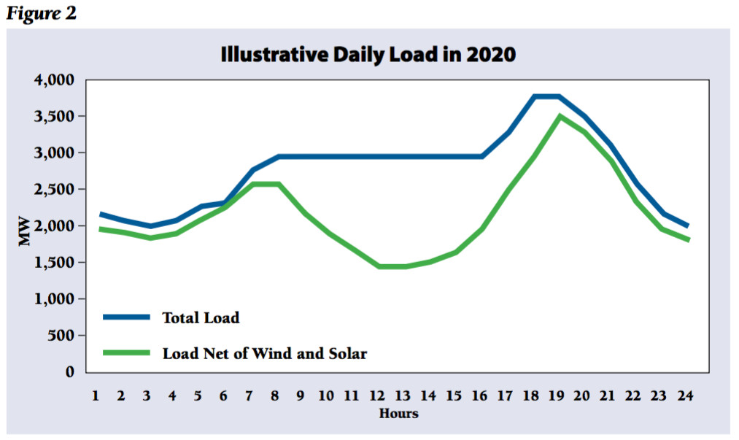

Figure 5.

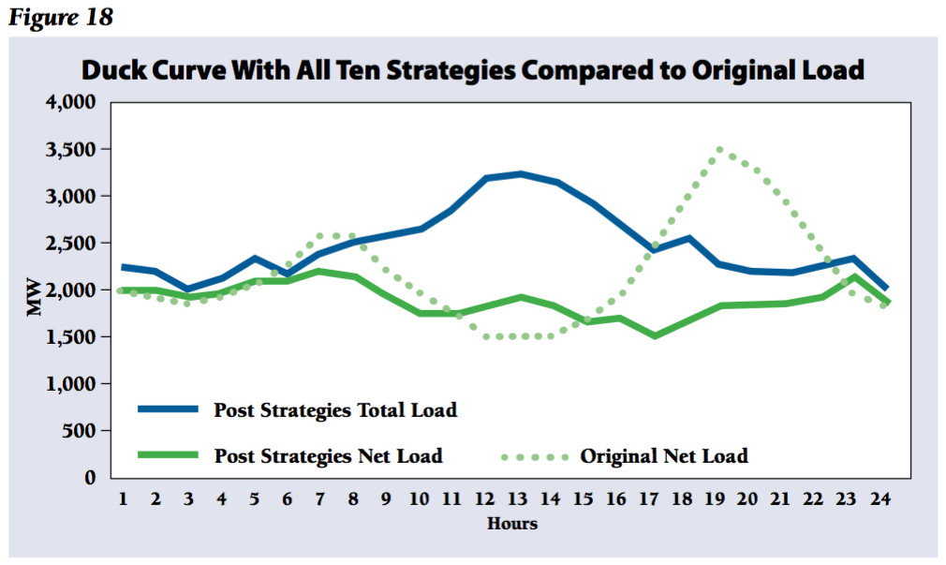

Figure 6.

10

Hydrogen storage is an important supply-side resource in leveling the variability of solar power and improving grid management. Scaled PV-EL-FC models from **Part 2, Table 9.1** are shown here in Table 1. The average US grid size is 10 MW as seen shaded in Table 1. Here, the hydrogen volume at atmospheric pressure is 241,000 m3. At a pressure of 150 bars, this volume is 1,607 m3. The average size of salt caverns, used in hydrogen storage, is 500,000 m3, making these facilities unnecessary for grids of this size. This volume of pressurized hydrogen would require a cubic container of 12 m per side or a spherical container with radius, 7.2 m.

Table 1. Scaled PV-EL-FC models

|  |  |  |  |  |  |  |  |  |
| --- | --- | --- | --- | --- | --- | --- | --- | --- |
| PV1  Direct  Power  to Grid/load  6 hours  Area  (m2) | PV2  Power  to EL,  Total  PV area  6 hours  Areas  (m2) | EL, MW  Mfr. Specs.  200 m3/h  1 MW  6 hours  H2  Prod  rate  (kg/s) | Water  Source  6 hours  (kg)  (m3)  (m3)1/3 | Water  Sink  18 hours  (kg), (m3)  (m3)1/3 | Hydrogen  Production  by EL  6 hours  (kg)  (m3)  1 bar  150 bars | Hydrogen  use rate  by FC  18 hours  Rate  (kg/s) | FC  input  power  18 hours  (KW) | Grid  Load  6 + 18 h  24 hours  (KW)  (KWh)  (%) |
| (10) | (11)  (12)  (13) | (1) | (3) | (3) | (2) | (4) | (5) | (6)  (7)  (8)  (9)  (14) |
| 1,030 | 5,000  6,030  4.9 | 1 MW  4.981x10-3 | 6450  6.45  1.86 | 6450  6.45  1.86 | 108  1,203  8 | 1.66 X 10-3 | 103 | 51.5  927  309  1,236  20 |
| 10,300 | 50,000  60,300  4.9 | 10 MW  4.98x10-2 | 64,500  64.5  4.00 | 64,500  64.5  4.00 | 1,080  12,030  80 | 1.66 x 10-2 | 1,030 | 515  9,270  3,090  12,360  20 |
| 2.06x105  **WSG**  **Part 6**  **Table 1** | 1.00x106  1.21x106  4.9 | 206 MW  9.96x10-1 | 1.29x16  1,290  10.9 | 1.29x106  1,290  10.9 | 2.16x104  2.41x105  1,607 | 3.32x10-1 | 20,600 | 10,300  185,400  61,800  247,000  20  **US Grid**  **10.3 MW** |
| 1.03x106 | 5.00x106  6.03x106  4.9 | 1 GW  4.98 | 6.5x106  6,450  18.6 | 6.5x106  6,450  18.6 | 10,800  120,300  8,020 | 1.66 | 103,000 | 51,500  927,000  309,000  1,236,000  20 |
| 1.03x107 | 5.00x107  6.03x107  4.9 | 10 GW  49.8 | 6.5x107  64,500  40.0 | 6.5x107  64,500  40.0 | 1.08x105  1.20x106  80,200 | 166 | 1.03x106 | 5.15x105  9.27x106  3.09x106  1..23x107  20 |

11

Various forms of “Smart Grids” have been applied by utility companies to balance the supply and demand. An example [3] of the integration of a smart grid with hydrogen storage is shown in Figure 7.

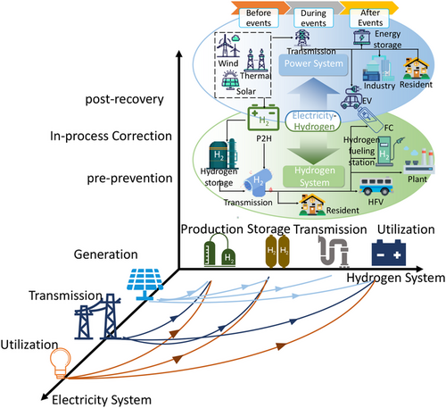

Figure 7. A smart grid with integrated hydrogen storage [3].

12

In addition to this management tool, specific measures can be taken by both producers and consumers as seen in Figure 8.

Management

Smart Grid

Demand

Consumers:

Decrease demand.

Increase appliance

efficiency.

Alter time of appliance

use.

Supply

Producers:

Hydrogen storage for

daily and seasonal

variations.

Fuel cells with fast

response times.

🡨 Balance 🡪

Figure 8. A management scheme for utilities.

13

These three views are shown in abbreviated form below in Table 3. Detailed calculations of the physical views are given in **Part 2**.

Table 3. Three views of hydrogen.

Hydrogen as a Commodity

The equilibrium price and quantity is

determined by the intersection of the

Supply and Demand curves.

S = D

Physical View of Hydrogen

Due to the system efficiency limitation, the

Input/Supply energy is related to the

Output/Demand energy as

Ein = E out

η

The Input/Supply power requires accounting

for the Capacity Factor and efficiency

Pin = Pout

(CF)η

Management Considerations

Grid management requires a “smart grid”

and integrated hydrogen storage.to balance

energy Supply and Demand.

Balance

Supply 🡨 🡪 Demand

14

5. Examples of Solar-Hydrogen Systems

An off-grid solar-hydrogen system in Turkey with PV-EL-FC components was designed and evaluated [4] as shown in Figure 9. The selection of the components was determined by the solar and weather data on site. Energy consumption was based on measured data.

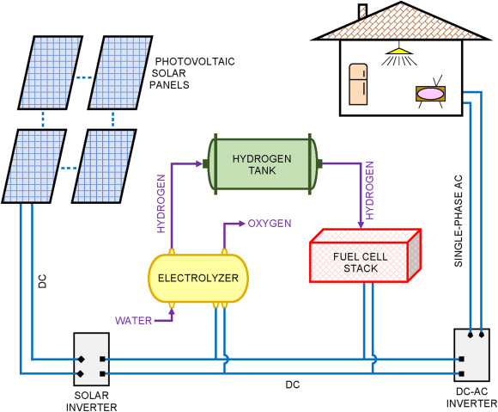

Figure 9. An off-grid system. Image from Ref. [4].

15

The integration of hydrogen and a smart grid was investigated [5]. This review considered four categories:

Hydrogen energy

Hydrogen fuel cell electric vehicles

Hydrogen economy in smart grids

Models for energy systems in smart grids

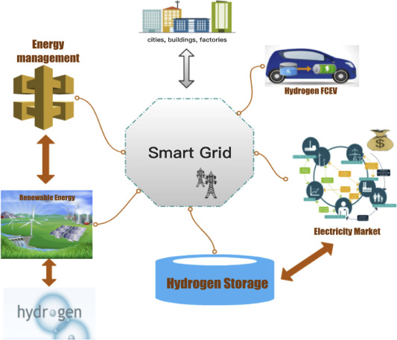

Figure 10. Integration of hydrogen energy and smart grids [5].

16

A model for producing green hydrogen in Japan is shown here in Figure 11 [6].

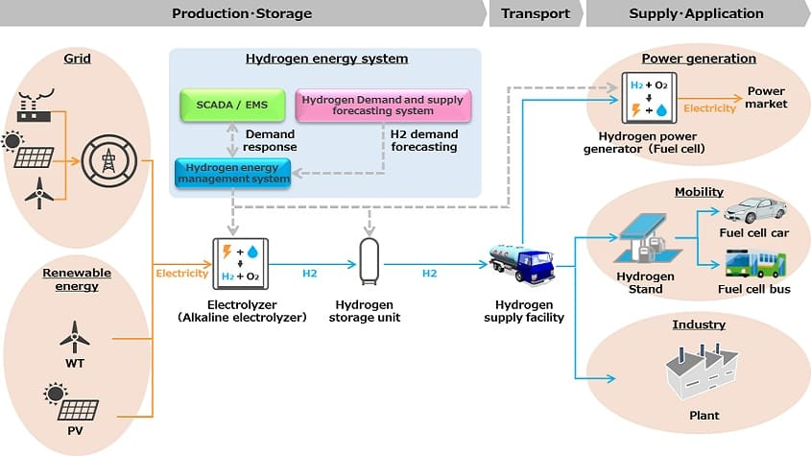

Figure 11. Grid supply-and-demand balance [6]

Image from Power Info Today, Toshiba Energy Systems

The electrolyzer in the model above is a Polymer Electrode Membrane (PEMEL) type. Shown below in Table 2 are power limits with the critical materials, IrO2 and Pt, used in the anode and cathode components as determined in **Part 4** of this Guide. These limits are set by the world annual production levels and reserves of these materials.

Table 2. Power limits of the PEMEL type electrolyzer.

|  |  |
| --- | --- |
| Anode/IrO2/OER | Cathode/Pt/HER |
| PL,a = 0.20(7x106 g-yr-1)(3.8 W-cm-2)  (11.66 g-cm-3)(1.0 x 10-3 cm)  PL,a = 4.6 x 10-4  TW-yr-1 | PL,a  = 0.20(190x106g-yr-1)(3.8 W-cm-2)  (22.56 g-cm-3)(1.0x10-3 cm)  PL,a = 6.9 x 10-3 TW-yr-1 |
| PL,r = 0.20(3,000 x 106 g)(3.8 W-cm-2)  (11.66 g-cm-3)(1.0 x 10-3 cm)  PL,r =0.20 TW | PL,r = 0.20(14,000 x 106 g)(3.8 W-cm-2)  (22.56 g-cm-3)(1.0 x 10-3 cm)  PL,r =0.47 TW |

Based on these limits, earth-abundant electrode catalysts will be required in the PEMEL type for global installations.

17

Analyses of salt cavern utilization are given in **Part 2**. A schematic diagram of a commercial facility powered by renewable energy sources [7] is shown in Figure 12.

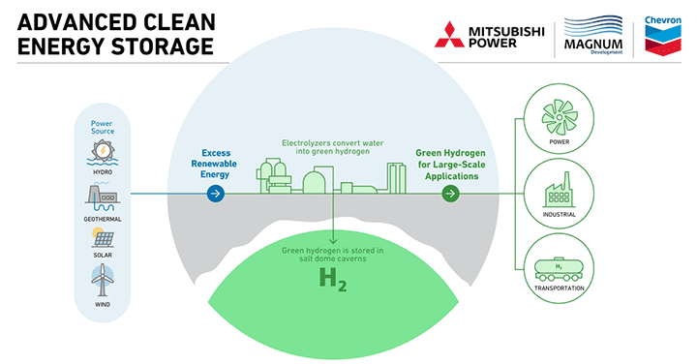

Figure 12. Hydrogen storage in salt dome. Image from [7] Mitsubishi Power

The Advanced Clean Energy Storage Project, located in Delta, Utah, will produce 100 tonnes of green hydrogen daily through water electrolysis powered by the renewable sources of solar and wind. This hydrogen will be stored in two salt caverns, each with a capacity of 150 GWh as a reservoir for grid power generation and for other sectors.

An electrolyzer bank consisting of forty 5.5 MW single-stack pressurized alkaline (commonly KOH) electrolyzers develops a total power of 220 MW. This alkaline-type normally uses nickel-based anodes and cathodes, materials which are **earth-abundant**.

The annual power installation limit for electrolyzers with nickel electrodes of 100 μm thickness, 2.0 W-cm-2 power density, and 20% of the available annual world production from equation (6.2) in **Part 4** is given by:

PL,a = maDp = 0.20(2.5 x 1012 g-yr-1)(2.0 W-cm-2) 11 TW-yr -1

ρt (8.9 g-cm-3)(1.0 x10-2 cm)

and the long-term power installation limit based on 20% of the world reserves of nickel from equation (6.3) is:

PL, r = mrDp = 0.20(94 x 1012 g)(2.0 W-cm-2) = 420 TW

ρt (8.9 g-cm-3)(1.0 x 10-2 cm)

18

A comparison of US and German hydrogen production and storage models is shown in Table 2 where the total annual energy consumption in Germany is approximately 12% of that in the US.

Table 2. Hydrogen production and storage for United States and German models.

|  |  |  |  |  |  |  |
| --- | --- | --- | --- | --- | --- | --- |
| Annual demand  Quantities and  Units | WSG US Model  total  energy  100 EJ-yr-1 | WSG US Model  electric  energy  20 EJ-yr-1 (20%)  5,600 TWh-yr-1 | Germany  total energy  12 EJ-yr-1 | Germany  electric  energy  517 TWh-yr-1 | Germany | Germany  electric  energy  540 TWh-yr-1 |
| Hydrogen  Produ0ction  and storage | PV-EL  6.89 MT-day-1  2,515 MT-yr-1 | PV-EL  1.38 MT-day-1  5.03 MT-yr-1 | NA | NA | Nat. gas facilities  0.72 MT  Saline aquifers  692 MT | NA |
| Hydrogen  Energy storage | 0.826 EJ-day-1  301 EJ-yr-1 | 46 TWh-**day-1**  16,790 TWh-yr-1 | NA | NA | 29 TWh  23,000 TWh | 56 TWh, optimal  storage  9,400 TWh, potential  Storage |
| Hydrogen  storage volume  and rate at  1 atm. STP | 8.30x1010 m3-day-1 | 1.67x1010 m3-day-1 | NA | NA | Natural gas  facilities  8x109 m3 | NA |
| Hydrogen  storage volume  and rate at  150 atm. | Salt caverns  5.53x108 m3-day-1 | Salt caverns  1.11x108 m3-day-1 | NA | NA | Salt caverns  5.53x107 m3  (Table 2 calculation) | NA |
| Number of  salt caverns  Vol: (5x105 m3) | 1106 | 221 | NA | NA | 107  (Table 2 calculation) | NA |
| References | **Part 2 Table 14.6**  1 day = 6 hours  MT = 106 tonnes | 1 day = 6 hours  MT = 106 tonnes | World  Population  Review [8] | World  Population  Review [8] | K Alms [9] | O Ruhnau [10] |

The second column of data in Table 2 refers to the WSG US Model shown in the **Table 14.6 of Part 2** in which the total energy is provided by electrical sources. In the third column, 20% of the total energy is electrical. The fourth and fifth columns show the total energy usage and the electrical energy for Germany [8]. Columns six and seven give potential hydrogen storage data for two models [9,10]. Although these data are based on different energy demands, models, and assumptions, there is a general relative comparability among the sources.

19

6. Summary and Conclusions

The utilization of direct solar PV power as a “daytime” grid input is a necessary but insufficient source of continuous global energy. The World Solar Guide assumes a Capacity Factor of 25% referring to the six daily hours of solar irradiance. Due to the daily and seasonal variability of solar energy, the storage of this source will be required for “nighttime” power with a duration of 18 hours. The primary means of energy storage on a global scale will be hydrogen, and it is important to understand various characterizations of this medium. Common features of these three views are the concept of supply and demand and the need to balance these factors.

As an **economic** commodity, the prices and quantities of hydrogen will be determined by the two-party, supply-demand, interactions of producers and consumers. With viable production levels available in most regions of the world, the efficiency of this market will be higher than that of fossil fuels, whose large productions are limited to a few geographical locations. Hydrogen will, therefore, be a more secure source of energy at national levels than fossil fuels, with a lower likelihood of price controls by limited groups of countries. As an export/import example, countries in North Africa and the Middle East may produce hydrogen for use by countries in Northern Europe with less solar irradiance levels in the production of hydrogen.

In **physical** terms, the PV-EL-FC-EG (solar-storage) system may be viewed as inputs/outputs to the electric grid and to hydrogen production for other sectors. Physical units include energy, power, and energy content. A third element, utility management, may employ “smart grids” to balance the inputs and outputs. Whereas economic and managerial views require equilibria and balances between supply and demand, the capacity factor of 25% and system efficiency of 20% necessitate the input/supply power to be greater than the output/demand power by a factor of 20. Similarly, the input/supply energy exceeds the output/demand energy by a factor of 4.7 for the models considered.

Solar and hydrogen energy sources will also require additional **management** considerations. Utility demand factors can be altered by consumers. An example of supply modification is the analysis of the “duck curve” phenomenon which requires integration of renewable sources into existing grids powered by fossil and possibly nuclear sources. It has been shown that energy storage methods can mitigate this problem. It should be noted that global systems will require hydrogen sources. Furthermore, as the transition to renewables continues, the fossil-fuel contribution to electric grids will diminish. Nevertheless, effective operation of utility grids will continue to require balancing of supply and demand components on daily and seasonal time scales. This management task can be implemented by the development of smart grids together with hydrogen storage. The WSG US Model requirements for hydrogen storage are comparable to those of German references.

` 20

7. References

1. Burnett, M., Energy Storage and the California “Duck Curve,” [www.stanford.edu/2015/ph240/burnett2](http://www.stanford.edu/2015/ph240/burnett2)

2. [www.vox.com/2016/flattening-the-duck-curve-renewable-energy-d-roberts](http://www.vox.com/2016/flattening-the-duck-curve-renewable-energy-d-roberts)

3. Han, J., Wang, J., He, Z., An, Q., Song, Y., Mujeeb, A., Tan, C.-W., and Gao, F., Hydrogen-powered smart grid resilience, [www.ietresearch.onlinelibrary.wiley/2023](http://www.ietresearch.onlinelibrary.wiley/2023)

4. Acar, C., Erturk, E, and Firtina-Ertis, I., Performance analysis of a stand-alone integrated solar hydrogen energy system for zero energy buildings, Intl. J. Hydrogen Energy, 48 (5) 2023.

5. Lin, R. H., Zhao, Y.-Y., and Wu, B.-D., Toward a hydrogen society: Hydrogen and smart grid integration, International Journal of Hydrogen Energy, 45 (39) 2020 20164-20175.

6. Bailey, M., Japan’s new technology-development project focused on green hydrogen, Chemical Engineering, 2020,

7. www.power.mhi.com/amer/refeences/advanced-clean-energy-storage-project/2020

8. [www.worldpopulationreview.com/country-rankings/energy-consumption-by-country/2023](http://www.worldpopulationreview.com/country-rankings/energy-consumption-by-country/2023)

9. Alms, K., Ahrens, B., Graf, M., Nehler, M., Linking geological and infrastructural requirements for large-scale underground hydrogen storage in Germany, Frontiers in Energy Research, 11 2023.

10. Ruhnau, O. and Qvist, S., Storage requirements in a 100% renewable electricity system: extreme events and inter-annual variability, Environmental Research Letters, 17 (4) 2022.