1

**WORLD SOLAR GUIDE**

**Part 3**

**Electrochemistry of Water Electrolyzers and Hydrogen Fuel Cells**

**Jon D. Canaday, Ph.D.**

[jon.canaday@world-solar-guide.com](mailto:jon.canaday@world-solar-guide.com)

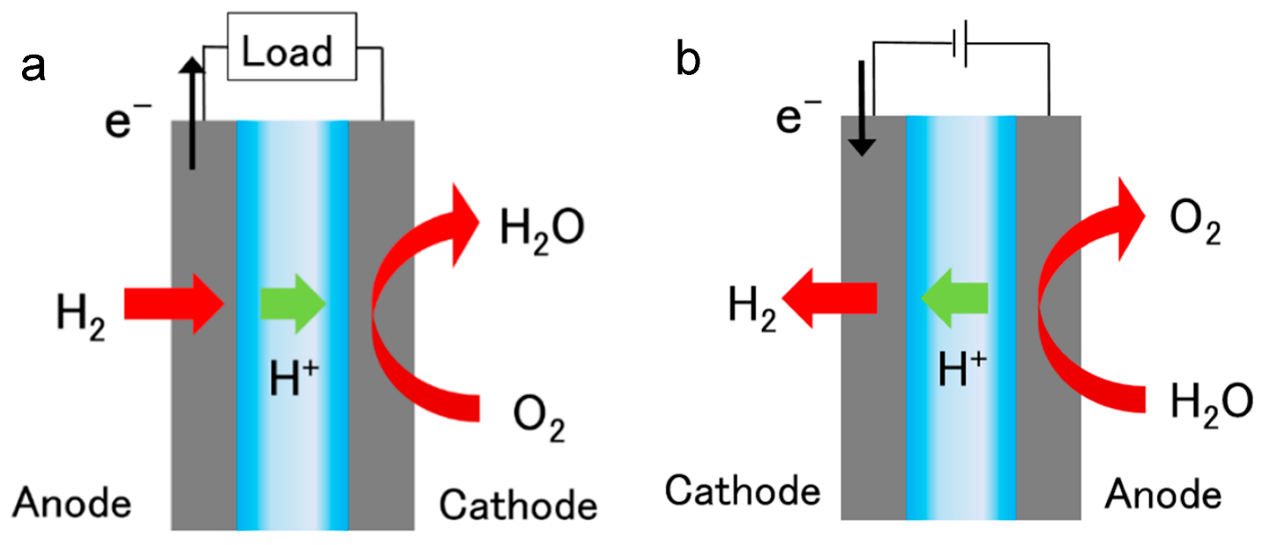

Schematic diagrams: Figure (a) Fuel Cell, Figure (b) Electrolyzer

Image from Ref. [1]

Copyright 2023 © Jon D. Canaday

2

**WORLD SOLAR GUIDE**

**Part 3**

**Electrochemistry of Water Electrolylyzers and Hydrogen Fuel Cells**

Table of Contents Page

1. Introduction 3

2. Integrated Systems 5

3. Electrolyzers 6

3.1 Types of Electrolyzers

3.2 Research and Development in Earth-Abundant Materials

4. Fuel Cells 14

4.1 Types of Fuel Cells

4.2 Research and Development in Earth-Abundant Materials

5. Conclusions 19

6. References 20

7. Appendix 21

7.1 Brief Chronology of Electrochemistry 22

7.2 Basic Electrochemical Principles 23

7.3 Hydrogen Production by Water Electrolysis 28

7.4 Hydrogen Utilization in Fuel Cells 33

7.5 Conversion Units 39

7.6 Density Functional Theory for Electrocatalysis 40

3

**WORLD SOLAR GUIDE**

**Part 3**

**Electrochemistry of Water Electrolyzers and Hydrogen Fuel Cells**

1. Introduction

**Part 1** and **Part 2** of this Guide discussed solar photovoltaic, water electrolysis, and hydrogen fuel cell devices as renewable energy systems for the replacement of fossil fuels on a global basis.

**Part 3** will present electrochemical reactions for electrolyzers and fuel cells. Detailed reviews of recent electrolyzer and fuel cell developments and strategies, widely discussed in the literature, are beyond the scope of this guide, but a few suggestions for future work will be highlighted.

**Part 4** will present concerns of limitations imposed by critical materials currently required in the implementation of these process. Anticipating the limitations of critical materials in **Part 5**, research and development efforts will focus on earth abundant materials which will be required for global hydrogen production and utilization. **Part 6** presents three views of hydrogen from the perspectives of commodity markets, physical characterizations, and grid/sector management.

The Paris Accord of 2015, generally described in **Part 1** of this guide, stipulates that the global temperature increase should be limited to the range of 1.5-2.0 C by 2050. It seems, however, that this mark may be unachievable unless a rapid acceleration of climate measures is undertaken immediately. This goal will be further challenged by the recent increase in temperature of about 1.0 C during the IPCC negotiating period of 1988-2015. In addition, only few countries have made adequate commitments to this goal, but it is encouraging to note that, as examples, Iceland and Costa Rica are now becoming fully renewable.

Some of the “Pathways to Net-Zero CO2 Emissions by 2050,” as described in **Part 2**, have allowed significant levels of fossil fuels to remain in the energy mix. This allocation may be necessary in practical terms, and much of the present turmoil has arisen because of the lack of plans to manage the eventual transition from fossil fuels to renewable sources. Some countries are now actually increasing their use of coal to produce renewable devices. However, it is encouraging to note that many utility companies are now investing more in renewable energy sources that those based on fossil fuels. Although the reserve estimates of fossil fuels vary, at some point, within 30, 50, or 100 years, these sources will likely be exhausted either physically or economically.

4

The building sector has been cited as using 40% of the world’s energy. Among the solutions to this demand is the concept of “passive housing” which is not considered in this Guide. A large portion of CO2 emissions is caused by the electrical sector, and some “pathways” require a 90% electrification to achieve net-zero emissions.

The models described in the World Solar Guide offer a somewhat different perspective for the replacement of fossil by renewables. First, the models assume 100% renewable sources, on the bases of simplicity, 100% solar photovoltaic with 90% of the energy going to electric grids and 10% in the production of hydrogen. The variability of solar is addressed by hydrogen storage with production from water electrolysis and electrical power from fuel cells.

Thus, the models may give over-estimates of electrical supply and demand requirements, but their results will provide global upper limits for the materialsnecessary for the installations of solar PV arrays, electrolyzers, fuel cells, hydrogen storage facilities. For example, silver as used in electrical contacts for PV arrays will be limited in supply. Similarly, the platinum group of metals, will face supply restrictions for use as catalysts in both electrolyzer and fuel cell electrodes. Land-use requirements of solar PV farms were discussed in **Parts 1 & 2**. To mitigate these limitations, substitute materials will be required. Studies of such materials have been under way for the past several years, and future research areas will be outlined.

5

2. Integrated Systems

Due to the variability of solar energy, its storage will be mandatory to make this renewable source fully capable of providing an adequate supply for its demand. An integrated system to supply this energy will consist of photovoltaic (PV) power to water electrolyzers (EL) in the production of green hydrogen which will be fed to fuel cells (FC) producing electricity for the grid as shown in Figure 1. This arrangement can be referred to as a PV-EL-FC system. 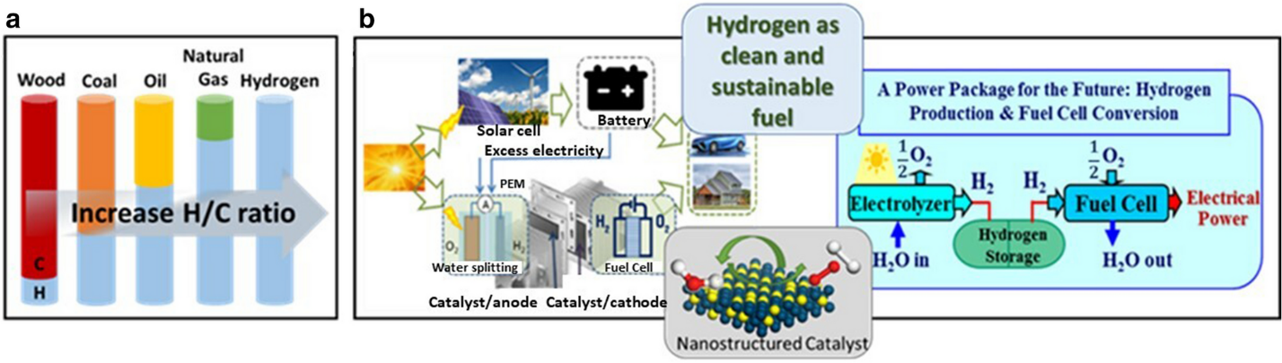

Figure 1. (a) Evolution of fuel types; (b) Electrolyzer-fuel cell system [2].

A simplified schematic diagram of the PV-EL-FC-EG/Sector system is shown in Figure 2, with a full diagram of this system given in **Figure 9.1 of Part 2** of the World Solar Guide. The PV array provides both direct power to the grid (EG) during the six-hour “day-time” period for a capacity factor of 25% and to the water electrolyzers for green hydrogen production. This hydrogen is then stored and later used in the fuels during the eighteen-hour “night-time” period.

Solar Photovoltaic (PV) Electroyzer (EL) Fuel Cell (FC) Grid/Sectors(EG/S)

6 hours 6 hours 18 hours 24 hours

“Daytime” “Nighttime”

Direct

6 hours

Storage

6 hours

Grid

Sectors

Anode Cathode

OER HER

Anode Cathode

HOR ORR

Water Source

Hydrogen Storage

Figure 2. Block diagram of PV-EL-FC-EG system

6

3. Electrolyzers

A schematic view of electrolyzer and fuel cell reactions is shown in Figure 3. Electric power for the water electrolyzer in the World Solar Guide models is provided by a solar PV source. Oxide evolution reactions, OER, occur at the anode, and hydrogen evolution reactions, HER, result at the cathode. Hydrogen and oxygen are then fed to the fuel cell in which hydrogen oxidation, HOR, takes place at the anode and oxygen reduction, ORR, occurs at the cathode together with the production of electricity and water.

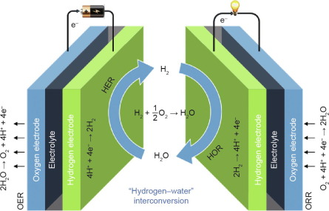

Figure 3. Electrolyzer and fuel cell reactions.

Image from Ref. [3]

7

3.1 Types of Electrolyzers

As defined by their electrolytes, several electrolyzers have been in operation for several years or are more recent developments as characterized in Table 1.

Table 1. Electrolyzer types and properties.

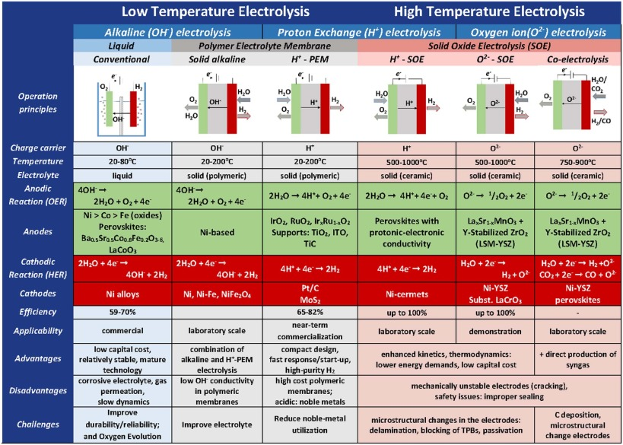

Image from ScienceDirect.com

8

3.2 Research and Development in Earth-Abundant Materials

To install water electrolyzes on the global scale as shown in **Part 2**, it will be necessary to produce their electrodes, electrolytes for solid-oxide electrolyzers, and other components from earth-abundant materials rather than the current reliance on critical elements. This development will require knowledge of the fundamental electrocatalytic processes occurring in the OER and HER steps. A complete discussion of these processes lies beyond the scope of this Guide, but several presentations appear in the literature. A few points will be highlighted in the Appendix.

Electrode development has been expanded to include methods of “Catalyst Engineering” as shown in Figure 4.

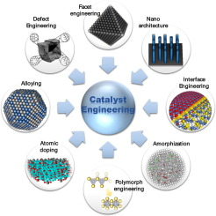

Figure 4. Examples of “Catalytic Engineering” methods.

Image from ScienceDirect.com and Ref. [3]

9

Figure 5 shows a graph of overpotentials vs. Tafel slopes for earth-abundant electrode materials [4] in the ranges of 100-400 mV and 25-90 mV/dec for OER processes. These ranges are comparable to those of the PGM.

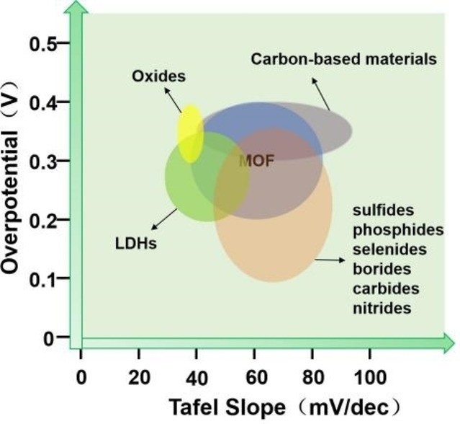

Figure 5. Overpotentials and Tafel slopes for OER with earth-abundant catalysts [4].

10

A review paper [2] compared the activity and stability of catalysts for the electrolysis processes of OER and HER. Averages of these data in four categories are shown below in Tables 2 and 3.

Table 2. Water electrolysis at the anode/OER [2]

|  |  |  |
| --- | --- | --- |
|  | Alkaline Electrolyte | Acid Electrolyte |
| Platinum  Group  Metals  (PGM) | Activity Stability  Overpotential Exchange Tafel Hours Cycles  current slope  175 10 65 1 NA | Activity Stability  Overpotential Exchange Tafel Hours Cycles  current slope  280 10 55 102 6,250  +/- 46 +/- 9 +/- 139 +/- 5,300 |
| Earth-  Abundant  Materials  (EAM) | Activity Stability  Overpotential Exchange Tafel Hours Cycles  current slope  187 14 54 136 2,000  +/- 38 +/-9 +/- 16 +/- 243 | Activity Stability  Overpotential Exchange Tafel Hours Cycles  current slope  NA NA NA NA NA |

For the OER, the activities of PGM and EAM are comparable in alkaline electrolytes. The data for PGM in alkaline and acid electrolytes are also similar, and the PGM catalysts are stable in acid media.

Table 3. Water electrolysis at the cathode/HER [2].

|  |  |  |
| --- | --- | --- |
|  | Alkaline Electrolyte | Acid Electrolyte |
| Platinum  Group  Metals  (PGM) | Activity Stability  Overpotential Exchange Tafel Hours Cycles  current slope  30 10 50 37 NA  +/- 15 +/- 26 +/- 46 | Activity Stability  Overpotential Exchange Tafel Hours Cycles  current slope  NA NA NA NA NA |
| Earth-  Abundant  Materials  (EAM) | Activity Stability  Overpotential Exchange Tafel Hours Cycles  current slope  151 10 59 NA 4,000  +/- 106 +/- 17 +/- 1,200 | Activity Stability  Overpotential Exchange Tafel Hours Cycles  current slope  153 15 55 16 2,700  +/- 35 +/- 8 +/- 6 +/- 22 +/-1,600 |

At the cathode, overpotentials are higher with EAM than for PGM, but stability of EAM occurs in alkaline electrolytes. The activities and stabilities of EAMs are similar in both types of electrolytes.

In general, water electrolysis proceeds in similar manners for the PGM and EAM catalysts in both alkaline and acid electrolytes, meaning that the latter materials should replace the PGM catalysts.

11

MXenes are viable candidates in the replacement of PGM with EAM. A review paper [5] recorded the activities and stabilities of several EAM materials of the transition-metal class. These activity results were analyzed statistically and recorded here in Table 4.

Table 4. Activities of MXenes [5]

|  |  |  |
| --- | --- | --- |
|  | Alkaline Electrolyte | Acid Electrolyte |
| Activity (Units) | Activity  Overpotential (mV) Tafel slope (mV-dec-1) | Activity  Overpotential (mV) Tafel slope (mV-dec-1) |
| Table 1  (PGM) | 84 +/- 61 74 +/- 32 | 57 +/- 34 38+/- 11 |
| Table 1  (EAM) | 242 +/- 126 66 +/- 20 | 125 +/- 23 57 +/- 14 |
| Table 2  (EAM)  Multi-layers | >600 NA | NA NA |
| Table 2  (EAM)  Few layers | 360 +/- 122 109 +/- 9 | 325 +/- 193 89 +/- 26 |
| Table 3  (EAM)  Multi-layer | 115 +/- 4 93 +/- 16 | 292 +/- 171 85 +/- 29 |
| Table 3  (EAM)  Few layers | 116 +/- 69 101 +/- 16 | 121 +/- 87 52 +/- 22 |
| Table 3  (EAM)  Porous structures | 96 +/- 56 52 +/- 14 | 124 +/- 136 64 +/- 31 |
| Table 3  (EAM)  Special structures | NA NA | 93 +/- 83 50 +/- 28 |

The primary result derived from the data in Table 4 is that the overpotentials and Tafel slopes for the EAM are significantly larger than those of the PGM. Secondarily, these measurements among the PGM are higher in alkaline electrolytes than in acid solutions. In addition, the data in Table 3 of this reference show only modest differences in overpotentials and Tafel slopes between the various morphologies.

Volmer, Tafel, and Heyrovski reaction steps for the HER process, as described in this reference are shown by Figure 15 in the Appendix.

12

Two of the material classes expected to replace the PGMs are transition metals and carbon-based. Combinations of metal-carbon compositions are also under development. In addition, Density Functional Theory (DFT) has become an important tool not only in improving fundamental knowledge and screening candidate materials, but in the design of electrocatalytic components. A brief description of DFT is given in the Appendix. Examples of these earth-abundant materials are shown here for electrolysis processes.

A polar nitrobenzene molecule, C6H4NO2, was combined with a g-C3N4 monolayer and then analyzed by DFT simulations [6] as shown in Figure 6. The electrocatalytic performances during OER/ORR were improved by the electron distributions in the g-C3N4 substrate and the most stable composite specimen exhibited overpotentials of 0.27/0.39. These calculations could be extended to design high-efficiency metal-free electrocatalysts.

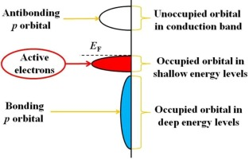

Figure 6. Electron structure of C6H4NO2/g-C3N4. Image from Ref.[6].

13

Multifunctional electrocatalysis of single-site metal catalysts have been analyzed [7]. The metals typically consist of the transition elements, Fe, Co, Ni, and Mn which are combined with graphite structures. MNC structures were calculated with DFT models as seen in Figure 7.

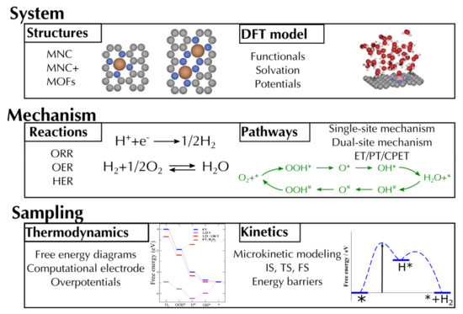

Figure 7. MNC structures for electrocatalysts. Image Ref. paper [7]

14

4. Fuel Cells

4.1 Types of Fuel Cells

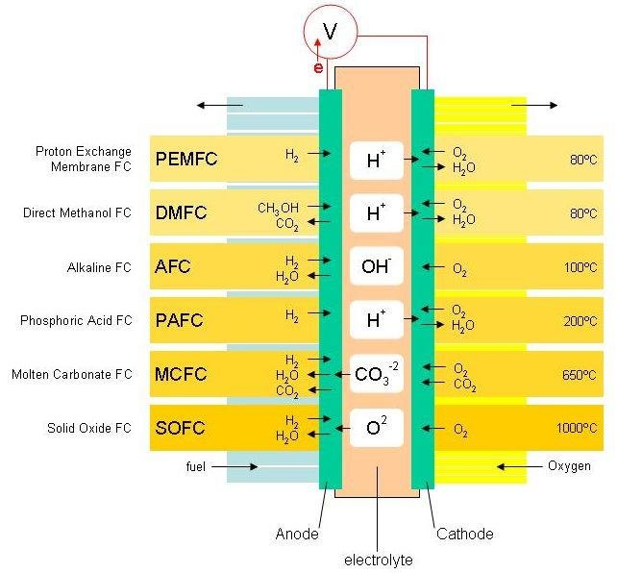

Figure 8. Fuel cell characteristics. Image from University of Cambridge

15

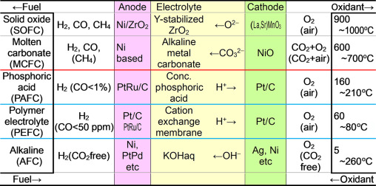

Figure 9. Fuel cell characteristics. Image from sciencedirect.com

16

4.2 Research and Development in Earth-Abundant Materials

As is the case for water electrolyzers, the global installation of hydrogen fuel cells will also require these electodes, electrolytes for solid-oxide fuel cells, and other components to be composed of earth-abundant materials. Here, the HOR and ORR steps must be understood. A few literature citations will be given.

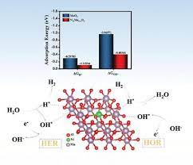

Figure 10. HOR by Ni doping of MoO3

Image from Ref. [8]

17

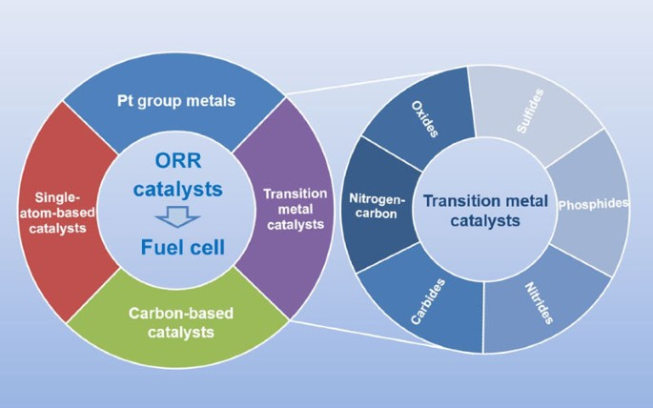

Figure 11. ORR catalysts. Image Ref. [9]

18

Hydrogen fuel cell characteristics with different cathode catalysts have been compared [10]. Summarized below in Table 5 are power densities based on ORR processes at the anodes with PGM and EAM compositions. The electrolytes are acid media as used in PEMFCs.

Table 5. Comparison of power densities for fuel cell ORR catalysts (mW-cm-2) [10].

|  |  |  |  |  |  |  |  |
| --- | --- | --- | --- | --- | --- | --- | --- |
|  | Pt Based | Pd Based | Non-Precious  Metal | Metal-Organic | Carbon-Based | Single-Atom | WSG  Overall  Results |
| Platinum  Group of Metals  (PGM) | Pt/C 175  Surface-mod.  Pt supports  Pt-com 7  Pt-syn 10  Pt-Fe 16  Pt-Co 20  Pt-Cr 21 | Pd2FeCoPt/C 308 | TMNC  Pt/C 561 | NA | Pt/C 62 | Table 8  248 +/- 400  Ir-SAC 932  Pt/C 236 | 359 +/- 295  (Platinum  supports  omitted) |
| Earth-  Abundant  Materials  (EAM) | NA | NA | TMNC  PeG 109  FeNG 1150  TMOx NA  Metal NA  Chalcogenide  TMCN NA | CoCNPC 79 | N-CNT 37    Table 7  778 +/- 218 | Table 8  141 +/- 283  Cu-SAC 196  Fe-SAC 823 | 414 +/- 433 |
| Reference  Conclusions | Pt catalysts  necessary for  continued  commercial  development  of PEM FCs | NA | NA | NA | Carbon-based  with N-dope  w/and w/o  TM may  replace Pt | Requires further analysis.  Shows large  Potential | WSG:  Power  densities  for PGM  and EAM  catalysts  comparable |

As was the case for water electrolyzers in comparison of activities for PGM and EAM electrodes, the fuel cell power densities are comparable for anodes of both material groups. These results suggest that the global installation of electrolyzers and fuel cells will be facilitated by the incorporation of EAMs is system components. In particular, the transition metals and carbon-based materials show large potentials as ORR catalysts. However, the power densities shown in Table 4 are far below the US DOE targets of 1.0 W-cm-2.

Results of alkaline and AEM fuel cells have also been reported with PGM and earth-abundant materials used at the anode and cathode. A few of these results are shown in Table 6.

Table 6. Power densities for AEM and alkaline fuel cells.

|  |  |  |  |  |
| --- | --- | --- | --- | --- |
| Anode  HOR | Electrolyte | Cathode  ORR | Power Density  (mW-cm-2) | Ref. |
| Pt | AEM | Various EAM | 1,000 – 2,000 | [11] |
| PtRu/C | AEM | TM/NC | 1,120 | [12] |
| NiCu/CB | AEM | Pd/XC72R | 350 | [13] |
| Ni@CNx | Alkaline (0.1 M KOH) | Co-Mn | 200 | [14] |

The above results are encouraging for developers of both PEMFCs and AEM/ALKFCs. Continued research will increase the likelihood for global installations of these device

19

5. Conclusions

Major advances in the development of practical electrolyzers and fuel cells have occurred during the past century. These advances are the result, to a large degree, of **critical** materials such as platinum electrodes and rare-earth electrolytes. Not only are these materials expensive, but they are in extremely short supply based on the annual world production and reserve levels. This aspect of renewable sources will be addressed in **Part 4**. Extensive research efforts are currently underway to understand the fundamentals of catalysis and to improve the activities and stabilities of **earth-abundant** materials.

The largest cost component, roughly 70% for green-hydrogen production, is its requirement for electrical power. This cost has been substantially reduced by the dramatic decrease in solar PV costs. Further cost reductions will result from the increased use of non-PGM catalysts and other earth-abundant elements. Further improvements in electrolyzers will result in the cost of hydrogen approaching $1 per kg by 2050.

Due to the variable nature of solar power, extensive energy storage systems will be required for “net zero by 2050” and “100% renewable replacement” scenarios. The hydrogen production and utilization systems will increase “day-time” solar installations by a factor of 3-5 for PV-EL-FC input systems to grids.

Global solar power, direct and stored, as described in **Part 1** and **Part 2,** will require the expeditious development of earth-abundant materials for use in electolyzer and fuel-cell components. Recent developments in the use of earth-abundant materials for these devices are encouraging with improvements seen in activity, efficiency, and durability.

**Part 4** will consider the material and power limitation imposed by the critical PGM. **Part 5** discusses alternative forms of hydrogen production. Subsequent segments, particularly **Parts 7 and 9** show EAMs as a natural resource in the global installation of PV-EL-FC systems.

In addition to basic electrochemical principles, presented as tutorial material in the **Appendix**, an outline of theoretical concepts is also given. Electrolysis is concerned with OER and HER processes, while fuels require an understanding of the HOR and ORR steps. Although these theories do not yield a complete picture of this knowledge, experimental “Catalytic Engineering” methods have resulted in significant improvements of **earth-abundant-material** device performance and durability as demonstrated by the enclosed **Part 3** reference data. It can be expected that devices based on EAMs will replace those consisting of PGM components, thus allowing the global installations of PV-EL-FC systems by 2050.

20

6. References

1. Ogawa, T., Takeuchi, M., Kajikawa, Y., Analysis of Trends and Emerging Technologies in Water Electrolysis Research Based on a Computational Method: A Comparison with Fuel Cell Research, Sustainability, 2018, 10(2) 478.

2. Wang, S., Lu, A., Zhong, C.-J., Hydrogen production from water electrolysis: role of catalysts, Nano Convergence, 8 (4), 2021.

3. Peng, L., and Wei, Z., Catalyst Engineering for Electrochemical Energy Conversion from Water to Water: Water Electrolysis and the Hydrogen Fuel Cell, Engineering, 6, 2020, 653-679.

4. Liu, Y., Zhou, D., Deng, T., Je, G., Chen, A., Sun. X., Yang, Y., and Miao, P., Research Progress of Oxygen Evolution Reaction Catalysts for Electrochemical Water Splitting, chemistry-europe.onlinelibrary.wiley.com, 2021.

5. Sulaiman, R., Hanan, A., Wong, W. Y., Yunas, R. M., Loh, K. S., Walvekai, R., Chaudhary, V. and Khalid, M., Structurally Modified MXenes-Based Catalysts for Application in Hydrogen Evolution Reaction: A Review, Catalysis, 2022, 12 (12) 1576.

6. Pan, H., Wu, Y., Li, C., Li, H., Gong, Y., Niu, L., Liu, X., Sun, C. Q., and Xu, S., Applied Surface Science, 531, 2020, 147292.

7. Cepitis, R., Kongi, N., Grozovski, V., and Ivanistev, V., Multifunctional Electrocatalysis on Single-Site Metal Catalysts: A Computational Perspective, Catalysis, 11(10), 1165, 2021.

8. Zhu, L., Li, X., Yang, M., Zhou, Y., Chen, J., Xie, F., Wang, N., Jin, Y., Sun, S., and Meng, H., An Effective Approach to Enhance Hydrogen Evolution Reaction and Hydrogen Oxidation Reaction by Ni doping to MoO3, newsletter.x-mol.com/paper, 2023.

9. Cao, S., Sun, T., Li, J.-R., Li, Q.-Z., Hou, C.-C., and Sun, Q, The cathode catalysts of hydrogen fuel cell: From laboratory toward practical application, Nano Research, 16, 4365-4380, 2023.

10. Ahmad, F., Kainat, K., and Farooq, U., Comprehensive Review of Materials Having High Oxygen Reduction Reaction Activity, J. Chem. Rev. 4 (4) 374-422, 2022.

11. Hossen, M., Hasan S., Sardar, R. I., Haider, J. B., Mottakin, Tammeveski, K., and Atanassov, P., State-of-the-art and developmental trends in platinum group metal-free cathode catalyst for anion exchange membrane fuel cell (AEMFC), Applied Catalyst B: Environmental, 325, 2023, 121733.

12. Lilloja, J., Kibena-Poldsepp, E., Sarapuu, A., Douglin, J. C., Kaarik, M., Kozlova, J., Paiste, P., Kikas, A., Aruvali, J., Leis, J., Sammelselg, V., Dekel, D. R., and Tammeveski, K., Transition-Metal and Nitrogen-Doped Carbide-Derived Carbon/Carbon Nanotube Composites as Cathode Catalysts for Anion-Exchange Membrane Fuel Cells, ACS Catal. 2021,11(4), 1920-1931.

13. Roy, A., Talarposhti, M. R., Normile, S. J., Zenyuk, I. V., De Andrade, V., Artyshkova, K., Serov, A., and Atenassov, P., Nickel-Copper Supported on Carbon Black Hydrogen Oxidation Catalyst Integrated into Anion-Exchange Membrane Fuel Cell, Sustainable Energy and Fuels, 10, 2018.

14. Gao, Y., Yang, Y., Schimmenti, R., and Zhuang, L., A completely precious metal-free alkaline fuel cell with enhanced performance using a carbon-coated nickel anode, Proc. Natl. Acad. Sci. USA, 2022, 119 (13).

15. [www.en.wikipedia.org/History-of-electrochemistry](http://www.en.wikipedia.org/History-of-electrochemistry)

16. Naimi, Y., and Antar, A., Hydrogen Generation by Water Electrolysis, intechopen, 2018.

21

17. researchgate.net/figure/the rate at which electron transfer takes place.

18. researchgate.net/figure/schematic diagram of electrode-electrolyte interface.

19. Bao, F. Kemppainen, E., Dorbandt, I., Bors, R., Xi, F., Schlatmann, R., van de Krol, R. and Calnan, S., Understanding the Hydrogen Evolution Reaction Kinetics of Electrodeposited Nickel-Molybdenum in Acidic Near-Neutral, and Alkaline Conditions, ChemElectroChem 2021,8, 195-208.

20. Liang, Q., Brocks, G., and Biebele-Hutter, A., Journal of Physics Energy, 3 (2), 2021.

21. Deng, S., Liu, X., Guo, X., Zhao, T., Lu, Y., Cheng, J., Chen, K., Shen, Tao., Zhu, Y., and Wang, D., Insight into the hydrogen oxidation electrocatalytic performance enhancement on Ni via oxophilic regulation of MoO2, Journal of Energy Chemistry, 54, 2021, 202-207.

22. Tang, S., Xiang, J., Song, F., Recent advances in transition metal nitrides for hydrogen electrocatalysis in alkaline media: From catalyst design to application, Front. Chem, 10, 2022.

23. Mu, X., Liu, S., Chen, L., and Mu, S., Alkaline Hydrogen Oxidation Reaction Catalysts: Insights into Catalytic Mechanisms, Classification, Activity Regulation and Challenges, onlinelibrary.wiley.com, 2023.

24. Ramaswamy, N., Ghoshal, S., Bates, M. K., Jia, Q., Li, J., and Mukerjee, S., Hydrogen oxidation reaction in alkaline media: Relationship between electrocatalysis and electrochemical double-layer structure, Nano Energy, 41, 2017, 765-771.

25. Ma, R., Lin, G. Zhou, Y., Liu, Q. Zhang, T. Shan, G., Yang, M., and Wang, J., A review of oxygen reduction mechanisms for metal-free carbon-based electrocatalysts, npj Computational Materials, 5 (78), 2019

26. researchgate.net/figure/schematic fuel cell polarization with contributions of various overpotentials.

27. [www.en.wikipedia.org/Density-functional-theory](http://www.en.wikipedia.org/Density-functional-theory)

28. Roman, A., Computational Physics Blog, Density Functional Theory, 2017.

29. Lee, H., Gwon, O., Choi, K., Zhang, L., Zhow, J., Park J., Yoo, J.-W., Wang, J.-Q.,Lee, J. H., and Kim, G., Enhancing Bifunctional Electrocatalytic Activities via Metal d-Band Center Lift Induced by Oxygen Vacancy on Subsurface of Perovskites, ACS Catal., 2020, 10, 8, 4664-4670.

30. Han Y., Li, Q., Du, A., and Yan, X., DFT-assisted low-dimensional carbon-based electrocatalysts design and mechanism study: a review, Front. Chem., 11, 2023.

22

7. Appendix

7.1 A Brief Chronology of Electrochemistry

As is the case of early solar photovoltaic processes, many electrochemistry principles have been known for more than two centuries. An outline of these developments is shown in Table 7. [15].

Table 7. A Brief Chronology of Electrochemistry

1789 – Jan Rudolph Deiman and Adriaan Paets van Troostwijk demonstrated electrolysis.

1800 – Allesandro Volta invented the battery.

1806 – Humphry Davy developed a theory of chemical affinity.

1832-4 – Michael Faraday developed the two laws of electrochemistry.

1839 – William Grove invented the fuel cell.

1869 – Dmitri Ivanovich Mendeleev created the periodic table of the elements.

1884 – Svante Arrhenius published the thesis on galvanic conductivity of electrolytes.

1888 – Herman Nernst developed the theory of electromotive force of voltaic cells.

1898 – Fritz Haber published the book, *Electrochemistry*.

1909 – Robert Millikan performed experiments on the electric charge of a single electron.

1960’s – Manned space craft utilized fuel cells for electric power and drinking water.

1972 – Fujishima and Honda discovered photo-electrochemistry with TiO2 electrodes.

1970s -1990s – Development of Density Functional Theory and its applications.

Present and future: Giga-Watt-size water electrolyzers are under development for utility-scale production of hydrogen. Large-scale hydrogen fuel cells are also being produced.

As seen in the table above, these devices and processes have known for more than two hundred years. Although the global economic expansion since the beginning of the Industrial Revolution around 1750 was produced in large part by fossil fuels, its uses have resulted in concentrations of CO2 increasing from the natural level of 300 ppm to 400 ppm with a corresponding increase of atmospheric temperature by more than 1 C. The solution to this problem lies in the replacement of fossil fuels by renewable sources such as solar energy.

Water electrolyzers and hydrogen fuel cells are “mirror images” of each other. A voltage applied to electrolyzer electrodes results in the separation of water molecules into its gaseous components, hydrogen and oxygen. When these gases are fed into a fuel cell, the resultant products are electricity and water. Due to the variability of solar energy, both devices are necessary for the storage of this energy in the form of hydrogen. From the consumption of hydrogen in fuel cells, its electricity can be transferred to grids or to off-grid uses.

**Part 3** of the World Solar Guide will lay a foundation for the understanding of electrochemical principles and for describing research efforts to develop **earth-abundant materials** for the global installation of PV-EL-FC systems.

23

7.2 Basic Electrochemistry Principles

Introduction

The significance of electrochemistry principles lies not only in the understanding of electrolyzer and fuel cell processes, but, from the perspective of this Guide, in projecting candidate materials and components which will allow **earth-abundant materials** to be scaled up in size from laboratory samples to global installations of renewable energy devices. The principles described in **Part 3** were used in the **Part 2** models and will be applied to the discussions of **Parts 4, 5, 6,** and **7** of the World Solar Guide. An outline of electrochemistry principles has been developed [16], portions of which will be presented here.

Electrochemical processes which occur at the anodes and cathodes of electrolyzers and fuel cells are extremely complex. The OER and HER processes in electrolyzers and the HOR and ORR processes in fuel cells will be briefly considered in this Appendix, Sections 7.3 and 7.4. General schematic diagrams are shown in Figures 12 and 13. Research is concerned with both the understanding of these processes and improving the catalytic activity and durability of the cell components. The processes include mass transport of ions in solution, chemical reactions, adsorption and desorption, and electron charge transfer.

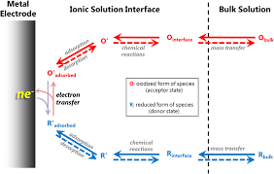

Figure 12. Electrode-electrolyte interface. Image from researchgate.net/figure/the rate

at which electron transfer takes place. Ref. [17].

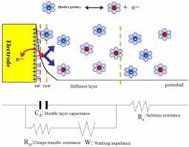

Figure 13. Electrode-electrolyte interface. Image from

researchgate.net/figure/schematic diagram

electrode-electrolyte interface. Ref. [18].

24

Faraday’s Laws

Faraday’s Laws can be used to calculate the amount and rate of hydrogen production by electrolysis and its utilization in fuel cells.

**Faraday’s first law** states that the mass, m, (grams) of a substance produced is proportional (~) to the electrical charge, Q applied,

m ~ Q, or

t

m ~ ʃ Idt, and

0

t

m = k ʃ Idt

0

where m is the mass of a substance in grams, and Q is the amount of electric charge in Coulombs (Q = It, I is the current in amps, and t is time in seconds) deposited or liberated at an electrode, anode or cathode. The term, k, is a constant of proportionality.

The **second law** as given by Faraday states that the masses of different substances formed by the passage of the same quantity of electricity are proportional to the chemical equivalent or equivalent weight, E, of each substance.

m ~ E, where E = M

z

and M is the atomic weight (g-mol-1) and z is the valence or the number of electrons transferred.

From the first and second laws, it can be deduced that

m = kQ. M , where the constant of proportionality is

z

k = 1 = 1

qNA F

q = charge of the electron, 1.602 x 10-19 Coulombs

NA = Avogadro’s Number, 6.022 x 1023, mole-1

qNA= Faraday’s Constant, F, 96,485 Coulombs-mole-1

which gives

m = MIt

zF

25

The number of moles is given by

n = m

M

From these relations,

n = It

zF

The rate of molar production or consumption for a particular species is

r = dn = I, moles-sec-1

dt zF

This relation can be used in model calculations of hydrogen production by water electrolysis and hydrogen consumption by fuel cell utilization. The quantity of hydrogen produced or consumed over a particular time-period is simply the product of the rate and the time interval.

H = rt, moles.

The molar rate of usage is then

rn = dn = I for one cell, nc = 1, or

dt zF

rn = nc I for multiple cells.

zF

The power of a stack is

Ps = nc IVc

where Vc is the voltage of an individual cell which gives

rn = 1 Ps

zF Vc

Since the mass is m = nM, the rate of mass usage is

rm = rn M = M Ps

zF Vc

26

For hydrogen with a molar mass of 2.02 x 10-3 kg-mole-1,

rH2 = 2.02 x 10-3 kg-mole-1 Ps = 1.05 x 10-8 Ps , kg-sec-1

(2) (96,484 Coul- mole-1) Vc Vc

From the ideal gas law, PV = nRT, the volume of gas produced can be calculated for a single electrochemical cell as

V = It RT

zF P

For multiple cells, this volume becomes

V = nc It RT

zF P

The volumetric rate of gas production is then

rv = dV = nc IRT,

dt zFP

When the process efficiency, η, is included,

rv = η nc IRT

zFP

An example of the hydrogen electrolytic production rate in SI (MKS) units is given here for the following conditions:

Electrolyzer efficiency: η = 70%

Number of cells: nc = 120

Current: I = 900 Amps (1 A = 1 Coulomb-sec-1)

Hydrogen gas: standard temperature and pressure,

T = 20 C = 293 K, P = 1 atmosphere = 1.0 x 105 Pascals (1Pa = 1 N-m-2)

Gas constant: R = 8.3145 Joules-mole-1 K-1 (J = N-m)

Hydrogen gas, H2: z = 2

Faraday Constant: F = 96,485 Coulomb-mole-1

Hp = 0.70 (120) (900 Coul-sec-1) (8,3145 N-m-mole-1-K-1) (293 K)

2(96,485 Coul-mole-1) (1.00 x 105 N-m-2)

Hp = 9.54 x 10-3 m3-sec-1

Hp = 34.4 m3-hr-1

27

The quantity of gas produced in a time, t, is

Q = Hpt, m3

so that in a 24-hour period, Q = 826 m3 at a pressure of one atmosphere.

Boyles law of gases states that

P1V1 = P2V2

For a pressure of 150 atmospheres, the above quantity of gas has a volume of 5.50 m3.

From the Ideal Gas Law,

PV = nRT, n = m

M

the hydrogen storage rate volume at STP can be calculated from the data in **Part 2, Table 14.6** as

V = (6.89 tonnes-day-1) [(106 kg)] (8.31N-m) (293 K) = 8.30x1010 m3-day-1.

(2.01x10-3 kg-mol-1) [(tonne)] (mol-K) (1.01x105 N-m-2)

At a typical salt-cavern storage pressure of 150 bar, this volumetric storage rate is equal to 5.59x108 m3-day-1.

As the average salt cavern volume is approximately 500,000 m3, the number of caverns filled daily is 1,120.

28

7.3 Hydrogen Production by Water Electrolysis

Electrolysis reactions at the anode and cathode are as follows:

Anode Cathode

Alkaline solution: 2OH- 🡪H2O +½O2 +2e-(E0 = -0.40 V), 2H2O +2e- 🡪H2 + 2OH-(E0 = - 0.83 V)

Acid solution: 2H2O 🡪 O2 + 4H+ 4e- (E0 = 1.23 V), 2H+ + 2e- 🡪 H2 (E0 = 0.00 V)

Several cases arise in the application of these reactions to electrolyzer operations including the electrolyzer type, electrode materials (PGM or EAM), electrolyte type (alkaline or acid), and the electrode processes (OER or HER). These configurations are shown in Table 8. The AEMEL and PEMEL are used here as examples, and they do not exclude other types of electrolyzers.

The terms, OER and HER refer to “oxygen evolution reaction” and “hydrogen evolution reaction,” respectively.

Table 8. OER and HER processes in electrolyzers.

|  |  |  |  |  |
| --- | --- | --- | --- | --- |
| Electrolyzer  Prototypes | Electrode  Materials | Anode  Steps | Electrolyte  Mobile Ion | Cathode  Steps |
| AEMEL | PGM | OER | Alkaline  OH- | HER |
| AEMEL | EAM | OER | Alkaline  OH- | HER |
| PEMEL | PGM | OER | Acid  H+ | HER |
| PEMEL | EAM | OER | Acid  H+ | HER |

The cell voltages are:

V = Veq + ηa + IR + ηc

where the electrode activation and the electrolyte concentration terms are included as:

ηa = ηa, act + ηa, conc and ηc = ηc, act + ηc, conc

The Butler-Volmer equation is:

J = J0{exp[αazFη/RT] – exp[-αczFη/RT]}

In the high-overpotential region, the Butler-Volmer equation simplifies to the Tafel equation,

J = J0exp[αazFη/RT]

These polarizations are shown in Figure 16.

29

Several OER and HER reaction steps occur at the electrolyzer anode and cathode depending on whether the electrolyte is an alkaline such as KOH or an acid in the case of a PEM cell. These steps are given in Tables 9 and 10 [19, 20].

Table 9. Electrolyzer reaction steps in an alkaline medium.

|  |  |
| --- | --- |
| **Anode**  **OER** | **Cathode**  **HER** |
| OH- + M 🡪 M-OH + e-  M-OH + OH- 🡪 M-O + H2O + e-  M-O +OH- 🡪 M-OOH + e- / 2M-O 🡪 2M  M-OOH + OH- 🡪 O2 + H2O + e- + M  M = Metal | Step 1-Volmer  H2O + e- 🡪 OH- + Had  and  Step 2-Heyrovsky  H2O + e- + Had 🡪 OH- + H2 |

Table 10. Electolyzer reaction steps in an acid medium.

|  |  |
| --- | --- |
| **Anode**  **OER** | **Cathode**  **HER** |
| H2O + M 🡪 M-OH + H+ + e-  M-OH 🡪 M-O + H+ + e-  H2O + M-O 🡪 M-OOH + H+ + e-  M-OOH 🡪 M + O2 + H+ + e-  M = Metal | Step 1-Volmer  H+ + e- 🡪 Had  and  Step 2-Heyrovsky  H+ + e- + Had 🡪 H2  or    Step 3-Tafel  2Had 🡪 H2 |

Experimental methods are used to determine the rate-limiting step of the OER and HER processes. From these analyses as well as from theoretical models such as Density of States calculations, “Electrocatalytic Engineering” such as doping, vacancy introduction, and morphology changes can be introduced to improve the catalytic activity and durability of the electrode materials.

30

An OER process in an alkaline electrolyte is shown schematically in Figure 14.

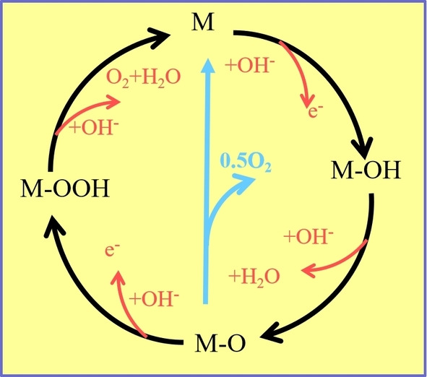

Figure 14. OER processes. Image from Ref. [4].

31

HER reaction steps are shown in Figure 15.

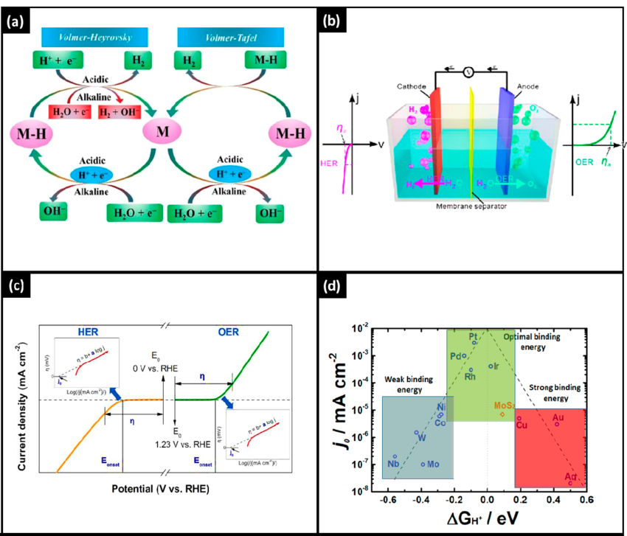

Figure 15. Volmer, Heyrovsky, Tafel steps in HER and OER processes.

Image from researchgate and Ref. [5].

32

An electrolysis polarization graph is shown in Figure 16:

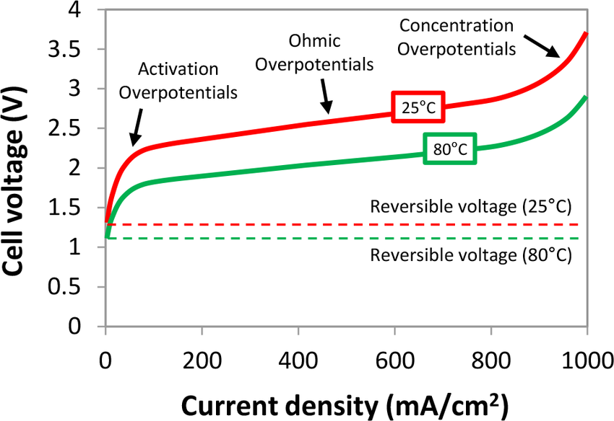

Figure 16. Polarization curve of alkaline electrolyzer. Image from Open Engineering

33

7.4 Hydrogen Utilization in Fuel Cells

Fuel cell reactions at the anode and cathode are:

Anode Cathode

Alkaline solution: H2 + 2OH- 🡪2H2O + 2e- (E0 = 0.83V), O2 + 2H2O + 4e- 🡪4OH-(E0 = 0.40 V)

Acid solution: H2 🡪 2H+ + 2e- (E0 = 0.00 V),O2 🡪 4H+ + 4e- + 2H2O (E0 = 1.23 V)

As with electrolyzers, fuel cell variables include the electrode materials (PGM or EAM) and electrolyte (alkaline or acid). The processes are HOR or ORR. Fuel cell type examples in Table 11 are the AEMFC and PEMFC. Other types are not excluded.

Table 11.

|  |  |  |  |  |
| --- | --- | --- | --- | --- |
| Fuel Cell  Prototypes | Electrode  Materials | Anode  Steps | Electrolyte  Mobile Ion | Cathode  Steps |
| AEMFC | PGM | HOR | Alkaline  OH- | ORR |
| AEMFC | EAM | HOR | Alkaline  OH- | ORR |
| PEMFC | PGM | HOR | Acid  H+ | ORR |
| PEMFC | EAM | HOR | Acid  H+ | ORR |

The fuel cell voltages are analogous to those of electrolyzers with OER and HER replaced by HOR and ORR:

V = Veq + ηa + IR + ηc

where the electrode activation and the electrolyte concentration terms are included as:

ηa = ηa, act + ηa, conc and ηc = ηc, act + ηc, conc

The Butler-Volmer equation is:

J = J0{exp[αazFη/RT] – exp[-αczFη/RT]}

In the high-overpotential region, the Butler-Volmer equation simplifies to the Tafel equation,

J = J0exp[αazFη/RT]

These polarizations are shown in Figure 20.

34

Fuel cell reaction steps at the anode and cathode for HOR and ORR processes are given in Tables 12 and 13 [21, 22].

Table 12. Alkaline media

|  |  |
| --- | --- |
| **Anode**  **HOR** | **Cathode**  **ORR** |
| Tafel-Volmer  Tafel (dissociative adsorption)  H2 🡪 2Had  Volmer (oxidative desorption)  Had + OH- 🡪 H2O + e-  or  Heyrovsky-Volmer  Heyrovsky (dissociative ionization)  H2 + OH- 🡪 Had + H2O + e-  Volmer (oxidative desorption)  Had + OH- 🡪 H2O + e- | Direct 4-electron transfer  O2 + 2H2O + 4e- 🡪 4OH-  and/or  Two-step, 2-electron transfer  O2 + 2H2O + 2e- 🡪 HO2 - + OH-  HO2 - + H2O + 2e- 🡪 3OH - |

Table 13. Acid media

|  |  |
| --- | --- |
| **Anode**  **HOR** | **Cathode**  **ORR** |
| Tafel-Volmer  Tafel (dissociative adsorption)  H2 🡪 2Had  Volmer (dissociative desorption)  Had + H2O 🡪 H3O+ + e-  or  Heyrovsky-Volmer  Heyrovsky (dissociative ionization)  H2 + H2O 🡪 Had + H3O+ e-  Volmer (dissociative desorption)  Had + H2O 🡪 H3O + e- | Direct 4-electron transfer  O2 + 4H+ + 4e- 🡪 2H2O  and/or  Two-step, 2-electron transfer  O2 + 2H+ + 2e- 🡪 H2O2    H2O2 + 2H+ + 2e- 🡪 2H2O |

35

Fuel cell HOR processes are shown in Figures 17 and 18.

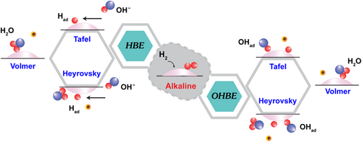

Figure 17. Steps in HOR processes. Image from Ref. [23].

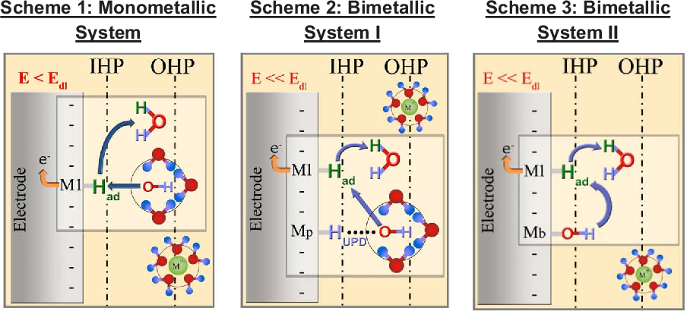

Figure 18. HOR processes in alkaline medium. Image from Ref. [24].

36

Fuel cell ORR steps are shown in Figure 19.

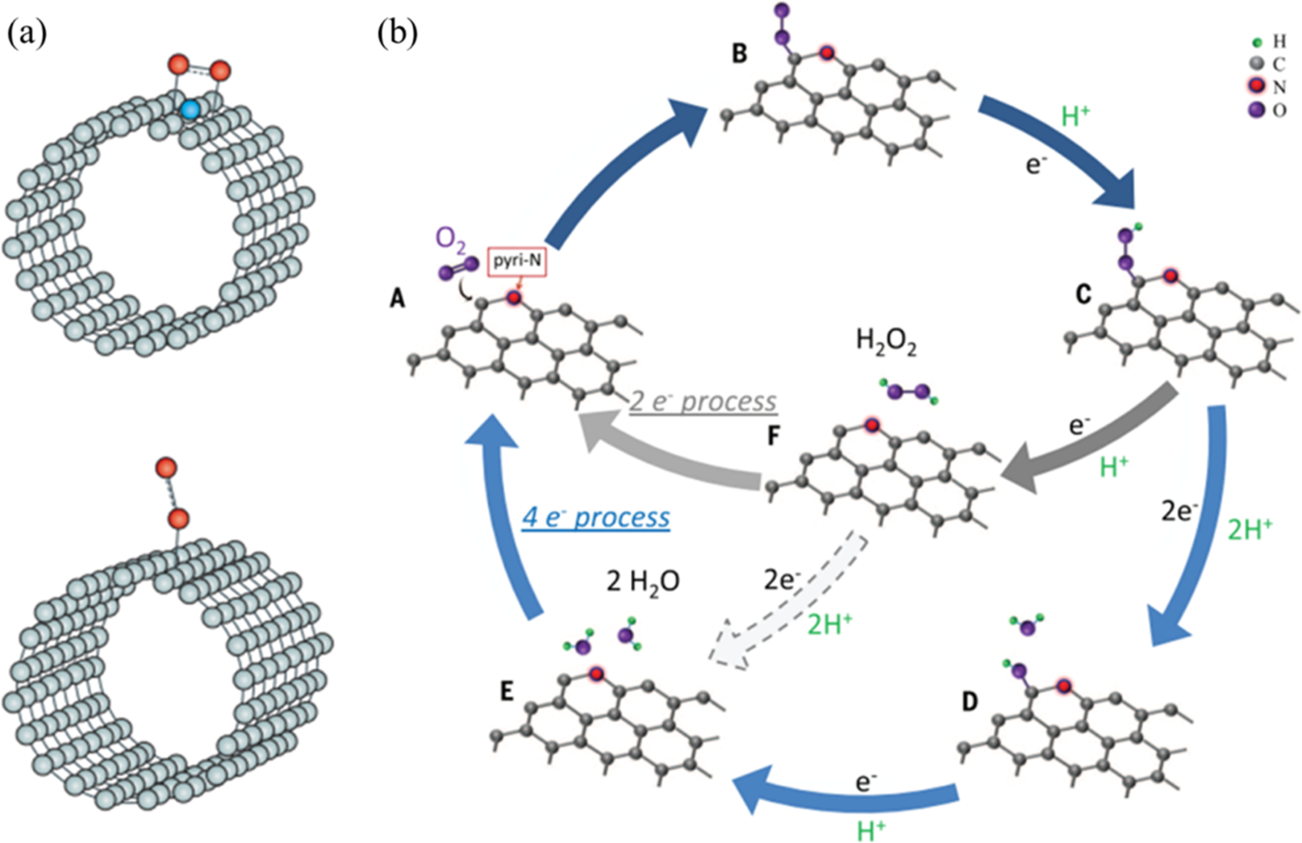

Figure 19. ORR mechanisms for metal-free carbon-based electrocatalysts Image from Ref. [25].

37

A fuel cell polarization curve is shown in Figure 20.

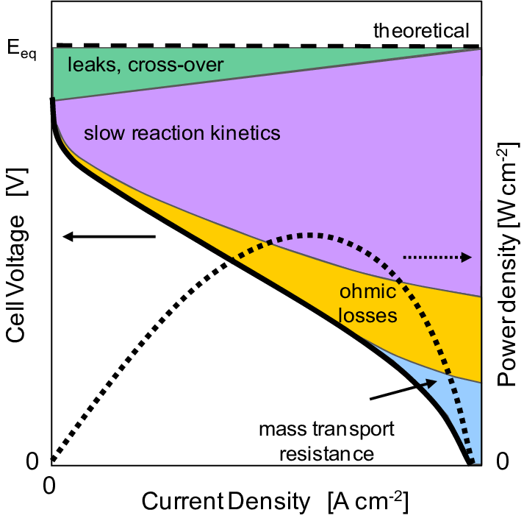

Figure 20. Fuel cell polarization curve with power density.

Image from researchgate.net/figure/schematic of fuel cell polarization

with contributions of various overpotentials Ref. [26].

38

A polarization curve for an AEMFC is shown in Figure 21. The power density of this fuel cell is also reported in Table 5.

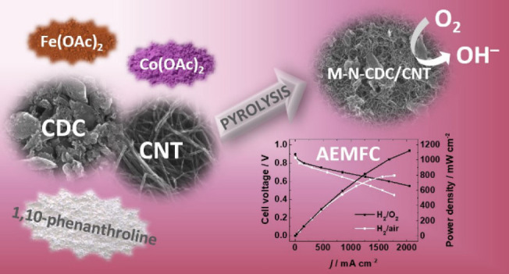

Figure 21. Polarization curves for AEMFC. Image from Ref. [12].

39

X7.5 Units and Conversion Factors

Common units and conversion factors for hydrogen production and utilization

is given in Table 15.

Table 15.

|  |  |
| --- | --- |
| Units and Conversions | Metric Prefixes (Range: 1036) |
| MKS system: meters, kilograms, seconds; m, kg, s  CGS system: centimeters, grams, seconds; cm, g, s  Energy  1 Exa-Joule = 1 EJ = 278 TWh = 2.78x1011 KWh  1 TWh = 3.6x10-3 EJ  1 KWh = 3.6x10-12 EJ  Power  1 watt = 1 W = 1 Joule-sec-1  Hydrogen energy content (energy density)  33.3 KWh-kg-1  Hydrogen density  ρH2 = 0.0899 kg-m-3 (STP)  Pressure  1 atmosphere = 1.0x105 Pascals, (Pa = N-m2), (N = Newton)  Hydrogen storage  Form of storage Energy Density  KWh-kg-1  gas (20 MPa) 33.3  gas (24.8 MPa) 33.3  gas (30 MPa) 33.3  liquid (- 253 C) 33.3  Constants  Avogadro’s Number, NA = 6.022x1026 kilo-mole-1  NA = 6.022x1023 mole-1  Electron charge, q = 1.602x10-19 coulombs  Faraday’s constant, F = NAq = 96,485 coulombs-mole-1  Gas constant, R = 8.3145 Joules-mole-1K-1, (J = N-m) | Zeta (Z) 1021  Exa (E) 1018  Peta (P) 1015  Tera (T) 1012  Giga (G) 109  Mega (M) 106  Kilo (K) 103  Deca (D) 101  milli (m) 10-3  micro (μ) 10-6  nano (n) 10-9  pico (p) 10-12  femto (f) 10-15 |

40

7.6 Density Functional Theory

Density Functional Theory (DFT) has become an important analytical tool in the research and development efforts to produce electrolyzer and fuel-cell components for renewable energy systems. A detailed presentation of this theory is beyond the scope of World Solar Guide, but a brief discussion of its basic concepts is given here. Readers are referred to the literature for further features.

DFT [27] is a quantum mechanical method used in solid-state physics, chemistry, and materials science to determine the electronic structure (density of states, DOS) for atoms, molecules, and condensed phases. The time-independent Schrodinger Equation of quantum mechanics is stated as [28],

H Ѱ = E Ѱ (1)

where the Hamiltonian contains the kinetic and potential energy terms which gives,

-ħ2∇2Ѱ + V(r) Ѱ = E Ѱ (2)

2m

In the Hartree-Fock method, a density term is added,

-ħ2 ∇2 Ѱi + V (r)Ѱi + ʃ n(r’)dr’Ѱi = εi Ѱi  (3)

2m r - r’

Electron correlations can be considered by adding an exchange-correlation potential term, Vxc(r’), in the Kohn-Sham equations,

-ħ2 ∇2Ѱi + V(xr)Ѱi + ʃ n(r’)dr’ Ѱi + Vxc(r’)= εi Ѱi  (4)

2m r-r’

Here, the exchange-correlation energy functional is a density functional,

Vxc(r)= δExc(n) (5)

δ(r)

The correlation-exchange function in not known exactly, and the local-density approximation is used,

Exc = ꭍn(r)εxc(n)dr (6)

41

An example of DFT analysis is the investigation of OER and ORR processes in the perovskite,

Sm0.5Sr0.5CoO3-δ , where delta (δ) is a measure of the oxygen vacancies [29] as shown in Figure 22. It was found that the improved performance of both OER and ORR could be explained by the change in oxidation state of the transition metal, Co, which was caused by the increase in oxygen vacancies. Here, these activities were simultaneously improved by the reduced energy gap, ΔEd-p, between the d-band of the Co atoms and the p-band of the oxygen atoms as δ is increased. The density of states (DOS) for the oxygen atoms and Co atoms are shown qualitatively in the valence band, while the unoccupied conduction band is shown above the Fermi level. It was reported that an important factor of ORR/OER is affected only by the oxidation state of the transition metal in the perovskite oxide, not by the oxygen vacancy concentration.

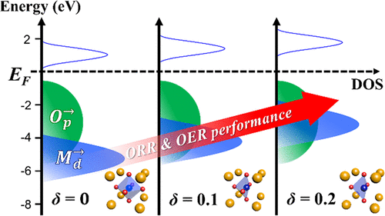

Figure 22. Effect of δ on density of states. Image from Ref. [29].

42

An important feature of DFT is its ability to avoid trial-and-errors approaches in the selection of candidate materials. An excellent review paper [30] describes this theory in combination with other theoretical and experimental measures in the development of OER, HER, and ORR catalysts. These concepts are depicted graphically in Figure 23. DFT examples of these reactions are given in Sections 7.3 and 7.3.

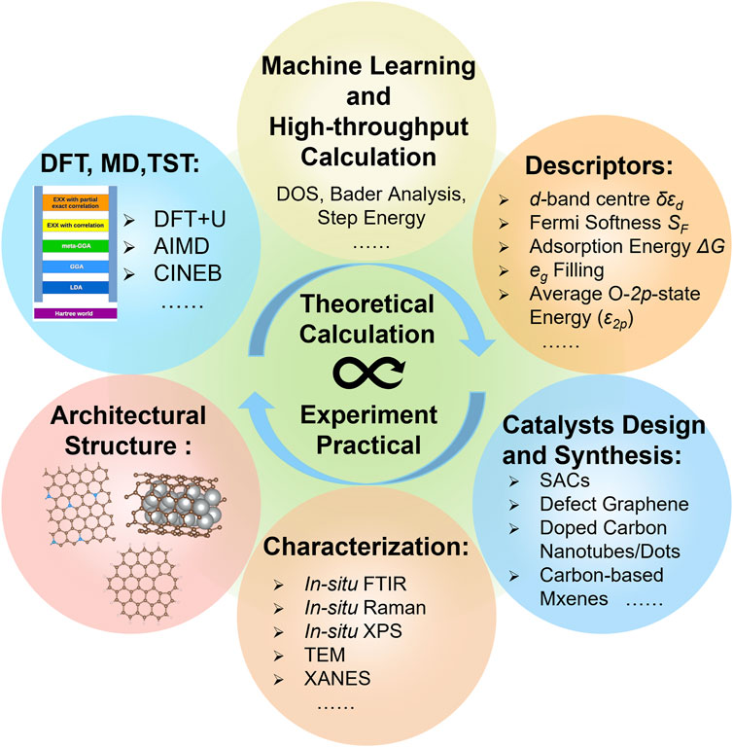

Figure 23. Schematic illustration showing the combination of theoretical calculations and

experimental studies. Image from Ref. [30].